Cash Is Back
Replicating the COVID-19 Liquidity Shock Evidence in
“The Savings of Corporate Giants”
Ziming Zhu
Master of Finance, Gies College of Business, University of Illinois Urbana-Champaign
October 2026
Abstract
Darmouni and Mota (2024) show that the largest U.S. non-financial firms hold about half of their financial assets in securities rather than cash, and that firms more exposed to the COVID-19 shock rebuilt cash in 2020. I replicate the paper’s evidence on the 2020 liquidity shock in Python, rebuilding the authors’ R data pipeline from manually downloaded Compustat and CRSP data and the authors’ hand-collected 10-K portfolio data. The replication reproduces the aggregate portfolio dynamics and the main difference-in-differences result: a one standard deviation higher industry exposure is associated with cash-like holdings about 1.6% of total assets higher. Estimates for marketable securities are smaller than published and insignificant, and the sign of the corporate bond estimate depends on a single firm. I reconcile the sample step by step against the authors’ code, which accounts for every excluded firm, and document several features of the original code that affect the estimation sample.

1. Introduction
Large non-financial firms hold an increasing share of corporate savings. Darmouni and Mota (2024) hand-collect the financial asset portfolios of the largest U.S. firms from 10-K filings and show that these firms behave more like asset managers than cash hoarders: about half of their financial assets are invested in securities, with a growing share in corporate bonds. A natural question is how such portfolios respond when firms suddenly need liquidity. Section 4.3 of the paper uses the COVID-19 shock in early 2020 to answer it and finds that “cash is back”: firms more exposed to the shock increased cash-like holdings.
This note replicates that section: the aggregate portfolio dynamics in Figure 5 and the difference-in-differences regressions in Table 3. The authors’ replication package is written in R and downloads data through a direct WRDS connection. I rebuild the data pipeline and the analysis in Python, using WRDS tables downloaded manually through the Web Query interface. Because the two data routes deliver files in different structures, part of the work consists of identifying and correcting the resulting differences before the analysis can be compared with the paper.
The replication confirms the paper’s main conclusion. The aggregate data show a sharp build-up of cash in the first half of 2020 while bond holdings stay flat, and the regression coefficients for total financial assets and cash-like holdings match the published estimates in sign, magnitude, and significance. Results for securities are weaker. A step-by-step reconciliation of the sample shows that every firm excluded from the estimation sample follows from the logic of the original code, and a leave-one-out analysis shows that the corporate bond estimate is driven by one firm. Section 5 lists features of the original code that readers of the paper may want to keep in mind.

2. Data and Sample Construction

2.1 Data sources
The analysis combines four sources. The core data are the authors’ hand-collected financial asset holdings (FIS data), covering about 200 large firms annually from 2000 to 2019 and quarterly from 2020Q1 to 2021Q4. Holdings are grouped into five categories: cash-like instruments, U.S. government securities, corporate bonds, equities, and other assets. Firm fundamentals come from Compustat North America (annual and quarterly), industry codes are supplemented from CRSP through the CRSP/Compustat link table, and COVID-19 exposure is the industry-level abnormal employment change of Chodorow-Reich et al. (2022), measured at the three-digit NAICS level and standardized.

2.2 Pipeline
I rebuild the parts of the authors’ pipeline that feed Section 4.3, in four steps. First, the Compustat annual file is cleaned and industry codes are filled using historical codes, CRSP codes, and the company names table. Second, the quarterly file is cleaned, merged with industry codes, and year-to-date cash flow items are converted to quarterly values. Third, annual FIS holdings are merged with the Compustat sample, which excludes financial firms, utilities, and government entities and requires positive assets and cash. Fourth, annual FIS data are treated as fiscal fourth-quarter observations, stacked with the 2020–2021 quarterly data, and merged with Compustat quarterly data for firms in the 2019 FIS sample.

2.3 Differences from the authors’ data access
Manually downloaded files differ from database downloads in ways that matter. Identifiers lose leading zeros, column names change case, and the CRSP names file follows a newer format with different date fields. The most consequential difference concerns the company names table. The authors use a table with one record per firm, which is not available through the Web Query interface; the closest substitute has one record per firm-year. Merging it without adjustment multiplied the data, expanding the quarterly file from 1.7 million to 9.3 million rows. The problem surfaced when the pipeline failed the authors’ own uniqueness check. Two duplicate counts that were exactly equal indicated that entire rows were being copied rather than a few firms having conflicting dates, which led to the names table. Keeping one record per firm restored the intended structure, after which all uniqueness checks pass.

3. Replication Results

3.1 Aggregate portfolio dynamics
Figure 1 reproduces Figure 5 of the paper. Following the original code, observations are aligned to ten time points: one per year for 2015–2019 and quarterly observations through 2020, followed by 2021Q4. The sample is a balanced panel of 119 firms.
Figure 1. Aggregate portfolio dynamics, 2015–2021 (replication of Figure 5)
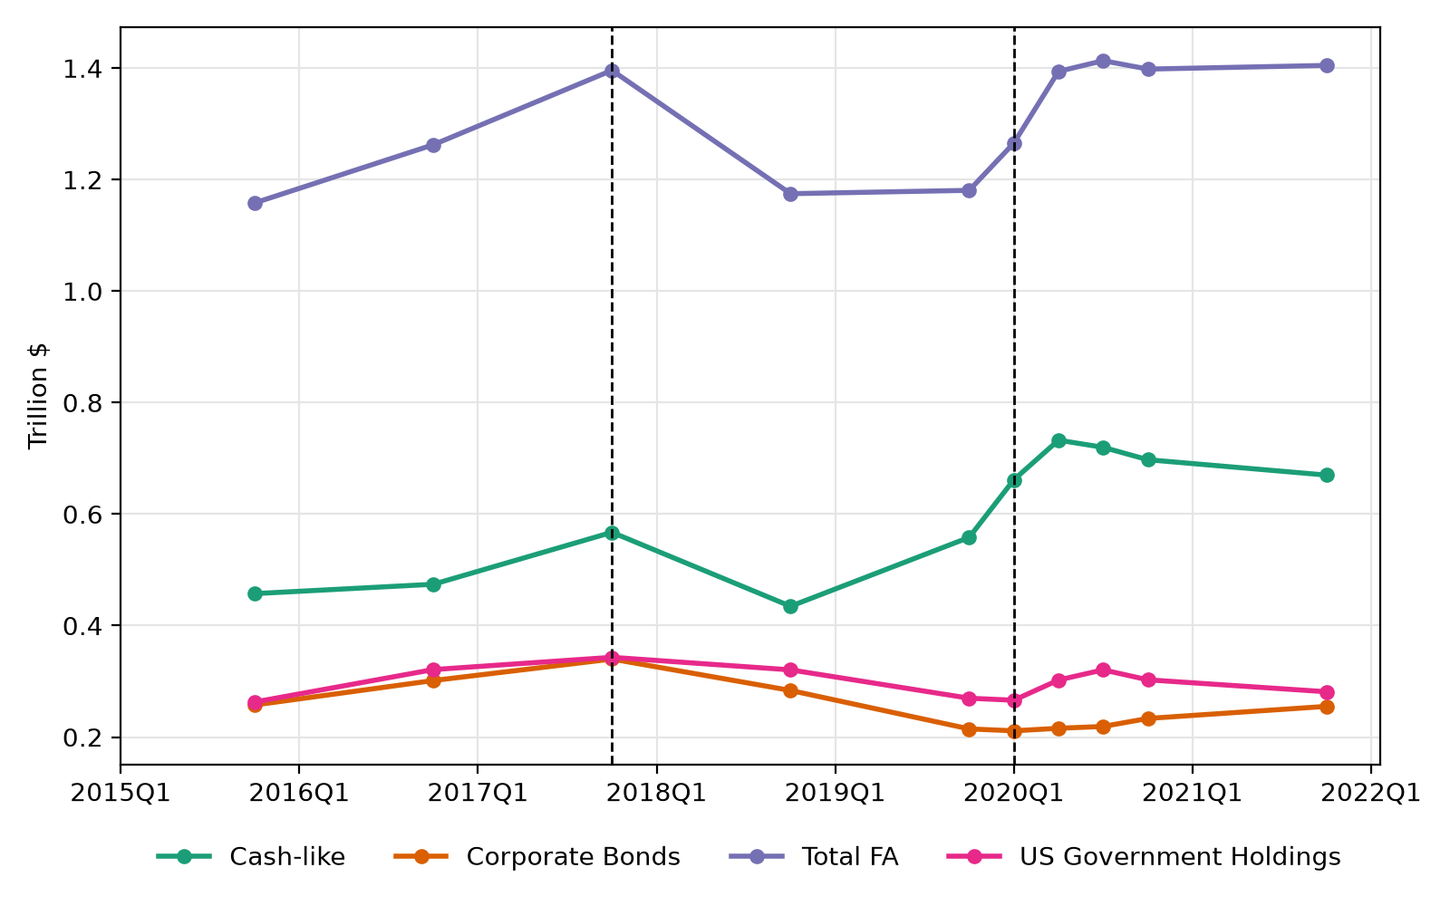
Notes: Sum of holdings across the 119 firms in the balanced panel, in trillions of U.S. dollars. Dashed lines mark 2017Q4 (Tax Cuts and Jobs Act) and 2020Q1 (onset of COVID-19).
The figure reproduces the two episodes discussed in the paper. After the 2017 tax reform, total financial assets fell from 1.40 trillion to 1.17 trillion U.S. dollars by the end of 2018, and corporate bond holdings declined from 0.34 trillion to 0.21 trillion by the end of 2019. During the COVID-19 shock, cash-like holdings rose from 0.56 trillion in 2019Q4 to 0.73 trillion in 2020Q2, while corporate and government bond holdings barely moved. Nearly all of the increase in financial assets in early 2020 took the form of cash.

3.2 Difference-in-differences estimates
Table 3 of the paper estimates, for firm i in quarter t,
y_{it} = β (Post_{t} × Exposure_{i}) + α_{i} + γ_{t} + ε_{it},
where y is a category of financial assets divided by total assets, Post equals one from 2020Q1 onward, Exposure is the standardized COVID-19 employment shock of the firm’s industry, and α and γ are firm and quarter fixed effects. The sample covers 2018Q4 to 2020Q4.
Table 1. Effects of the COVID-19 shock: paper versus replication
Dependent variable | Paper | Replication | R² (paper / replication)
Total financial assets / AT | 0.019*** (0.005) | 0.018*** (0.005) | 0.918 / 0.918
Cash-like / AT | 0.013*** (0.004) | 0.016*** (0.004) | 0.757 / 0.763
Marketable securities / AT | 0.006** (0.003) | 0.002 (0.003) | 0.945 / 0.947
U.S. government bonds / AT | 0.003** (0.001) | 0.002* (0.001) | 0.979 / 0.979
Corporate bonds / AT | 0.003 (0.002) | −0.001 (0.002) | 0.858 / 0.859
Observations | 720 | 714
Notes: Coefficient on Post × Exposure with standard errors in parentheses. All regressions include firm and quarter fixed effects. ∗, ∗∗, and ∗∗∗ denote significance at the 10%, 5%, and 1% levels.
The main result replicates. Firms in more exposed industries increased financial assets and cash-like holdings relative to total assets, with coefficients close to the published values and significant at the 1% level. A one standard deviation higher exposure is associated with cash-like holdings about 1.6% of total assets higher. R² values are nearly identical across all five columns, indicating that the underlying data are very close.
The replication differs in columns 3 to 5. It assigns slightly more of the increase to cash and less to securities: the cash-like coefficient is 0.003 higher and the marketable securities coefficient 0.004 lower. The corporate bond coefficient changes sign, although it is insignificant in both versions. The estimation sample contains 119 firms rather than 120. Section 4 examines both differences.

4. Reconciling the Differences

4.1 Sample reconciliation
To locate the missing firm, I trace every firm in the FIS sample through the pipeline. Table 2 reports the number of firms remaining after each step and the reason for each exclusion.
Table 2. Sample reconciliation
Step | Firms | Firms excluded and reason
FIS sample | 200
Active in Compustat in 2019 | 158 | 42 firms delisted, acquired, or merged before 2019 (e.g., Enron, Compaq, Monsanto)
Pass industry filters | 156 | Honeywell (SIC 9997) and PayPal (NAICS 522320)
Matched to COVID-19 exposure | 150 | 6 firms in NAICS 312 and 316, which have no exposure value
Balanced panel (10 time points) | 119 | 29 firms with non-December fiscal years, mergers around 2020, or late listings
Notes: Firms remaining after each step of the pipeline for Section 4.3.
Each exclusion follows from the logic of the original code rather than from errors in the replication. The 29 firms dropped from the balanced panel fall into identifiable groups. Eleven firms with fiscal years ending in January or March, including Walmart, Target, and Home Depot, can never fill the 2019Q4 time point: their fiscal 2019 annual report is dated early 2020 and is assigned to 2020Q1, while the quarterly data begin in fiscal 2020. Five firms with April or May fiscal year ends miss several points because their fiscal quarters do not align with calendar quarters. The remaining firms were acquired or merged around 2020, were not yet public in 2015–2016, or have no quarterly data for 2020–2021.
Since every step is consistent with the authors’ code, the remaining one-firm gap most likely reflects differences in Compustat industry codes between data vintages. Honeywell and PayPal are the natural candidates, since their exclusion depends entirely on industry codes. Checking the firm list in the paper’s appendix will settle which firm the original sample includes.

4.2 Sensitivity of the corporate bond estimate
Because the regressions weight firms equally, a single firm can move an insignificant coefficient. I re-estimate the corporate bond regression 119 times, each time omitting one firm. Omitting Booking Holdings alone changes the coefficient from −0.001 to +0.002, close to the published 0.003; omitting any other firm except Qualcomm leaves it negative. Booking, an online travel platform, was among the firms most exposed to the shock and held a large corporate bond portfolio, so its sale of bonds in 2020 has an outsized effect. The corporate bond result is therefore fragile in both the paper and the replication, and neither version supports a firm conclusion about corporate bonds specifically.

5. Observations on the Original Code
Working through the code line by line revealed several features that affect how the published results should be read.
1. Estimation window. The note to Table 3 states that Post covers 2020Q1 to 2021Q4 and that the sample runs to 2021Q4. The code restricts the regressions to 2018Q4–2020Q4, and the reported 720 observations equal 120 firms times the six time points in the code, so the published estimates follow the code.
2. Industry filter. The code drops firms whose SIC code starts with 9 to exclude public administration. Compustat assigns code 9997 to conglomerates, so diversified industrial firms such as Honeywell are excluded as well.
3. Balanced panel. Requiring ten time points removes all large retailers with January fiscal year ends, a group whose cash needs during the pandemic were unusual. A code comment indicates that the fiscal year threshold was adjusted to retain such firms, but the balanced-panel requirement excludes them again.
4. Reporting details. Dependent variables are ratios rather than percentages, despite the “(%)” in the column headers, and standard errors are not clustered.

6. Conclusion and Next Steps
The replication supports the central conclusion of Section 4.3: when the COVID-19 shock hit, the largest U.S. firms met their liquidity needs by building cash, not by expanding their securities portfolios. The evidence for securities is weaker than published, and the corporate bond estimate hinges on a single firm. A full reconciliation of the sample shows that the replication differs from the original by one firm, most likely because of revisions to industry codes in Compustat.
Two extensions follow. The first is a set of robustness checks: clustering standard errors by firm, examining the sensitivity of the securities estimate to individual firms, and using December 2020 rather than March 2021 data for the 2020Q4 time point of December fiscal year firms. The second extends the sample beyond 2021. The paper’s data end just before the 2022–2023 interest rate increases, when bond prices fell sharply. Using SEC EDGAR filings, I plan to measure unrealized losses on these firms’ bond portfolios and test, with the same design as Table 3, whether firms with greater interest rate exposure at the end of 2021 shifted toward cash. This is the mechanism behind the 2023 failure of Silicon Valley Bank, applied to non-financial firms.

References
Darmouni, Olivier, and Lira Mota. 2024. “The Savings of Corporate Giants.” Review of Financial Studies 37 (10).
Darmouni, Olivier, and Lira Mota. Replication package, Harvard Dataverse, doi:10.7910/DVN/KDFUHV; hand-collected data at corporategiants.net.

