1-

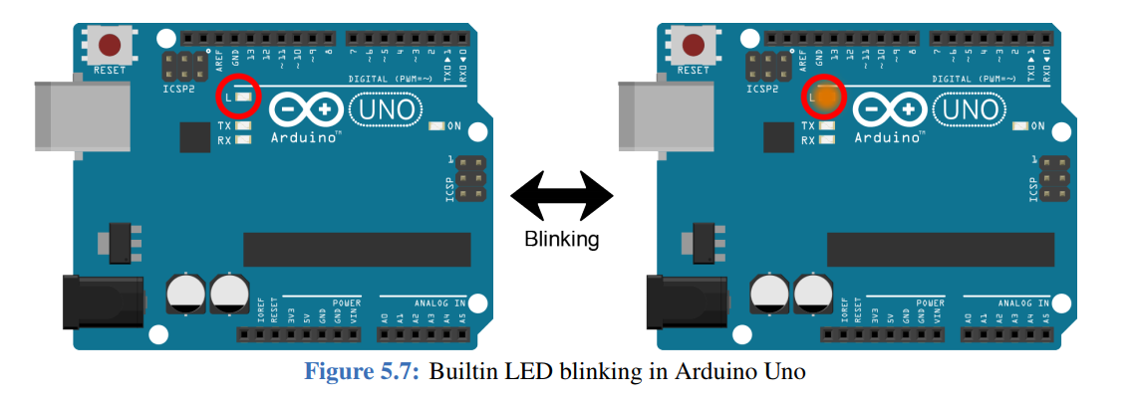

2-

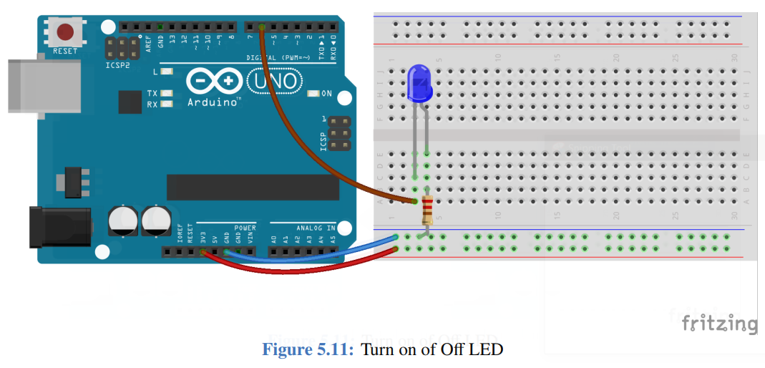

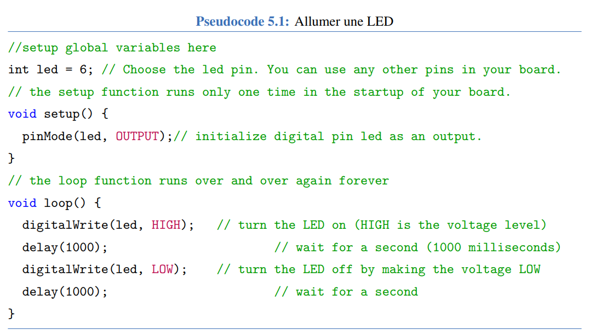

//setup global variables here

int led = 6; // Choose the led pin. You can use any other pins in your board.

// the setup function runs only one time in the startup of your board.

void setup() {

pinMode(led, OUTPUT);// initialize digital pin led as an output.

}

// the loop function runs over and over again forever

void loop() {

digitalWrite(led, HIGH); // turn the LED on (HIGH is the voltage level)

delay(1000); // wait for a second (1000 milliseconds)

digitalWrite(led, LOW); // turn the LED off by making the voltage LOW

delay(1000); // wait for a second

}

3-

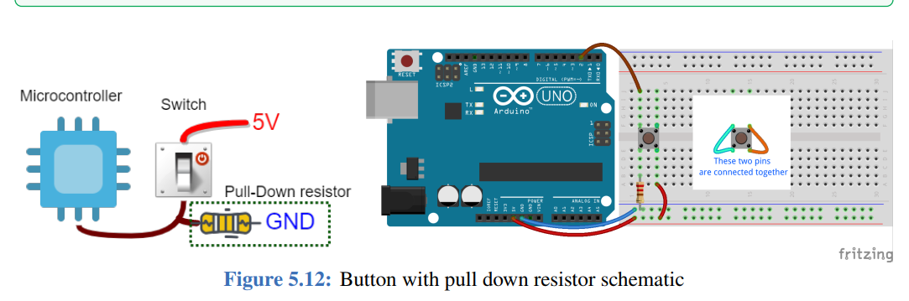

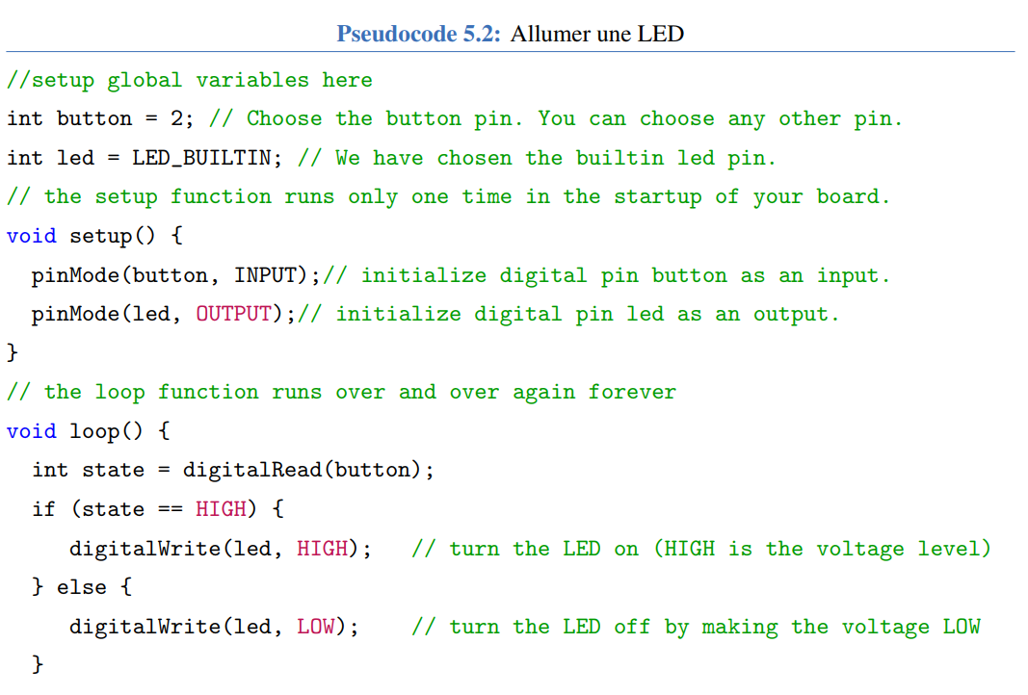

//setup global variables here

int button = 2; // Choose the button pin. You can choose any other pin.

int led = LED_BUILTIN; // We have chosen the builtin led pin.

// the setup function runs only one time in the startup of your board.

void setup() {

pinMode(button, INPUT);// initialize digital pin button as an input.

pinMode(led, OUTPUT);// initialize digital pin led as an output.

}

// the loop function runs over and over again forever

void loop() {

int state = digitalRead(button);

if (state == HIGH) {

digitalWrite(led, HIGH); // turn the LED on (HIGH is the voltage level)

} else {

digitalWrite(led, LOW); // turn the LED off by making the voltage LOW

}

}

4-

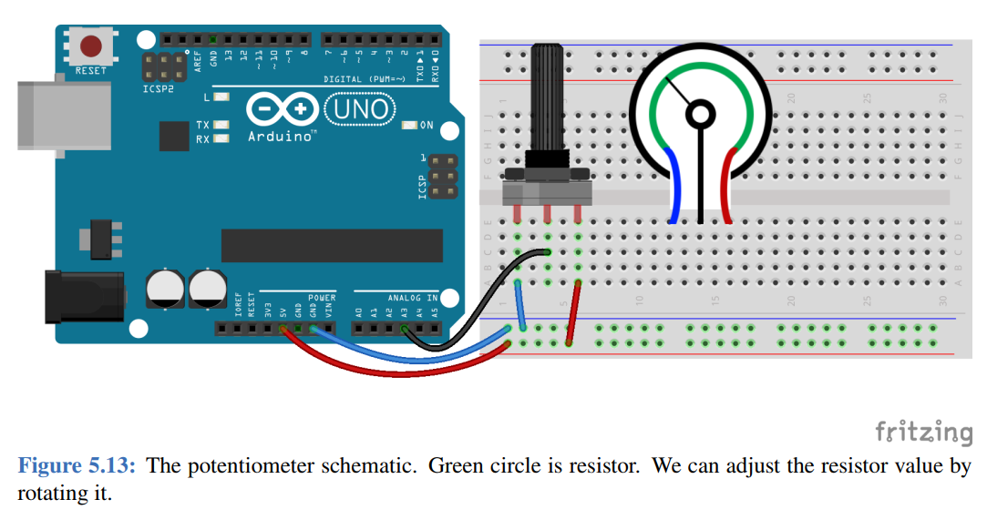

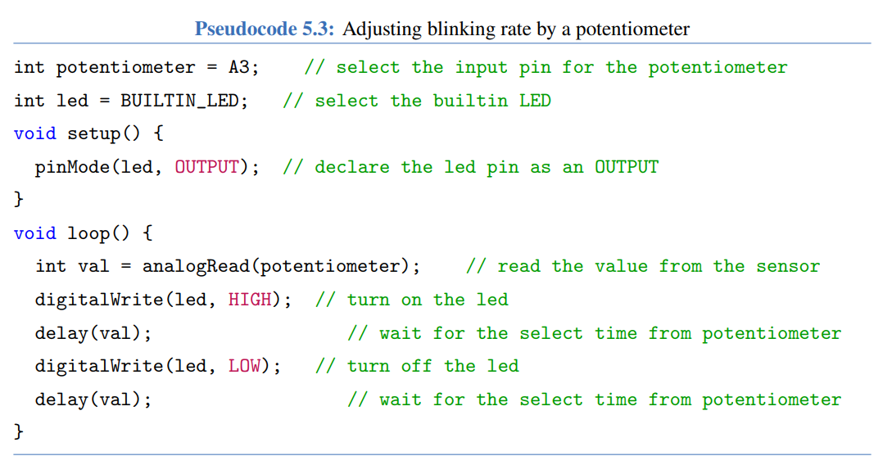

int potentiometer = A3; // select the input pin for the potentiometer

int led = BUILTIN_LED; // select the builtin LED

void setup() {

pinMode(led, OUTPUT); // declare the led pin as an OUTPUT

}

void loop() {

int val = analogRead(potentiometer); // read the value from the sensor

digitalWrite(led, HIGH); // turn on the led

delay(val); // wait for the select time from potentiometer

digitalWrite(led, LOW); // turn off the led

delay(val); // wait for the select time from potentiometer

}

5-(optional)

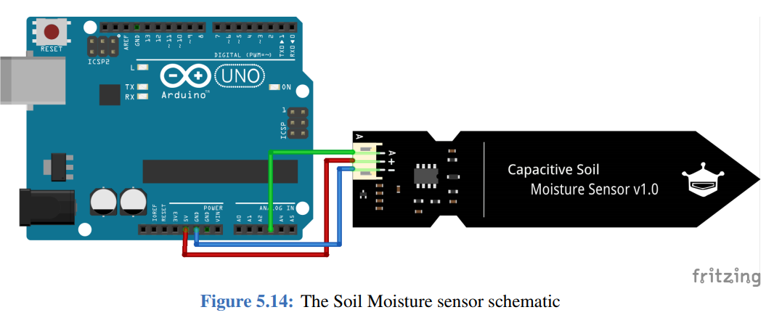

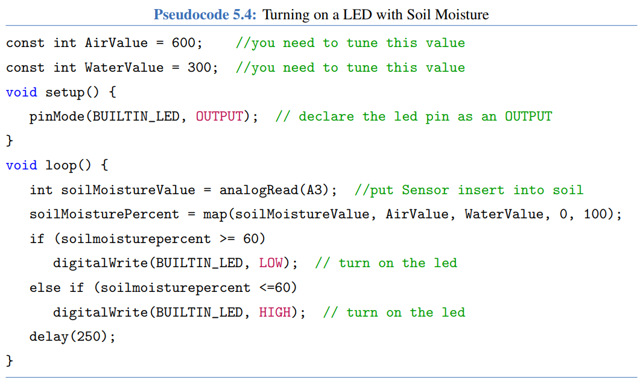

const int AirValue = 600; //you need to tune this value

const int WaterValue = 300; //you need to tune this value

void setup() {

pinMode(BUILTIN_LED, OUTPUT); // declare the led pin as an OUTPUT

}

void loop() {

int soilMoistureValue = analogRead(A3); //put Sensor insert into soil

soilMoisturePercent = map(soilMoistureValue, AirValue, WaterValue, 0, 100);

if (soilmoisturepercent >= 60)

digitalWrite(BUILTIN_LED, LOW); // turn on the led

else if (soilmoisturepercent <=60)

digitalWrite(BUILTIN_LED, HIGH); // turn on the led

delay(250);

}

6-



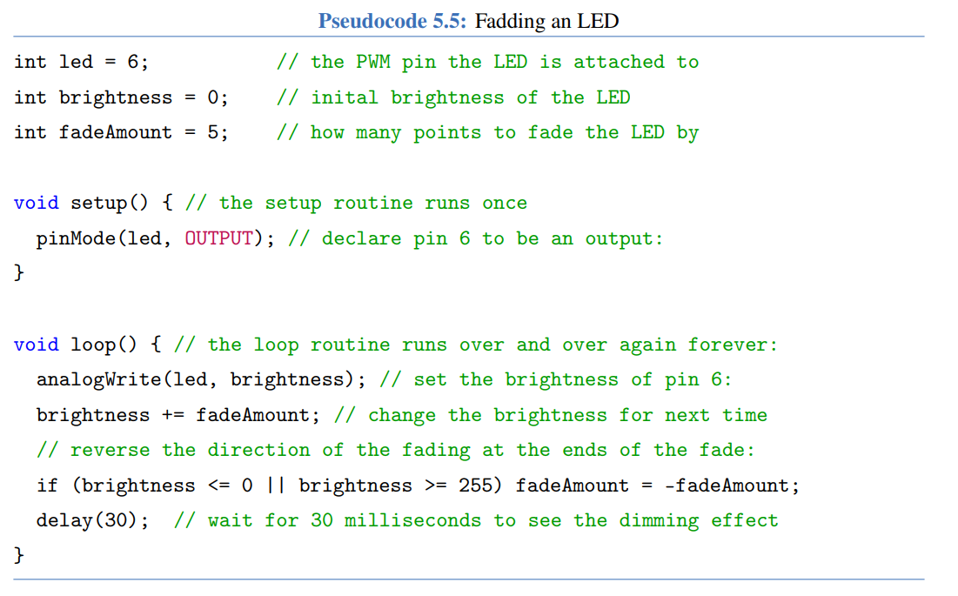

int led = 6; // the PWM pin the LED is attached to

int brightness = 0; // inital brightness of the LED

int fadeAmount = 5; // how many points to fade the LED by

void setup() { // the setup routine runs once

pinMode(led, OUTPUT); // declare pin 6 to be an output:

}

void loop() { // the loop routine runs over and over again forever:

analogWrite(led, brightness); // set the brightness of pin 6:

brightness += fadeAmount; // change the brightness for next time

// reverse the direction of the fading at the ends of the fade:

if (brightness <= 0 || brightness >= 255) fadeAmount = -fadeAmount;

delay(30); // wait for 30 milliseconds to see the dimming effect

}

7-

\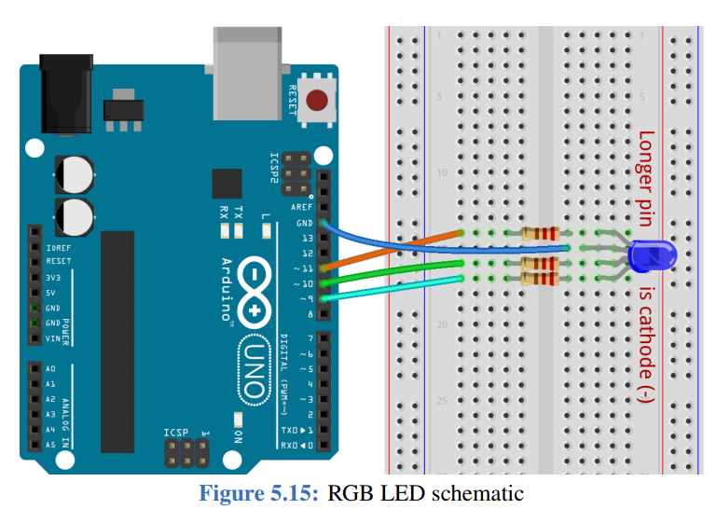

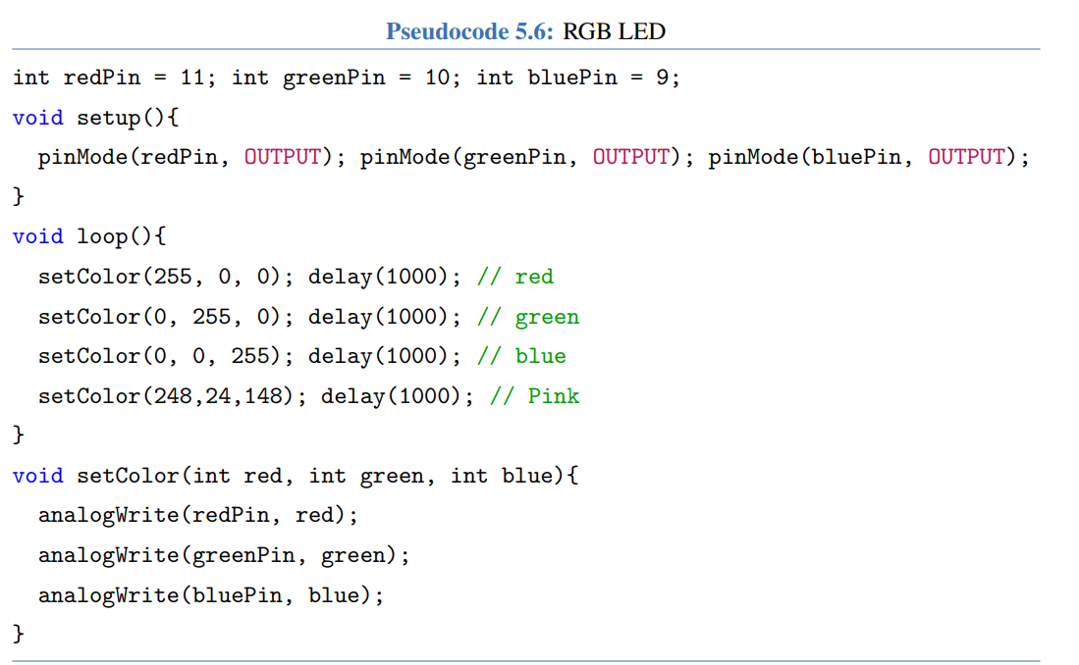

int redPin = 11; int greenPin = 10; int bluePin = 9;

void setup(){

pinMode(redPin, OUTPUT); pinMode(greenPin, OUTPUT); pinMode(bluePin, OUTPUT);

}

void loop(){

setColor(255, 0, 0); delay(1000); // red

setColor(0, 255, 0); delay(1000); // green

setColor(0, 0, 255); delay(1000); // blue

setColor(248,24,148); delay(1000); // Pink

}

void setColor(int red, int green, int blue){

analogWrite(redPin, red);

analogWrite(greenPin, green);

analogWrite(bluePin, blue);

}

8-

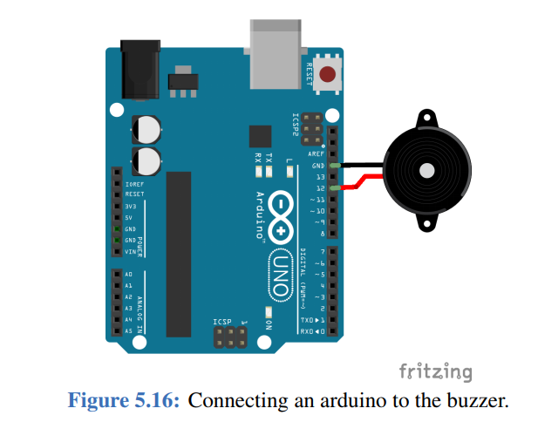

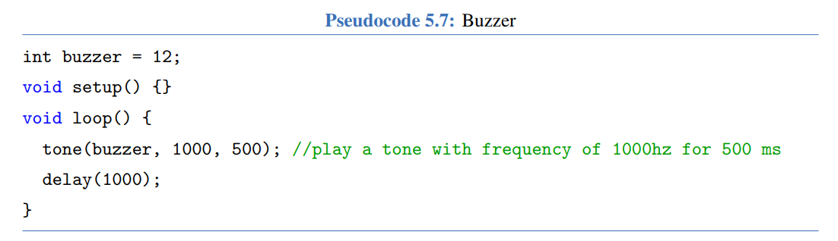

int buzzer = 12;

void setup() {}

void loop() {

tone(buzzer, 1000, 500); //play a tone with frequency of 1000hz for 500 ms

delay(1000);

}

10-

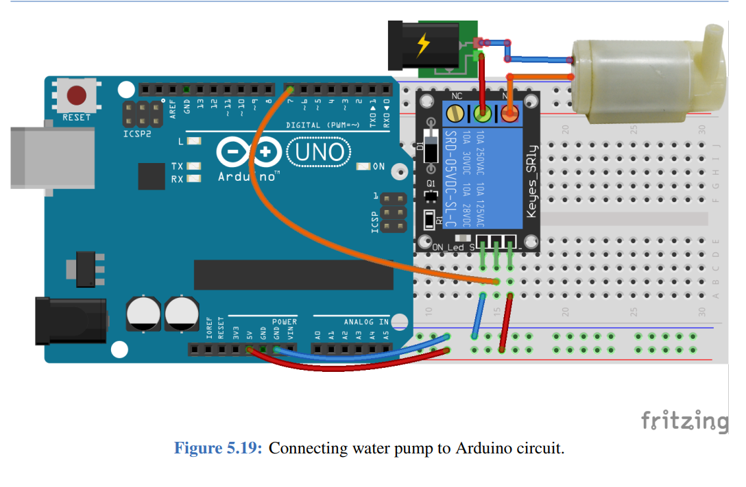

11-

