# Steps to review before Running the Hamilton

### Before Running *ANY* Method, please check if the Daily and Weekly Maintenance was done on the machine

* Open the **Hamilton Run Control** application
  + Go to the Settings tab and make sure ‘Simulation Mode’ is turned off
  + Live Mode = Green Light
  + Simulation Mode = Yellow Light
* 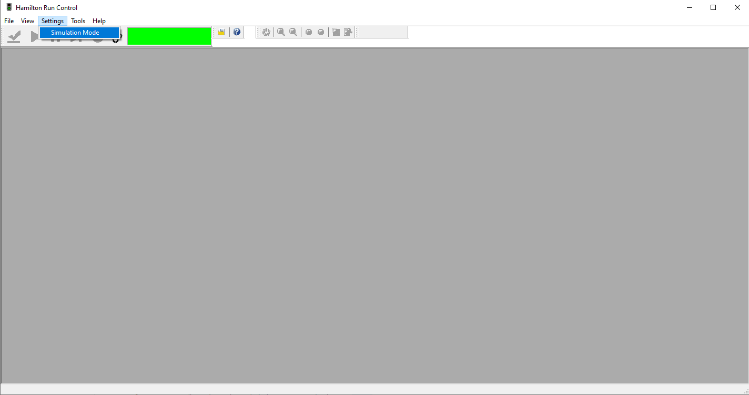
* Open the