CROSS BILLING

|  |
| --- |
| MODIFICATIONS FROM PREVIOUS DOCUMENT |
|  |

PREVIOUS VERSION:

|  |  |  |  |  |  |  |
| --- | --- | --- | --- | --- | --- | --- |
| Ed. | Elaborated | Date | Reviewed | Date | Approved | Date |
|  |  |  |  |  |  |  |
|  |  |  |  |  |  |  |
|  |  |  |  |  |  |  |

CURRENT VERSION:

|  |  |  |
| --- | --- | --- |
| Author  Lionel Pinon | Reviewed by Gonzalo Dierksmeier | Reviewed by: Gonzalo Dierksmeier |
| Date 17.01.2014 | Date: | Date: |

**Confidentiality Clause:**

This document was created using the methodology of INDRA Project Management. The document and its contents may only be used within the scope of the CMS system implementation project in EDM.

Contents

1 INTRODUCTION 3

2 WORK SCHEDULE. 3

3 VALIDATIONS 4

4 FORMATS 4

# INTRODUCTION

This document details the tasks to be performed for the execution of the CMS cross billing test in the EDM environments. This task is encompassed in the implementation plan approved by EDM (20140117_EDM_plan_implementacion_v1.xls and xxxxx.doc)

# WORK SCHEDULE

The schedule of activities for CMS cross billing test is as follows:

| **Task** | **Description** | **Date** | **Responsible** |
| --- | --- | --- | --- |
| Data extraction | The data extraction must be performed on 28-02-2014 | 01-03-2014 | EDM |
| Data upload from migration process | This will be based on the fifth cycle of data migration for all the post-payment in Maputo. | 14-03-2014 | INDRA |
| Readings in legacy systems | The readings extraction for February will take place. These files will be awarded for loading into CMS . See the readings format in Chapter 4. | 28-02-2014 | EDM |
| Extration of data related to the invoices from legacy systems | An extraction should be done from the legacy systems with the information of all the invoices issued during the period (billing cycle). See Chapter 4 – formats. The export will be uploaded in temporary tables used later for the comparing with the invoices from CMS. | 14-03-2014 | EDM |
| Selection of printed invoices | There will be requested the printed invoices (or PDF) of a selection of LV supplies and all bills related to AT / MT. | 28-02-2014 | EDM |
| Readings upload | In ITIFACT_VO (APA) | 04-03-2014  14-03-2014 | INDRA |
| Reading processing | A total of 3 cycles of billing will be performed.  The first cycle will aim to ensure that there are no major differences in billing and will be considered just one file of readings, with few supplies for each type of supply (with pre billing). After this cycle will be processed all pending billing records for LV. Finally will be processed the consumption for the HV and MV customers. | 04-03-2014  14-03-2014 | INDRA |
| Extraction of invoices issued by CMS | An extraction should be done from CMS with the information of all invoices issued during the period (billing cycle). See Chapter 4 - formats. The export will be uploaded in temporary tables used later for the comparing with the invoices from CMS. | 04-03-2014  14-03-2014 | INDRA |
| Report results & differences | It must issue a report with the results of cycle (See Chapter 4 - formats) | 14-03-2014 | INDRA |
| Validation of results | All the differences should be analyzed and there must be an explanation for each case. | 14-03-2014 | INDRA / EDM |
| Re-running the tests in case not pass validations. | If errors are detected which can invalidate the test, this cycle should be repeated until satisfactory results have been achieved. | 17-03-2014 | INDRA / EDM |

**Gantt**

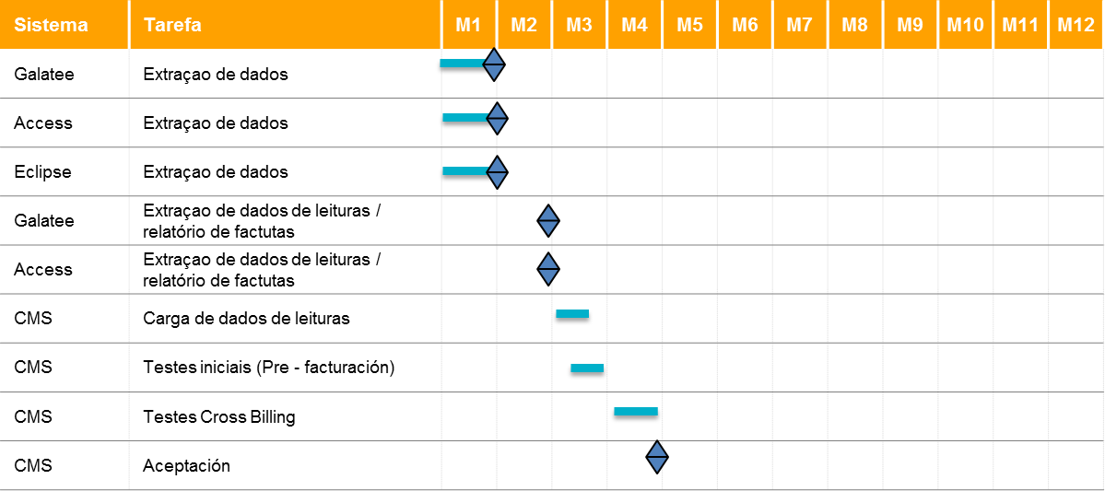

**Recursos**

|  |  |  |  |  |  |  |
| --- | --- | --- | --- | --- | --- | --- |
| **MODULE** | **RESOURCE** | **Place** | Month 1 | Month 2 | Month 3 | Month 4 |
| Management | Lionel Piñon | Maputo | X | X | X | X |
| Management | Ratmir Costiliov | Maputo | X |  | X | X |
| Migration | Tapiwa | Nairobi | X | X |  |  |
| CMS | FACT1 | Maputo |  |  |  | X |
| CMS | FACT2 | Maputo |  |  |  | X |

# VALIDATIONS

Any difference is noted, should investigated and the whole process will be repeated in case there were any bugs with the billing programs.

The test will be accepted like valid if:

Percentage of supplies with error                                                                                              < 5%

Percentage of supplies with error not attributable to the converted data  < 10%

Percentage of supplies with error with consumption over XXX MT                                        < 10%

In the calculation for validation will be excluded cases with a reason for the difference in calculus, for example changes in supplies rate within the period (February) and that this modification is not in CMS (Data Extraction dated 28-02-2014).

# FORMATS

## Reading file (LV)

1. Client ID
2. Client name
3. Meter Nr.
4. Reading date
5. Reading type
6. Consumption type
7. reading

## Invoices file (LV)

1. Client ID
2. Client name
3. Invoice amount
4. Amount related to Energy concept
5. Amount related to Fix charge concept
6. Amount related to TVA concept
7. Amount related to LIXO concept
8. Amount related to RADIO concept
9. Amount related to ETC…
10. Balance(?)

## Invoices file (MV).

An export with required fields (usages, transformer details, all required and computed technical concepts and the billing concepts i.e charges per each concept and total amount of the bill)

1. Client ID
2. Client name
3. Invoice amount
4. Amount related to Energy concept
5. Amount related to technical concept
6. Amount related to billing concept

## Report results.

Below is a simple report we would produce after each run of cross-billing.

|  |  |  |  |  |  |  |  |
| --- | --- | --- | --- | --- | --- | --- | --- |
| * Billed in legacy systems. | Readings provided to bill | Quantity by type of client | Billed | 1398 | Balanced | | 702 |
| With differences | | 693 |
| Others (not comparable) | | 3 |
| Inactive | 12 |  | | |
|  | | |  | |
|  |  |  |  |  |  |  |  |

Details are shown below:

|  |  |  |
| --- | --- | --- |
| **CONVERTED DATA comparison** | | |
| Billing Item | Balanced | PENDING |
| subscription load | 1395 | 0 |
| Metering Side | 1395 | 0 |
| Assigned Load | 790 | 605 |
| Transformer Load | 1348 | 47 |
| PREV_ACTV_EXP_OFF_PEAK | 1393 | 2 |
| PREV_ACTV_EXP_PEAK | 1393 | 2 |
| PREV_ACTV_IMP_OFF_PEAK | 1390 | 5 |
| PREV_ACTV_IMP_PEAK | 1391 | 4 |
| PREV_REACTV_IMP_OFF_PEAK | 1391 | 4 |
| PREV_REACTV_IMP_PEAK | 1391 | 4 |
| CURR_ACTV_EXP_OFF_PEAK | 1395 | 0 |
| CURR_ACTV_EXP_PEAK | 1395 | 0 |
| CURR_ACTV_IMP_OFF_PEAK | 1395 | 0 |
| CURR_ACTV_IMP_PEAK | 1395 | 0 |
| CURR_REACTV_IMP_PEAK | 1395 | 0 |
| CURR_REACTV_IMP_OFF_PEAK | 1395 | 0 |
| Active Energy Peak | 1348 | 47 |
| Active Energy Offeak | 1364 | 31 |
| Current Max Load Indictor | 1395 | 0 |
| Peak Energy | 1348 | 47 |
| OffPeak Energy | 1364 | 31 |
| Reactive Energy | 1373 | 22 |

|  |  |  |
| --- | --- | --- |
| **CALCULATED DATA** | | |
| Billing Item | Balanced | PENDING |
| Extra Load | 1393 | 2 |
| Cos_phi | 1367 | 28 |
| % Extra (No bsa data) | 0 | 0 |
| Peak Energy Amt | 1224 | 171 |
| OffPeak Energy Amt | 1194 | 201 |
| Meter Rent | 1395 | 0 |
| Vat Meter Rent | 1395 | 0 |
| Transformer Rent | 808 | 587 |
| Vat Transformer Rent | 823 | 572 |
| Fixed Charge | 1390 | 5 |
| Vat Fixed Charge (No bsa data) | 0 | 0 |
| Over Load Charge | 1393 | 2 |
| Vat Over Load Charge | 1392 | 3 |
| Bad Cos Charge | 1055 | 340 |
| Vat Bad Cos Charge | 1062 | 333 |
| Zonc Franche 10% | 1395 | 0 |
| Gvt Subsidy | 1395 | 0 |
| Vat Gvt Subsidy | 1395 | 0 |
| Amount w/o tax | 702 | 693 |
| Bill Total | 702 | 693 |