学号：XXXXXXXXXX

姓名：XXX

Let f(x) = (sinx) 2 for 0 < x < 2π.

1. Graph the function.

**# 如果未安装数据可视化包 gglot2 需要先进行安装**

**# install.packages(“ggplot2”)**

**# 加载 ggplot2 包**

**library**(ggplot2)

**# 定义函数**

f <- **function**(x) {

(sin(x))^2

}

**# 绘制函数图像**

x <- seq(0, 2*pi, length.out = 1000)

y <- f(x)

df <- data.frame(x, y)

ggplot(df, aes(x, y)) + geom_line() + xlab("x") + ylab("f(x)") + ggtitle("Graph of f(x)")

绘制的函数图像如下：

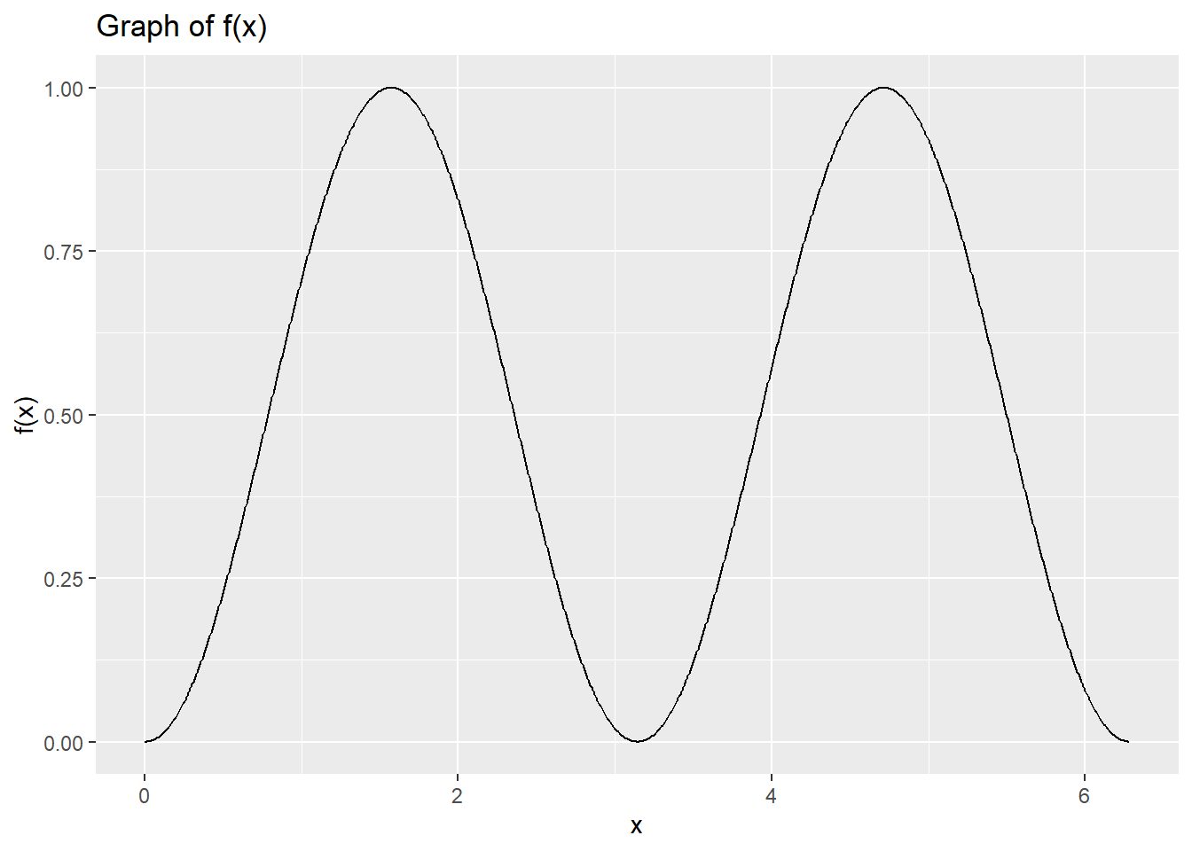

1. Use Monte Carlo integration to find the area under f(x) on the range 0 < x < 2π, and to find a 95% confidence interval for the area.

set.seed(123) *# 设置随机种子*

N <- 100000 *# 抽样次数*

x_samples <- runif(N, min = 0, max = 2*pi) *# 在区间 [0, 2π] 中进行均匀抽样*

f_samples <- f(x_samples) *# 计算样本的函数值*

area <- mean(f_samples) * (2*pi) *# 估计的面积*

error <- 1.96 * sd(f_samples) / sqrt(N) *# 误差*

lower_bound <- area - error *# 置信区间下界*

upper_bound <- area + error *# 置信区间上界*

print(area)

## [1] 3.143735

print(lower_bound)

## [1] 3.141545

print(upper_bound)

## [1] 3.145924

可见使用蒙特卡罗积分法得到的面积大小为3.143735，95%置信区间为 (3.141545, 3.145924)。

1. Use trigonometry or calculus to find the same area exactly. Did the confidence interval cover the true value?

exact_area <- integrate(f, 0, 2*pi)$value

print(exact_area)

## [1] 3.141593

可见微积分计算得到的精确面积为3.141593，被置信区间所覆盖。

1. Write a function called rsin2 which generates random values from the density f(x)/k, 0 < x < 2π, where k is the area found above. The function should take a single argument specifying how many samples are required, e.g. rsin2(10) would return a vector of 10 samples from this distribution. Use the rejection method to draw the samples. Plot a histogram based on 1000 samples.

rsin2 <- **function**(n) {

k <- area *# the area found above*

samples <- c()

i <- 1

**while** (i <= n) {

x <- runif(1, min = 0, max = 2*pi)

y <- runif(1, min = 0, max = k)

**if** (y <= f(x)) {

samples[i] <- x

i <- i + 1

}

}

samples

}

set.seed(123) *# 设置随机种子，保证结果可复现*

samples <- rsin2(1000) *# 生成1000个样本*

*# 绘制直方图*

ggplot(data.frame(samples), aes(samples)) + geom_histogram(bins = 30, fill = "steelblue", color = "white") + xlab("x") + ylab("Frequency") + ggtitle("Histogram of 1000 Samples")

绘制得到的直方图如下：

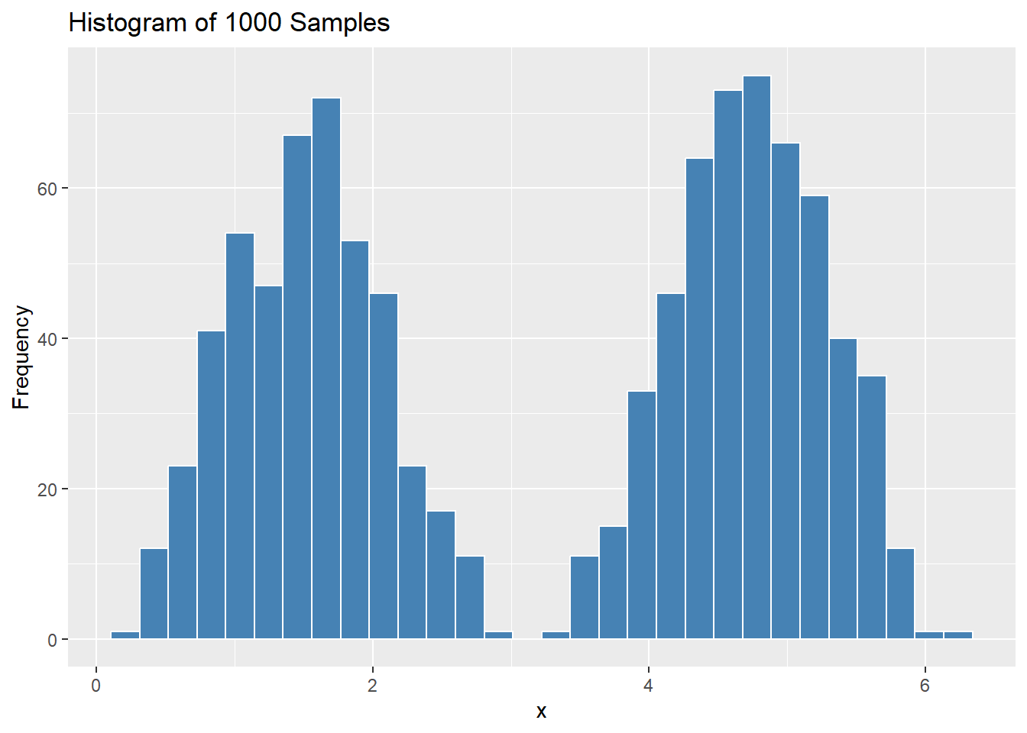

1. Use your function to draw a sample of 1,000,000 samples, and calculate a 95% confidence interval for the mean. (By symmetry, the true mean must be π. Did your confidence interval cover the true value?)

set.seed(123) *# 设置随机种子，保证结果可复现*

n <- 1000000

samples <- rsin2(n) *# 生成1,000,000个样本*

mean_value <- mean(samples) *# 计算均值*

*# 计算置信区间*

error <- 1.96 * sd(samples) / sqrt(n)

lower_bound <- mean_value - error

upper_bound <- mean_value + error

print(mean_value)

## [1] 3.144681

print(lower_bound)

## [1] 3.141406

print(upper_bound)

## [1] 3.147957

可见均值置信区间为（3.141406, 3.147957），包含真值π。