DevOps Internship - Complete Kubernetes Cluster Deployment Guide (From Zero to Hero)
Name: Zinab Mohamed Elsayed
Task: Kubernetes Cluster Setup, Configuration & Multi-Container Application Deployment

Introduction & Overview
This document provides a comprehensive, step-by-step technical walkthrough of setting up a 2-node Kubernetes cluster (1 Master, 1 Worker) on Rocky Linux 9 from scratch, configuring networking, managing cluster taints, and deploying the multi-container application (PostgreSQL + Redis + Python app replicas + NGINX) into the barq-assessment namespace.

Environment
Role | Hostname | OS | vCPU | RAM | Disk | IP
Master | k8s-master | Rocky Linux 9 | 2+ | 4 GB | 20 GB+ | 192.168.66.132
Worker | k8s-worker1 | Rocky Linux 9 (full clone of master **before** `kubeadm init`) | 2 | 2 GB | 20 GB+ | 192.168.66.133

Cluster parameters:
- Pod network CIDR: 10.244.0.0/16 (Flannel default)
- CNI: Flannel
- Container runtime: containerd (with SystemdCgroup = true)
- Namespace: barq-assessment
- Application manifests (in this repo under k8s/): namespace.yaml, secret.yaml,
postgres.yaml, redis.yaml, app.yaml, nginx.yaml

VM Preparation
- Install Rocky Linux 9 on the master VM (user zinabelamir, or your own user).
- Create the worker as a full clone of the master before running kubeadm init:
In VMWare : right-click master name -> Manage -> Clone -> Full clone.
- Set worker resources to 2 GB RAM (minimum) and 2 vCPUs.
Make the master with this configurations: , worker :
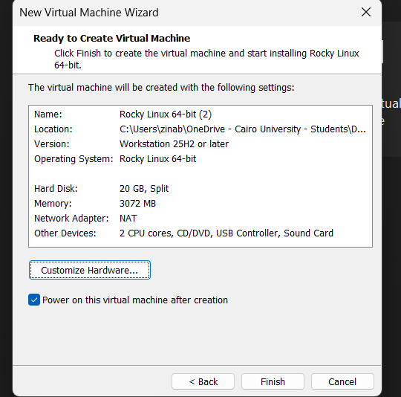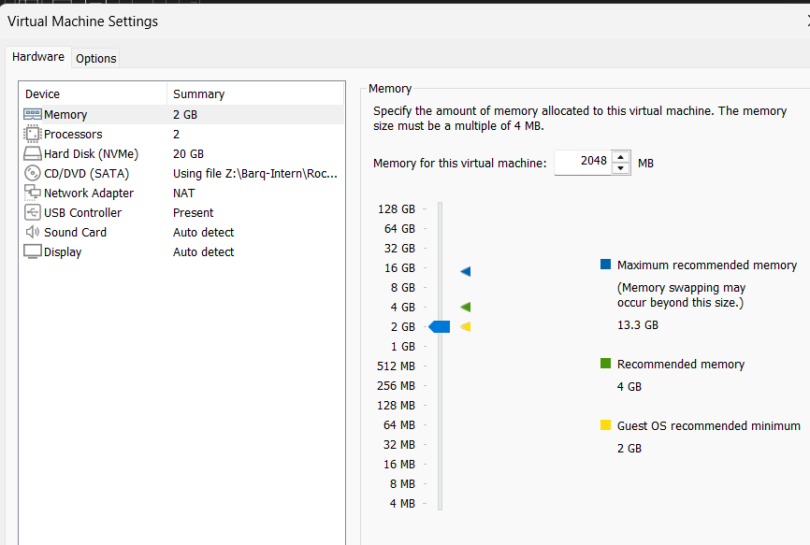

- Power on both VMs and confirm they can reach each other and the internet:

ip addr
ping -c 3 192.168.66.133 (for master)
ping -c 3 192.168.66.132 (for worker)
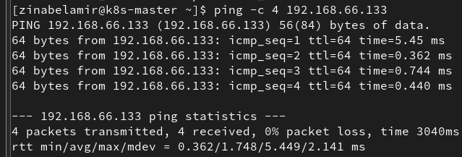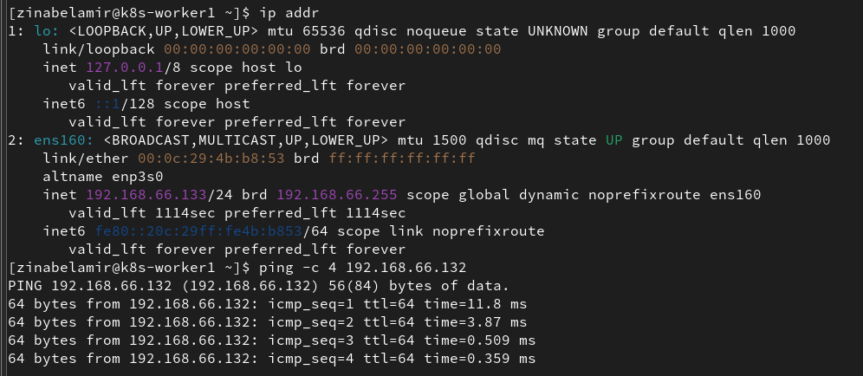

1. Prerequisites & System Configuration (Both Nodes)
Run on both master and worker before initializing Kubernetes.

1.1 Disable swap
Kubernetes requires swap to be off.
sudo swapoff -a
sudo sed -i.bak '/\sswap\s/s/^/#/' /etc/fstab
free -h

Expected: the Swap: line shows 0B used.
System configuration and swap disabled check
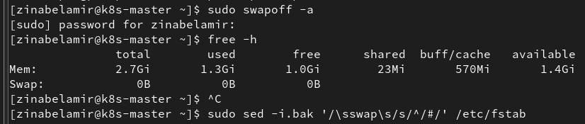

1.2 Load kernel modules and set sysctl
sudo modprobe overlay
sudo modprobe br_netfilter

sudo tee /etc/sysctl.d/k8s.conf <<EOF
net.bridge.bridge-nf-call-iptables = 1
net.bridge.bridge-nf-call-ip6tables = 1
net.ipv4.ip_forward = 1
EOF

sudo sysctl --system

Verify:
lsmod | grep -E 'overlay|br_netfilter'
sysctl net.bridge.bridge-nf-call-iptables net.ipv4.ip_forward

1.3 Set SELinux to permissive and update the system
sudo setenforce 0
sudo sed -i 's/^SELINUX=enforcing/SELINUX=permissive/' /etc/selinux/config
getenforce
sudo dnf update -y

Expected getenforce output: Permissive.

2. Installing Container Runtime & Kubernetes Tools (Both Nodes)

2.1 Install containerd
sudo dnf install -y dnf-plugins-core
sudo dnf config-manager --add-repo https://download.docker.com/linux/centos/docker-ce.repo
sudo dnf install -y containerd.io

sudo mkdir -p /etc/containerd
sudo containerd config default | sudo tee /etc/containerd/config.toml
sudo sed -i 's/SystemdCgroup = false/SystemdCgroup = true/' /etc/containerd/config.toml
grep SystemdCgroup /etc/containerd/config.toml

sudo systemctl restart containerd
sudo systemctl enable containerd

Expected: SystemdCgroup = true and containerd active (running).

2.2 Add the Kubernetes yum repository (required on Rocky 9)
The kubelet/kubeadm/kubectl packages are not in the base repos, so add the upstream repository first:
sudo tee /etc/yum.repos.d/kubernetes.repo <<EOF
[kubernetes]
name=Kubernetes
baseurl=https://pkgs.k8s.io/core:/stable:/v1.30/rpm/
enabled=1
gpgcheck=1
gpgkey=https://pkgs.k8s.io/core:/stable:/v1.30/rpm/repodata/repomd.xml.key
exclude=kubelet kubeadm kubectl cri-tools kubernetes-cni
EOF

2.3 Install kubelet, kubeadm, kubectl
sudo dnf install -y kubelet kubeadm kubectl --disableexcludes=kubernetes
sudo systemctl enable --now kubelet
kubectl version --client

3. Initializing the Master Node
Run only on `k8s-master`:
sudo kubeadm init --pod-network-cidr=10.244.0.0/16 -- apiserver-advertise-address=192.168.66.132

Save the kubeadm join ... --token ... --discovery-token-ca-cert-hash ... line from the output. If you lose it later, regenerate with:
kubeadm token create --print-join-command

Configure kubectl for your regular user:
mkdir -p $HOME/.kube
sudo cp -i /etc/kubernetes/admin.conf $HOME/.kube/config
sudo chown $(id -u):$(id -g) $HOME/.kube/config
kubectl get nodes
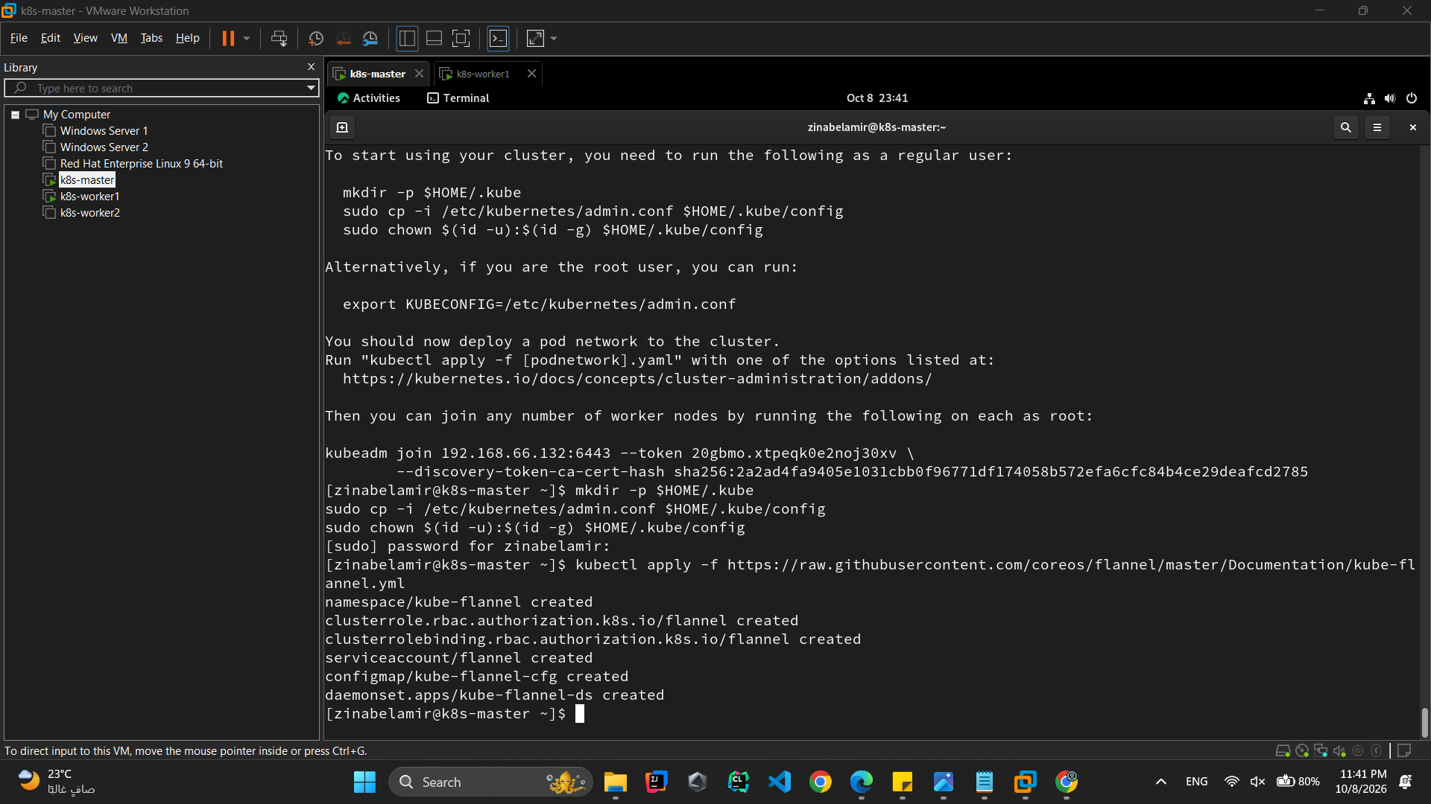

4. Installing the CNI Network Plugin (Flannel)
Run on the master:
kubectl apply -f https://raw.githubusercontent.com/flannel-io/flannel/master/Documentation/kube-flannel.yml
kubectl get pods -n kube-system -w
kubectl get nodes

Expected: Flannel pods Running, master node becomes Ready.

5. Joining the Worker Node
Run on `k8s-worker1` :
sudo kubeadm join 192.168.66.132:6443 -- token 20gbmo.xtpeqk0e2noj30xv -- discovery-token-ca-cert-hash sha256:2a2ad4fa9405e1031cbb@f96771df174058b572efa6cfc84b4ce29deafcd2785

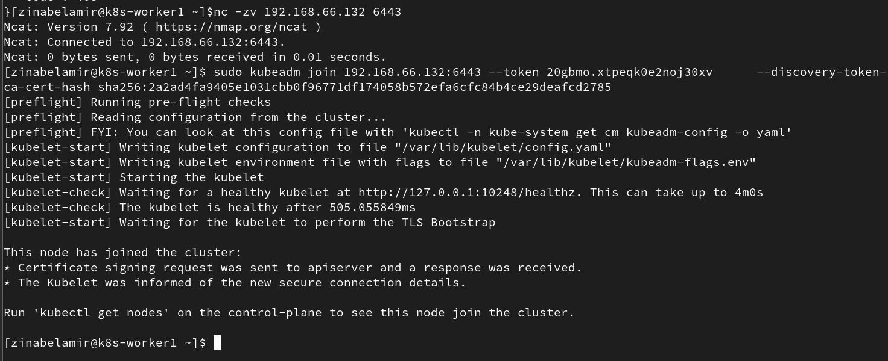
If the join fails because of firewall rules, open the required ports or stop firewalld for lab use:
sudo systemctl stop firewalld
sudo systemctl disable firewalld

Then verify on the master:
kubectl get nodes -o wide

6. Verifying Node Readiness
kubectl get nodes
kubectl get pods -A -o wide

Expected: k8s-master and k8s-worker1 both Ready, all kube-system pods Running.
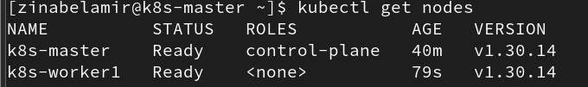

7. Managing Control Plane Taints
By default the control plane has a NoSchedule taint so workloads land on the worker. Re-apply it explicitly (idempotent) and verify:
kubectl taint nodes k8s-master node-role.kubernetes.io/control-plane:NoSchedule
kubectl describe node k8s-master | grep -i taints

Expected: Taints: node-role.kubernetes.io/control-plane:NoSchedule.
To allow scheduling on the master again (optional, not used in this task):
kubectl taint nodes k8s-master node-role.kubernetes.io/control-plane:NoSchedule-

8. Deploying the Multi-Container Application
The application stack is: PostgreSQL (1 replica) + Redis (1 replica) + Python barq-app (3 replicas) + NGINX (2 replicas, NodePort 30080), all in namespace barq-assessment. The manifests live in k8s/ in this repository.
Apply them in order (secret before postgres/app):
kubectl apply -f k8s/namespace.yaml
kubectl apply -f k8s/secret.yaml
kubectl apply -f k8s/postgres.yaml
kubectl apply -f k8s/redis.yaml
kubectl apply -f k8s/app.yaml
kubectl apply -f k8s/nginx.yaml

kubectl -n barq-assessment get pods -o wide -w

Notes:
- k8s/app.yaml uses image docker.io/zinabelamir/barq-app:latest. The cluster pulls
it from Docker Hub, so the BONUS CD pipeline (.github/workflows/cd.yml) must have pushed it at least once, or kubectl set image must point at a tag you pushed.
- k8s/secret.yaml provides POSTGRES_PASSWORD for postgres and the app.
- k8s/postgres.yaml includes the postgres-init ConfigMap that creates the records table; k8s/nginx.yaml includes the nginx-conf ConfigMap and exposes NodePort 30080.
Wait until everything is Ready, then confirm distribution across nodes:
kubectl -n barq-assessment get pods -o wide
kubectl -n barq-assessment rollout status deployment/barq-app --timeout=180s
kubectl -n barq-assessment rollout status deployment/postgres --timeout=120s
kubectl -n barq-assessment rollout status deployment/redis --timeout=120s
kubectl -n barq-assessment rollout status deployment/nginx --timeout=120s

[SCREENSHOT: `kubectl get pods -o wide` showing postgres, redis, barq-app replicas and nginx running]

9. Services & Endpoints Verification
kubectl -n barq-assessment get svc
kubectl -n barq-assessment get endpoints barq-app
kubectl -n barq-assessment get endpoints postgres
kubectl -n barq-assessment get endpoints redis

Expected services:
Service | Type | Port
`postgres` | ClusterIP | 5432
`redis` | ClusterIP | 6379
`barq-app` | ClusterIP | 8080
`nginx` | NodePort | 80 -> 30080

[SCREENSHOT: `kubectl get svc` and endpoints output]

10. Connectivity & Response Testing

10.1 Test the app ClusterIP service from inside the cluster
kubectl -n barq-assessment run temp-curl --rm -it --image=curlimages/curl --restart=Never -- \
curl -s http://barq-app:8080/

Expected: JSON with service: barq-api, the configured message, and an instance_id.

10.2 Test health, readiness, records and counter
kubectl -n barq-assessment run temp-curl --rm -it --image=curlimages/curl --restart=Never -- \
curl -s http://barq-app:8080/health; echo

kubectl -n barq-assessment run temp-curl --rm -it --image=curlimages/curl --restart=Never -- \
curl -s http://barq-app:8080/ready; echo

kubectl -n barq-assessment run temp-curl --rm -it --image=curlimages/curl --restart=Never -- \
curl -s -X POST -H 'Content-Type: application/json' \
-d '{"title":"k8s smoke test"}' http://barq-app:8080/records; echo

kubectl -n barq-assessment run temp-curl --rm -it --image=curlimages/curl --restart=Never -- \
curl -s http://barq-app:8080/counter; echo

/ready must report "status": "ready" with both postgres and redis ready.

10.3 Test NGINX from outside the cluster (host)
curl -s http://<MASTER_IP>:30080/; echo
curl -s http://<WORKER_IP>:30080/; echo

Expected: the same app JSON, routed through NGINX (NodePort 30080).
[SCREENSHOT: curl responses showing HTTP 200 and app JSON from both paths]

Troubleshooting Quick Reference
Symptom | Likely cause | Fix
Node stays `NotReady` | Flannel not applied or pod CIDR mismatch | Re-apply Flannel; confirm `--pod-network-cidr=10.244.0.0/16`
`ImagePullBackOff` on `barq-app` | Image not pushed to Docker Hub yet | Run the CD pipeline once (`Actions -> cd`), or `podman push docker.io/zinabelamir/barq-app:latest`
`CrashLoopBackOff` on `barq-app` | Missing secret or DB unreachable | `kubectl -n barq-assessment get secret postgres-secret`; check `/ready` output
Worker cannot join | Firewall or expired token | Stop firewalld for lab; regenerate join command with `kubeadm token create --print-join-command`
Pods only on master | Taint removed | Re-apply `kubectl taint nodes k8s-master node-role.kubernetes.io/control-plane:NoSchedule`

Screenshot Checklist (add these where marked above)
- VM clone settings + worker 2 GB RAM
- free -h (swap off)
- containerd + kubelet status
- kubeadm init success + join command (redact token in shared docs if needed)
- Flannel pods + master Ready
- Worker join output + 2 nodes Ready
- Taint describe output
- get pods -o wide (all app pods Running)
- get svc + endpoints
- curl 200 responses (in-cluster + NodePort)

