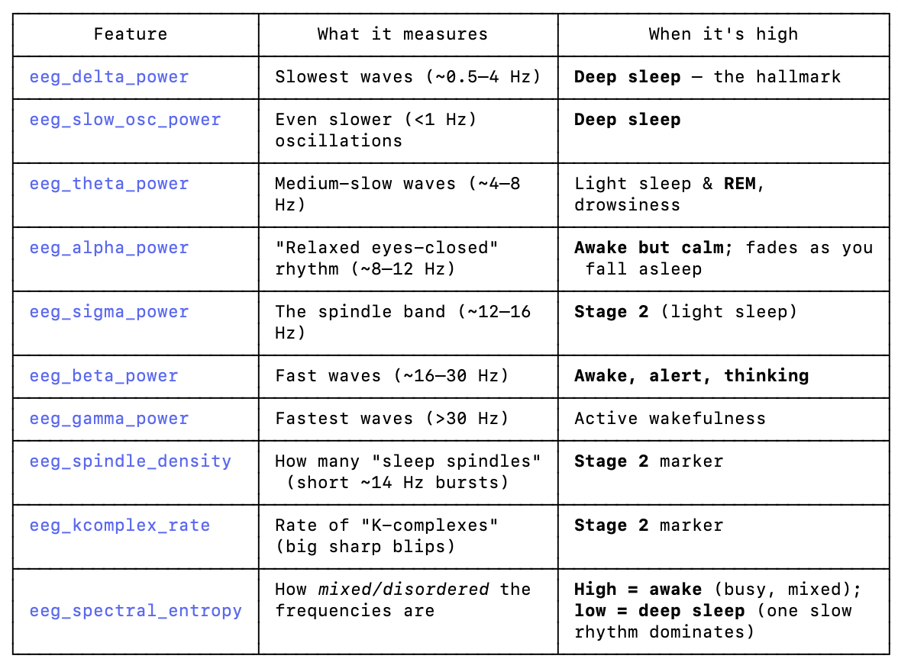

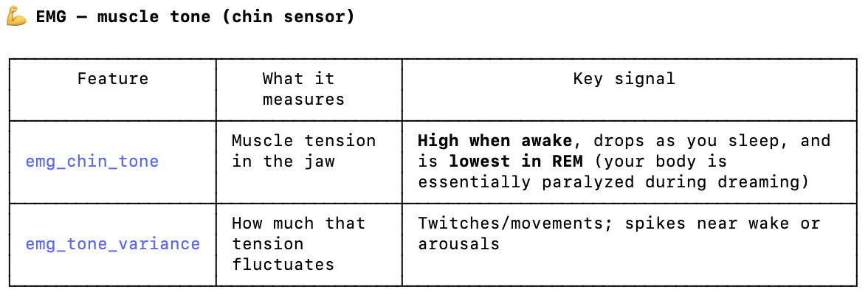
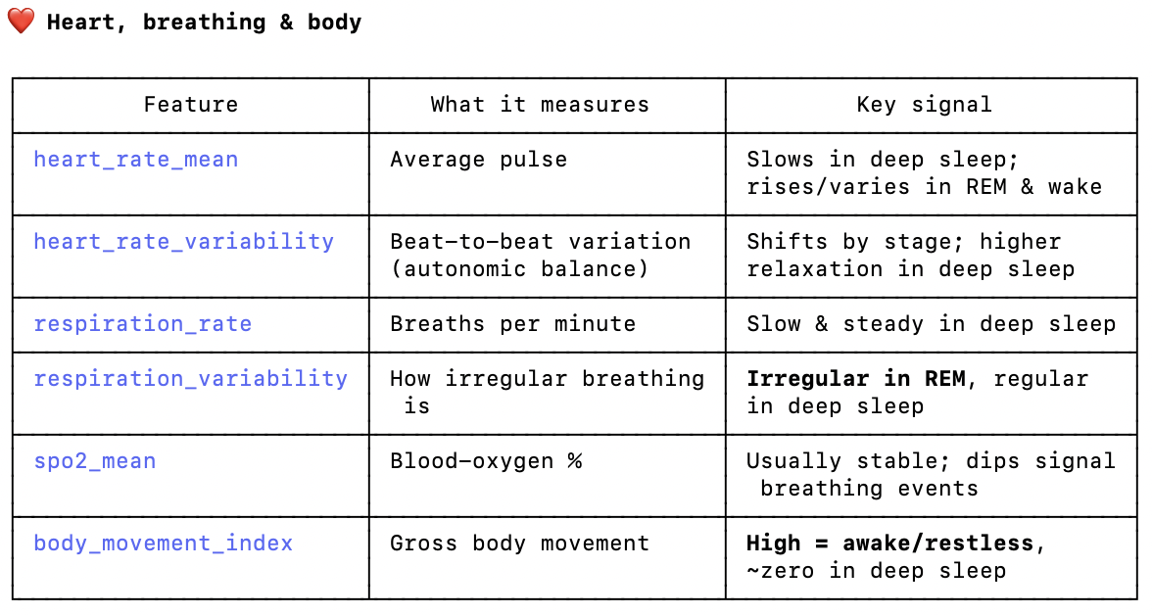

EEG = brain activity
Columns:
- eeg_delta_power
- eeg_theta_power
- eeg_alpha_power
- eeg_sigma_power
- eeg_beta_power
- eeg_gamma_power
- eeg_slow_osc_power
- eeg_spectral_entropy
- eeg_spindle_density
- eeg_kcomplex_rate

EMG = muscle activity
Columns:
- emg_chin_tone
- emg_tone_variance

EOG = eye movement
Columns:
- eog_movement_density
- eog_amplitude
- eog_burst_index

Heart
Columns:
- heart_rate_mean
- heart_rate_variability

Breathing
Columns:
- respiration_rate
- respiration_variability

Other
Columns:
- spo2_mean
- body_movement_index

Sleep stage cheat-sheet: which features signal each stage
Signal / what to expect | Features to look at | Why it matters
Stage 0 = Wake (Awake)
Person is awake.
High body movement | body_movement_index ↑ | People move more when awake.
High muscle tone | emg_chin_tone ↑ | Muscles are active.
More alpha and beta | eeg_alpha_power ↑  eeg_beta_power ↑ | These are classic awake rhythms.
Less delta | eeg_delta_power ↓ | Deep-sleep waves shouldn’t dominate.
Potentially higher heart rate | heart_rate_mean ↑ | Not always, but often.
Stage 2 = Deep Sleep (N3)
Easiest to recognize — the brain produces huge slow waves.
Massive delta activity | eeg_delta_power ↑↑↑ | The hallmark of deep sleep — the most important feature.
High slow oscillations | eeg_slow_osc_power ↑ | Also characteristic of deep sleep.
Very low body movement | body_movement_index ↓ | The body is still.
Stable breathing | respiration_variability ↓ | Breathing is regular.
Lower heart rate | heart_rate_mean ↓ | Autonomic activity slows down.
Lower entropy | eeg_spectral_entropy ↓ | Deep-sleep EEG is more regular and predictable.
Stage 3 = REM
Weird: the brain looks almost awake, but the body is basically paralyzed.
Huge clue #1 — Eye movements | eog_movement_density ↑  eog_amplitude ↑  eog_burst_index ↑ | REM literally means Rapid Eye Movement. If one feature screams REM, it is probably one of these.
Huge clue #2 — Muscle paralysis | emg_chin_tone ↓↓↓ | During REM the body suppresses muscle activity — one of the strongest REM markers.
Huge clue #3 — Brain looks active | eeg_beta_power ↑  eeg_gamma_power ↑ | REM brain activity resembles wakefulness more than deep sleep.
Huge clue #4 — Irregular physiology | heart_rate_variability ↑  respiration_variability ↑ | REM often produces more irregular autonomic activity.
Stage 1 = Light Sleep
Usually the hardest class — it sits between everything else and gets confused with Wake, Deep Sleep and REM.
Theta waves increase | eeg_theta_power ↑ | Very common in light sleep.
Sleep spindles | eeg_spindle_density ↑ | A classic marker of N2 sleep.
K-complexes | eeg_kcomplex_rate ↑ | Another famous N2 marker.
Movement decreases | body_movement_index ↓ | Less than wake.
Muscle tone decreases slightly | emg_chin_tone ↓ | But not nearly as low as REM.

