Who Survived the Titanic? A Data-Driven Analysis of Factors Influencing Survival

*By: Zinat Shaban (Aspiring Data Analyst | Python & ML Enthusiast)*

# Introduction

The sinking of the Titanic is one of the most infamous maritime disasters in history. Over 1,500 passengers lost their lives in the icy waters of the North Atlantic in April 1912. But what determined who lived and who perished? In this project, I used Python and data analysis tools to explore the Titanic dataset and uncover key patterns that influenced survival rates. This analysis served as both a practical exercise in data science and an opportunity to tell a story through data.

# About the Dataset

The dataset used in this project is one of the most well-known beginner-friendly datasets, commonly found on Kaggle. It includes demographic and passenger information such as:

- Survived: Survival (0 = No, 1 = Yes)

- Pclass: Ticket class (1 = 1st, 2 = 2nd, 3 = 3rd)

- Sex: Gender

- Age: Age in years

- SibSp: Number of siblings/spouses aboard

- Parch: Number of parents/children aboard

- Fare: Ticket fare

# Key Questions

- Did gender play a role in survival?

- Were passengers in higher classes more likely to survive?

- Did age influence survival chances?

# Analysis Summary

Out of all passengers, approximately 40.6% survived and 59.4% died. This initial distribution shows the severity of the disaster.

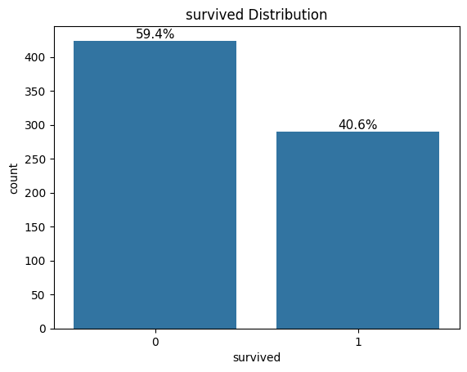

## 2. Gender and Survival

Gender turned out to be the strongest single factor:  
- Around 75% of female passengers survived  
- Only 20% of male passengers survived  
  
This aligns with the well-known policy of “women and children first” when lifeboats were being filled.

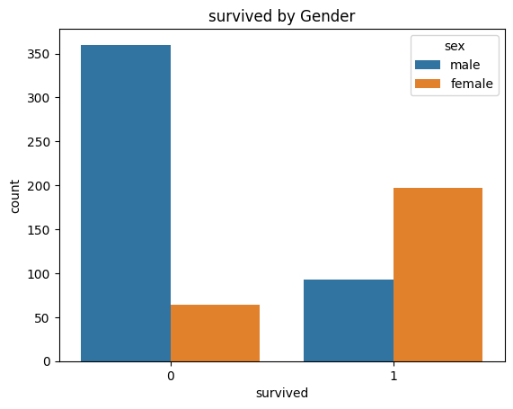

## 3. Passenger Class and Survival

Class mattered—a lot:  
- 1st class: ~65% survival rate  
- 2nd class: ~48%  
- 3rd class: ~24%  
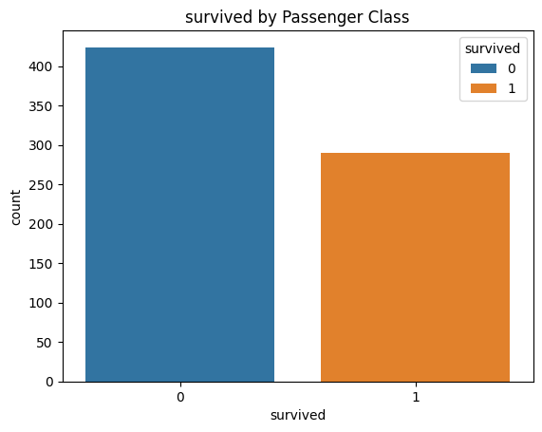  
Those in 1st class had better cabin access and likely earlier access to lifeboats.

## 4. Age and Survival

A deeper look at age revealed:  
- Children (especially under 10) had higher survival rates  
- Older passengers generally had lower chances of survival  
- Median age of survivors was lower than non-survivors

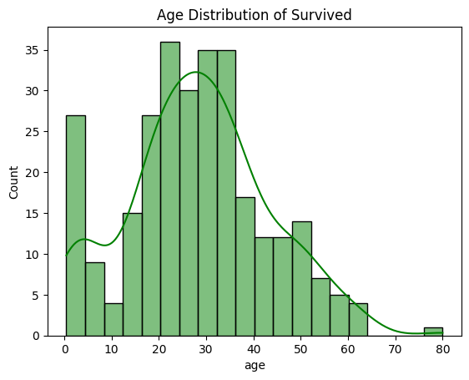

# Final Insights

This analysis shows that survival on the Titanic was far from random. Key findings:  
- Being female significantly increased survival chances

- Higher ticket class provided greater safety  
- Younger passengers had better odds  
  
This project not only helped me understand historical events better but also strengthened my skills in Python, Pandas, and data visualization with Seaborn and Matplotlib.

# What’s Next?

This is just the beginning of my data science journey. I’ll continue publishing projects like this, sharing both the code and key insights. You can find the full project on GitHub and a walkthrough video on YouTube soon!

# Stay Connected

- GitHub: https://github.com/zinat1994

- LinkedIn: https://linkedin.com/in/ziat-shaban

- YouTube: Coming soon