**Laboratory work-2**

**DDL**

**1,2,4.**

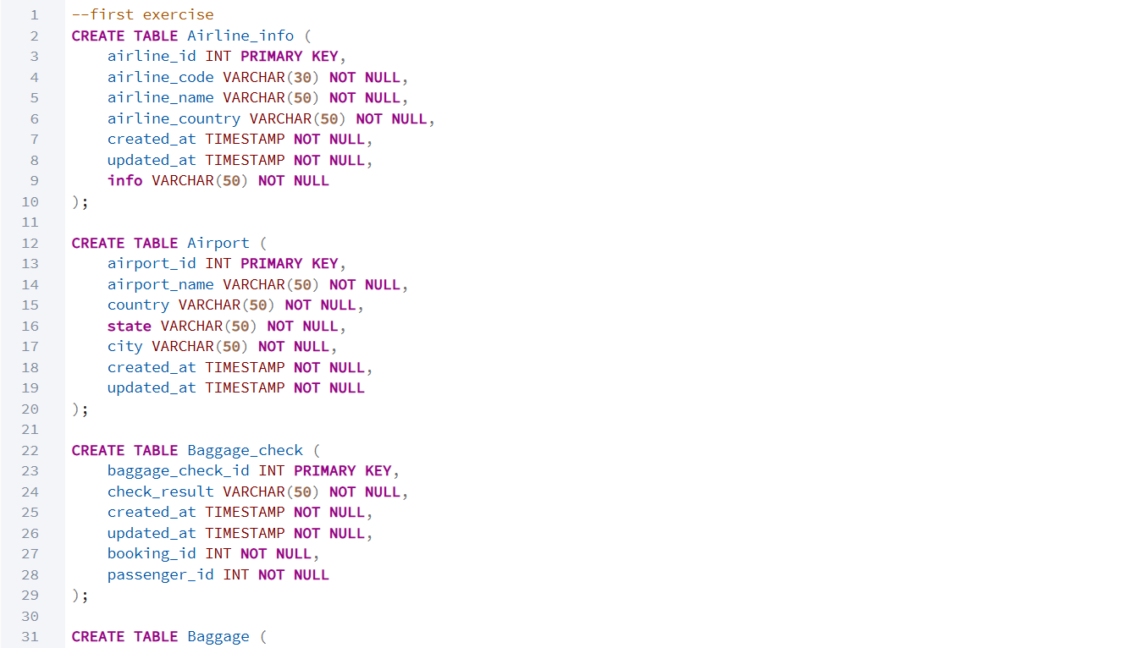

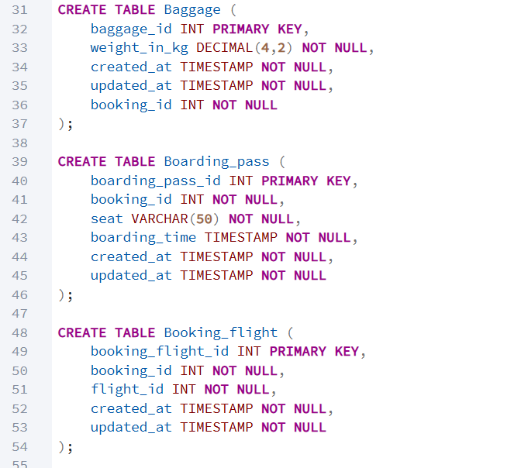

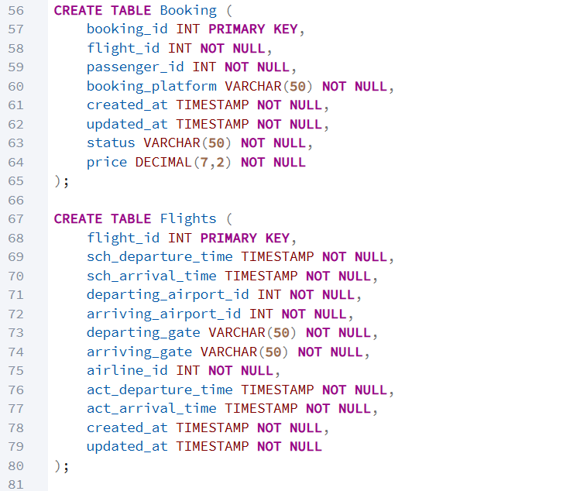

**5.**

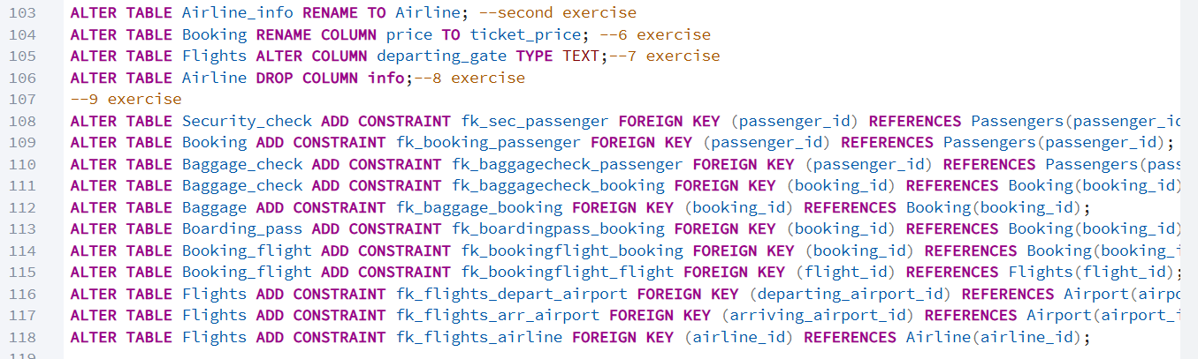

**-first,second,fourth exercise results**

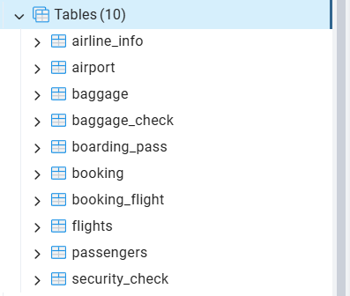

**-fives exercise result**



**6 exercise result**

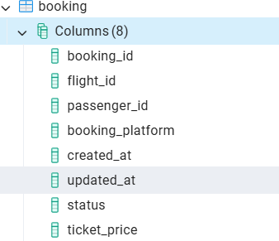

**7 exercise result**



**8 exercise result**

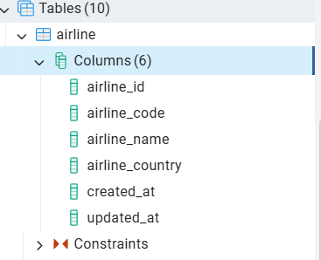

**9 exercise result**

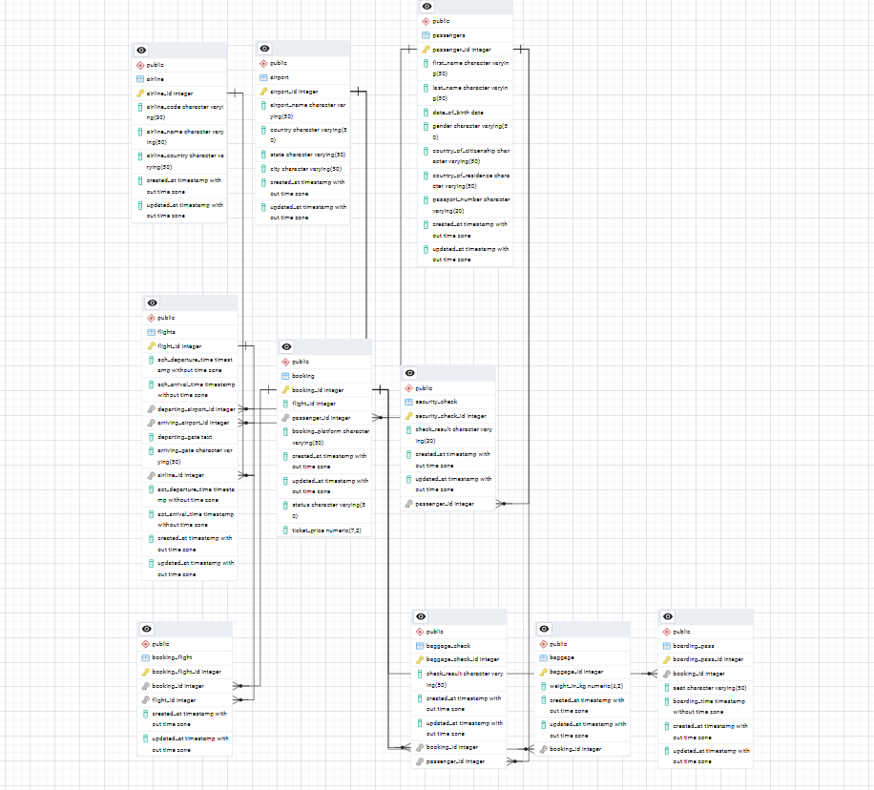

**DML**

**1 exercise result**

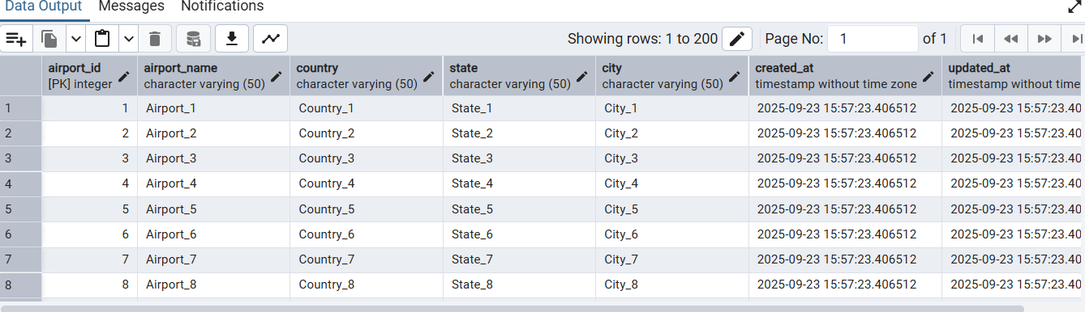

**2 exercise result**

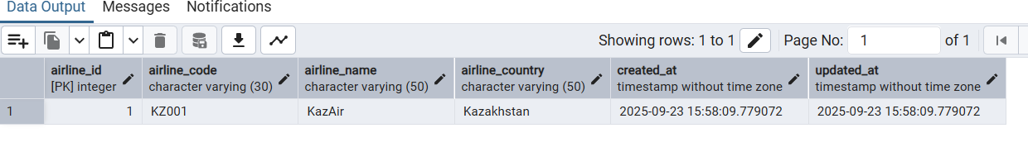

**3 exercise result**

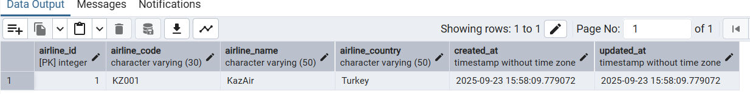

**4 exercise result**