**Project: Personalized Education Ecosystem**

**Description:**

The Personalized Education Ecosystem is a groundbreaking initiative aimed at revolutionizing traditional education by leveraging AI and data-driven insights to provide tailored and engaging learning experiences for students. This platform adapts to individual learning styles, preferences, strengths, and pacing, fostering a more effective and personalized educational journey.

**Features:**

* Adaptive Learning Paths: Dynamic curriculum adjustments based on student performance and preferences.

This feature involves the dynamic tailoring of each student's learning journey. As students engage with the platform, their interactions, performance on assessments, and preferences are continuously analyzed. The system uses this data to create personalized learning paths. For instance, if a student excels in mathematics but struggles with literature, the system will adjust the curriculum, providing more challenging math exercises while offering additional support in literature.

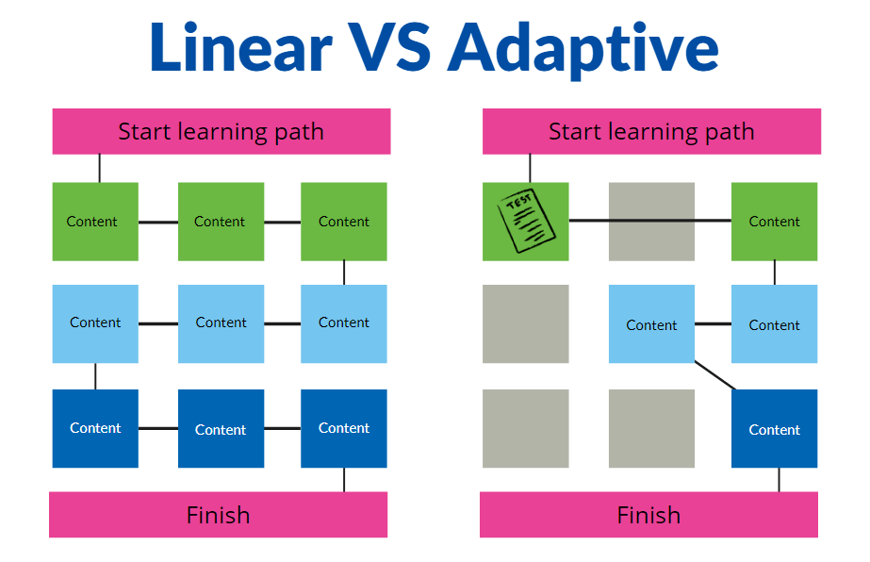

* Real-Time Assessment and Feedback: Continuous evaluation with instant feedback for students and educators.

Students are assessed through quizzes, assignments, and interactive activities. The innovative aspect is the real-time feedback loop. As students complete assessments, they receive immediate feedback, helping them understand their mistakes and learn from them promptly. Educators also benefit from insights into student progress, allowing them to tailor their teaching strategies accordingly.

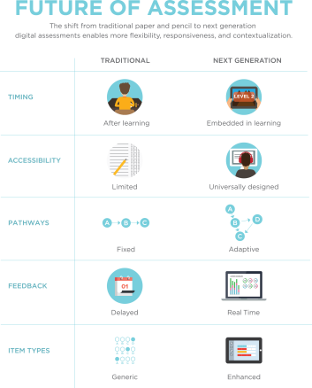

* Multimodal Content Delivery: Diverse content formats to accommodate various learning styles.

Recognizing that students have diverse learning preferences, this feature provides content in various formats. Some students might learn better through videos, others through interactive simulations, and some through traditional text. By offering content in multiple formats, the platform ensures that learners can engage with materials in ways that resonate best with them.

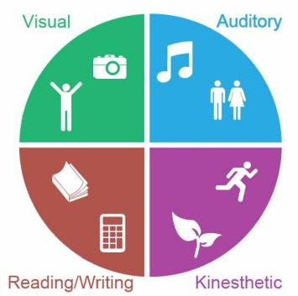

* AI Tutoring and Assistance: AI-driven virtual tutors offering explanations and guidance.connect with chatgpt.

AI-powered virtual tutors act as personalized learning companions. They answer students' questions, provide explanations, and guide them through challenging concepts. These AI tutors use natural language processing to understand and respond to students in a conversational manner, enhancing the learning experience

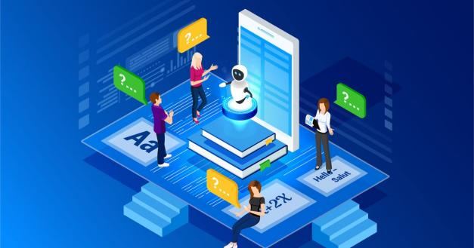

* Collaborative Learning Spaces: Virtual classrooms and study groups for global collaboration.

Virtual classrooms and study groups create a global learning community. Students can join discussions, collaborate on projects, and share insights with peers from around the world. The AI system can suggest study partners based on complementary strengths and learning goals, encouraging cooperative learning and cross-cultural exchanges.

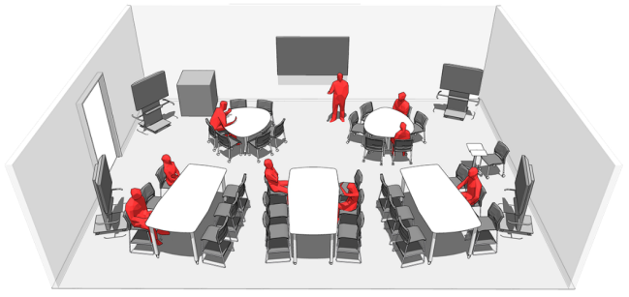

* Learning Analytics Dashboard: Comprehensive visualizations of student progress and engagement.

A comprehensive dashboard provides students, educators, and parents with visualizations of progress, engagement levels, and performance trends. This data-driven approach empowers stakeholders to make informed decisions about adjusting learning strategies, setting goals, and providing support where needed.



* Cognitive Skills Development: Activities promoting critical thinking, problem-solving, and creativity.

Beyond subject-specific content, the platform includes activities designed to enhance cognitive skills such as critical thinking, problem-solving, creativity, and emotional intelligence. These activities are integrated into the curriculum to foster holistic skill development.

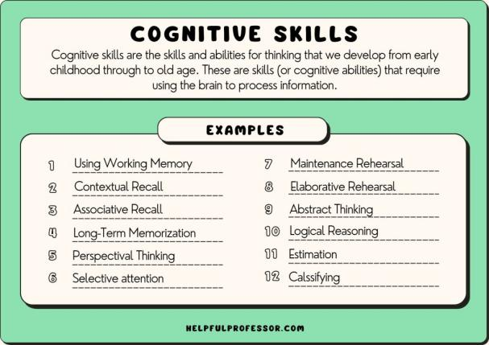

* Personalized Assessments: Tailored assessments aligned with individual learning paths.

Assessments are customized to align with each student's unique learning journey. As students progress, the assessments evolve in complexity and scope. This ensures that evaluations accurately reflect individual growth and achievement rather than relying on a standardized one-size-fits-all approach

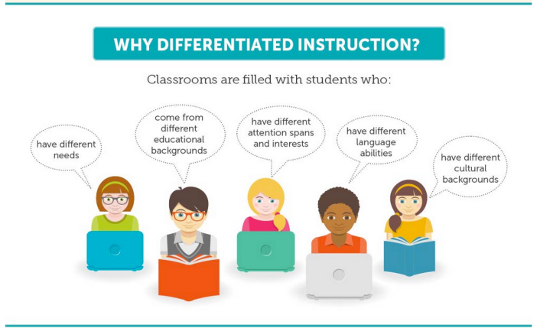

* Career Path Recommendations: AI-guided suggestions for potential career paths.

The AI system analyzes students' learning trajectories, strengths, and interests. Based on this analysis, it provides suggestions for potential career paths and educational routes that align with students' aptitudes and passions, helping them make informed decisions about their future.

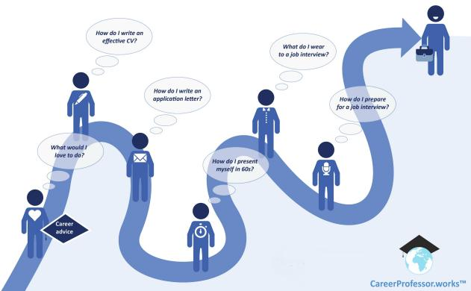

* Access to Experts and Mentors: Connecting students with real-world professionals.

The platform facilitates connections between students and professionals, experts, and mentors in various fields. This feature exposes students to real-world insights, career advice, and guidance, enhancing their understanding of how their education relates to practical applications.

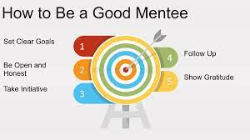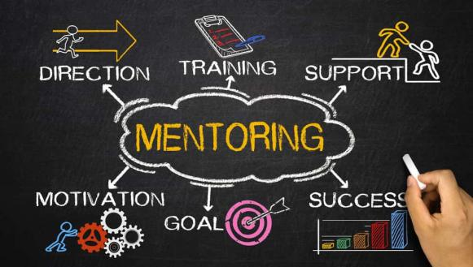

* Gamification and Rewards: Gamified elements to enhance engagement and motivation.

Gamified elements, badges, and rewards add a layer of engagement to the learning process. By completing challenges, hitting milestones, and demonstrating mastery, students earn virtual rewards and recognition, fostering a sense of achievement and motivation.

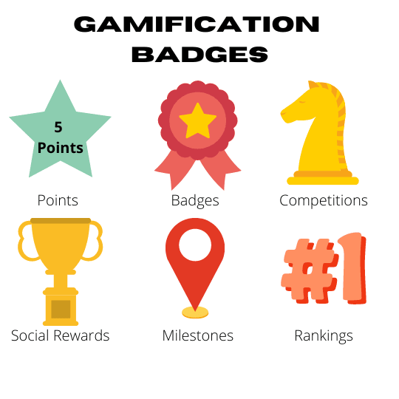

* Global Learning Network: Collaboration with institutions and cultural exchange programs.

Collaboration with other educational institutions, organizations, and cultural exchange programs creates a diverse and interconnected learning network. Students can engage with peers and educators from different backgrounds, exposing them to varied perspectives and experiences.

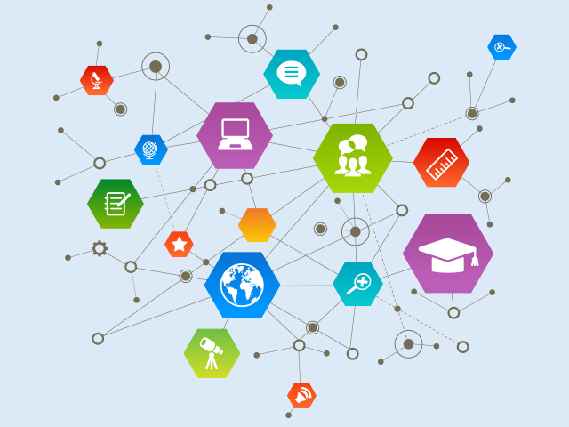

**Challenges:**

* Data Privacy: Ensuring sensitive student data is protected and handled responsibly.
* Algorithm Bias: Mitigating potential biases in AI-driven content recommendations.
* Scalability: Designing a system capable of handling a large user base and diverse content.
* Human Interaction: Balancing AI-driven learning with meaningful human interaction.
* Access Equality: Addressing technology disparities for equitable access to education.

Used Technology:

* AI and Machine Learning: Personalization, content recommendation, and assessment analysis.
* Natural Language Processing: AI tutors and interactive communication.
* Data Analytics: Learning analytics dashboard and progress tracking.
* Virtual Reality (Potential): Immersive learning experiences and virtual classrooms.
* Cloud Infrastructure: Scalable and secure data storage and processing.

**Future Impact:**

The Personalized Education Ecosystem has the potential to transform education by tailoring learning experiences to individual needs, enhancing engagement, and bridging learning gaps. It empowers students to take charge of their education while enabling educators to provide personalized guidance. This innovative approach could lead to improved learning outcomes, increased retention rates, and a more inclusive and accessible education for diverse learners.

**ALL THE REQUIRMENTS NEEDED FOR STUDENT IN UNDER ONE ROOF**

name the website that can satisfy the every needs of students including carrer path, instant college acadamic, students working tools, student collabration, financial aid, trending courses, global current educational events etc...

|  |
| --- |
| Art and Creativity Tools |
| college |
| Online Mentorship and Networking Platforms: |
| Remote Internship and Job Opportunities |
| Career Assessment and Personality Tests |
| E-Portfolio Platforms |
| Online Writing Communities: |
| Study Abroad and Exchange Programs Information: |
| Professional Certification Programs: |
| Emergency and Safety Resources |
| Global Current Events and News Analysis |
| Coding Challenges and Competitions: |
| Social Media Courses |

|  |
| --- |
| Language Learning Platforms |
| Career and Job Resources |