

Alzheimer's Disease Detection Using Lightweight CNN on MRI Scans

Authors

ZINDAZED ABDSHAHD KASAULI

2024/HD05/21948U

NIYONKURU VENANT

2024/HD05/27454E

Mohamed

Table of Contents

Abstract 2

Introduction 3

Problem Statement 3

Main Objective and Specific Objectives 3

Main Objective 3

Specific Objectives 3

Impact of the Research / Significance 4

Literature Review 4

Materials and Methods 8

Dataset 8

Preprocessing 8

Model Architecture 8

Training 9

Evaluation 10

Code and Data Availability 10

Setup Instructions 10

Results and Discussion 12

Data Exploration 12

Binary Model Performance 12

Multi-Class Model Performance 14

Test Image Predictions 15

Discussion 16

Conclusions 16

References 16

# Abstract

This research presents a lightweight Convolutional Neural Network (CNN) model for the detection and classification of Alzheimer's Disease (AD) using Magnetic Resonance Imaging (MRI) scans. Two models were developed: a binary model distinguishing AD from non-AD cases and a multi-class model classifying four stages of dementia (Non-Demented, Very Mild Demented, Mild Demented, and Moderate Demented). The models were trained on a dataset from Kaggle, achieving high accuracy (97.5% for binary, 89.3% for multi-class). The study demonstrates the potential of lightweight CNNs for accessible and accurate AD diagnosis, addressing class imbalance through data augmentation.

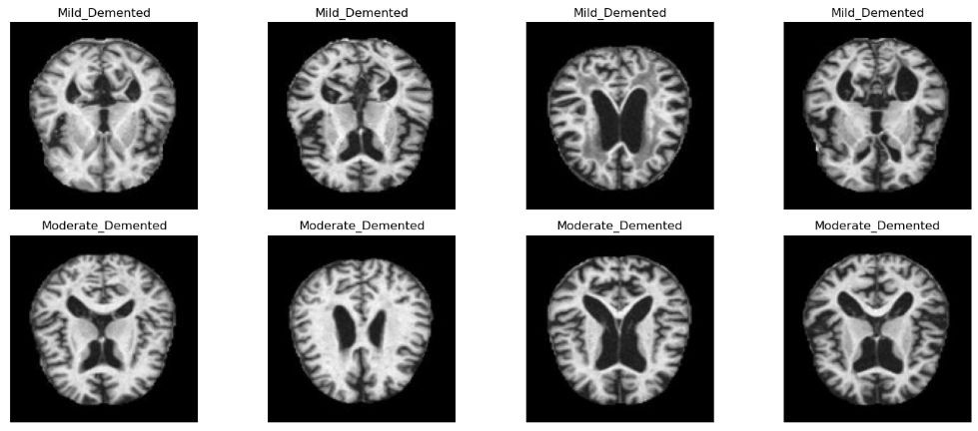

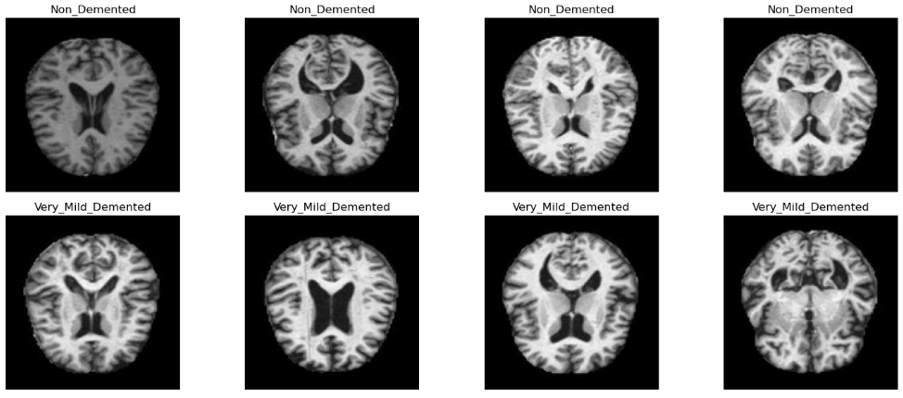

*Visual exploration of the training dataset, with four representative images shown for each of the Mild, Moderate, Non, and Very Mild Demented classes.*

# Introduction

Alzheimer's Disease is a progressive neurodegenerative disorder and a leading cause of dementia worldwide. Early detection is critical for timely intervention, but current diagnostic methods often rely on expensive or invasive techniques. MRI scans provide a non-invasive approach to visualize brain changes associated with AD. This study leverages deep learning, specifically lightweight CNNs, to develop an automated, accurate, and resource-efficient tool for AD detection and classification using MRI data.

# Problem Statement

Diagnosing AD early and accurately remains challenging due to subtle brain changes in early stages, limited access to advanced imaging in resource-constrained settings, and the need for expert radiologists. Additionally, datasets for AD classification often suffer from class imbalance, with fewer samples for severe cases like Moderate Demented. There is a need for a cost-effective, automated system that can reliably detect AD and differentiate its stages using widely available MRI scans.

# Main Objective and Specific Objectives

## Main Objective

To develop a lightweight CNN-based system for the automated detection and classification of Alzheimer's Disease using MRI scans.

## Specific Objectives

* To design and train a binary CNN model to distinguish AD from non-AD cases.
* To develop a multi-class CNN model to classify four stages of dementia.
* To address class imbalance through data augmentation techniques.
* To evaluate model performance using metrics such as accuracy, precision, recall, and F1-score.
* To validate the models on test images from an independent dataset.

# Impact of the Research / Significance

This research offers a scalable and resource-efficient solution for AD detection, potentially increasing access to early diagnosis in low-resource settings. The lightweight CNN models require less computational power than traditional deep learning models, making them suitable for deployment on standard hardware. Accurate classification of dementia stages can support personalized treatment plans, improve patient outcomes, and reduce healthcare costs. The models also contribute to the growing field of AI-assisted medical diagnostics, paving the way for broader adoption of deep learning in clinical practice.

# Literature Review

In recent years, techniques employing deep learning to diagnose AD have gained prominence [8–16]. Deep learning is a type of machine learning that is particularly well suited for the analysis of complex medical images, as it has the ability to automatically learn and extract features from large datasets. In addition to medical applications, deep learning is used in other applications [30–32]. For example, Darehnaei et al. [30] presented an approach for multiple vehicle detection in UAV images using swarm intelligence ensemble deep transfer learning (SI-EDTL). The presented method has the potential to enhance the effectiveness of various applications, such as surveillance and disaster response. A number of studies have explored the use of deep learning for AD detection using various imaging modalities, including structural MRI, functional MRI, PET, and amyloid imaging. However, in this project, we focused on the methods that used the same dataset of MRI images. These studies have demonstrated the potential of deep learning to accurately classify the AD disease.

Several different approaches have been used to develop deep learning models for AD diagnosis using MRI images. Menagadevi et al. [8] developed a computer-aided diagnosis system for detecting AD based on a combination of a deep learning model with traditional classification methods. They first start with preprocessing stages on the input MRI images to enhance the images. After that, they perform segmentation on the preprocessed images to obtain the region of interest. Then, they extract the features using the presented multiscale pooling residual autoencoder model. Finally, they used separate classifiers such as K-Nearest Neighbor (KNN) and Extreme Learning Machine (ELM) for final classification. They obtained an overall accuracy of 96.88% using the KNN classifier and 98.97% using the ELM classifier for the binary classification task. However, the study focused on only one imaging modality, MRI, and used relatively small datasets. Murugan et al. [9] introduced a deep learning modality called “DEMNET” for diagnosing AD from MRI images. They used several image processing techniques, such as preprocessing, oversampling, and splitting the input data. After that, they fed the split data to the presented deep model for feature extraction and classification. They obtained an overall accuracy of 95.23% for the multi-classification task. However, similar to Menagadevi et al. [8], the study only focused on MRI imaging and used small datasets. Loddo et al. [10] presented a fully automatic model based on ensemble deep learning approaches for diagnosing AD from MRI images.

They employed three pretrained deep models: AlexNet, ResNet 101, and InceptionResNetV2. After that, they used an average strategy to generate the ensemble output. They obtained the best accuracy of 96.57% for the binary classification task and an accuracy of 97.7% for the multi-classification task. However, the study did not use any image preprocessing techniques, and the ensemble approach may not always improve the performance of deep learning models. Sharma et al. [11] presented a hybrid modality called “HTLML” based on AI approaches for the detection of AD from MRI images. They perform the first preprocessing stage on the input MRI images. After that, they fed these preprocessed images in parallel into two pretrained models, such as DenseNet201 and DenseNet121. Then, they perform classification using separate classifiers for each pretrained model. Finally, they combine the output for each classifier using the voting strategy to obtain the final decision. They obtained an overall accuracy of 91.75% for the multi-classification task. However, the study did not employ any data augmentation techniques and used relatively small datasets. Hazarika et al. [33] presented an approach for the classification of AD using deep neural networks and MRI. The approach involves preprocessing the MRI scans, extracting features from segmented brain images using a combination of 2D and 3D CNNs, and classifying the scans into AD and non-AD using a fully connected neural network. The authors achieved promising results with an accuracy of 95.34%, a sensitivity of 96% and a specificity of 94.67%. The presented method has the potential to significantly improve the early detection and treatment of AD. However, further validation on larger and more diverse datasets is necessary to assess its generalizability and robustness.

Another hybrid model based on deep learning and traditional classifiers was pre- sented by Mohammed et al. [12] for the early diagnosis of AD from MRI images. The authors first enhanced the input MRI images using several preprocessing techniques. After that, they fed the preprocessed images to the presented deep model, which is a convolutional neural network (CNN) model for extracting the features. Finally, these features are fed to a separate classifier, such as a support vector machine (SVM), for final classification. They worked on a multi-classification task and obtained an overall accu- racy of 94.80%. However, the use of a traditional classifier may limit the performance of the model. Balasundaram et al. [13] used the ResNet50 pretrained model for the diagnosis of AD from MRI images. They used preprocessing techniques such as resizing and thresholding on the input images. After that, they fed these images to the presented pretrained model for final classification. They obtained an overall accuracy of 94.1% on the multi-classification task. However, the study did not employ any data augmentation techniques, and the use of a single pretrained model may limit the performance of the model. Bangyal et al. [14] applied deep learning techniques to MRI images to detect AD.

A comparative analysis between them proves that deep learning approaches can detect AD better than traditional machine learning approaches. They finally obtained an overall accuracy of 94.63% using deep learning approaches on a multi-classification task from MRI images. However, the study did not employ any data augmentation techniques and used relatively small datasets. Ahmed et al. [15] presented a classification method called “DAD-Net” using an optimized neural network for the early diagnosis of AD. They split the data and performed preprocessing techniques on the input MRI images. After that, they fed these images to the presented deep classification model for extract- ing features and final classification. They obtained an overall accuracy of 90% for the multi-classification task. Tuvshinjargal and Hwang [16] presented a combination model between the VGG-C transform and CNN for the prediction of AD from MRI images. They use Z-score scaling to preprocess the input images and quantize pixel intensity. After that, they fed these images to the VGG pretrained model for final prediction. They obtained an overall testing accuracy of 77.46 when working on a multi-classification task. However, the study used a relatively simple deep learning model and achieved lower performance compared to the other studies.

Balaji et al. [34] presented a hybridized deep learning approach for detecting AD using MRI images. The authors combine a CNN and a long short-term memory (LSTM) network to learn spatial and temporal features from MRI scans. The authors report an accuracy of 98.50% in classifying MRI scans into AD or normal cases using the presented hybridized deep learning approach. However, the study requires a large amount of data to learn complex features and patterns accurately. In addition, the use of this combination can be computationally expensive, which may limit the scalability of the model. Hu et al. [22] introduced a deep learning model for a short-term longitudinal study of MCI using brain structural MRI (sMRI) as the main biomarker. The VGG-TSwinformer model combines a VGG-16-based CNN and Transformer to extract and encode features from longitudinal sMRI images, and it uses sliding-window and temporal attention mechanisms to integrate local and distant spatial features for MCI progression prediction. They obtained an accuracy of 77.20% for the binary classification task. The study still has some limitations, such as not mining 2D local features inside slices, not adopting an effective feature fusion method for axial, coronal and sagittal plane slices, and not taking full advantage of available cross-sectional biomarkers.

The summary of all previous methods is shown in Table 1, along with the disadvan- tages of each method. In this study, we present a novel lightweight CNN model that overcomes the previous limitations for all related work with higher performance in both binary and multi-classification tasks. Our model and the dataset we used are discussed in detail in the following section.

Table 1 Summary of previous works for AD detection based on deep learning.

|  |  |  |
| --- | --- | --- |
| **Authors and Reference Methodology Disadvantages** | **Methodology** | **Disadvantages** |
| Menagadevi et al. [8] (2023) | Pooling residual autoencoder + ELM | * Classifier-dependent method * Require more time for training * Not suitable for real applications |
| Murugan et al. [9] (2021) | Preprocessing + CNN + RMS | * High computational complexity * Overfitting problem * A problem in model convergence. * Low performance on big data |
| Loddo et al. [10] (2022) | Pretrained models + Ensemble classifier | * Less interpretable time and cost complexity * Not suitable for real applications * Low accuracy on bigand small data |
| Sharma et al. [11] (2022)  Mohammed et al. [12] (2021)  - | Pretrained models + SVM  Pretrained models + SVM | * Low accuracy with big data * Perform poorly in imbalanced datasets * Overfitting problem * Classifier dependent method |
| Balasundaram et al. [13] (2023) | Segmentation + Pretrained models | * Overfitting problem * Takes large number of resources (time and computation power) * Not suitable for real applications * Low performance on big data |
| Bangyal et al. [14] (2022) | CNN | * Exploding gradient * Problem with imbalanced datasets * Overfitting problem * Complex model |
| Ahmed et al. [15] (2022)  Tuvshinjargal and Hwang [16] (2022) | Preprocessing + CNN+optimization method  Preprocessing + pretrained model | * Obtained low accuracy * Complex model * Not suitable for real applications * Overfitting problem * High computational complexity * Low accuracy on big data * Not suitable for real applications * Perform poorly in imbalanced datasets |
| Hazarika et al. [33] (2023) | Preprocessing + 2D CNN and 3D CNN | * Obtained low accuracy for binary classification task * Low accuracy with big data * Not robust |
| Balaji et al. [34] (2023) | 3D CNN + LSTM | * Difficult to understand how the model making its predictions * Computationally expensive * Require a large amount of data to learn complex features accurately |
| Hu et al. [22] (2023) | Pretrained model + CNN | * Not adopting an effective feature fusion method for axial * Obtained very low accuracy for binary classification task * Not robust |

# Materials and Methods

## Dataset

The training dataset was sourced from Kaggle (https://www.kaggle.com/datasets/borhanitrash/alzheimer-mri-disease-classification-dataset), containing 5120 training and 1280 test MRI scans in .parquet format, labeled as Non-Demented, Very Mild Demented, Mild Demented, and Moderate Demented. Test images for prediction were obtained from another Kaggle dataset (https://www.kaggle.com/datasets/lukechugh/best-alzheimer-mri-dataset-99-accuracy).

## Preprocessing

Images were resized to 150x150 pixels and normalized (pixel values divided by 255). Data augmentation included brightness adjustments, zooming, and horizontal flipping to enhance model robustness. Class imbalance was addressed by augmenting minority classes (e.g., Moderate Demented) to match the majority class count (2566 samples per class post-augmentation).

## Model Architecture

Two CNN models were developed using TensorFlow:

* **Binary Model**: Classifies AD vs. non-AD with three convolutional layers (32, 64, 128 filters), max-pooling, and two dense layers (151 units each), ending with a sigmoid output.
* **Multi-Class Model**: Classifies four dementia stages with a similar architecture but with 154-unit dense layers and a softmax output for four classes.

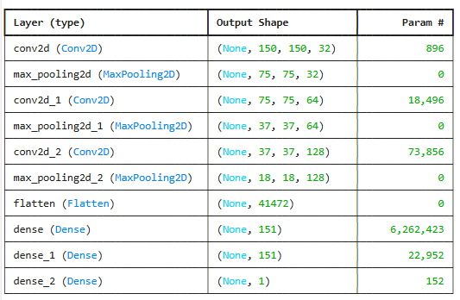

Figure 1 The detailed architecture of the Binary model

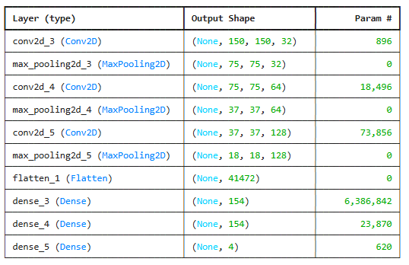

Figure 2 The detailed architecture of the multi-class model

## Training

Models were trained for up to 100 epochs with a batch size of 50, using Adam optimizer (learning rate 0.001), early stopping (patience=10), and learning rate reduction (factor=0.2, patience=5). Binary models used binary cross-entropy loss, while multi-class models used sparse categorical cross-entropy.

## Evaluation

Performance was assessed using accuracy, loss, confusion matrices, and classification reports (precision, recall, F1-score). Models were saved as .h5 files for reuse.

## Code and Data Availability

The complete codebase, including the Jupyter notebook (Alzheimer.ipynb), trained model weights (alzheimer_binary_model.h5, alzheimer_multi_class_model.h5), and sample test images, is available in a public GitHub repository: https://github.com/zindazed/computer_vision_finals.git. The repository contains all necessary scripts to preprocess data, train models, and make predictions. Below are instructions to set up and run the project:

### Setup Instructions

#### Clone the Repository:

1. Open a terminal and run:
2. git clone <https://github.com/zindazed/computer_vision_finals.git>
3. cd computer_vision_finals

#### Install Dependencies:

1. Ensure Python 3.8 or higher is installed.
2. Install required packages listed in the notebook:
   * pip install tensorflow keras matplotlib scikit-learn pandas numpy seaborn pyarrow pillow
   * Verify TensorFlow version (should be ~2.19.0):

#### Datasets:

1. Downloaded the training dataset from Kaggle: https://www.kaggle.com/datasets/borhanitrash/alzheimer-mri-disease-classification-dataset.
2. Placed the .parquet files (train-00000-of-00001-c08a401c53fe5312.parquet and test-00000-of-00001-44110b9df98c5585.parquet) in a Data/ folder within the repository.
3. Downloaded test images from: https://www.kaggle.com/datasets/lukechugh/best-alzheimer-mri-dataset-99-accuracy.
4. Placed sample test images (e.g., none.jpg, mild.jpg, moderate.jpg, very.jpg) in the repository root.

#### Run the Notebook:

1. Launch Jupyter Notebook:
2. Open Alzheimer.ipynb and run all cells to:
   * Load and preprocess the .parquet datasets.
   * Train the binary and multi-class models (or load pre-trained weights from .h5 files).
   * Evaluate model performance and generate visualizations (e.g., confusion matrices, accuracy/loss plots).
   * Make predictions on test images.

#### Use Pre-trained Models:

1. The repository includes alzheimer_binary_model.h5 and alzheimer_multi_class_model.h5.
2. To make predictions on new images, modify the predict_single_image function call in the notebook with the path to your test image (e.g., predict_single_image("test_images/none.jpg", binary_model, multi_class_model)).

This setup enables users to replicate the study, train models from scratch, or use pre-trained models for predictions on new MRI scans.

# Results and Discussion

## Data Exploration

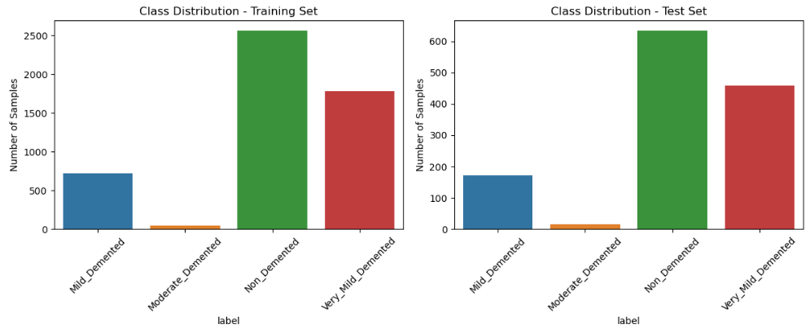

Figure 3 Class distribution in training and test datasets reveals an imbalance, with more 'Non_Demented' and 'Very_Mild_Demented' samples.

The training dataset showed class imbalance: Non-Demented (2566 samples), Very Mild Demented (1781), Mild Demented (724), and Moderate Demented (49). Augmentation balanced classes to 2566 samples each.

## Binary Model Performance

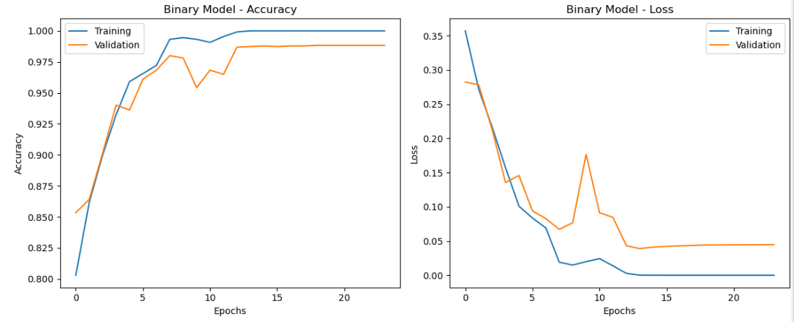

Figure 4 accuracy/loss plots for binary model.

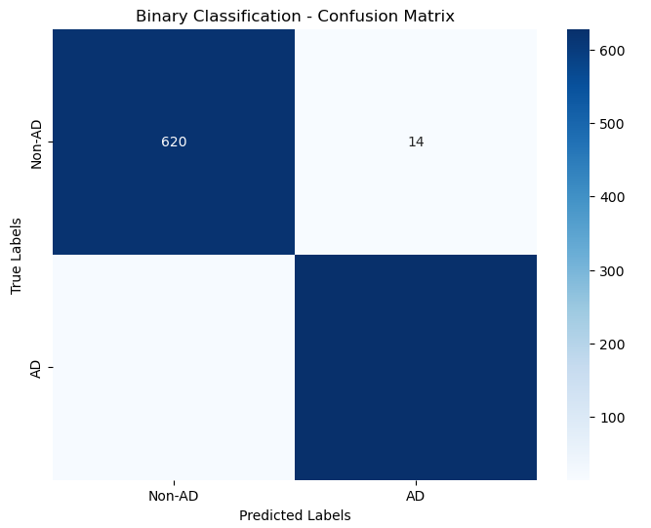

Figure 5 Confusion matrix for binary model

The binary model achieved a test accuracy of 97.5% and a test loss of 0.0803. The confusion matrix indicated high true positives (620 Non-AD, 629 AD) with minimal misclassifications (14 Non-AD, 17 AD). The classification report showed precision, recall, and F1-scores of 0.97–0.98 for both classes.

## Multi-Class Model Performance

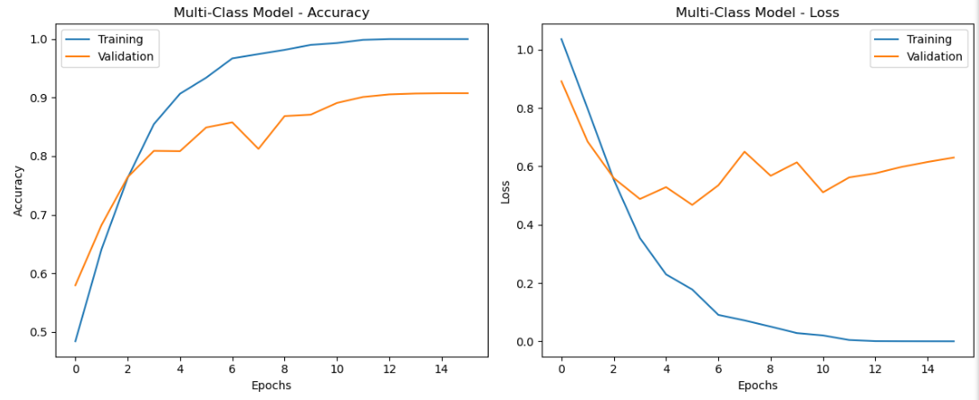

Figure 6 accuracy/loss plots for multi-class model

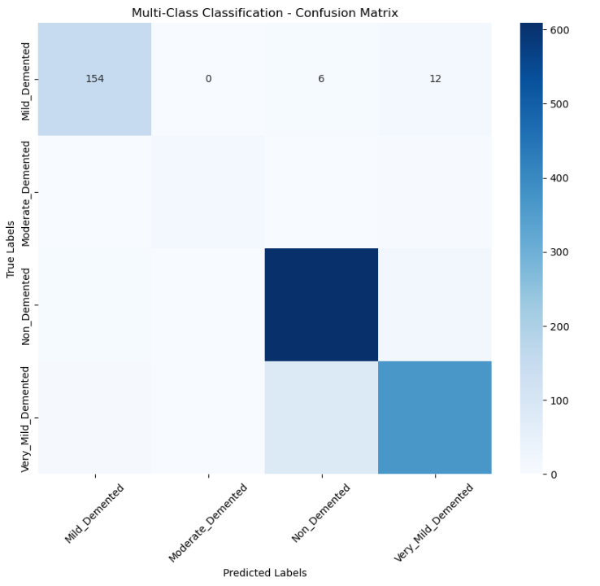

Figure 7 Confusion matrix for multi-class model

The multi-class model achieved a test accuracy of 89.3% and a test loss of 0.3541. The confusion matrix showed strong performance for Non-Demented (96% recall) and Mild Demented (90% recall), with Moderate Demented having lower recall (80%) due to limited original samples. The classification report indicated F1-scores ranging from 0.85 (Very Mild Demented) to 0.91 (Mild Demented, Non-Demented).

## Test Image Predictions

Four test images (Non-Demented, Mild Demented, Moderate Demented, Very Mild Demented) from an independent dataset were predicted with high confidence. For example, a Non-Demented image was classified as Non-AD (confidence 0.9999) and Non-Demented (confidence 0.9999), while a Mild Demented image was classified as AD (confidence 1.0000) and Mild Demented (confidence 0.9931).

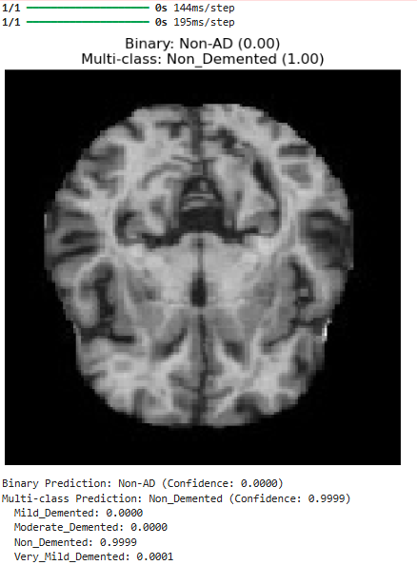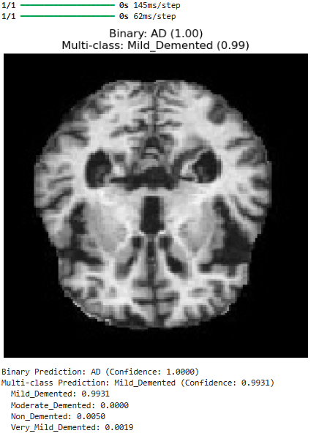

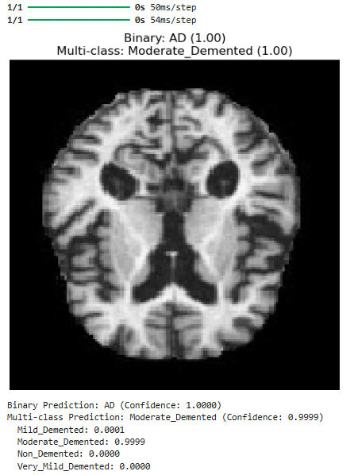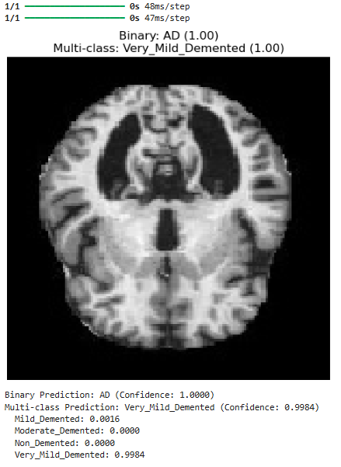

## Discussion

The binary model outperformed the multi-class model due to the simpler task of distinguishing two classes. The multi-class model's lower accuracy reflects the challenge of differentiating subtle differences between dementia stages, particularly for Moderate Demented cases. Augmentation mitigated class imbalance but could not fully compensate for the small original sample size of minority classes. Validation loss plateauing suggests potential overfitting, which could be addressed with additional regularization or dropout.

# Conclusions

This study successfully developed lightweight CNN models for AD detection and classification, achieving high accuracy and demonstrating feasibility for resource-constrained environments. The binary model is highly reliable for initial screening, while the multi-class model provides nuanced classification for clinical use. Future work could explore transfer learning, larger datasets, or advanced augmentation techniques to further improve performance, particularly for minority classes.

# References

1. DeTure, M.A.; Dickson, D.W. The Neuropathological Diagnosis of Alzheimer’s Disease. Mol. Neurodegener. 2019, 14, 32.

2. Kocaelli, H.; Yaltirik, M.; Yargic, L.I.; Özbas, H. Alzheimer’s Disease and Dental Management. Oral Surg. Oral Med. Oral Pathol. Oral Radiol. Endod. 2002, 93, 521–524.

3. Chassain, C.; Cladiere, A.; Tsoutsos, C.; Pereira, B.; Boumezbeur, F.; Debilly, B.; Marques, A.-R.; Thobois, S.; Durif, F. Evaluation of Common and Rare Variants of Alzheimer’s Disease-Causal Genes in Parkinson’s Disease. Park. Relat. Disord. 2022, 97, 8–14.

4. Kalaria, R. Similarities between Alzheimer’s Disease and Vascular Dementia. J. Neurol. Sci. 2002, 203, 29–34.

5. Sarasso, E.; Gardoni, A.; Piramide, N.; Volontè, M.A.; Canu, E.; Tettamanti, A.; Filippi, M.; Agosta, F. A Multiparametric MRI Study of Structural Brain Damage in Dementia with Lewy Bodies: A Comparison with Alzheimer’s Disease. Park. Relat. Disord. 2021, 91, 154–161.

6. Simic, G.; Stanic, G.; Mladinov, M.; Jovanov-Milosevic, N.; Kostovic, I.; Hof, P. Does Alzheimer’s Disease Begin in the Brainstem?

Neuropathol. Appl. Neurobiol. 2009, 35, 532–554.

7. Desai, A.K.; Grossberg, G.T. Diagnosis and Treatment of Alzheimer’s Disease. Neurology 2005, 64 (Suppl. 3), S34–S39.

8. Menagadevi, M.; Mangai, S.; Madian, N.; Thiyagarajan, D. Automated Prediction System for Alzheimer Detection Based on Deep Residual Autoencoder and Support Vector Machine. Optik 2023, 272, 170212.

9. Murugan, S.; Venkatesan, C.; Sumithra, M.G.; Gao, X.Z.; Elakkiya, B.; Akila, M.; Manoharan, S. DEMNET: A Deep Learning Model for Early Diagnosis of Alzheimer Diseases and Dementia from MR Images. IEEE Access 2021, 9, 90319–90329.

10. Loddo, A.; Buttau, S.; Di Ruberto, C. Deep Learning Based Pipelines for Alzheimer’s Disease Diagnosis: A Comparative Study and a Novel Deep-Ensemble Method. Comput. Biol. Med. 2022, 141, 105032.

11. Sharma, S.; Gupta, S.; Gupta, D.; Altameem, A.; Saudagar, A.K.J.; Poonia, R.C.; Nayak, S.R. HTLML: Hybrid AI Based Model for Detection of Alzheimer’s Disease. Diagnostics 2022, 12, 1833.

12. Mohammed, B.A.; Senan, E.M.; Rassem, T.H.; Makbol, N.M.; Alanazi, A.A.; Al-Mekhlafi, Z.G.; Ghaleb, F.A. Multi-Method Analysis of Medical Records and MRI Images for Early Diagnosis of Dementia and Alzheimer’s Disease Based on Deep Learning and Hybrid Methods. Electronics 2021, 10, 2860.

13. Balasundaram, A.; Srinivasan, S.; Prasad, A.; Malik, J.; Kumar, A. Hippocampus Segmentation-Based Alzheimer’s Disease Diagnosis and Classification of MRI Images. Arab. J. Sci. Eng. 2023, 1–17, online ahead of print.

14. Bangyal, W.H.; Rehman, N.U.; Nawaz, A.; Nisar, K.; Ibrahim, A.A.A.; Shakir, R.; Rawat, D.B. Constructing Domain Ontology for Alzheimer Disease Using Deep Learning Based Approach. Electronics 2022, 11, 1890.

15. Ahmed, G.; Er, M.J.; Fareed, M.M.S.; Zikria, S.; Mahmood, S.; He, J.; Aslam, M. DAD-Net: Classification of Alzheimer’s Disease Using ADASYN Oversampling Technique and Optimized Neural Network. Molecules 2022, 27, 7085.

16. Tuvshinjargal, B.; Hwang, H. VGG-C Transform Model with Batch Normalization to Predict Alzheimer’s Disease through MRI Dataset. Electronics 2022, 11, 2601.

17. Varalakshmi, P.; Priya, B.T.; Rithiga, B.A.; Bhuvaneaswari, R.; Sundar, R.S.J. Diagnosis of Parkinson’s Disease from Hand Drawing Utilizing Hybrid Models. Park. Relat. Disord. 2022, 105, 24–31.

18. Inguanzo, A.; Sala-Llonch, R.; Segura, B.; Erostarbe, H.; Abos, A.; Campabadal, A.; Uribe, C.; Baggio, H.; Compta, Y.; Marti, M.; et al. Hierarchical Cluster Analysis of Multimodal Imaging Data Identifies Brain Atrophy and Cognitive Patterns in Parkinson’s Disease. Park. Relat. Disord. 2021, 82, 16–23.

19. Liu, C.; Huang, F.; Qiu, A.; Alzheimer’s Disease Neuroimaging Initiative. Monte Carlo Ensemble Neural Network for the Diagnosis of Alzheimer’s Disease. Neural Netw. 2023, 159, 14–24.

20. Lahmiri, S. Integrating Convolutional Neural Networks, kNN, and Bayesian Optimization for Efficient Diagnosis of Alzheimer’s Disease in Magnetic Resonance Images. Biomed. Signal Process. Control 2023, 80, 104375.

21. Abbas, S.Q.; Chi, L.; Chen, Y.P.P. Transformed Domain Convolutional Neural Network for Alzheimer’s Disease Diagnosis Using Structural MRI. Pattern Recognit. 2023, 133, 109031.

22. Hu, Z.; Wang, Z.; Jin, Y.; Hou, W. VGG-TSwinformer: Transformer-Based Deep Learning Model for Early Alzheimer’s Disease Prediction. Comput. Methods Programs Biomed. 2023, 229, 107291.

23. Marwa, E.G.; Moustafa, H.E.D.; Khalifa, F.; Khater, H.; AbdElhalim, E. An MRI-Based Deep Learning Approach for Accurate Detection of Alzheimer’s Disease. Alex. Eng. J. 2023, 63, 211–221.

24. Hammad, M.; Abd El-Latif, A.A.; Hussain, A.; Abd El-Samie, F.E.; Gupta, B.B.; Ugail, H.; Sedik, A. Deep Learning Models for Arrhythmia Detection in IoT Healthcare Applications. Comput. Electr. Eng. 2022, 100, 108011.

25. Hammad, M.; Bakrey, M.; Bakhiet, A.; Tadeusiewicz, R.; Abd El-Latif, A.A.; Pławiak, P. A Novel End-to-End Deep Learning Approach for Cancer Detection Based on Microscopic Medical Images. Biocybern. Biomed. Eng. 2022, 42, 737–748.

26. Jabeen, F.; Rehman, Z.U.; Shah, S.; Alharthy, R.D.; Jalil, S.; Khan, I.A.; Almohammedi, A.; Alhumaidi, A.S.; Abd El-Latif, A.A. Deep Learning-Based Prediction of Inhibitors Interaction with Butyrylcholinesterase for the Treatment of Alzheimer’s Disease. Comput. Electr. Eng. 2023, 105, 108475.

27. Hammad, M.; Meshoul, S.; Dziwin´ski, P.; Pławiak, P.; Elgendy, I.A. Efficient Lightweight Multimodel Deep Fusion Based on ECG for Arrhythmia Classification. Sensors 2022, 22, 9347.

28. Wani, M.A.; ELAffendi, M.A.; Shakil, K.A.; Imran, A.S.; Abd El-Latif, A.A. Depression Screening in Humans with AI and Deep Learning Techniques. IEEE Trans. Comput. Soc. Syst. 2022.

29. Dubey, S. Alzheimer’s Dataset (4 Class of Images); Kaggle: San Francisco, CA, USA, 2020. Available online: https://www.kaggle.com/datasets/tourist55/alzheimers-dataset-4-class-of-images (accessed on April 10, 2025).

30. Ghasemi Darehnaei, S.A.; Amiri, A.R.; Karimipour, H.; Huang, Y. SI-EDTL: Swarm intelligence ensemble deep transfer learning for multiple vehicle detection in UAV images. Concurr. Comput. Pract. Exp. 2022, 34, e6726.

31. Shokouhifar, M.; Bagheri, M.; Jahani, S. Multivariate time-series blood donation/demand forecasting for resilient supply chain management during COVID-19 pandemic. Clean. Logist. Supply Chain. 2022, 5, 100078.

32. Hammad, M.; Iliyasu, A.M.; Elgendy, I.A.; Abd El-Latif, A.A. End-to-end data authentication deep learning model for securing IoT configurations. Hum.-Cent. Comput. Inf. Sci. 2022, 12, 4.

33. Hazarika, R.A.; Maji, A.K.; Kandar, D.; Jasinska, E.; Krejci, P.; Leonowicz, Z.; Jasinski, M. An Approach for Classification of Alzheimer’s Disease Using Deep Neural Network and Brain Magnetic Resonance Imaging (MRI). Electronics 2023, 12, 676.

34. Balaji, P.; Chaurasia, M.A.; Bilfaqih, S.M.; Muniasamy, A.; Alsid, L.E.G. Hybridized Deep Learning Approach for Detecting Alzheimer’s Disease. Biomedicines 2023, 11, 149.

35. Gamberger, D.; Ženko, B.; Mitelpunkt, A.; Shachar, N.; Lavracˇ, N. Clusters of Male and Female Alzheimer’s Disease Patients in the Alzheimer’s Disease Neuroimaging Initiative (ADNI) Database. Brain Inf. 2016, 3, 169–179.

36. Kurdi, B.; Lozano, S.; Banaji, M.R. Introducing the Open Affective Standardized Image Set (OASIS). Behav. Res. Methods 2017, 49, 457–470.

37. Manaswi, N.K.; Manaswi, N.K. Understanding and Working with Keras. In Deep Learning with Applications Using Python: Chatbots and Face, Object, and Speech Recognition with TensorFlow and Keras; Apress: Berkeley, CA, USA, 2018; pp. 31–43.

38. Zhang, Z. Improved Adam Optimizer for Deep Neural Networks. In Proceedings of the 2018 IEEE/ACM 26th International Symposium on Quality of Service (IWQoS), Banff, AB, Canada, 4–6 June 2018; pp. 1–2.

39. van der Gaag, M.; Hoffman, T.; Remijsen, M.; Hijman, R.; de Haan, L.; van Meijel, B.; van Harten, P.N.; Valmaggia, L.; de Hert, M.; Cuijpers, P.; et al. The Five-Factor Model of the Positive and Negative Syndrome Scale II: A Ten-Fold Cross-Validation of a Revised Model. Schizophr. Res. 2006, 85, 280–287.

40. Sethuraman, S.K.; Malaiyappan, N.; Ramalingam, R.; Basheer, S.; Rashid, M.; Ahmad, N. Predicting Alzheimer’s Disease Using Deep Neuro-Functional Networks with Resting-State fMRI. Electronics 2023, 12, 1031.

41. Shojaei, S.; Abadeh, M.S.; Momeni, Z. An evolutionary explainable deep learning approach for Alzheimer’s MRI classification. Expert Syst. Appl. 2023, 220, 119709.