405410016楊淨 資工3B

A:

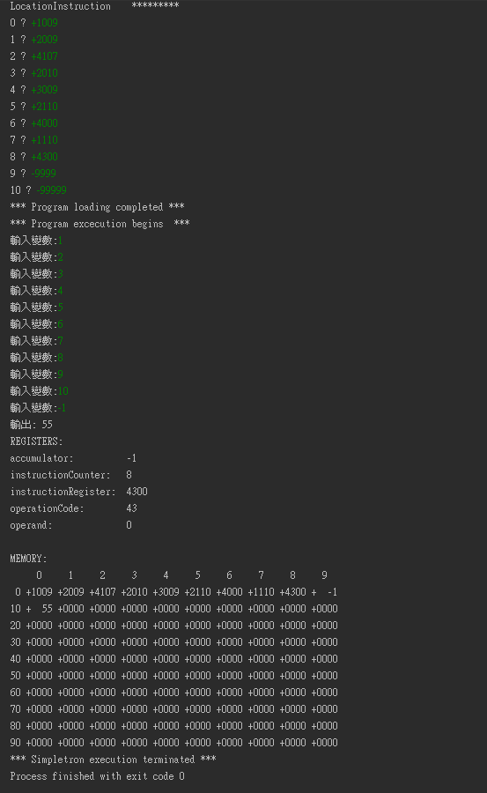

+1009 read 09

+2009 load 09

+4107 Branchneg 07

+2010 load 10

+3009 add 09

+2110 store to 10

+4000 Branch 00

+1110 write 10

+4300 halt

-99999

B:

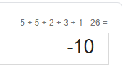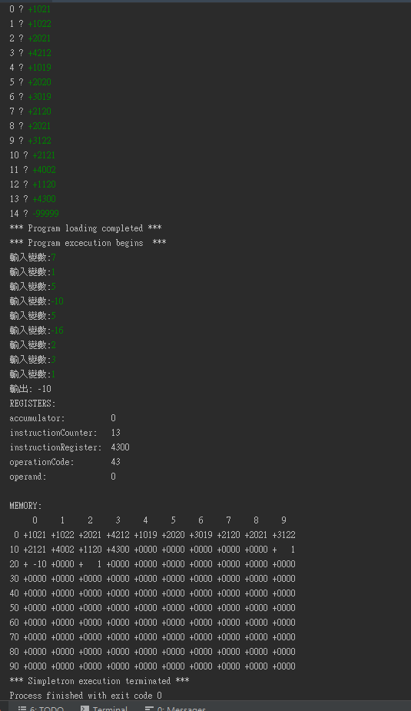

+1021 read 21 存放loop圈數 7

+1022 read 22 存放1 常數

+2021 load 21

+4212 Branchzero 12

+1019 read 19

+2020 load 20

+3019 add 19

+2120 store 20

+2021 load 21

+3122 sub 22(1)

+2121 store 21

+4002 Branch 02

+1120 write 20

+4300 halt

-99999

C:

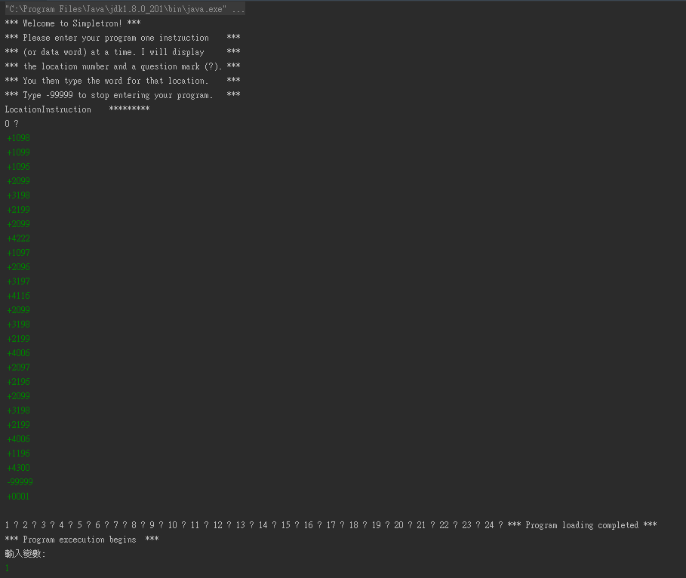

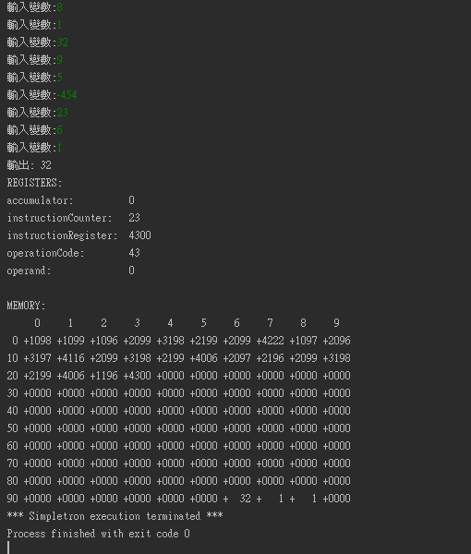

+1098 read 98 存放1 常數

+1099 read 99 存放loop圈數

+1096 read a 存放第一個變數

+2099 load loop

+3198 sub 1

+2199 store 存放loop圈數

+2099 load 99

+4222 Branchzero 跳至輸出

+1097 read b

+2096 load a

+3197 sub b

+4116 compare neg (a-b)<0

+2099 load loop

+3198 sub 1

+2199 store 存放loop圈數

+4006 Branch 06 重新開始迴圈

+2097 load b

+2196 store to a 更新最大值

+2099 load loop

+3198 sub 1

+2199 store 存放loop圈數

+4006 Branch 06 重新開始迴圈

+1196 write a(輸出最大值)

+4300

-99999

+0001