**50.012 Networks (2023 Term 6)**

**Homework 3**

Hand-out: 20 Mar

Due: 2 Apr 23:59

Name: _______________ Student ID: ________________

1. (adapted from textbook chapter 4, problem P14)
2. Consider sending a 1,600-byte datagram into a link that has an MTU of 500 bytes. Suppose the original datagram is stamped with the identification number 291. How many fragments are generated? What are the values in the various fields related to fragmentation in the IP datagram(s) generated? (Recall that there are three fields in the IP datagram header that are related.)
3. Suppose after receiving from the above link (i.e., the link with MTU = 500 bytes), the receiver router needs to further forward the datagram(s) over a different link with MTU = 300 bytes. Please list down all the fragments that will be sent over this second link (with MTU = 300 bytes) and highlight for each fragment the values in all the fragmentation-related fields in the IP datagrams.

**2**. (textbook chapter 4, problem P17) Suppose you are interested in detecting the number of hosts behind a NAT. You observe that the IP layer stamps an identification number sequentially on each IP packet. The identification number of the first IP packet generated by a host is a random number, and the identification numbers of the subsequent IP packets are sequentially assigned. Assume all IP packets generated by hosts behind the NAT are sent to the outside world.

a. Based on this observation, and assuming you can sniff all packets sent by the NAT to the outside, can you outline a simple technique that detects the number of unique hosts behind a NAT? Justify your answer.

b. If the identification numbers are not sequentially assigned but randomly assigned, would your technique work? Justify your answer.

**3.** (Adapted from 2019 final exam) Consider the network in the Figure below (noticed that there is a direct link between node u and z), where the numbers show the symmetrical link costs. Assume a link state routing protocol is used. **Node x** applies Dijkstra’s algorithm to compute the best route to every other node. Step 0 of Dijkstra’s algorithm (i.e., immediately after initialization) is shown below. Write down **all** the rows after step 0 until the algorithm completes.

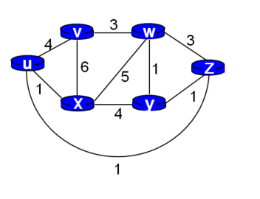

|  |  |  |  |  |  |  |
| --- | --- | --- | --- | --- | --- | --- |
| **Step** | **N’** | **D(u), p(u)** | **D(v),p(v)** | **D(w), p(w)** | **D(y),p(y)** | **D(z),p(z)** |
| 0 | X | 1,x | 6,x | 5,x | 4,x | ∞ |
| 1  … |  |  |  |  |  |  |

**4**. (textbook chapter 5, problem P11): Consider the network below and suppose that poisoned reverse is used in the distance-vector routing algorithm.

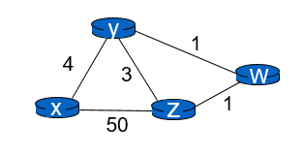

1. When the distance vector routing is stabilized, router w, y, and z inform their distances to x to each other. What distance values do they tell each other?
2. Now suppose that the link cost between x and y increases to 60. Will there be a count-to-infinity problem even if poisoned reverse is used? Why or why not? If there is a count-to-infinity problem, show the first three rounds of message exchanged among w, y, and z and how their DV change.

**Solution template:**



|  |  |
| --- | --- |
|  |  |
| Router z | Informs w, Dz(x)=___ |
|  | Informs y, Dz(x)= ___ |
| Router w | Informs y, Dw(x)= ___ |
|  | Informs z, Dw(x)= ___ |
| Router y | Informs w, Dy(x)= ___ |
|  | Informs z, Dy(x)= ___ |

1. If there is a count-to-infinity problem, you can use the following table to fill in the first few iterations.

|  |  |  |  |  |
| --- | --- | --- | --- | --- |
| time | t0 | Round 1 | Round 2 | Round 3 |
| Z |  | Hint: what Z does after receiving Y’s update? |  |  |
|  |  |  |  |  |
| W |  | Hint: what W does after receiving Y’s update? |  |  |
|  |  |  |  |  |
| Y | Hint: Y detects change, and updates its DV |  |  |  |
|  |  |  |  |  |