**50.012 Networks (2023 Term 6)**

**Homework 4**

Hand-out: 4 Apr

Due: 18 Apr 23:59

Name: _______________ Student ID: ________________

**1.** (textbook chapter 5, adapted from problem P14 and P15): Consider the network shown below. Suppose all the four ASes are running OSPF for their intra-AS routing protocol and assume the cost for every link in the graph is 1. Suppose eBGP and iBGP are used for the inter-AS routing protocol. Initially suppose there is no physical link between AS2 and AS4.

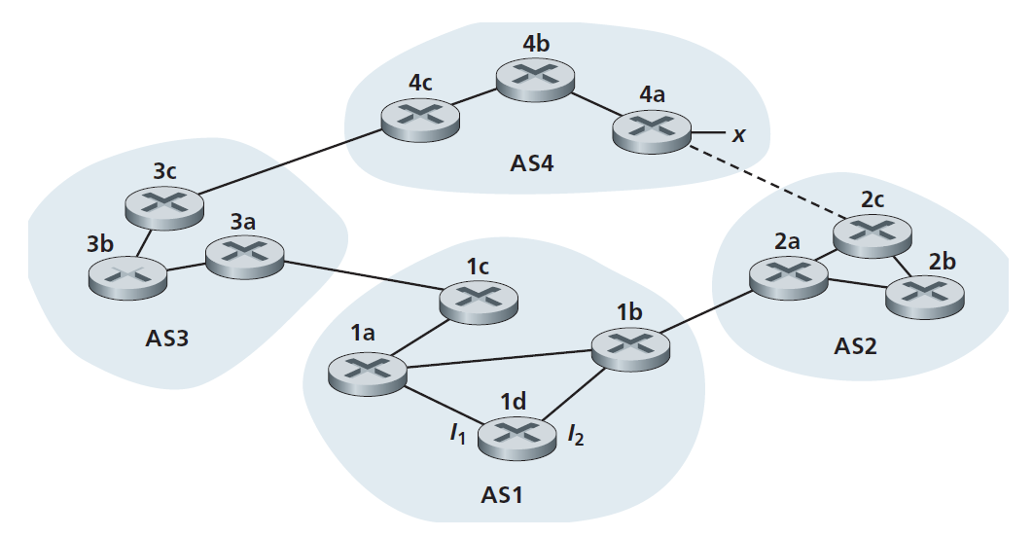

a. Router 3c learns about prefix x from which routing protocol: OSPF, eBGP, or iBGP?

b. Router 3a learns about x from which routing protocol?

c. Router 1c learns about x from which routing protocol?

d. Router 1d learns about x from which routing protocol?

e. Once router 1d learns about x it will put an entry (x, I) in its forwarding table. Will I be equal to I1 or I2 for this entry? Explain why in one sentence.

f. Now suppose that there is a physical link between AS2 and AS4, shown by the dotted line. Suppose router 1d learns that x is accessible via AS2 as well as via AS3. Will I be set to I1 or I2? Explain why in one sentence.

g. Now suppose there is another AS, called AS5, which lies on the path between AS2 and AS4 (not shown in diagram). Suppose router 1d learns that x is accessible via AS2 AS5 AS4 as well as via AS3 AS4. Will I be set to I1 or I2? Explain why in one sentence.

**2.** (textbook chapter 6, adapted from problem P15): Consider the following network:

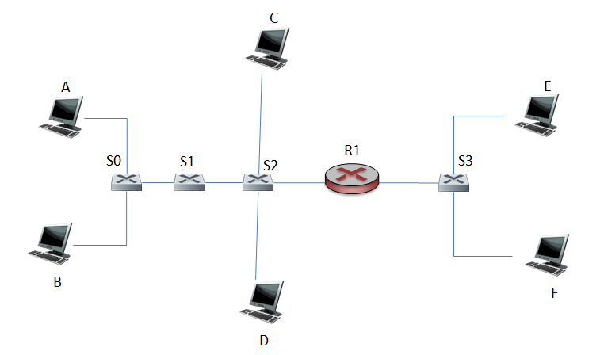

Where S0, S1, S2, and S3 are switches and R1 is a router. Note that the hosts at different side of R1 belong to different subnets.

a. Consider sending an IP datagram from Host E to Host F. Will Host E ask router R1 to help forward the datagram? Why? In the Ethernet frame containing the IP datagram, what are the source and destination IP and MAC addresses?

b. Suppose host E would like to send an IP datagram to host B, and assume that E’s ARP cache does not contain B’s MAC address. Will E perform an ARP query to find B’s MAC address? Why? In the Ethernet frame (containing the IP datagram destined to B) that is delivered to router R1, what are the source and destination IP and MAC addresses?

c. Suppose Host A would like to send an IP datagram to Host B, and neither A’s ARP cache contains B’s MAC address nor does B’s ARP cache contain A’s MAC address. Further suppose that the switch S1’s forwarding table contains entries for Host B and router R1 only. Thus, A will broadcast an ARP request message. What actions will switch S1 perform once it receives the ARP request message? Will router R1 also receive this ARP request message? If so, will R1 forward the message? Once Host B receives this ARP request message, it will send back to Host A an ARP response message. But will it send an ARP query message to ask for A’s MAC address? Why? Will switch S1 receive the ARP response message from Host B?

3. Consider the Cyclic Redundancy Check (CRC) algorithm. Suppose that the 4-bit generator (G) is 1001, that the data payload (D) is 11111001 and that r = 3. What are the CRC bits (R) associated with the data payload D? Please include in your answer the process you calculate the CRC.

**4.** (2019 Final exam question)Consider the network in the figure below, which consists of two switches (S1 and S2) and one router R. There are two VLANs, where port 1 to port 8 in S1 and port 2 to port 5 in S2 belong to VLAN 1; and port 9 to port 15 in S1 and port 6 to port 8 in S2 belong to VLAN2. There are 8 end hosts (A to H) connected to the two switches.

**Fig. 7**

* 1. The port 16 in S1 and port 1 in S2 are connected to each other to carry traffic for both VLAN1 and VLAN2. How do we call these two ports? How does a frame sent between these two ports differ from a standard Ethernet frame?
  2. Assume you are the network administrator. Please allocate static IP addresses to all the devices and ensure that all the IP addresses have the prefix of 10.0.0.64/28, and all the devices can communicate with each other properly.

|  |  |  |
| --- | --- | --- |
| Device or device’s interface | IP address | Network mask |
| Host A |  |  |
| Host B |  |  |
| Host C |  |  |
| Host D |  |  |
| Host E |  |  |
| Host F |  |  |
| Host G |  |  |
| Host H |  |  |
| R’s interface 1 |  |  |
| R’s interface 2 |  |  |

* 1. Suppose host A and host H have exchanged multiple packets with each other successfully. Please list down **all** the relevant entries in the **ARP table** at host A and host H respectively, as well as **all** the relevant entries in the **forwarding table** of switches S1 and S2 and router R respectively. An entry is considered relevant, if it is used in generating or forwarding a packet between host A and host H.
  2. Assume that all the relevant entries in relevant tables (as in 4.3) have been created. For host A to send a packet to host H, list all the links (in sequence) that this packet will traverse. Please identify each link by its two physical ends (the first and last link are provided below):

link 1: A -> S1 port 2

Last link: S2 port 7 -> H