Assigment-5

1. Consider how to implement a mutex lock using an atomic hardware instruction. Assume that a mutex lock is defined as

boolean lock

(lock == 0) indicates that the lock is available, and a value of 1 indicates that the lock is unavailable. Illustrate how the following functions

void acquire(boolean *lock)

void release(boolean *lock)

can be implemented using the atomic test_and_set() instruction. The meaning of test_and_set() can be explained as:

boolean test and set(boolean *target) {

boolean res = *target;

*target = true;

return res;

}

Be sure to include any initialization that may be necessary.

Answer:

boolean lock = false; //initialize

void acquire(boolean *lock)

{

while(test_and_set(lock))

; //wait

}

void release(boolean *lock)

{

*lock = false;

}

1. Consider the code example for allocating and releasing processes shown in the following figure:

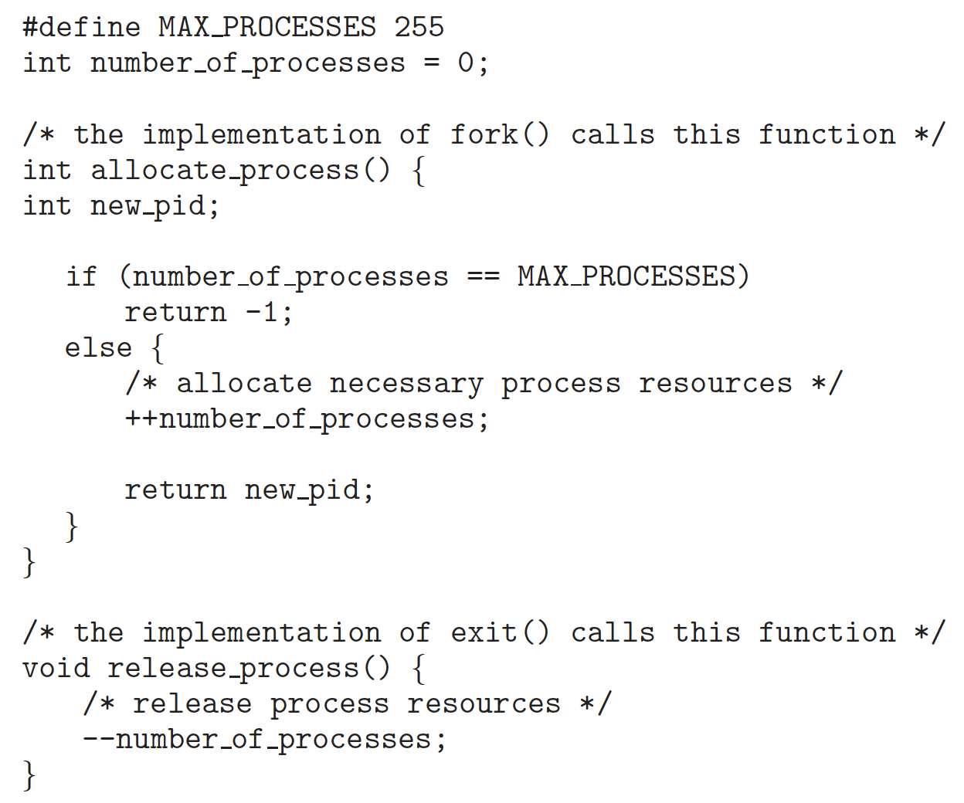

a. Identify the race condition(s).

b. Assume you have a mutex lock named **mutex_lock** with the operations acquire() and release(). Indicate where the locking needs to be placed to prevent the race condition(s).

Answer:

1. When functions are executed two times at the same time(e.g. in two CPU core). For the allocate_process(), they may check the ‘number_of_processes’ at the same time and both comes out that ‘number_of_processes’ is not MAX, although the variable may originally be 254. As a result, there may be 256 processes keeping running with number_of_processes equals to 255.

Also, it is similar in release_process(). As the pid may be allocated incorrectly when the functions’ statements are executed in real time in this order:

++number_of_processes; //allocate_process()

--number_of_processes; //release_process()

Return new_pid; //allocate_process()

1. In both allocate and release functions, the acquire() and release() should be just before and after the statement with the ‘number_of_processes’ variable respectively. Example:

int allocate_process(){

int new_pid;

acquire(&mutex_lock);

if (number_of_processes == MAX_PROCESSES)

return -1;

else{

++number_of_processes;

}

release(&mutex_lock);

return new_pid;

}

void release_process(){

acquire(&mutex_lock);

--number_of_processes;

release(&mutex_lock);

}