HCP Boundary + HCP Vault + Datadog + AWS Load Handling
Complete Step-by-Step Implementation Guide
13 September 2026
This repository contains one implementation only: the deployed session-based autoscaling design for self-managed HCP Boundary workers on AWS.
The design keeps one permanent worker online and uses an AWS Auto Scaling Group (ASG) to launch one temporary Boundary worker when active Boundary sessions reach the scaling threshold. HCP Vault protects the registration and automation credentials. Datadog receives the active-session gauge, evaluates scale-out and scale-in conditions, and changes ASG desired capacity. During scale-in, an Auto Scaling lifecycle hook pauses termination while BoundaryWorkerCleanup removes the temporary worker object from HCP Boundary.
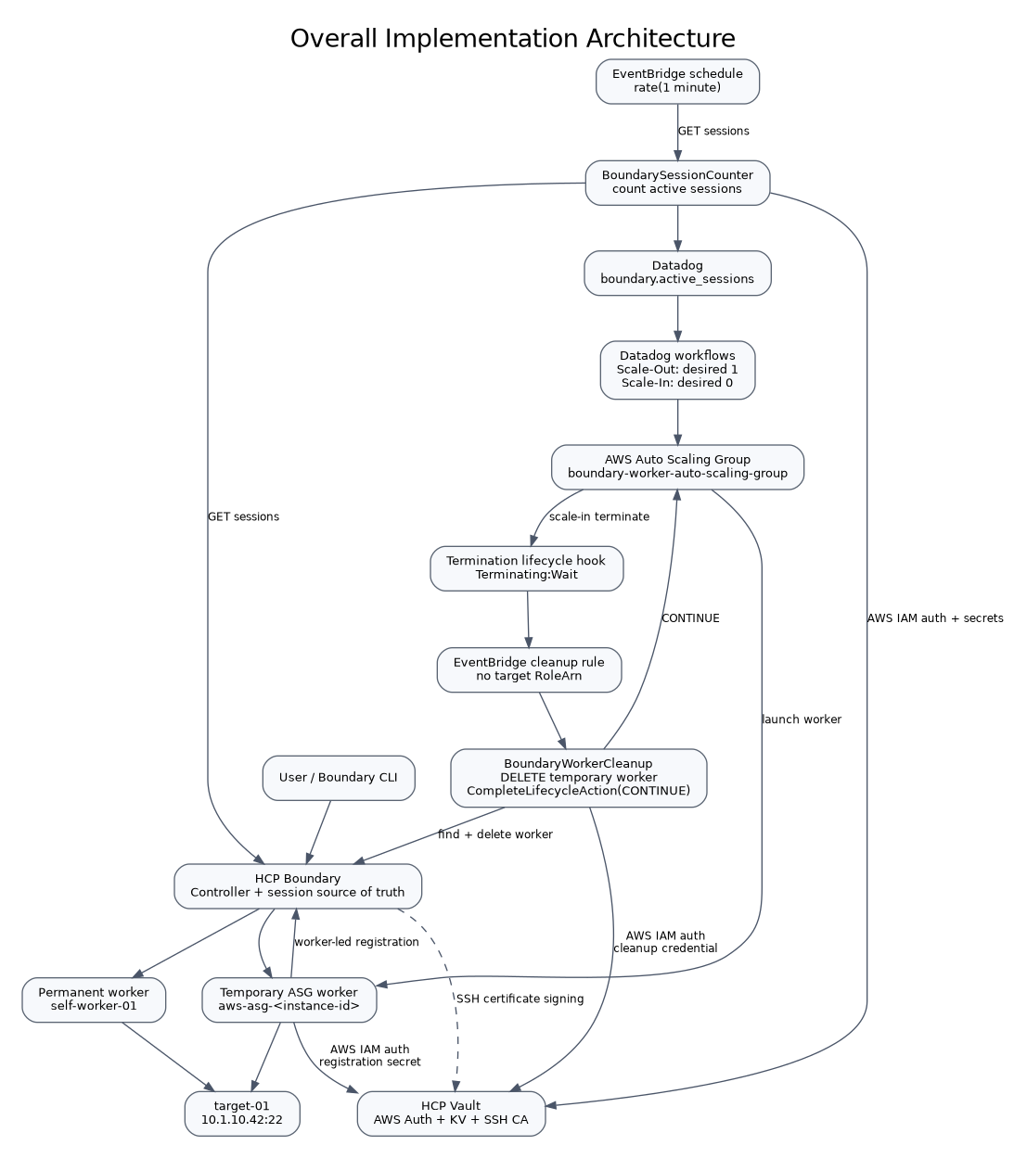

1. Implementation outcome
The completed implementation provides:
- one permanent self-managed Boundary worker: self-worker-01
- one ASG-based temporary Boundary worker named aws-asg-<EC2_INSTANCE_ID>
- automatic session counting every minute
- custom Datadog gauge boundary.active_sessions
- Datadog scale-out when the session metric crosses the threshold (> 9)
- Datadog scale-in when the 3-minute MAX window remains below 10
- ASG desired capacity 1 for scale-out and 0 for scale-in
- worker bootstrap with Vault AWS IAM authentication
- automatic worker-led registration into HCP Boundary
- automatic Boundary worker deletion during EC2 termination
- Vault SSH certificate signing for target access with a 10-minute certificate TTL

2. Environment values
Component | Value
AWS account | 691914216603
AWS region | us-east-1
HCP Boundary cluster ID | 458bfef0-c859-478d-957e-ebbc993caa7f
Boundary address | https://458bfef0-c859-478d-957e-ebbc993caa7f.boundary.hashicorp.cloud
Boundary proxy | 458bfef0-c859-478d-957e-ebbc993caa7f.proxy.boundary.hashicorp.cloud:9202
Boundary org | load-testing (o_TvzIsIEHJU)
Boundary project | load-testing-project (p_ip9YfY89p5)
Boundary target | target-01 (tssh_TKkCKYZerT)
Target address | 10.1.10.42:22
Password auth method | ampw_fAa3Lwqkqy
Permanent worker | self-worker-01
Permanent EC2 | i-0968e4bb274b9dc6b
Permanent worker IP | 10.1.99.241
Permanent Boundary worker ID | w_Y3A2thdNNq
ASG | boundary-worker-auto-scaling-group
ASG Min / Desired / Max | 0 / 0 / 2 normally; workflows set Desired to 1 or 0
Launch template | autoscaling-worker-template
Launch template ID | lt-08f33004ee1394a99
AMI | ami-0b6d9d3d33ba97d99
Instance type | t2.small
Security group | sg-044c3429332bd60ae
ASG EC2 IAM role | BoundaryWorkerRole
Session counter Lambda | BoundarySessionCounter
Session Lambda role | BoundarySessionMonitorLambdaRole
Session schedule rule | boundary-session-counter-every-minute
Datadog metric | boundary.active_sessions
Datadog AWS connection | Boundary-AWS-Scaling
Datadog AWS role | DatadogIntegrationRole
Scale-out workflow | Boundary-Worker-Scale-Out
Scale-in workflow | Boundary-Worker-Scale-In
Cleanup Lambda | BoundaryWorkerCleanup
Cleanup Lambda role | BoundaryWorkerCleanup-role-ro7ij99a
Lifecycle hook | boundary-worker-terminate-cleanup
Cleanup EventBridge rule | boundary-worker-termination-cleanup
Vault address | https://vault-cluster-aws-private-vault-3c87b32f.7274f87b.z1.hashicorp.cloud:8200
Vault namespace | admin
Vault SSH mount | boundary-ssh/
Vault SSH role | boundary-client

3. Traffic and automation architecture
The permanent worker is the baseline capacity. The temporary worker is created by ASG only when required.
User
|
v
HCP Boundary
|
+--> self-worker-01 (permanent)
|
+--> aws-asg-<instance-id> (temporary)
|
v
target-01 : 10.1.10.42:22
The scaling control path is independent from the SSH data path:
EventBridge (every minute)
-> BoundarySessionCounter
-> Boundary API session list
-> count status == active
-> Datadog metric boundary.active_sessions
-> Datadog monitor/workflow
-> DatadogIntegrationRole
-> AWS Auto Scaling SetDesiredCapacity
The termination cleanup path is:
ASG termination
-> lifecycle hook (Terminating:Wait)
-> EventBridge
-> BoundaryWorkerCleanup
-> Vault AWS Auth
-> Boundary login
-> delete aws-asg-<instance-id> worker
-> CompleteLifecycleAction(CONTINUE)
-> EC2 terminates

4. Prerequisites and network requirements
Before configuring autoscaling, confirm these base services exist and are reachable:
- HCP Boundary cluster is running.
- HCP Vault cluster is running with the private endpoint reachable from AWS.
- AWS VPC routing/DNS can resolve and reach the Vault private endpoint on TCP 8200.
- Boundary workers can reach HCP Boundary/proxy services and the target network.
- The ASG worker can reach target-01 on TCP 22.
- Session-counter Lambda can reach:
  - Vault private endpoint on 8200
  - HCP Boundary HTTPS endpoint
  - Datadog HTTPS API
- Cleanup Lambda can reach:
  - Vault private endpoint on 8200
  - HCP Boundary HTTPS endpoint
  - AWS Auto Scaling API
- If Lambda functions run inside private subnets, provide NAT or the required VPC endpoints for public AWS/SaaS APIs.
Validate Vault from an AWS host on the same network path:
export VAULT_ADDR="https://vault-cluster-aws-private-vault-3c87b32f.7274f87b.z1.hashicorp.cloud:8200"
export VAULT_NAMESPACE="admin"
curl -sS -o /dev/null -w '%{http_code}\n' "$VAULT_ADDR/v1/sys/health"
A Vault health status such as 200, 429, 472, or 473 proves that TCP/TLS connectivity reaches Vault; interpret the exact code according to cluster state.

5. Configure HCP Vault SSH certificate signing
This section provides short-lived SSH certificates to Boundary sessions. The certificate TTL is 10 minutes.

5.1 Set Vault environment
export VAULT_ADDR="https://vault-cluster-aws-private-vault-3c87b32f.7274f87b.z1.hashicorp.cloud:8200"
export VAULT_NAMESPACE="admin"
Authenticate with an administrative Vault identity before configuring the engine.

5.2 Enable the SSH secrets engine
vault secrets enable -path=boundary-ssh ssh
Purpose: the boundary-ssh/ mount becomes the dedicated signing service for Boundary SSH user certificates.

5.3 Generate the SSH CA
vault write boundary-ssh/config/ca generate_signing_key=true
Read the CA public key:
vault read -field=public_key boundary-ssh/config/ca
The private CA key remains protected by Vault. Only the public CA key is distributed to SSH targets.

5.4 Create the signing role
vault write boundary-ssh/roles/boundary-client \
key_type=ca \
allow_user_certificates=true \
allowed_users=azureuser \
default_user=azureuser \
ttl=10m \
max_ttl=10m \
not_before_duration=30s
Verify:
vault read boundary-ssh/roles/boundary-client
The role constrains certificates to the azureuser principal and a maximum lifetime of 10 minutes.

5.5 Configure the target to trust the Vault CA
Save the CA public key on target-01, for example:
sudo install -d -m 755 /etc/ssh
sudo nano /etc/ssh/trusted-user-ca-keys.pem
Paste only the public CA key. Then configure OpenSSH:
sudo nano /etc/ssh/sshd_config
Add:
TrustedUserCAKeys /etc/ssh/trusted-user-ca-keys.pem
Validate and restart SSH:
sudo sshd -t
sudo systemctl restart ssh

5.6 Create Vault policies for Boundary credential brokering
vault/boundary-controller.hcl:
path "auth/token/lookup-self" {
capabilities = ["read"]
}
path "auth/token/renew-self" {
capabilities = ["update"]
}
path "auth/token/revoke-self" {
capabilities = ["update"]
}
path "sys/leases/renew" {
capabilities = ["update"]
}
path "sys/leases/revoke" {
capabilities = ["update"]
}
path "sys/capabilities-self" {
capabilities = ["update"]
}
vault/boundary-ssh-policy.hcl:
path "boundary-ssh/sign/boundary-client" {
capabilities = ["create", "update"]
}
Load them:
vault policy write boundary-controller vault/boundary-controller.hcl
vault policy write boundary-ssh-policy vault/boundary-ssh-policy.hcl
Create a renewable periodic orphan token for the Boundary Vault credential store:
vault token create \
-no-default-policy=true \
-policy="boundary-controller" \
-policy="boundary-ssh-policy" \
-orphan=true \
-period=24h \
-renewable=true
Store the returned token securely. Do not commit it.

5.7 Configure the Boundary Vault credential store
In HCP Boundary, open the load-testing-project project and create a Vault credential store using:
- Vault address: https://vault-cluster-aws-private-vault-3c87b32f.7274f87b.z1.hashicorp.cloud:8200
- Namespace: admin
- Token: the periodic token from the previous step
- Worker filter: use the worker tag used for Vault access, e.g. "vault" in "/tags/cred-store"
Create an SSH certificate credential library that signs through:
boundary-ssh/sign/boundary-client
Attach that credential library to target-01 as the application credential source.
Result: Boundary requests a new 10-minute SSH certificate from Vault for a session instead of storing a long-lived SSH private credential.

6. Verify the permanent Boundary worker
The baseline worker is:
Name: self-worker-01
EC2: i-0968e4bb274b9dc6b
Private IP: 10.1.99.241
Worker ID: w_Y3A2thdNNq
From an authenticated Boundary CLI:
boundary workers list \
-scope-id=global \
-format=json \
-token env://BOUNDARY_TOKEN \
| jq -r '.items[] | [.id,.name,.last_status_time] | @tsv'
self-worker-01 must remain healthy regardless of ASG desired capacity. It is outside the Auto Scaling Group.

7. Configure AWS IAM identities
Four IAM identities have distinct responsibilities. Keep them separate.

7.1 BoundaryWorkerRole
This is the EC2 instance profile identity used by temporary ASG workers.
Trust policy: iam/BoundaryWorkerRole-trust.json
{
"Version": "2012-10-17",
"Statement": [
{
"Effect": "Allow",
"Principal": {"Service": "ec2.amazonaws.com"},
"Action": "sts:AssumeRole"
}
]
}
No AWS secret-read permission is required for the current worker bootstrap. Vault authorizes the EC2 role through AWS IAM Auth.
Create or verify an instance profile that contains BoundaryWorkerRole and attach that instance profile in the launch template.

7.2 BoundarySessionMonitorLambdaRole
Trust principal:
lambda.amazonaws.com
Attach:
AWSLambdaBasicExecutionRole
AWSLambdaVPCAccessExecutionRole
This role does not need CloudWatch PutMetricData; the metric is sent directly to Datadog over HTTPS.

7.3 BoundaryWorkerCleanup-role-ro7ij99a
Trust principal:
lambda.amazonaws.com
Attach normal Lambda logging/VPC permissions and the lifecycle permission in:
iam/BoundaryWorkerCleanup-lifecycle-policy.json
It grants only:
autoscaling:CompleteLifecycleAction
for boundary-worker-auto-scaling-group.

7.4 DatadogIntegrationRole
Datadog assumes this role using the Datadog-generated External ID.
Use iam/DatadogIntegrationRole-trust-TEMPLATE.json and replace only:
<DATADOG_AWS_ACCOUNT_ID>
<DATADOG_EXTERNAL_ID>
Do not publish the real External ID.
Attach iam/DatadogIntegrationRolePolicy.json. It grants:
- autoscaling:DescribeAutoScalingGroups on *
- autoscaling:SetDesiredCapacity only on boundary-worker-auto-scaling-group

8. Configure Vault AWS IAM Auth for AWS workloads

8.1 Ensure AWS auth is enabled
vault auth list
If aws/ is not present:
vault auth enable aws

8.2 Ensure KV v2 exists at boundary-registration/
vault secrets list
If it does not exist:
vault secrets enable -path=boundary-registration kv-v2

8.3 Load workload policies
vault policy write boundary-asg-worker vault/boundary-asg-worker.hcl
vault policy write boundary-session-monitor vault/boundary-session-monitor.hcl
vault policy write boundary-worker-cleanup vault/boundary-worker-cleanup.hcl
The policies are intentionally read-only to the specific KV records required by each workload.

8.4 Create Vault AWS Auth roles
Run:
cd vault
./configure-current-vault-roles.sh
Equivalent important mappings are:
boundary-asg-worker
-> arn:aws:iam::691914216603:role/BoundaryWorkerRole
-> policy boundary-asg-worker
boundary-session-monitor-lambda
-> arn:aws:iam::691914216603:role/BoundarySessionMonitorLambdaRole
-> policy boundary-session-monitor
boundary-worker-cleanup
-> arn:aws:iam::691914216603:role/BoundaryWorkerCleanup-role-ro7ij99a
-> policy boundary-worker-cleanup
All three use:
auth_type=iam
ttl=15m
max_ttl=30m
resolve_aws_unique_ids=false

8.5 Store the four KV records
Do not put real values in Git.
ASG registration credential:
vault kv put boundary-registration/asg-worker \
login_name="<BOUNDARY_REGISTRATION_LOGIN>" \
password="<BOUNDARY_REGISTRATION_PASSWORD>"
Session-monitor credential:
vault kv put boundary-registration/session-monitor \
login_name="<BOUNDARY_MONITOR_LOGIN>" \
password="<BOUNDARY_MONITOR_PASSWORD>"
Datadog API key:
vault kv put boundary-registration/datadog-metrics \
api_key="<DATADOG_API_KEY>"
Cleanup credential:
vault kv put boundary-registration/worker-cleanup \
login_name="<BOUNDARY_CLEANUP_LOGIN>" \
password="<BOUNDARY_CLEANUP_PASSWORD>"

8.6 Boundary authorization requirements for these accounts
Use dedicated Boundary users and least privilege:
- Registration identity: must be allowed to create/register the temporary global worker used by worker-led registration.
- Session-monitor identity: must be able to list/read sessions recursively for the scopes being monitored. In this project the monitored scope is global, including the load-testing org and load-testing-project project.
- Cleanup identity: must be able to list/read global workers and delete the matching temporary worker.
Validate each identity functionally before proceeding. Do not give these automation users administrator rights when narrower roles are sufficient.

9. Configure the temporary worker launch template
Launch template:
Name: autoscaling-worker-template
ID: lt-08f33004ee1394a99
AMI: ami-0b6d9d3d33ba97d99
Type: t2.small
IAM instance profile: BoundaryWorkerRole
Security group: sg-044c3429332bd60ae
Set the launch-template user data to the exact file:
implementation/boundary_asg_userdata_vault_no_kms.sh
The user data performs these operations in order:
- installs Boundary Enterprise, Vault CLI, AWS CLI, and jq
- retrieves EC2 instance ID and private IP through IMDSv2
- creates worker name aws-asg-<EC2_INSTANCE_ID>
- writes /etc/boundary.d/worker.hcl
- starts boundary-worker.service
- waits for Boundary worker-led auth_request_token
- authenticates to Vault with AWS IAM using BoundaryWorkerRole
- reads boundary-registration/asg-worker
- authenticates to HCP Boundary
- runs boundary workers create worker-led
- removes bootstrap secrets from the shell environment
The worker configuration uses:
listener "tcp" {
address = "0.0.0.0:9202"
purpose = "proxy"
}
listener "tcp" {
address = "127.0.0.1:9203"
purpose = "ops"
tls_disable = true
}
and tags:
type = ["egress"]
cloud = ["aws"]
pool = ["aws-autoscaling"]
target = ["on-aws"]
cred-store = ["vault"]
After an instance boots, verify:
sudo systemctl status boundary-worker.service --no-pager
sudo journalctl -u boundary-worker.service -n 100 --no-pager
sudo tail -n 200 /var/log/boundary-user-data.log

10. Configure the Auto Scaling Group
ASG:
boundary-worker-auto-scaling-group
Set:
Minimum capacity: 0
Desired capacity: 0
Maximum capacity: 2
Launch template: autoscaling-worker-template
The Datadog workflows in this implementation use only desired capacities 0 and 1; therefore the normal running state is either no temporary worker or one temporary worker.
Verify:
aws autoscaling describe-auto-scaling-groups \
--region us-east-1 \
--auto-scaling-group-names boundary-worker-auto-scaling-group \
--query 'AutoScalingGroups[0].{Min:MinSize,Desired:DesiredCapacity,Max:MaxSize,Instances:Instances[*].[InstanceId,LifecycleState,HealthStatus]}' \
--output json

11. Deploy BoundarySessionCounter
This Lambda converts Boundary session state into the Datadog gauge used for scaling.

11.1 Function settings
Function: BoundarySessionCounter
Runtime: Python 3.12
Role: BoundarySessionMonitorLambdaRole
Source: implementation/BoundarySessionCounter.py
Configure the Lambda in VPC subnets/security groups that can reach the Vault private endpoint and still reach HCP Boundary and Datadog HTTPS endpoints.

11.2 Environment variables
VAULT_ADDR=https://vault-cluster-aws-private-vault-3c87b32f.7274f87b.z1.hashicorp.cloud:8200
VAULT_NAMESPACE=admin
VAULT_AWS_ROLE=boundary-session-monitor-lambda
BOUNDARY_ADDR=https://458bfef0-c859-478d-957e-ebbc993caa7f.boundary.hashicorp.cloud
BOUNDARY_AUTH_METHOD_ID=ampw_fAa3Lwqkqy
BOUNDARY_SCOPE_ID=global
DD_SITE=datadoghq.com
No Boundary password and no Datadog API key is stored in Lambda environment variables.

11.3 Lambda execution logic
The function:
- signs AWS STS GetCallerIdentity
- authenticates to Vault AWS Auth
- reads boundary-registration/session-monitor
- reads boundary-registration/datadog-metrics
- authenticates to Boundary
- calls the sessions API recursively from global scope
- counts only sessions where status == "active"
- posts a Datadog gauge named boundary.active_sessions
- tags/resources the metric as service hcp-boundary
Expected logs:
Vault AWS authentication successful
Boundary monitoring credentials retrieved from Vault
Datadog API key retrieved from Vault
Boundary authentication successful
Active Boundary sessions: <N>
Published Datadog metric: boundary.active_sessions=<N>

12. Configure the one-minute EventBridge schedule
Create the rule:
aws events put-rule \
--name boundary-session-counter-every-minute \
--schedule-expression 'rate(1 minute)' \
--state ENABLED \
--region us-east-1
Add Lambda permission:
events/add-session-counter-lambda-permission.sh
Set the Lambda as the target. Use the real function ARN returned by AWS:
SESSION_COUNTER_ARN=$(aws lambda get-function \
--function-name BoundarySessionCounter \
--region us-east-1 \
--query 'Configuration.FunctionArn' \
--output text)
aws events put-targets \
--rule boundary-session-counter-every-minute \
--region us-east-1 \
--targets "Id=1,Arn=$SESSION_COUNTER_ARN"
Important: the EventBridge target does not require a target IAM role. Lambda invocation is authorized by the Lambda resource-based policy.
Verify:
aws events list-targets-by-rule \
--rule boundary-session-counter-every-minute \
--region us-east-1

13. Verify the Datadog metric
Open:
Datadog -> Metrics -> Explorer
Search:
boundary.active_sessions
Filter/resource:
service:hcp-boundary
Before configuring scaling actions, confirm the metric follows the value returned by:
tests/count-active-sessions.sh
The Lambda is the authoritative collector for this autoscaling signal. Boundary audit-log streaming to Datadog can still be enabled for observability and history, but the scaling monitor uses boundary.active_sessions.

14. Configure Datadog AWS connection
Use the Datadog AWS connection:
Boundary-AWS-Scaling
Configure it to assume:
DatadogIntegrationRole
with the Datadog-generated External ID in the IAM role trust policy.
Verify that Datadog can describe the ASG and perform SetDesiredCapacity only on:
boundary-worker-auto-scaling-group

15. Configure the scale-out monitor and workflow
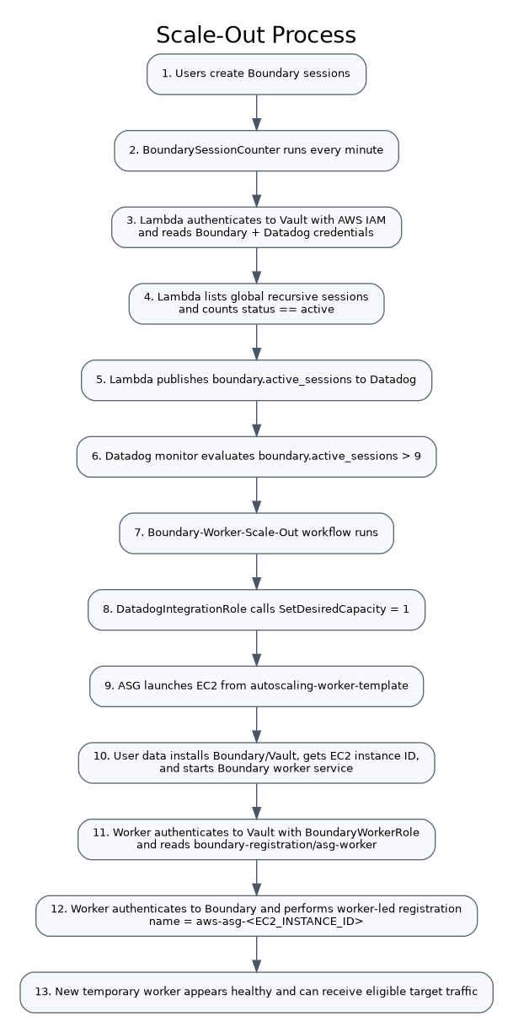

15.1 Monitor condition
Use the boundary.active_sessions metric scoped to service:hcp-boundary.
Threshold semantics:
boundary.active_sessions > 9
This means 10 or more active Boundary sessions enters the scale-out condition.

15.2 Scale-out workflow
Create/use:
Workflow: Boundary-Worker-Scale-Out
Connection: Boundary-AWS-Scaling
Action: AWS Auto Scaling -> Set desired capacity
ASG: boundary-worker-auto-scaling-group
Desired: 1
The workflow should run on the scale-out monitor alert transition.

15.3 What happens after the workflow
- Datadog assumes DatadogIntegrationRole.
- It calls autoscaling:SetDesiredCapacity with 1.
- ASG launches an EC2 instance from autoscaling-worker-template.
- User data creates worker name aws-asg-<instance-id>.
- EC2 authenticates to Vault using BoundaryWorkerRole.
- The worker retrieves the registration credential.
- The worker authenticates to Boundary.
- Worker-led registration creates the temporary Boundary worker.
- The worker appears in the global Boundary Workers page.

16. Configure scale-in lifecycle cleanup
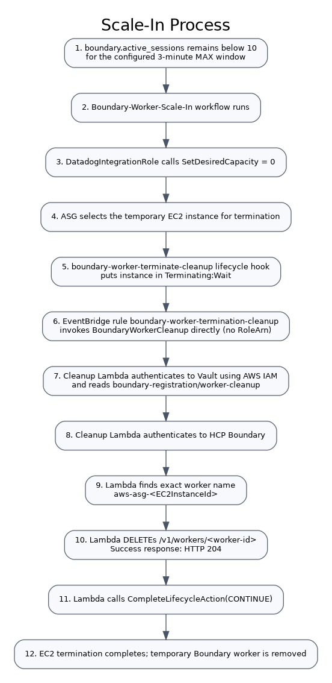

16.1 Create the termination lifecycle hook
aws autoscaling put-lifecycle-hook \
--lifecycle-hook-name boundary-worker-terminate-cleanup \
--auto-scaling-group-name boundary-worker-auto-scaling-group \
--lifecycle-transition autoscaling:EC2_INSTANCE_TERMINATING \
--heartbeat-timeout 120 \
--default-result CONTINUE \
--region us-east-1
Purpose: the instance pauses in Terminating:Wait so the Boundary object can be deleted before EC2 disappears.
Verify:
aws autoscaling describe-lifecycle-hooks \
--auto-scaling-group-name boundary-worker-auto-scaling-group \
--region us-east-1

16.2 Create BoundaryWorkerCleanup
Function: BoundaryWorkerCleanup
Runtime: Python 3.12
Role: BoundaryWorkerCleanup-role-ro7ij99a
Source: implementation/BoundaryWorkerCleanup.py
Environment variables:
VAULT_ADDR=https://vault-cluster-aws-private-vault-3c87b32f.7274f87b.z1.hashicorp.cloud:8200
VAULT_NAMESPACE=admin
VAULT_AWS_ROLE=boundary-worker-cleanup
BOUNDARY_ADDR=https://458bfef0-c859-478d-957e-ebbc993caa7f.boundary.hashicorp.cloud
BOUNDARY_AUTH_METHOD_ID=ampw_fAa3Lwqkqy
The Lambda role must have autoscaling:CompleteLifecycleAction from iam/BoundaryWorkerCleanup-lifecycle-policy.json.

16.3 Cleanup function logic
The cleanup function reads these fields from the Auto Scaling lifecycle event:
EC2InstanceId
AutoScalingGroupName
LifecycleHookName
LifecycleActionToken
It then:
- authenticates to Vault using the Lambda execution-role identity
- reads boundary-registration/worker-cleanup
- authenticates to Boundary
- constructs expected worker name aws-asg-<EC2InstanceId>
- lists global Boundary workers
- finds the exact name match
- sends DELETE /v1/workers/<worker-id>
- treats HTTP 204 as successful deletion
- calls CompleteLifecycleAction(CONTINUE)
If the worker is already absent (404), cleanup treats that as safe and continues.
The function also attempts CONTINUE from its exception handler so the EC2 instance does not remain stuck indefinitely in Terminating:Wait. Therefore always verify CloudWatch logs for a successful Boundary delete during acceptance testing.

17. Configure the cleanup EventBridge rule
Create the EventBridge rule using:
events/boundary-worker-termination-pattern.json
Pattern:
{
"source": ["aws.autoscaling"],
"detail-type": ["EC2 Instance-terminate Lifecycle Action"],
"detail": {
"AutoScalingGroupName": ["boundary-worker-auto-scaling-group"]
}
}
Create the rule:
aws events put-rule \
--name boundary-worker-termination-cleanup \
--event-pattern file://events/boundary-worker-termination-pattern.json \
--state ENABLED \
--region us-east-1
Add Lambda resource-based permission:
events/add-cleanup-lambda-permission.sh
Set the Lambda target with no RoleArn:
CLEANUP_ARN=$(aws lambda get-function \
--function-name BoundaryWorkerCleanup \
--region us-east-1 \
--query 'Configuration.FunctionArn' \
--output text)
aws events put-targets \
--rule boundary-worker-termination-cleanup \
--region us-east-1 \
--targets "Id=1,Arn=$CLEANUP_ARN"
Verify:
aws events list-targets-by-rule \
--rule boundary-worker-termination-cleanup \
--region us-east-1
Required shape:
{
"Id": "1",
"Arn": "arn:aws:lambda:us-east-1:691914216603:function:BoundaryWorkerCleanup"
}
There must be no RoleArn field.

18. Configure the Datadog scale-in monitor and workflow

18.1 Scale-in condition
Evaluate a 3-minute MAX window and scale in only when that window stays below 10.
Semantics:
MAX(boundary.active_sessions over last 3 minutes) < 10
Why MAX: if the metric reaches 10 at any point during the three-minute window, the scale-in condition is not satisfied for the complete window.

18.2 Scale-in workflow
Workflow: Boundary-Worker-Scale-In
Connection: Boundary-AWS-Scaling
Action: AWS Auto Scaling -> Set desired capacity
ASG: boundary-worker-auto-scaling-group
Desired: 0
Once desired capacity becomes zero, the lifecycle-hook/EventBridge/Lambda cleanup path handles worker removal.

19. End-to-end scale-out test

19.1 Authenticate to Boundary
Export your Boundary token securely:
export BOUNDARY_TOKEN='<TOKEN>'
Do not place it in Git history.

19.2 Confirm starting state
tests/count-active-sessions.sh
tests/list-workers.sh
tests/check-asg.sh
Expected ASG desired capacity before the load test:
0

19.3 Start ten sessions
tests/start-10-sessions.sh
The script starts ten SSH connections to:
tssh_TKkCKYZerT
using ssh -N so the connections stay open without interactive shells.

19.4 Confirm the count
tests/count-active-sessions.sh
Expected:
10

19.5 Validate the monitoring path
Check BoundarySessionCounter CloudWatch logs for:
Active Boundary sessions: 10
Published Datadog metric: boundary.active_sessions=10
Then confirm Datadog Metrics Explorer shows approximately 10 for boundary.active_sessions.

19.6 Validate scale-out
Check ASG:
tests/check-asg.sh
Desired capacity should become:
1
Wait for the EC2 instance to reach InService.
Check Boundary:
tests/list-workers.sh
Expected temporary worker name:
aws-asg-i-xxxxxxxxxxxxxxxxx

20. End-to-end scale-in test

20.1 Stop the load sessions
tests/stop-test-sessions.sh

20.2 Confirm the Boundary session count falls below 10
tests/count-active-sessions.sh

20.3 Wait for the 3-minute scale-in condition
Datadog must observe the MAX window below 10 before the scale-in workflow runs.

20.4 Confirm desired capacity changes to zero
tests/check-asg.sh

20.5 Observe termination lifecycle
The temporary instance enters:
Terminating:Wait
Then boundary-worker-termination-cleanup invokes BoundaryWorkerCleanup.

20.6 Check cleanup logs
CloudWatch log group:
/aws/lambda/BoundaryWorkerCleanup
Expected sequence:
Authenticating to Vault using AWS IAM...
Vault AWS authentication successful
Reading Boundary cleanup credentials from Vault...
Boundary cleanup credentials retrieved
Authenticating to HCP Boundary...
Boundary authentication successful
Looking for Boundary worker: aws-asg-i-...
Matching Boundary worker found: aws-asg-i-...
Deleting Boundary worker: w_...
Boundary worker deleted. HTTP status: 204
Completing Auto Scaling lifecycle action...
Lifecycle action completed with CONTINUE

20.7 Confirm final state
tests/list-workers.sh
tests/check-asg.sh
Expected:
- no temporary aws-asg-* worker from the terminated instance
- permanent self-worker-01 still healthy
- ASG desired capacity 0

21. Operational validation commands
Count active sessions:
tests/count-active-sessions.sh
List workers:
tests/list-workers.sh
Check ASG:
tests/check-asg.sh
Verify cleanup EventBridge target:
tests/check-cleanup-event-target.sh
Inspect ASG worker bootstrap:
sudo tail -f /var/log/boundary-user-data.log
Inspect Boundary worker service:
sudo journalctl -u boundary-worker.service -f
Check worker service status:
sudo systemctl status boundary-worker.service --no-pager

22. Troubleshooting by failure point

Session metric does not change
Check BoundarySessionCounter logs first.
Expected stages:
Vault AWS auth
-> Vault secrets read
-> Boundary login
-> session API
-> Datadog metric POST
If Vault authentication fails, verify the Vault AWS Auth role principal matches:
arn:aws:iam::691914216603:role/BoundarySessionMonitorLambdaRole
If Boundary login fails, verify boundary-registration/session-monitor and the Boundary auth method ID.
If Datadog publishing fails, verify the API key in boundary-registration/datadog-metrics, DD_SITE, and outbound HTTPS connectivity.

ASG does not scale out
Confirm:
- Datadog metric is >= 10.
- Scale-out monitor enters alert.
- Workflow Boundary-Worker-Scale-Out executes.
- AWS connection is Boundary-AWS-Scaling.
- DatadogIntegrationRole trust has the correct Datadog account and External ID.
- DatadogIntegrationRolePolicy can set desired capacity on the exact ASG ARN.

EC2 launches but Boundary worker does not appear
On the new instance:
sudo tail -n 300 /var/log/boundary-user-data.log
sudo journalctl -u boundary-worker.service -n 200 --no-pager
aws sts get-caller-identity
Then verify Vault role:
vault read auth/aws/role/boundary-asg-worker
The bound IAM principal must be:
arn:aws:iam::691914216603:role/BoundaryWorkerRole

EC2 terminates but Boundary worker remains
Inspect /aws/lambda/BoundaryWorkerCleanup and determine the exact last successful step.
Also verify the EventBridge target:
tests/check-cleanup-event-target.sh
The target must have the Lambda ARN and no RoleArn.
Confirm the Lambda function policy:
aws lambda get-policy \
--function-name BoundaryWorkerCleanup \
--region us-east-1
Confirm Vault cleanup role:
vault read auth/aws/role/boundary-worker-cleanup
The bound principal must be:
arn:aws:iam::691914216603:role/BoundaryWorkerCleanup-role-ro7ij99a
If DELETE returns 403, verify the Boundary cleanup user can list/read/delete workers globally.

23. Security requirements
Never commit or log:
- Boundary tokens
- Boundary passwords
- Vault tokens
- Datadog API/App keys
- Datadog External ID
- AWS access keys
- Boundary worker auth request tokens
Use Vault for all automation credentials. Keep the GitHub repository private because the implementation contains infrastructure identifiers, IP addressing, ARNs, and architecture details.
The least-privilege separation is:
BoundaryWorkerRole
-> EC2 identity for Vault worker-registration secret
BoundarySessionMonitorLambdaRole
-> Lambda identity for Vault session-monitor + Datadog key
BoundaryWorkerCleanup-role-ro7ij99a
-> Lambda identity for Vault cleanup secret
-> CompleteLifecycleAction on the Boundary ASG
DatadogIntegrationRole
-> Describe ASGs
-> SetDesiredCapacity only for the Boundary ASG

24. Acceptance checklist
The implementation is complete when all items below pass:
- ☐ self-worker-01 is healthy.
- ☐ Vault private endpoint is reachable from workers and Lambdas.
- ☐ Vault SSH CA signs 10-minute user certificates.
- ☐ boundary-registration secrets exist and are readable only by their intended Vault AWS roles.
- ☐ BoundarySessionCounter runs every minute.
- ☐ boundary.active_sessions appears in Datadog.
- ☐ At 10 active sessions, the scale-out monitor triggers.
- ☐ Datadog sets ASG desired capacity to 1.
- ☐ New worker registers as aws-asg-<EC2_INSTANCE_ID>.
- ☐ When the 3-minute MAX window remains below 10, scale-in triggers.
- ☐ Datadog sets ASG desired capacity to 0.
- ☐ Lifecycle hook places the EC2 instance in Terminating:Wait.
- ☐ EventBridge invokes BoundaryWorkerCleanup without a target RoleArn.
- ☐ Cleanup Lambda finds the exact temporary worker.
- ☐ Boundary DELETE returns HTTP 204.
- ☐ Lifecycle action completes with CONTINUE.
- ☐ EC2 termination completes.
- ☐ Permanent worker remains available.

25. Repository layout
boundary-vault-datadog-current-implementation/
├── README.md
├── GITHUB_PUSH.md
├── .gitignore
├── .env.example
├── implementation/
│ ├── BoundarySessionCounter.py
│ ├── BoundaryWorkerCleanup.py
│ └── boundary_asg_userdata_vault_no_kms.sh
├── iam/
│ ├── BoundaryWorkerRole-trust.json
│ ├── LambdaExecutionRole-trust.json
│ ├── DatadogIntegrationRole-trust-TEMPLATE.json
│ ├── DatadogIntegrationRolePolicy.json
│ └── BoundaryWorkerCleanup-lifecycle-policy.json
├── vault/
│ ├── boundary-asg-worker.hcl
│ ├── boundary-session-monitor.hcl
│ ├── boundary-worker-cleanup.hcl
│ ├── boundary-controller.hcl
│ ├── boundary-ssh-policy.hcl
│ └── configure-current-vault-roles.sh
├── events/
│ ├── boundary-worker-termination-pattern.json
│ ├── add-session-counter-lambda-permission.sh
│ ├── add-cleanup-lambda-permission.sh
│ └── reset-cleanup-target-no-role.sh
├── tests/
│ ├── start-10-sessions.sh
│ ├── stop-test-sessions.sh
│ ├── count-active-sessions.sh
│ ├── list-workers.sh
│ ├── check-asg.sh
│ └── check-cleanup-event-target.sh
├── diagrams/
│ ├── overall.png
│ ├── scale-out.png
│ └── scale-in.png
└── docs/
└── Boundary_Vault_Datadog_Current_Implementation.docx
The implementation files in this repository are intended to be used together as one deployment design.

