12.3.19

https://stackoverflow.com/questions/6101956/generating-a-random-password-in-php/6101969

**PHP: Get Values of Multiple Checked Checkboxes**

<https://www.formget.com/php-checkbox/>

<https://www.w3schools.com/php/func_math_rand.asp>

# How to Store Array in MySQL with PHP

<https://makitweb.com/how-to-store-array-in-mysql-with-php/>

# [Php multi-dimensional array from mysql result](https://stackoverflow.com/questions/5053857/php-multi-dimensional-array-from-mysql-result)

<https://stackoverflow.com/questions/5053857/php-multi-dimensional-array-from-mysql-result>

# PHP Multidimensional Arrays

<https://www.studytonight.com/php/multidimensional-arrays>

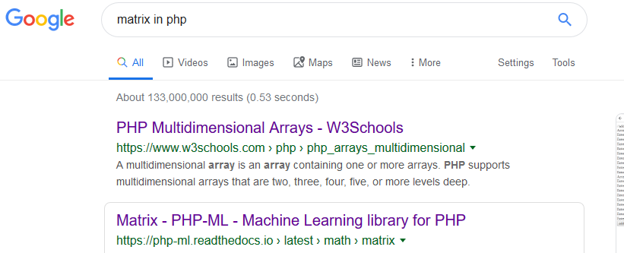

2nd day

# Checklist-model

# [AngularJS](http://angularjs.org/) directive for list of checkboxes

<https://vitalets.github.io/checklist-model/>

4th day

# The Basics of Passing Values From JavaScript to PHP and Back

<https://www.coderslexicon.com/the-basics-of-passing-values-from-javascript-to-php-and-back/>

# [How do I pass JavaScript variables to PHP?](https://stackoverflow.com/questions/1917576/how-do-i-pass-javascript-variables-to-php)

<https://stackoverflow.com/questions/1917576/how-do-i-pass-javascript-variables-to-php>

# [How to save user input into a variable in html and js](https://stackoverflow.com/questions/17433557/how-to-save-user-input-into-a-variable-in-html-and-js)

<https://stackoverflow.com/questions/17433557/how-to-save-user-input-into-a-variable-in-html-and-js/54037203>

# [Passing multiple parameter to PHP from Javascript](https://stackoverflow.com/questions/1600360/passing-multiple-parameter-to-php-from-javascript)

<https://stackoverflow.com/questions/1600360/passing-multiple-parameter-to-php-from-javascript>

<https://www.c-sharpcorner.com/UploadFile/16154c/how-to-insert-multiple-checkbox-value-in-one-column-in-datab/>

java Servlet

<https://www.javaguides.net/2019/03/jsp-servlet-jdbc-mysql-crud-example-tutorial.html>

git remote add origin https://github.com/zinmyoswe/[PassLogic-Authentication](https://github.com/zinmyoswe/PassLogic-Authentication).git

git remote add origin https://github.com/zinmyoswe/PassLogic-with-PHP-and-JS.git

<https://www.youtube.com/watch?v=McaG-w35w1A>

# Update Multiple Checkboxes Using PHP MySql - Tutorial

<https://www.youtube.com/watch?v=W4yUghe09BI>

# 

# [How to Get the multiple radio buttons values in PHP which having names dynamically](https://stackoverflow.com/questions/34013583/how-to-get-the-multiple-radio-buttons-values-in-php-which-having-names-dynamical)

<https://stackoverflow.com/questions/34013583/how-to-get-the-multiple-radio-buttons-values-in-php-which-having-names-dynamical/34013674#34013674>

# How to Insert Data using PHP Ajax

<https://www.studentstutorial.com/ajax/insert-data>

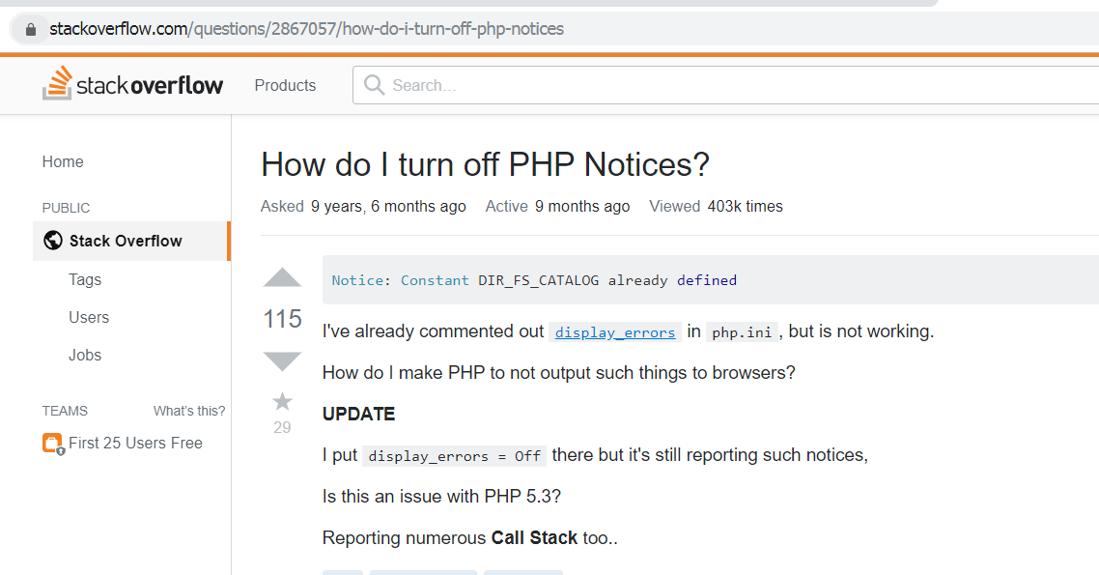

# [How do I turn off PHP Notices?](https://stackoverflow.com/questions/2867057/how-do-i-turn-off-php-notices)

<https://stackoverflow.com/questions/2867057/how-do-i-turn-off-php-notices>