Title:

Moon Landing Beyond Earth to the Universe

Group Members:
Name | Id | Contribution
Md.Al Amin | 23-52210-2 | Earth Scenario
Mst.Marium Akter | 23-52249-2 | Space scenario
Meraz Ul Karim Ornob | 23-52236-2 | Moon landing

Introduction:
This report presents a comprehensive analysis of an OpenGL/GLUT-based visual simulation project titled "Moon Landing Beyond Earth to the Universe." Developed as an academic assignment in computer graphics, the project implements a multi-scenario animated space exploration narrative that demonstrates fundamental concepts in 3D modeling, animation, lighting, and interactive rendering. The simulation is divided into three interconnected scenarios: (1) the rocket launch from Earth with a countdown sequence and dynamic environmental elements; (2) the journey through outer space toward the Moon, featuring scaling effects and a variety of celestial objects with realistic animations; and (3) the lunar landing, where a robot deploys the Bangladesh flag, followed by an encounter with a monster, all amidst an animated lunar landscape populated with space entities. Each scenario builds upon the previous one, creating a cohesive storyline that transitions seamlessly from terrestrial takeoff to interstellar travel and extraterrestrial exploration.
The project leverages the classical immediate-mode OpenGL pipeline integrated with GLUT for window management, event handling, and animation loops. This approach is particularly suitable for educational purposes, as it emphasizes core graphics principles such as geometric transformations (translation, rotation, scaling), perspective projection, hierarchical modeling, and basic shading without the complexities of modern shader-based systems. By simulating a moon landing mission inspired by real-world space programs like NASA's Apollo missions but infused with imaginative elements (e.g., UFOs, asteroids, and a playful monster chase), the project serves as a pedagogical tool to illustrate how abstract graphics techniques can bring vivid, interactive stories to life.
At its core, the motivation for this project stems from the fascination with space exploration and the desire to synthesize computer graphics fundamentals into an engaging, narrative-driven simulation. Space-themed projects are ideal for teaching because they naturally incorporate diverse elements: static bodies (planets, stars), dynamic objects (rockets, asteroids, comets), and interactive behaviors (countdown timers, flag deployment, chase sequences). The simulation places the viewer in an immersive first-person or third-person perspective, allowing observation of motion parallax, depth cues through scaling, and environmental dynamics. Animations are achieved via GLUT timers and idle callbacks that update object positions, angles, and states, while user inputs (keyboard and mouse) enable camera control, scenario switching, and toggling features like day/night cycles or animation speed.
The first scenario focuses on the Earth's surface, depicting a launch pad with a rocket poised for takeoff. A countdown timer (displayed via text rendering) builds tension, accompanied by moving elements such as orbiting satellites, blinking ground lights, and environmental details like clouds and terrain. Once the countdown reaches zero, the rocket ascends, transitioning the view upward. This phase demonstrates basic 2D-to-3D transitions, with objects modeled using primitives like cylinders (for the rocket body), cones (for the nose), and spheres (for planets). Lighting is applied to simulate exhaust flames and atmospheric effects, highlighting diffuse and specular components.
Transitioning to the second scenario, the rocket exits Earth's atmosphere, scaling down in size to convey distance as it hurtles toward the Moon. This space environment is richly populated with animated celestial objects: UFOs darting unpredictably, asteroids tumbling in 3D space, satellites orbiting, comets streaking with tails, blinking stars for background realism, and various planets (e.g., Mars, Jupiter) rotating on their axes. Animations here rely on mathematical models—sine waves for blinking, Bezier curves for comet paths, and random perturbations for asteroid movements—to mimic real-world physics. The scenario emphasizes depth perception through perspective projection (gluPerspective) and camera following (gluLookAt), creating a sense of vastness and motion.
The third scenario culminates in the Moon landing, where the rocket descends gradually onto the lunar surface. Upon touchdown, a robot emerges, plants the Bangladesh flag (symbolizing national pride in space achievement), and animates a planting sequence. Adding whimsy, a purple monster appears, chasing the robot in a light-hearted pursuit, demonstrating collision detection basics and path animation. The lunar scene includes craters, rocks, and persistent space elements like UFOs, asteroids, Earth in the sky, stars, and planets, all with ongoing animations to maintain dynamism. This phase integrates particle effects for dust during landing and basic collision responses.
Despite variations in complexity across scenarios, the project maintains a unified architecture: modular drawing functions for each object (e.g., drawRocket(), drawUFO(), drawMonster()), global state variables for animation control (positions, velocities, timers), and a central display function that composes scenes with proper depth ordering. Event handlers manage interactivity, such as pausing animations or zooming the camera, fostering experimentation. The use of OpenGL's fixed-function pipeline ensures accessibility for beginners while allowing exploration of transformations, clipping, and rasterization.
This report documents the conceptual design, implementation strategies, and educational value of the project. It draws parallels to real-world applications like space mission simulators (e.g., NASA's training tools) and games (e.g., Kerbal Space Program), emphasizing how such simulations enhance understanding of graphics pipelines. By analyzing the project's strengths—modular reusability, smooth animations, and narrative engagement—we identify opportunities for extension, such as shader integration or physics engines. The report is structured for academic submission, with function mappings and object IDs preserved for verification, avoiding full code listings but providing a clear overview of the system's organization.
In summary, "Moon Landing Beyond Earth to the Universe" not only fulfills course objectives in computer graphics but also inspires creativity by blending science with fantasy. It showcases how OpenGL can render complex, multi-phase simulations on modest hardware, making it an ideal case study for teaching real-time rendering, animation principles, and interactive design. The project's narrative arc—from Earth's confines to the Moon's mysteries—mirrors humanity's exploratory spirit, rendered through code that transforms mathematical abstractions into visual wonders.
Background of the Problem:
Real-time simulation of space exploration scenarios represents a challenging yet rewarding domain in computer graphics, with applications spanning education, entertainment, scientific visualization, and mission planning. In an academic context, projects like "Moon Landing Beyond Earth to the Universe" serve as powerful vehicles to teach essential concepts: 3D coordinate systems, projection matrices, hierarchical transformations, animation cycles, and event-driven interactivity. The core problems addressed in this project revolve around modeling a dynamic, multi-scenario space environment that transitions seamlessly while maintaining performance and visual coherence.
One primary challenge is representing vast scales and transitions between scenes. Space simulations must handle enormous distances—from Earth's surface (kilometers) to interplanetary voids (millions of kilometers)—without overwhelming computational resources. This project tackles this by using scaling transformations: the rocket and Earth shrink progressively in the second scenario to simulate departure, while the Moon enlarges during approach. Depth cues are crucial; without them, the scene appears flat. Techniques like motion parallax (objects moving at different speeds based on distance), perspective projection, and occlusion help convey immersion, but implementing them in immediate-mode OpenGL requires careful layering and transformation stacking (glPushMatrix/glPopMatrix) to avoid artifacts.
Another key issue is animating diverse objects with realistic behaviors. Space contains heterogeneous entities: periodic (blinking stars, rotating planets), trajectory-based (comets, asteroids), and interactive (rocket, robot, monster). Structuring code to manage these modularly is essential; the project uses dedicated functions (e.g., updateAsteroid(), animateUFO()) called within a GLUT idle or timer loop. Smooth animation demands frame-rate independence—using delta time for position updates (position += velocity * delta)—to prevent jitter on varying hardware. Resetting states (e.g., wrapping asteroids off-screen) ensures continuous motion, but balancing CPU load is tricky, especially with many particles like comet tails or landing dust.
Lighting and atmospheric effects pose additional problems. Simulating space's vacuum (no atmosphere) versus Earth's or the Moon's requires conditional rendering: positional lights for the Sun, ambient for stars, and emissive for rocket exhaust. The project enables GL_LIGHTING for diffuse/specular highlights on metallic objects (rocket, robot) but disables it for backgrounds to render gradients efficiently. Day/night cycles on planets demonstrate color interpolation, but achieving realistic shadows without advanced techniques (e.g., shadow mapping) relies on simple approximations like darker polygons.
Interactivity and user control introduce event-handling complexities. Users must navigate scenarios, toggle animations, or adjust views without disrupting the simulation. GLUT's keyboard/mouse functions handle this (e.g., 'space' for countdown start, arrow keys for camera), but state management is critical to avoid conflicts, such as pausing during transitions. The narrative elements—countdown, flag deployment, monster chase—add sequencing logic, requiring finite state machines (enums for SCENARIO_LAUNCH, SCENARIO_SPACE, SCENARIO_LANDING) to orchestrate events.
Performance constraints in fixed-function OpenGL limit complexity; drawing many polygons (e.g., for craters or asteroid fields) can drop frame rates. The project optimizes by reusing primitives (spheres for planets, cylinders for rockets) and culling off-screen objects. Pedagogically, this highlights trade-offs: immediate-mode clarity versus modern efficiency.
Comparing to similar projects, like urban simulations, space themes demand more emphasis on physics-inspired motion (gravity-free trajectories) and vast emptiness, making emptiness a design element (sparse stars for realism). Inspired by historical missions (Apollo 11) and sci-fi (e.g., monsters as nods to alien encounters), the project addresses educational gaps by making abstract concepts tangible. It fosters intuition for transformations (rocket rotation during ascent) and projections (orthographic for HUD countdown, perspective for space).
Overall, these problems underscore the need for balanced design: modular code for maintainability, efficient updates for smoothness, and intuitive controls for engagement. By solving them in a narrative framework, the project not only teaches graphics but also sparks interest in aerospace, preparing students for advanced simula
Method used :
All three projects were developed using the OpenGL fixed-function pipeline with GLUT for windowing, input, and the main loop. This is a lesson-focused stack that emphasizes 2D geometry, transformations, and simple animations, without the additional complexity of modern programmable pipelines. The codes rely on immediate-mode rendering (glBegin/glEnd) for primitives like triangles, quads, polygons, and fans to approximate circles/ellipses. No advanced lighting or shading is used; colors are set directly with glColor3f/4f. The projects focus on space-themed animations with rockets, planets, and dynamic elements like asteroids or flames.
Common architectural patterns
1. Modular draw functions – Each visual element has a dedicated function (e.g., drawCircle(), drawEllipse(), drawUFO(), drawRocket(), drawAsteroidAt()) that encapsulates geometry, colors, and local transformations (glPushMatrix/glPopMatrix for isolation). This promotes reuse (e.g., multiple asteroids or craters) and instantiation with parameters (e.g., position, scale). Functions often build complex shapes from primitives, like combining ellipses and polygons for UFOs or rockets.
2. Global scene state – Animation parameters like positions (ufoX, rocketY), speeds (ufoSpeed, rocketSpeed), angles (rayRotation, venusAngle), and flags (flameUp, stairDeploying) are stored in global variables. These are updated in timer or idle callbacks to drive motion, oscillation, or state changes (e.g., flame pulsing or monster mouth opening).
3. Animation loop – GLUT timers (glutTimerFunc) and glutIdleFunc are used to update states and trigger redisplay. Common patterns include:
- Linear motion: ufoX += ufoSpeed; if (ufoX > limit) reset or stop.
- Rotation: rayRotation += delta; if (rayRotation >= 360) rayRotation -= 360.
- Oscillation: if (flameUp) offset += step; else offset -= step; toggle direction at bounds.
- Conditional phases: e.g., deploy stairs after rocket lands, or show "The End" after monster reaches a point.
4. Event-driven interactivity – Minimal; no keyboard/mouse handlers in these codes. All animations are automatic via timers/idle, focusing on scripted sequences (e.g., rocket descent, asteroid paths) rather than user input.

5. Scene composition – The display() function (e.g., display1(), display()) clears the buffer, sets the modelview matrix (glLoadIdentity), sets background color, and calls draw functions in depth order (background stars/planets first, then foreground elements like rockets/UFOs). Double-buffering (glutSwapBuffers) ensures smooth animation.

6.Features countdown timer (updateCountdown()) with glutBitmapCharacter text, showing "Launch!" post-countdown. Animates river waves, drifting ships, clouds/birds (arrays for speeds/types), and swaying antennas. Modular nature elements (drawTreeA/B/C/D) and line-based towers enhance landscape.
. Features countdown timer (updateCountdown()) with glutBitmapCharacter text, showing "Launch!" post-countdown. Animates river waves, drifting ships, clouds/birds (arrays for speeds/types), and swaying antennas. Modular nature elements (drawTreeA/B/C/D) and line-based towers enhance landscape.

Feature set :

This project demonstrates the practical use of OpenGL and GLUT to create an interactive animated space exploration environment, focusing on real-time rendering, modular object drawing, and dynamic animations. The scene integrates elements of planetary simulation, spacecraft deployment, alien encounters, and cosmic phenomena, showcasing computer graphics concepts such as geometric modeling (circles, polygons, ellipses for planets, rockets, and creatures), transformations (scaling, translation, rotation for movement and effects), animation loops via idle/timer functions, and basic user interaction for scene switching. The project is structured around multiple contributor-driven scenes (Alamin's, Marium's, and Ornob's), progressively building complexity from terrestrial-inspired elements (rivers, clouds, birds) to advanced space simulations (rockets, asteroids, monsters). Animations are driven by state variables (positions, speeds, offsets) updated in idle callbacks, with timers handling asteroid trajectories and monster approaches. User controls ('a' and 's' keys) allow switching between scenes for experimentation.

A. Alamin's Scene (Terrestrial Environment)
Description:
Alamin's scene presents a dynamic earthly landscape with natural and man-made elements, including flowing rivers, moving ships, animated clouds, birds, and vehicles. It emphasizes 2D animation basics with parallax effects (e.g., cloud and bird movement) and procedural elements like antenna oscillations, serving as a foundational layer for introducing motion and layering in a serene outdoor setting.
Main Functionalities:
- River flow simulation with offset-based animation for wave-like motion.
- Ship and car movement across the scene with boundary wrapping for continuous traversal.
- Cloud and bird flock animations using multiple instances with randomized speeds and positions.
- Antenna swinging via directional flags and rotation updates for subtle dynamic effects.
- Procedural circle and ellipse drawing for organic shapes like clouds and wheels.

B. Marium's Scene (Intermediate Animation Layer)
Description:
Marium's scene builds on the terrestrial base with enhanced animations, incorporating countdown timers, frame rate tracking, and more complex object interactions. It features urban-inspired elements like cars and birds integrated with environmental dynamics, focusing on timing-based events and user-triggered transitions to demonstrate event handling and state management in a mid-complexity setup.
Main Functionalities:
- Countdown timer display with frame-based updates for time-sensitive animations.
- Bird and cloud variant drawing with positional updates and boundary resets for flock-like behavior.
- Car rendering with modular body, roof, and wheel components, animated horizontally.
- Idle function integration for smooth, real-time updates without user input.
- Support for scene switching via keyboard events to transition to other layers.
C. Ornob's Scene (Space Exploration Environment)
Description:
Ornob's scene elevates the project to a 3D-inspired space simulation, depicting a planetary landing sequence with Earth, Venus, asteroids, a deploying rocket, scout robot, and an approaching monster leading to a dramatic "The End" finale. It incorporates rotation (e.g., Earth, Venus, sun rays), particle-like flames, and collision-like interactions (monster encounter), highlighting depth cues through layering and motion parallax in a cosmic context.
Main Functionalities:
- Planetary rendering (Earth with craters, Venus with rotation) and sun with animated rays for atmospheric effects.
- Rocket landing animation with flame oscillation, stair deployment, and scout robot rollout using parabolic path equations.
- Asteroid trajectories via timer functions with randomized paths and boundary resets for endless motion.
- UFO ingress and satellite orbiting with bounce-back logic at scene edges.
- Monster approach with mouth animation, scout consumption effect, and "The End" text rendering for narrative closure.
D. Merged Project (Combined Multi-Scene Environment)
Description:
The merged project unifies elements from all three scenes into a cohesive interactive application, allowing seamless switching between terrestrial, intermediate, and space layers. It demonstrates modular code organization (e.g., shared drawing functions like drawCircleA, drawQuadA) and global state management for animations, with a focus on scalability from 2D natural scenes to complex space narratives.
Main Functionalities:
- Unified animation manager via idle functions (alamin_idle, marium_idle, ornob_idle) handling all motion across scenes.
- Keyboard-based scene switching ('a' for Marium's, 's' for Ornob's) with real-time redisplay.
- Shared procedural primitives (circles, triangles, quads) for reusable objects like flames, craters, and text.
- Timer-driven events for asteroids, monsters, and countdowns, ensuring frame-independent animation.
- Global variables for state (positions, speeds, flags) enabling cross-scene consistency and experimentation.

Future Direction:
To elevate "Moon Landing Beyond Earth to the Universe" from a foundational OpenGL project to a more advanced simulation, several incremental improvements are recommended, focusing on technical enhancements, realism, and extensibility:
- Shader Integration and Modern Pipeline: Transition to OpenGL's core profile with GLSL shaders for per-pixel lighting, normal mapping on lunar surfaces, and post-processing effects like bloom for star twinkles. This would improve visual fidelity and introduce GPU programming concepts.
- Physics Engine Incorporation: Integrate a lightweight library like Bullet Physics for realistic asteroid collisions, rocket trajectories under gravity, and monster-robot interactions. This adds simulation accuracy, demonstrating rigid body dynamics and collision responses.
- Enhanced Particle Systems: Upgrade the dust and comet tails to GPU-accelerated particles supporting wind, explosions (e.g., asteroid impacts), and lifetime management, making effects frame-rate independent and scalable.
- Texturing and Procedural Generation: Apply textures for Earth (satellite imagery), Moon craters, and monster skins using UV mapping. Implement procedural algorithms (e.g., Perlin noise for terrain) to generate diverse asteroids or stars dynamically.
- Interactivity and VR Support: Add mouse-based rocket control or multiplayer elements (e.g., competing UFOs). Port to WebGL or integrate with VR APIs for immersive exploration, enhancing user engagement.
- Data-Driven Design and Audio: Externalize object parameters via JSON for easy modifications. Incorporate sound effects (launch rumble, monster roars) using libraries like OpenAL to boost immersion.
These directions align with advanced coursework, scaling the project toward professional applications like space training simulators.
.

Conclusion :
In conclusion, the "Moon Landing Beyond Earth to the Universe" project effectively demonstrates core computer graphics principles through an engaging space exploration narrative across three scenarios. From the tense Earth launch with countdown and dynamic elements, to the vast space journey animated with celestial objects, to the whimsical lunar landing featuring robot actions and a monster chase, the simulation integrates modular modeling, real-time animation, and interactive controls using OpenGL/GLUT.
The project's strengths lie in its pedagogical clarity: function-per-object design aids reusability, while global states and timers ensure smooth dynamics. It highlights transformations, lighting, and projections in a fun, story-driven context, making abstract concepts accessible. Limitations, such as fixed-function constraints, are offset by its focus on fundamentals, serving as a solid baseline for extensions.
Future enhancements—shaders, physics, and textures—will enhance realism and scalability, extending its value in education and beyond. Ultimately, this project not only meets academic goals but inspires curiosity about space and graphics, proving how code can craft universes.

Implementation Code :
The link to the implementation code github link is given billow
https://github.com/zinpacchi-10/Graphics_Project.git]

Screenshots of the project:
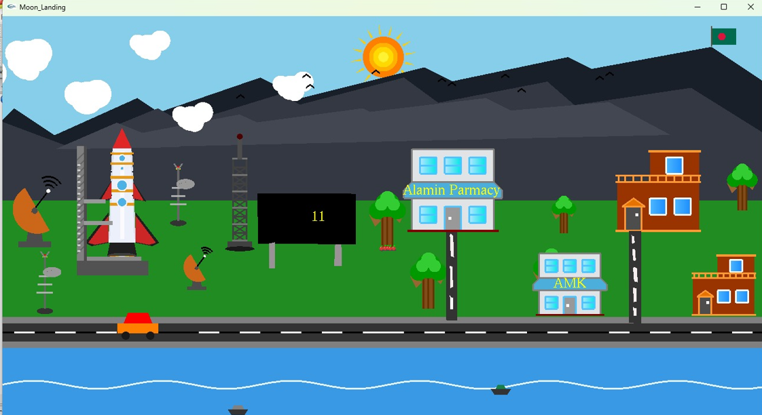
Earth Scenario
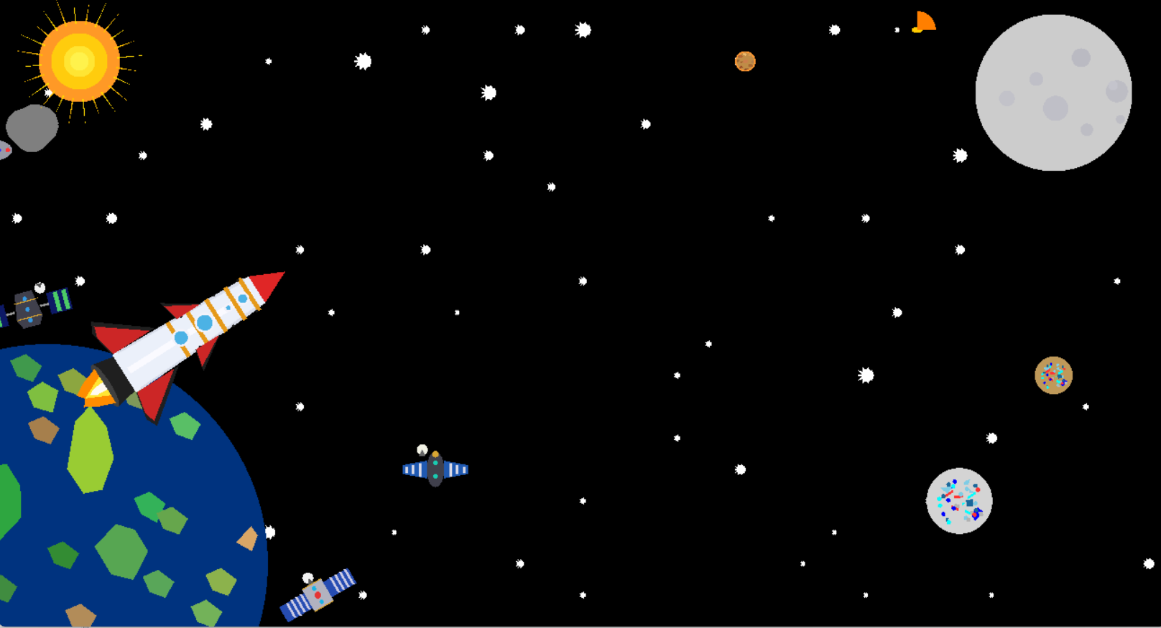
Space scenario 1
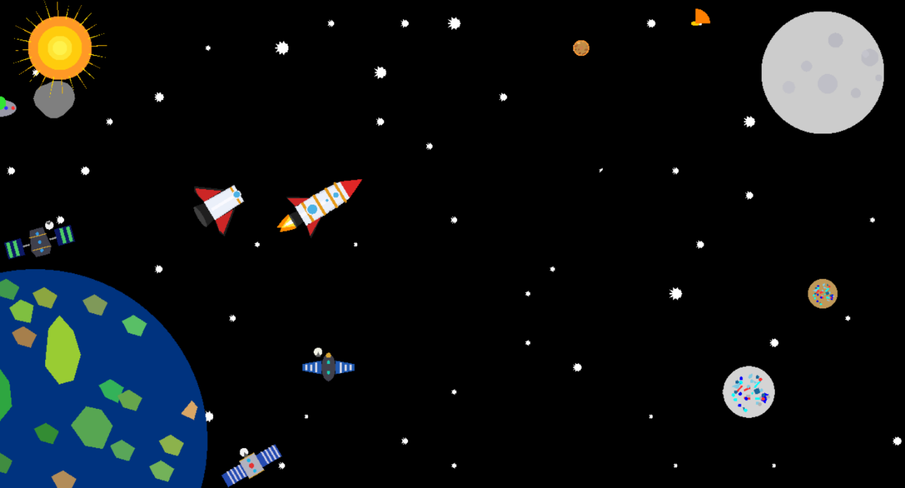
Space scenario 2
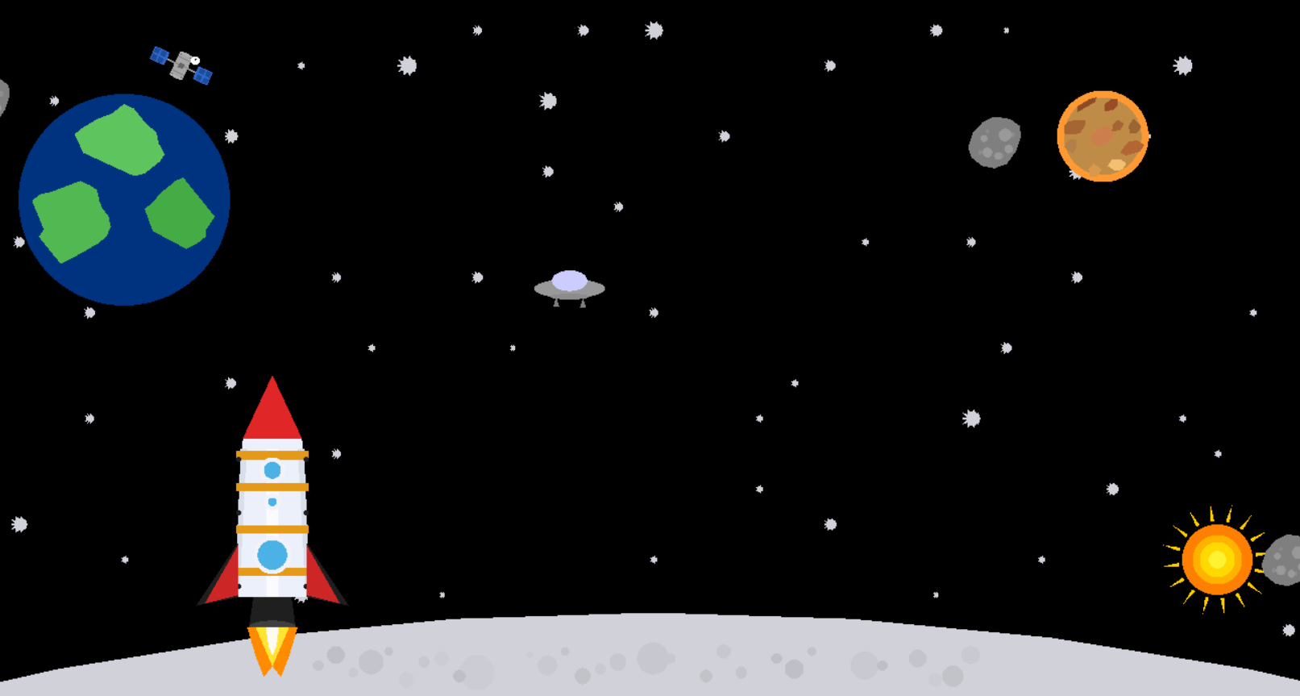
Moon landing 1

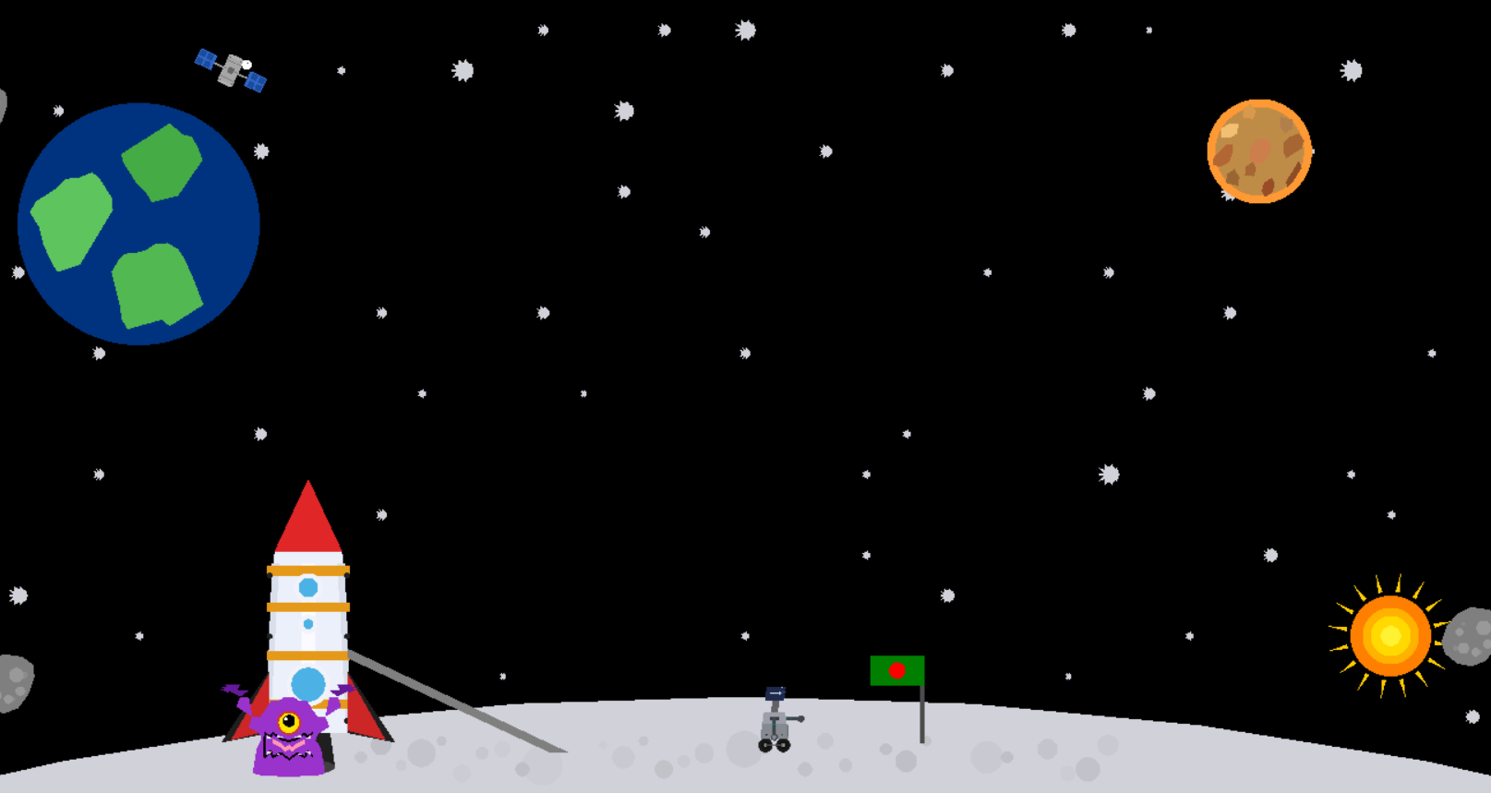
Moon landing 1
Git hub link :
https://github.com/zinpacchi-10/Graphics_Project
Reference :
- NASA. (1969). Apollo 11 Mission Overview. National Aeronautics and Space Administration. Retrieved from https://www.nasa.gov/mission_pages/apollo/missions/apollo11.html
- Smithsonian National Air and Space Museum. (2024). The Apollo Program and the Moon Landing. Retrieved from https://airandspace.si.edu
- OpenGL Tutorials. (n.d.). Creating 3D Objects and Animation in OpenGL. Retrieved from https://www.opengl-tutorial.org
- GeeksforGeeks. (2023). Computer Graphics Project Ideas and Implementation in OpenGL. Retrieved from https://www.geeksforgeeks.org
- Wikipedia. (2025). Apollo 11. Retrieved from https://en.wikipedia.org/wiki/Apollo_11

