Final Course Layout: Storytelling in the Classroom

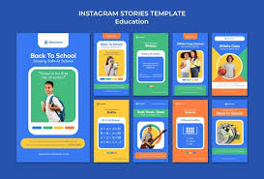

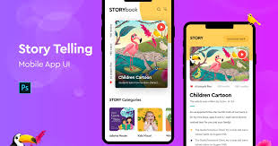

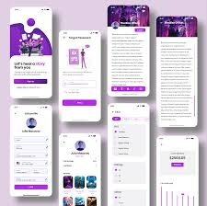

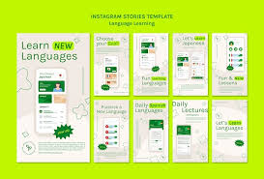

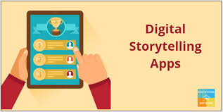

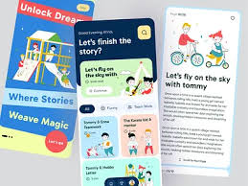

Page 1: Introduction & Course Framework
- Course Title: Storytelling in the Classroom
- Introduction: Narrative as the native language of learning.
- Mission: Restore storytelling as a central teaching strategy.
- Vision: Empower educators to teach through story.
- Objectives:
  - Apply storytelling to enhance conceptual teaching.
  - Build critical thinking and communication.
  - Integrate storytelling into abstract subjects.
  - Use indigenous and contemporary stories for transformation.

Page 2: Module 1 & Module 2

Module 1: Thinking Through Stories
- Section A: Critical Thinking through Storytelling
- Section B: Using Riddles to Enhance Thinking

Module 2: Communicating Through Stories
- Section A: Listening and Speaking Skills
- Section B: Nonverbal Communication through Story Rituals

Page 3: Module 3

Module 3: Storytelling and Mathematical Thinking
- Section A: Analytic Thinking Through Narrative Structure Humans are natural storytellers; even math problems begin with a story.
- Section B: Number Sense Through Narrative
- Section C: Geometry, Patterns & Logical Sequencing

Page 4: Module 4 & Lecturer’s Notes

Module 4: Discovering Meaning Through Stories
- Section A: Latent Thinking & Hidden Meaning
- Section B: Imagination and Creative Reasoning
- Section C: Moral Reasoning and Ethical Dilemmas

Lecturer’s Notes
- Theoretical frameworks
- Facilitator tips
- Bonus materials
- Assessment ideas

Promotional Summary for Zintsomi App & Others
Course Title: Storytelling in the Classroom Format: 4 modules + Lecturer’s Notes | App-ready | Classroom-tested
Summary: This course reimagines education through the lens of storytelling. From critical thinking to mathematics, it shows how narrative structure enhances learning, engagement, and emotional intelligence. Rooted in indigenous wisdom and modern pedagogy, it equips educators to teach with creativity, clarity, and cultural relevance.
Promotional Description: Unlock the power of story in your classroom. Storytelling in the Classroom is a dynamic, 4-module course designed for educators who want to transform abstract subjects into meaningful experiences. Whether you're teaching critical thinking, communication, or mathematics, this course offers practical tools, rich narratives, and a philosophy of learning that resonates. Available now on Zintsomi and other educational platforms. join the movement!

Visual Resources & App Mockups
To support the rollout, here are visual references and app mockups that align with the course’s aesthetic and purpose:
- Education App PSD, High Quality Free PSD Templates for Download | Freepik — clean, professional app interface
- Story Telling Mobile App, UX and UI Kits ft. education app & app presentation - Envato — storytelling-focused UI design
- storifier- Story telling app | Figma — interactive storytelling app concept
- 8 Best Storytelling Apps - EducationalAppStore — curated list of storytelling apps for inspiration
- Story App designs, themes, templates and downloadable graphic elements on Dribbble — design inspiration for app branding

