College of Information Technology
S.Y 2026-2027
CC101: INTRODUCTION TO COMPUTING

Name: FAJARDO, KELLY A.
Course/Yr.&Blk: BSIT- 1A

Prelim Laboratory Examination: Creating a Personal Resume Using HTML and CSS
(100 points)
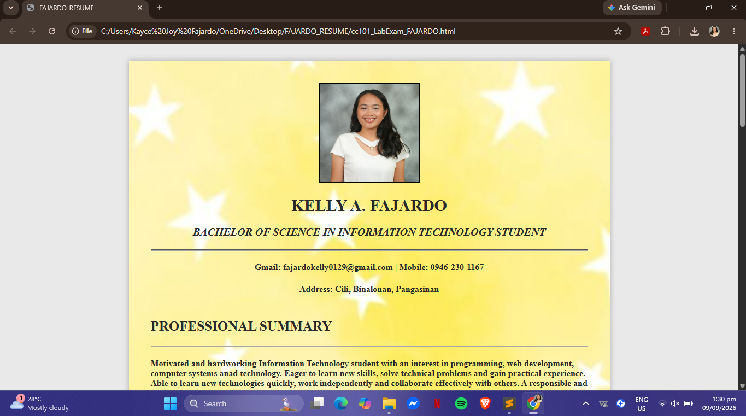

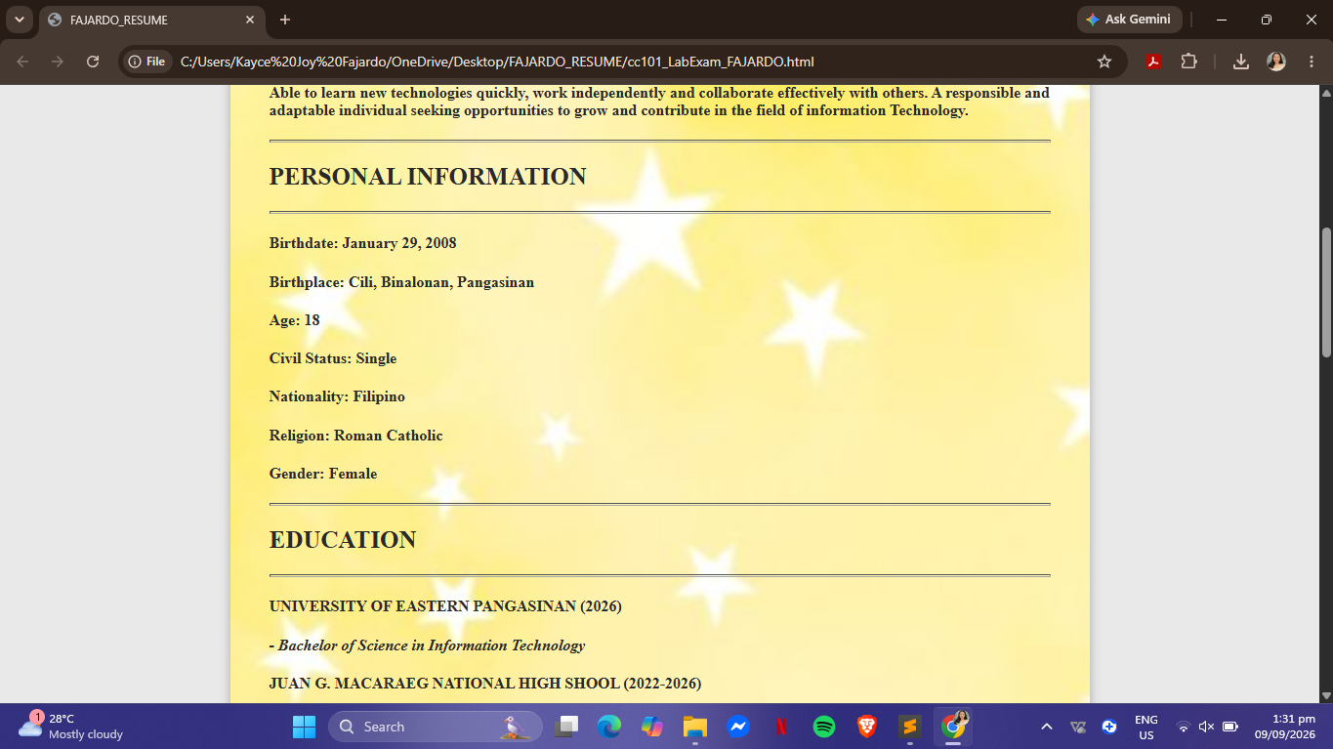

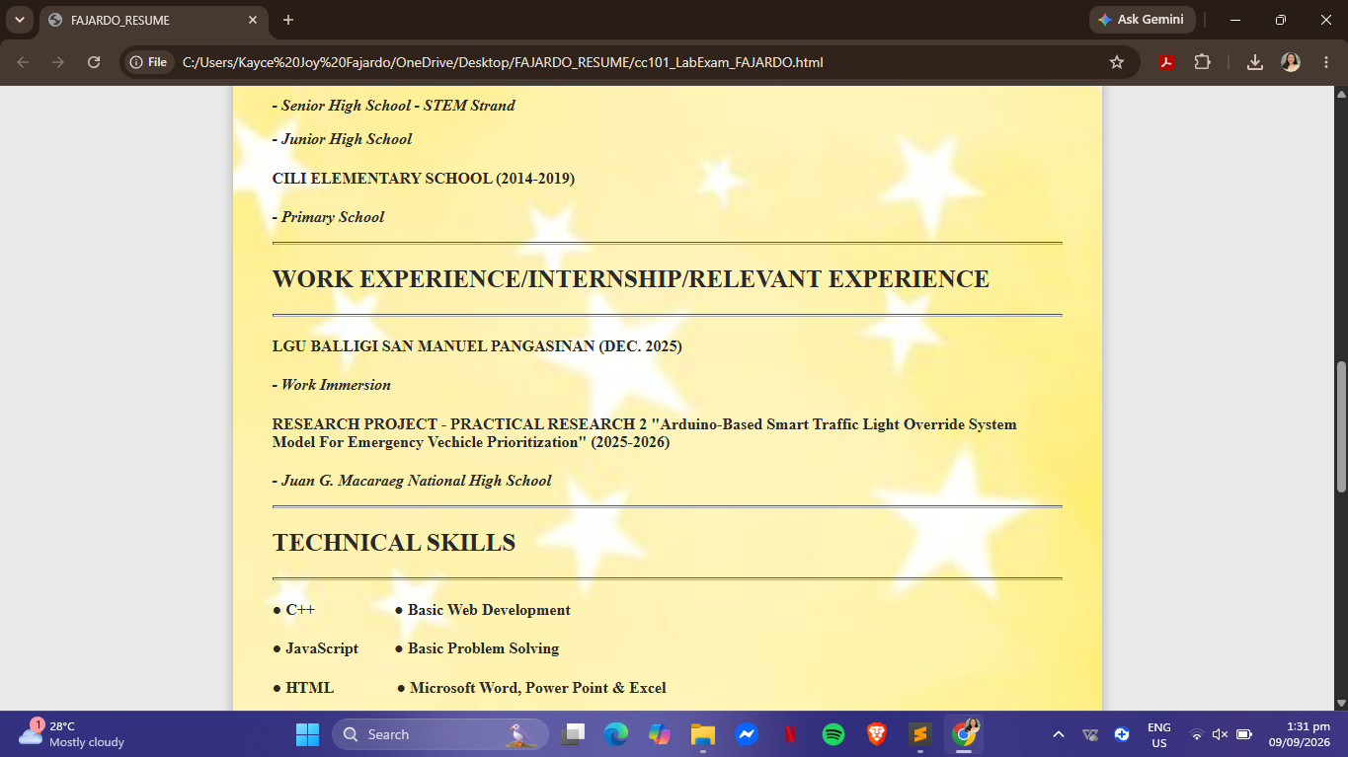

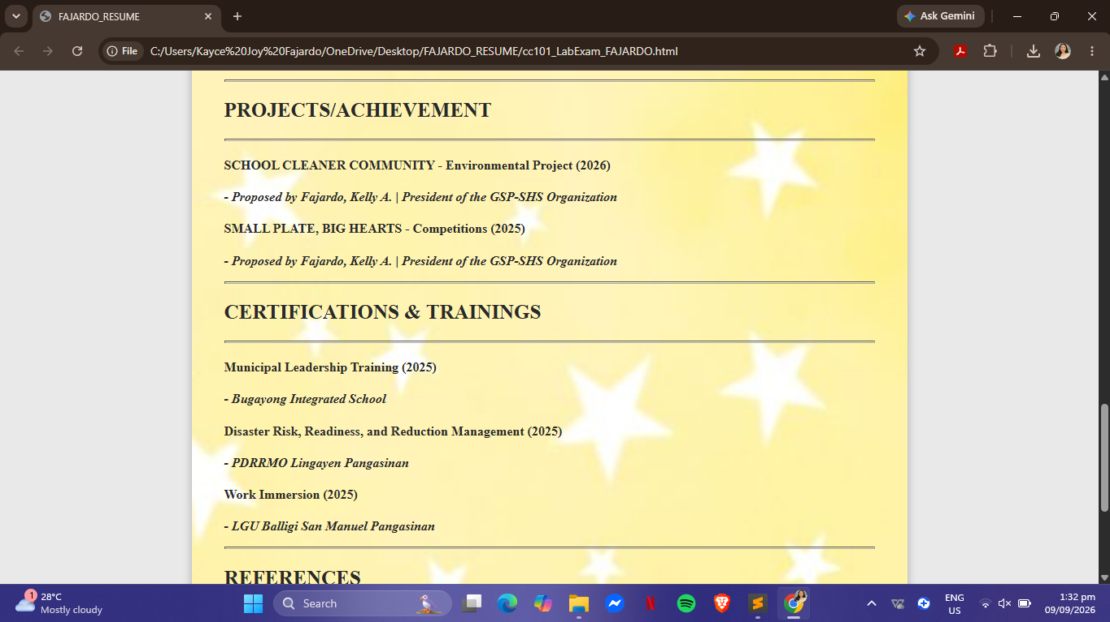

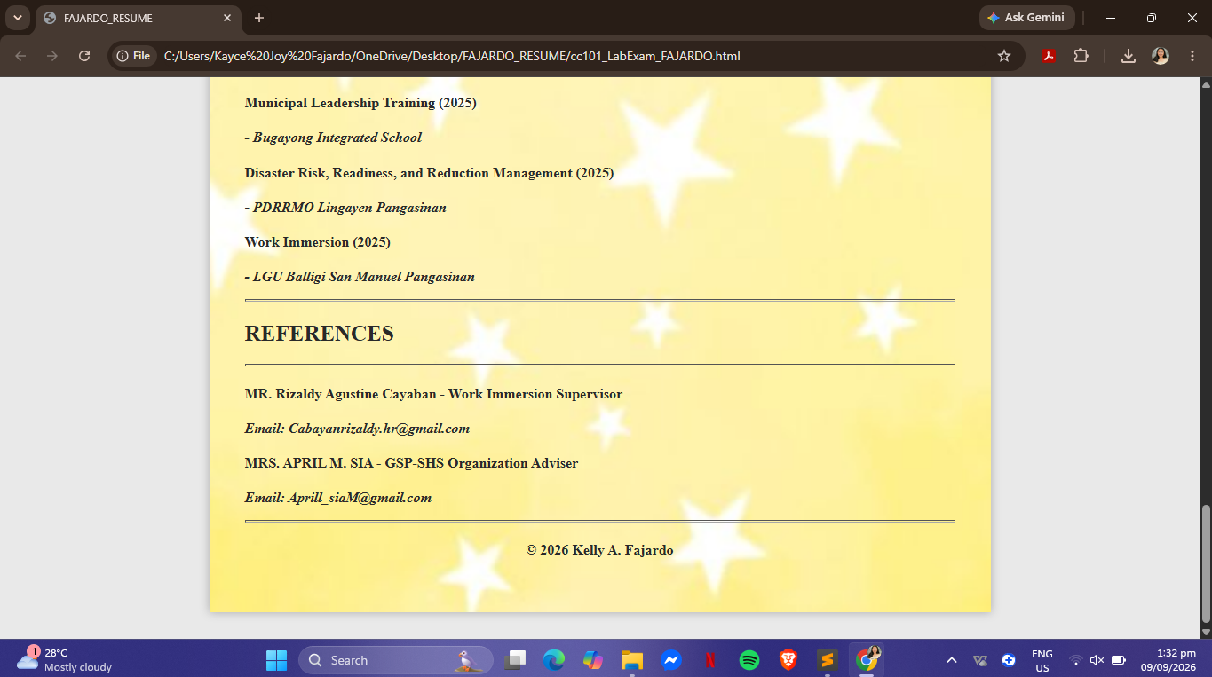

HTML CODE

<!DOCTYPE html>
<html>
<head>
<meta charset="utf-8">
<meta name="viewport" content="width=device-width, initial-scale=1">
<title>FAJARDO_RESUME</title>
<link rel="stylesheet" href="style.css">

<div class="resume" style="background-image: url('elyang.jpg');
background-size: cover;
background-position: center;">
<center>
<img src="kelya.jpg" style="border: 2px solid black; display: margin: auto; width: 180px" width="180px" height="180px"; alt="Profile Picture" ></center>
<div class="header">
<div class="info">
<center>
<h1>KELLY A. FAJARDO</h1>
<h3>BACHELOR OF SCIENCE IN INFORMATION TECHNOLOGY STUDENT</h3>
</center>
<hr>
<center>
<h4><b>Gmail:</b> fajardokelly0129@gmail.com <b>|</b><b> Mobile:</b> 0946-230-1167<b></b><h4>
<h4><b>Address: </b> Cili, Binalonan, Pangasinan<h4>

</div>

<hr>

</head>

<body>

<h2>PROFESSIONAL SUMMARY</h2>
<hr>
<h4>
Motivated and hardworking Information Technology student with an interest in programming, web development, computer systems and technology. Eager to learn new skills, solve technical problems and gain practical experience. Able to learn new technologies quickly, work independently and collaborate effectively with others. A responsible and adaptable individual seeking opportunities to grow and contribute in the field of information Technology.<h4>

<hr>

<h2>PERSONAL INFORMATION</h2>
<hr>
<h4><b>Birthdate: </b>January 29, 2008<h4>
<h4><b>Birthplace: </b> Cili, Binalonan, Pangasinan<h4>
<h4><b>Age: </b>18<h4>
<h4><b>Civil Status: </b>Single<h4>
<h4><b>Nationality: </b>Filipino<h4>
<h4><b>Religion: </b>Roman Catholic<h4>
<h4><b>Gender: </b>Female<h4>
</hr>

<hr>

<h2>EDUCATION</h2>
<hr>
<h4><b>UNIVERSITY OF EASTERN PANGASINAN </b>(2026)<h4>
<p>- Bachelor of Science in Information Technology</p>

<h4><b>JUAN G. MACARAEG NATIONAL HIGH SHOOL </b>(2022-2026)<h4>
<p>- Senior High School - STEM Strand</p>
<p>- Junior High School</p>

<h4><b>CILI ELEMENTARY SCHOOL </b>(2014-2019)<h4>
<p>- Primary School</p>

</hr>

<hr>

<h2>WORK EXPERIENCE/INTERNSHIP/RELEVANT EXPERIENCE</h2>

<hr>
<h4><b>LGU BALLIGI SAN MANUEL PANGASINAN</b> (DEC. 2025)<h4>
<p>- Work Immersion </P>
<h4><b>RESEARCH PROJECT - PRACTICAL RESEARCH 2 "Arduino-Based Smart Traffic Light Override System Model For Emergency Vechicle Prioritization"</b> (2025-2026)<h4>
<p>- Juan G. Macaraeg National High School</p>

<hr>

<h2>TECHNICAL SKILLS</h2>

<hr>
<h4><b>●</b> C++ <b> &nbsp;&nbsp;&nbsp;&nbsp;&nbsp;&nbsp;&nbsp;&nbsp;&nbsp;&nbsp;&nbsp;&nbsp;&nbsp;&nbsp;&nbsp;&nbsp;&nbsp;&nbsp; </b><b>●</b> Basic Web Development
<h4><b>●</b> JavaScript <b> &nbsp;&nbsp;&nbsp;&nbsp;&nbsp;&nbsp;&nbsp; </b><b>●</b> Basic Problem Solving
<h4><b>●</b> HTML <b> &nbsp;&nbsp;&nbsp;&nbsp;&nbsp;&nbsp;&nbsp;&nbsp;&nbsp;&nbsp;&nbsp;&nbsp;&nbsp;&nbsp; </b><b>●</b> Microsoft Word, Power Point & Excel
<hr>

<h2>PROJECTS/ACHIEVEMENT</h2>
<hr>
<h4><b>SCHOOL CLEANER COMMUNITY - Environmental Project</b> (2026)<h4>
<p>- Proposed by Fajardo, Kelly A. | President of the GSP-SHS Organization</p>
<h4><b>SMALL PLATE, BIG HEARTS - Competitions</b> (2025)<h4>
<p>- Proposed by Fajardo, Kelly A. | President of the GSP-SHS Organization</p>

<hr>

<h2>CERTIFICATIONS & TRAININGS</h2>

<hr>
<h4><b>Municipal Leadership Training</b> (2025)<h4>
<p>- Bugayong Integrated School</p>
<h4><b>Disaster Risk, Readiness, and Reduction Management</b> (2025)<h4>
<p>- PDRRMO Lingayen Pangasinan</p>
<h4><b>Work Immersion</b> (2025)<h4>
<p>- LGU Balligi San Manuel Pangasinan</p>

<hr>

<h2>REFERENCES</h2>

<hr>
<h4><b>MR. Rizaldy Agustine Cayaban </b> - Work Immersion Supervisor<h4>
<p>Email: Cabayanrizaldy.hr@gmail.com</p>
<h4><b>MRS. APRIL M. SIA </b> - GSP-SHS Organization Adviser<h4>
<p>Email: Aprill_siaM@gmail.com</p>

<hr>

<center>
<footer>

<h4>
© 2026 Kelly A. Fajardo
<h4>

</footer>
</center>

</body>
</html>

CSS CODE

body {

font-family: "Times new roman", sans-serif;
background: #e9e9e9;
color: #292929;
padding: 30px;
margin: 0;
}
.resume {
width: 800px;
margin: auto;
padding: 40px;

background-image: url("elyang.jpg");
background-size: cover;
background-position: center;
background-repeat: no-repeat;
box-shadow: 0 0 10px #aaa;
}
hr{
color: black;
font-size: 30px;
height: 1px;
border-color: black;

}
h1{
text-align: center;
font-size: 30px;

}
h2{
font-size: 25px;
font-style: Arial;

}
h3{
text-align: center;
font-size: 20px;
font-style: italic;
}
h4{
font-style: Arial;
font-size: normal;
font-weight: 30px;
}
p{
text-align: justify;
font-style: italic;
font-weight: 20px;
}

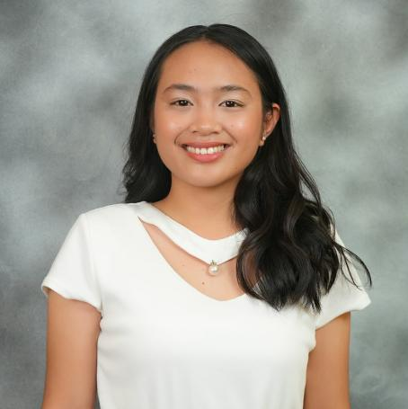
IMG_kelya.jpg

IMG_elyang.jpg



