College of Information Technology
S.Y 2026-2027
CC101: INTRODUCTION TO COMPUTING

Name: CAOILE, ANGELA MAE R.
Course/Yr.&Blk: BSIT 1-A

Prelim Laboratory Examination: Creating a Personal Resume Using HTML and CSS
(100 points)
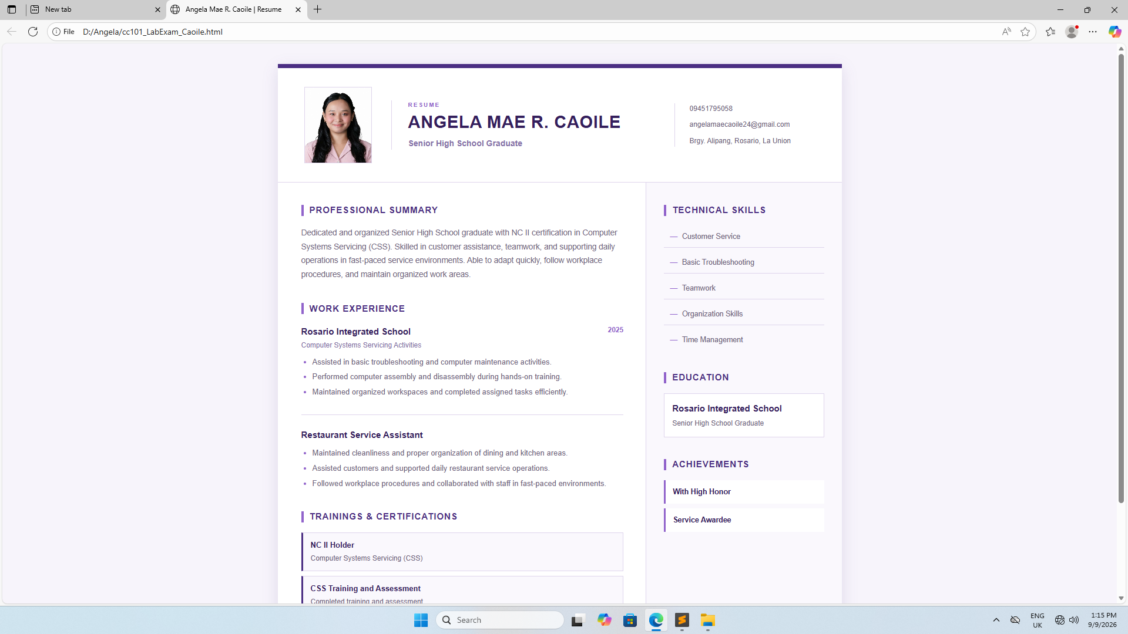

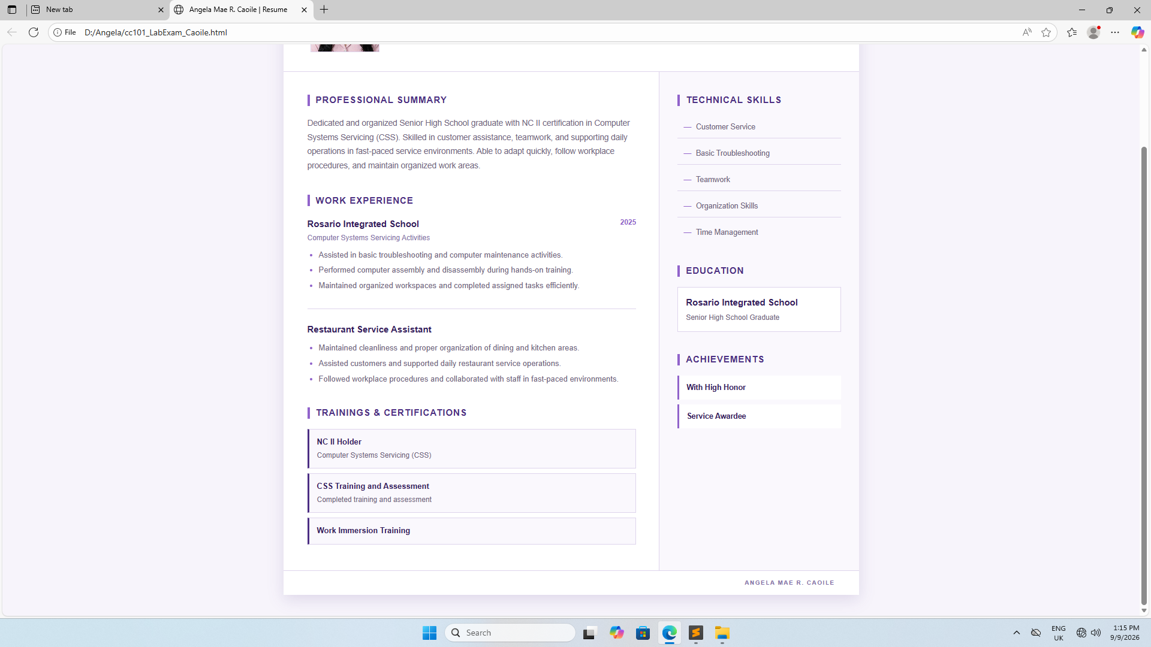



profile.jpg

HTML:
<!DOCTYPE html>
<html lang="en">
<head>
<meta charset="UTF-8">
<meta name="viewport" content="width=device-width, initial-scale=1.0">
<title>Angela Mae R. Caoile | Resume</title>
<link rel="stylesheet" href="style.css">
</head>
<body>

<div class="resume">

<header class="header">
<div class="photo-wrap">
<img src="profile.jpg" alt="Angela Mae R. Caoile" class="profile">
</div>

<div class="identity">
<p class="eyebrow">RESUME</p>
<h1>ANGELA MAE R. CAOILE</h1>
<p class="title">Senior High School Graduate</p>
</div>

<div class="contact">
<p>09451795058</p>
<p>angelamaecaoile24@gmail.com</p>
<p>Brgy. Alipang, Rosario, La Union</p>
</div>
</header>

<div class="body">

<main>
<section>
<h2>Professional Summary</h2>
<p>
Dedicated and organized Senior High School graduate with NC II certification
in Computer Systems Servicing (CSS). Skilled in customer assistance, teamwork,
and supporting daily operations in fast-paced service environments. Able to
adapt quickly, follow workplace procedures, and maintain organized work areas.
</p>
</section>

<section>
<h2>Work Experience</h2>

<article class="job">
<div class="job-top">
<div>
<h3>Rosario Integrated School</h3>
<p class="role">Computer Systems Servicing Activities</p>
</div>
<span class="date">2025</span>
</div>

<ul>
<li>Assisted in basic troubleshooting and computer maintenance activities.</li>
<li>Performed computer assembly and disassembly during hands-on training.</li>
<li>Maintained organized workspaces and completed assigned tasks efficiently.</li>
</ul>
</article>

<article class="job">
<div class="job-top">
<div>
<h3>Restaurant Service Assistant</h3>
</div>
</div>

<ul>
<li>Maintained cleanliness and proper organization of dining and kitchen areas.</li>
<li>Assisted customers and supported daily restaurant service operations.</li>
<li>Followed workplace procedures and collaborated with staff in fast-paced environments.</li>
</ul>
</article>
</section>

<section>
<h2>Trainings &amp; Certifications</h2>

<div class="certification">
<strong>NC II Holder</strong>
<span>Computer Systems Servicing (CSS)</span>
</div>

<div class="certification">
<strong>CSS Training and Assessment</strong>
<span>Completed training and assessment</span>
</div>

<div class="certification">
<strong>Work Immersion Training</strong>
</div>
</section>
</main>

<aside>

<section>
<h2>Technical Skills</h2>
<ul class="skills">
<li>Customer Service</li>
<li>Basic Troubleshooting</li>
<li>Teamwork</li>
<li>Organization Skills</li>
<li>Time Management</li>
</ul>
</section>

<section>
<h2>Education</h2>
<div class="education">
<h3>Rosario Integrated School</h3>
<p>Senior High School Graduate</p>
</div>
</section>

<section>
<h2>Achievements</h2>
<ul class="achievements">
<li>With High Honor</li>
<li>Service Awardee</li>
</ul>
</section>

</aside>

</div>

<footer>
ANGELA MAE R. CAOILE
</footer>

</div>

</body>
</html>

CSS:

:root {
--forest: #4b2e83;
--forest-dark: #341f5c;
--sage: #8570a8;
--gold: #9163cb;
--gold-light: #ece2f9;
--cream: #f7f4fb;
--paper: #ffffff;
--text: #2f2a3a;
--muted: #6f6480;
--line: #ded4ec;
}

* {
margin: 0;
padding: 0;
box-sizing: border-box;
}

body {
font-family: Arial, Helvetica, sans-serif;
background: var(--cream);
color: var(--text);
line-height: 1.6;
padding: 35px 20px;
}

.resume {
width: 100%;
max-width: 960px;
margin: 0 auto;
background: var(--paper);
box-shadow: 0 8px 25px rgba(75, 46, 131, 0.15);
}

.header {
display: grid;
grid-template-columns: 125px 1fr 245px;
align-items: center;
gap: 28px;
padding: 32px 40px;
border-top: 7px solid var(--forest);
border-bottom: 1px solid var(--line);
}

.photo-wrap {
display: flex;
justify-content: center;
}

.profile {
width: 115px;
height: 130px;
object-fit: cover;
object-position: center top;
border: 1px solid var(--line);
}

.identity {
border-left: 1px solid var(--line);
padding-left: 28px;
}

.eyebrow {
margin-bottom: 5px;
color: var(--gold);
font-size: 10px;
font-weight: bold;
letter-spacing: 2px;
}

.identity h1 {
color: var(--forest-dark);
font-size: 29px;
line-height: 1.15;
letter-spacing: 0.7px;
}

.title {
margin-top: 8px;
color: var(--sage);
font-size: 14px;
font-weight: bold;
}

.contact {
padding-left: 25px;
border-left: 1px solid var(--line);
}

.contact p {
margin-bottom: 8px;
color: var(--muted);
font-size: 12px;
overflow-wrap: anywhere;
}

.contact p:last-child {
margin-bottom: 0;
}

.body {
display: grid;
grid-template-columns: 1.7fr 0.9fr;
}

main {
padding: 35px 38px 35px 40px;
border-right: 1px solid var(--line);
}

aside {
padding: 35px 30px;
background: #faf8fd;
}

section {
margin-bottom: 34px;
}

section:last-child {
margin-bottom: 0;
}

h2 {
display: flex;
align-items: center;
gap: 10px;
margin-bottom: 15px;
color: var(--forest);
font-size: 15px;
letter-spacing: 1px;
text-transform: uppercase;
}

h2::before {
content: "";
display: inline-block;
width: 4px;
height: 19px;
background: var(--gold);
}

main section > p {
color: var(--muted);
font-size: 13.5px;
line-height: 1.75;
}

.job {
padding: 0 0 22px;
margin-bottom: 22px;
border-bottom: 1px solid var(--line);
}

.job:last-child {
padding-bottom: 0;
margin-bottom: 0;
border-bottom: 0;
}

.job-top {
display: flex;
justify-content: space-between;
align-items: flex-start;
gap: 15px;
}

.job h3,
.education h3 {
color: var(--forest-dark);
font-size: 15px;
}

.role {
margin-top: 2px;
color: var(--sage);
font-size: 12px;
}

.date {
color: var(--gold);
font-size: 12px;
font-weight: bold;
}

.job ul {
padding-left: 19px;
margin-top: 9px;
}

.job li {
margin-bottom: 5px;
color: var(--muted);
font-size: 13px;
}

.job li::marker {
color: var(--gold);
}

.certification {
display: flex;
flex-direction: column;
gap: 2px;
padding: 11px 13px;
margin-bottom: 8px;
border: 1px solid var(--line);
border-left: 3px solid var(--forest);
background: #faf8fd;
}

.certification strong {
color: var(--forest-dark);
font-size: 13px;
}

.certification span {
color: var(--muted);
font-size: 12px;
}

.skills,
.achievements {
list-style: none;
padding: 0;
}

.skills li {
padding: 8px 10px;
margin-bottom: 7px;
border-bottom: 1px solid var(--line);
color: var(--muted);
font-size: 12.5px;
}

.skills li:last-child {
border-bottom: 0;
}

.skills li::before {
content: "—";
margin-right: 8px;
color: var(--gold);
}

.education {
padding: 13px;
border: 1px solid var(--line);
background: var(--paper);
}

.education p {
margin-top: 4px;
color: var(--muted);
font-size: 12px;
}

.achievements li {
padding: 10px 12px;
margin-bottom: 8px;
border-left: 3px solid var(--gold);
background: var(--paper);
color: var(--forest-dark);
font-size: 12.5px;
font-weight: bold;
}

footer {
padding: 12px 40px;
border-top: 1px solid var(--line);
color: var(--sage);
font-size: 10px;
font-weight: bold;
letter-spacing: 1.5px;
text-align: right;
}

@media (max-width: 780px) {
body {
padding: 15px;
}

.header {
grid-template-columns: 110px 1fr;
}

.contact {
grid-column: 1 / -1;
border-left: 0;
border-top: 1px solid var(--line);
padding: 15px 0 0;
display: flex;
flex-wrap: wrap;
gap: 5px 20px;
}

.contact p {
margin-bottom: 0;
}

.body {
grid-template-columns: 1fr;
}

main {
border-right: 0;
border-bottom: 1px solid var(--line);
}
}

@media (max-width: 550px) {
body {
padding: 0;
background: white;
}

.resume {
box-shadow: none;
}

.header {
display: block;
padding: 28px 22px;
text-align: center;
}

.photo-wrap {
margin-bottom: 18px;
}

.identity {
border-left: 0;
padding-left: 0;
}

.identity h1 {
font-size: 24px;
}

.contact {
justify-content: center;
margin-top: 20px;
text-align: center;
}

main,
aside {
padding: 28px 22px;
}

.job-top {
flex-direction: column;
gap: 3px;
}

footer {
padding: 12px 22px;
}
}

@media print {
@page {
size: A4;
margin: 10mm;
}

body {
padding: 0;
background: white;
}

.resume {
max-width: none;
box-shadow: none;
}

.header,
aside,
.certification,
.education,
.achievements li {
-webkit-print-color-adjust: exact;
print-color-adjust: exact;
}

section,
.job,
.certification,
.education,
.achievements li {
break-inside: avoid;
page-break-inside: avoid;
}
}

