College of Information Technology
S.Y 2026-2027
CC101: INTRODUCTION TO COMPUTING

Name: FAJARDO, KELLY A.
Course/Yr.&Blk: BSIT - 1A

Prelim Laboratory Activity 1: Computer Identification (100 points)

Instructions: Using an actual desktop/laptop computer or images from the Internet, identify the following computer elements. . Put your answers using the provided file format, save your file as PRELIM LABORATORY ACTIVITY 1
Insert one picture for each and write its function. Use one image only and two sentences for the functions. Make sure your images is visible as much as possible use one pages for every elements.

Computer Elements

Hardware
Picture:
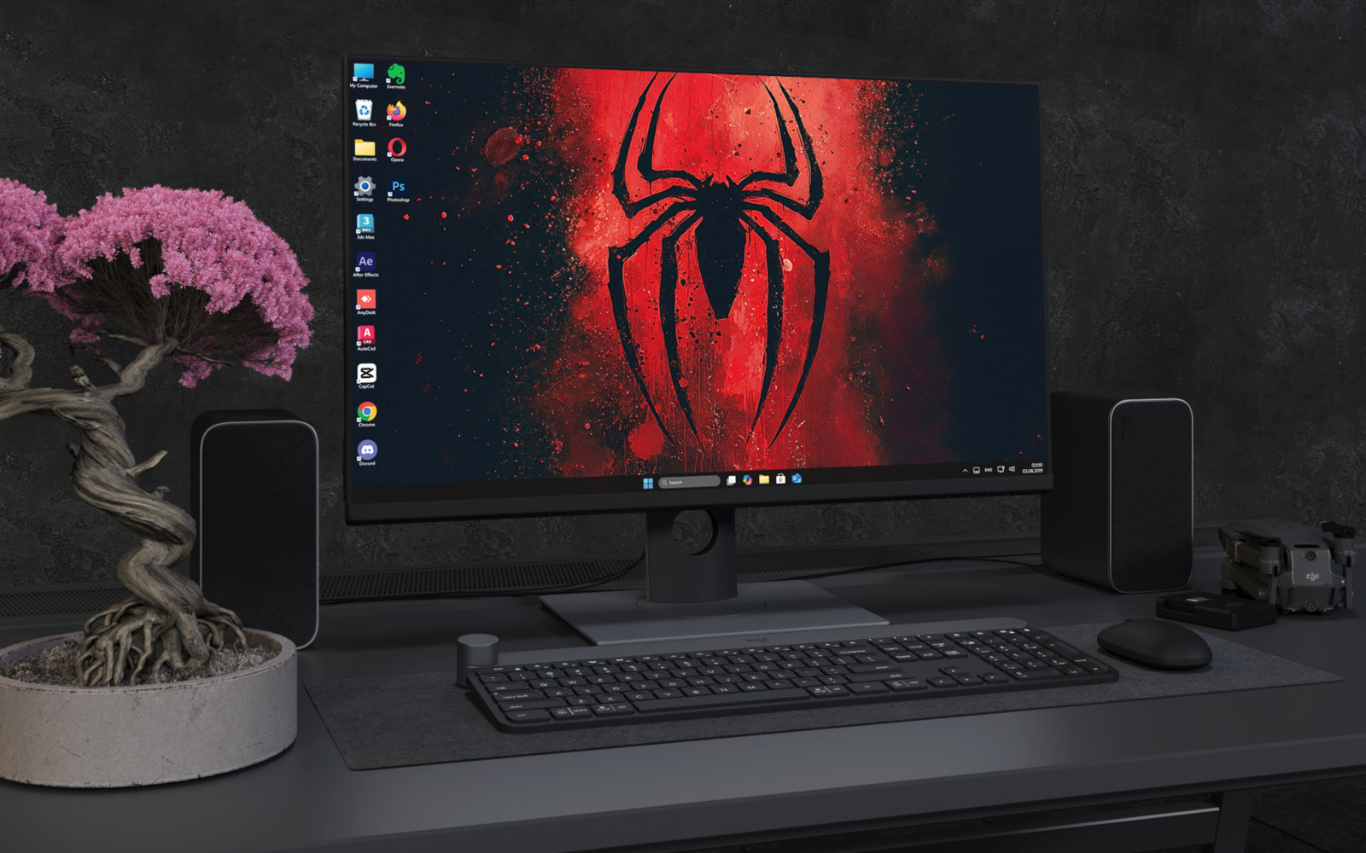

Function:

Hardware refers to the physical parts of a computer that can be seen and touched. It performs input, processing, storage, and output tasks to make the computer work. Without hardware, a computer cannot function or run any software.

Software

Picture:



Function:

Software is a collection of programs and instructions that tell the computer what to do. It allows users to perform tasks such as creating documents, browsing the internet, and playing games. Software works together with hardware to perform different computer operations.

People (Users)

Picture:



Function:

People or users operate the computer and use its hardware and software to accomplish different tasks. They provide input, make decisions, and interpret the computer's output. Users are responsible for using the computer properly and efficiently.

Procedures

Picture:

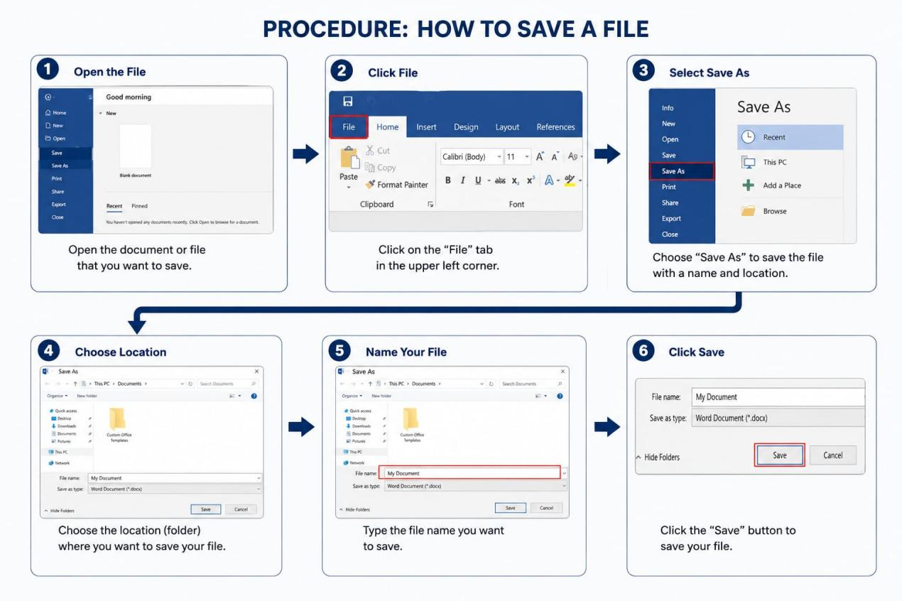

Function:

Procedures are the step-by-step instructions or rules for using and managing a computer system correctly. They help ensure that tasks are performed efficiently, accurately, and safely. Following proper procedures reduces errors and protects computer systems and data.

Data

Picture:



Function:

Data consists of raw facts and information entered into a computer for processing. After processing, data becomes meaningful information that users can understand and use. Data is essential because it serves as the basis for making decisions and completing tasks.

Connectivity

Picture:

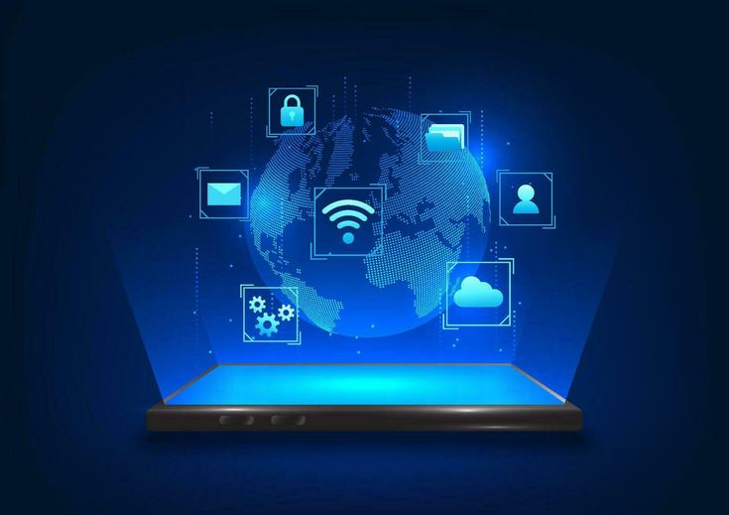

Function:

Connectivity enables a computer to communicate and exchange data with other computers, devices, and networks. It allows users to access the internet, share files, send emails, and use online services through wired or wireless connections. Good connectivity improves communication, collaboration, and access to information.

