College of Information Technology
S.Y 2026-2027
CC101: INTRODUCTION TO COMPUTING

Name: Aspillaga Kevinn B.
Course/Yr.&Blk: BSIT-1A

Prelim Laboratory Activity 1: Computer Identification (100 points)

Instructions: Using an actual desktop/laptop computer or images from the Internet, identify the following computer elements. Put your answers using the provided file format, save your file as PRELIM LABORATORY ACTIVITY 1
Insert one picture for each and write its function. Use one image only and two sentences for the functions. Make sure your images is visible as much as possible use one pages for every elements.

Computer Elements

1. Hardware
Picture:
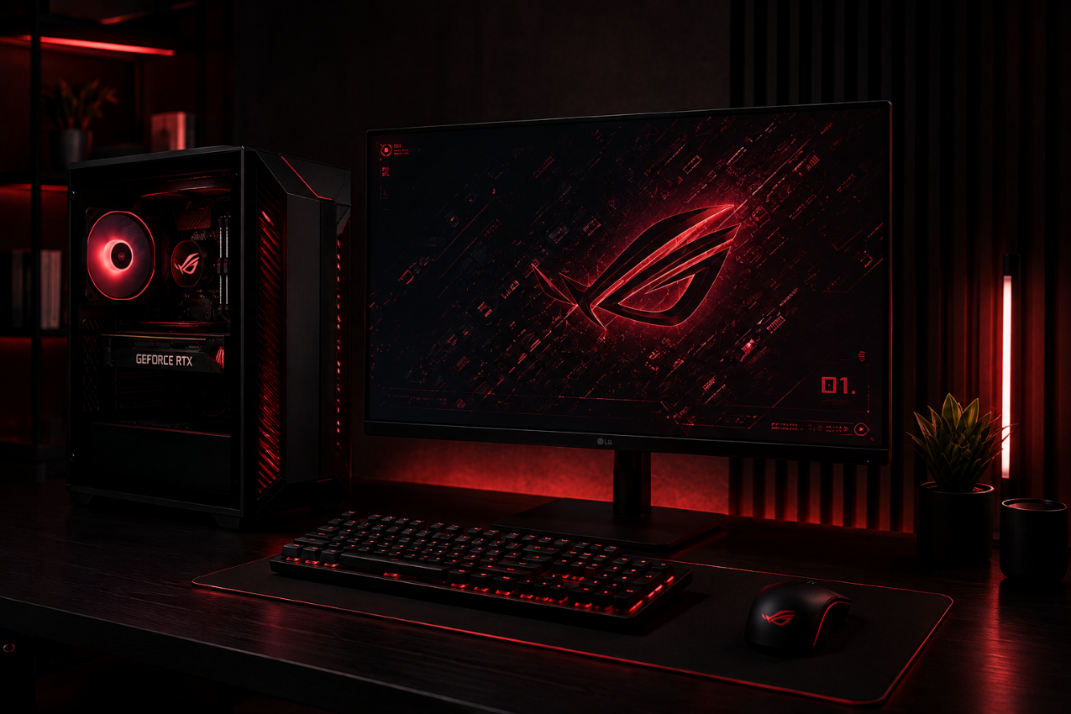

Function:
Hardware consists of the physical components of a computer that perform input, processing, storage, and output operations. It works together with software to execute commands and enable users to complete different computing tasks.

2. Software
Picture:
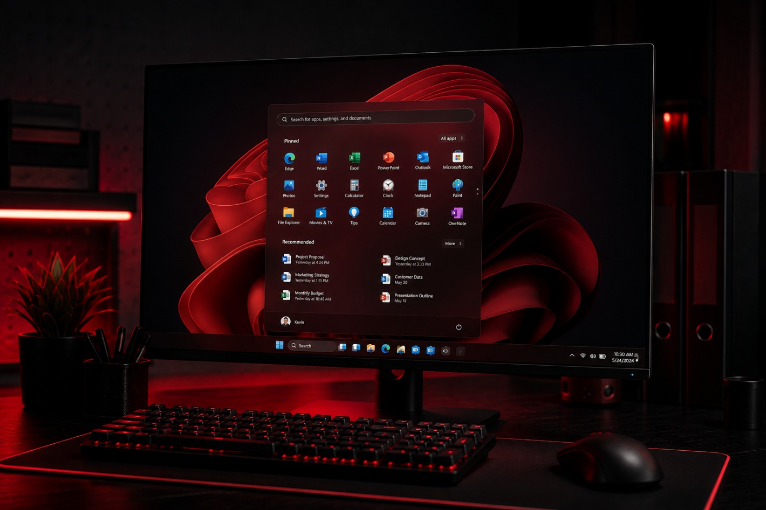

Function:
Software provides the instructions that tell the computer's hardware how to perform specific tasks. It allows users to run applications, manage files, and interact with the computer through a graphical interface.

3. People (Users)
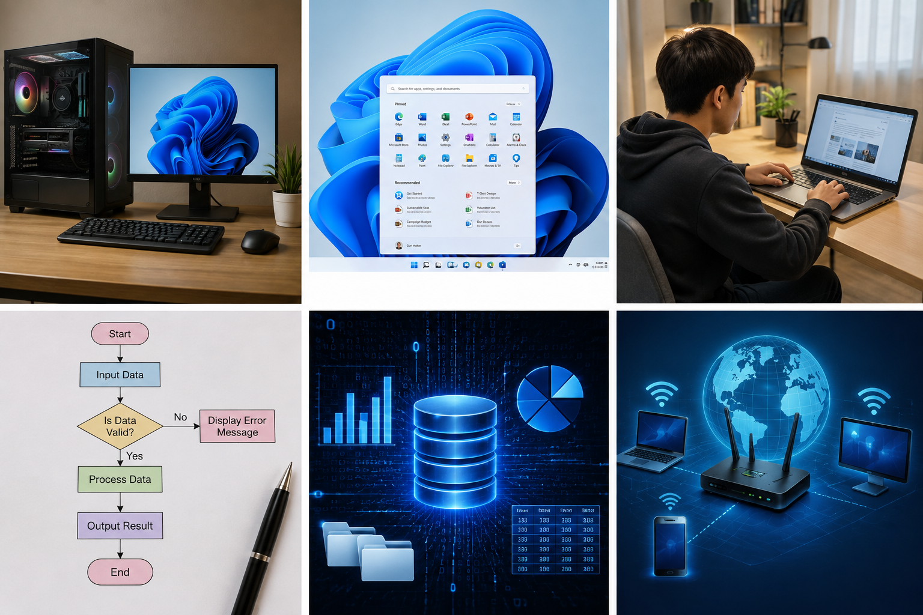
Picture:

Function:
People, also called users, operate the computer by providing commands and interacting with its hardware and software. They are responsible for entering data, using applications, and interpreting the information produced by the system.

4. Procedures
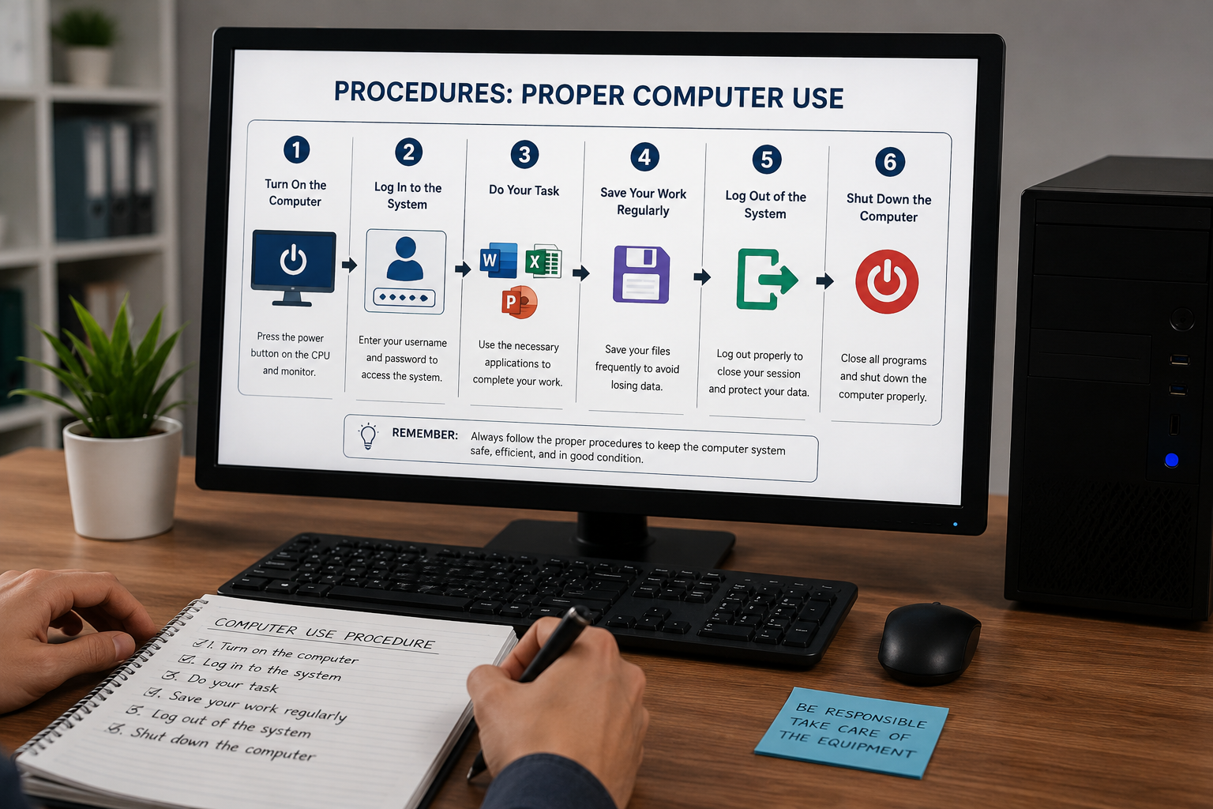
Picture:
Function:
Procedures are organized sets of instructions that guide users in performing computer-related tasks correctly and efficiently. They help ensure consistency, reduce errors, and maintain the proper operation of the computer system.

5. Data
Picture:

Function:
Data refers to raw facts and information that are collected, stored, and processed by a computer system. After processing, data becomes meaningful information that can be used for decision-making and other purposes.

6. Connectivity
Picture:

Function:
Connectivity enables computers and other devices to communicate and exchange data through wired or wireless networks. It provides access to the internet, online resources, and network services such as file sharing and communication.

