|  |
| --- |
|  |
| Screen Specification |
| Use case Add new book and add new copy |
|  |
| **Nguyen Dinh Hai Nam** |
| **11/10/2017** |

Table of Contents

[To update the table of contents, right click the message below and select Update Field (F9 on PC, ⌥⌘U on Mac).]

1. Pages 3

1.1. Page Tree 3

1.2. Home 4

1.2.1. User Interface 4

1.3. Add New Book 5

1.3.1. User Interface 5

1.3.2. Widget Table 5

1.4. Add Copy of Book 6

1.4.1. User Interface 6

1.4.2. Widget Table 6

1.5. Book catalog 7

1.5.1. User Interface 7

1.5.2. Widget Table 7

1.6. Add book success 8

1.6.1. User Interface 8

1.6.2. Widget Table 8

1.7. Book detail 9

1.7.1. User Interface 9

1.7.2. Widget Table 9

1.8. Add copy success 10

1.8.1. User Interface 10

1.8.2. Widget Table 10

1. Pages
   1. Page Tree

Home  
 Add New Book  
 Add Copy of Book  
 Book catalog  
 Add book success  
 Book detail  
 Add copy success

* 1. Home
     1. User Interface

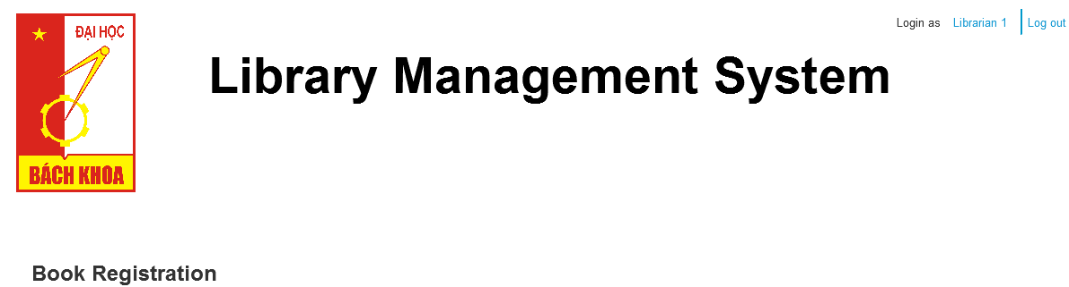

* 1. Add New Book
     1. User Interface

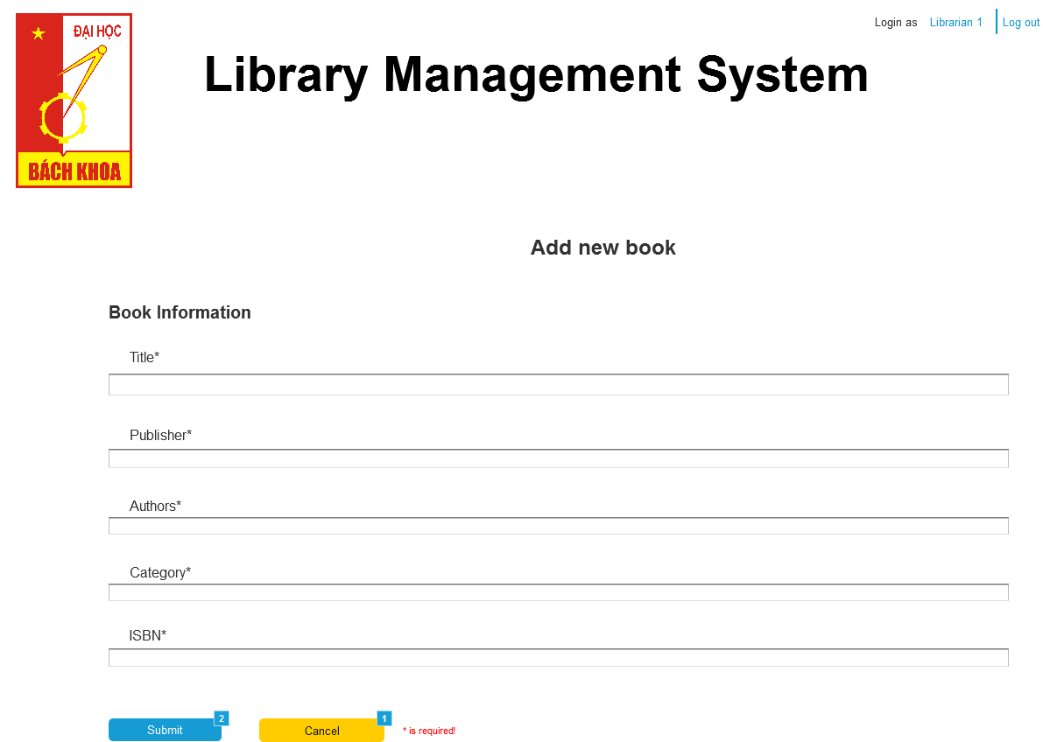

* + 1. Widget Table

|  |  |
| --- | --- |
| **Footnote** | **Interactions** |
| 1 | OnClick:  Case 1:  Open Book catalog in Current Window |
| 2 | OnClick:  Case 1:  Open Add book success in Current Window |

* 1. Add Copy of Book
     1. User Interface

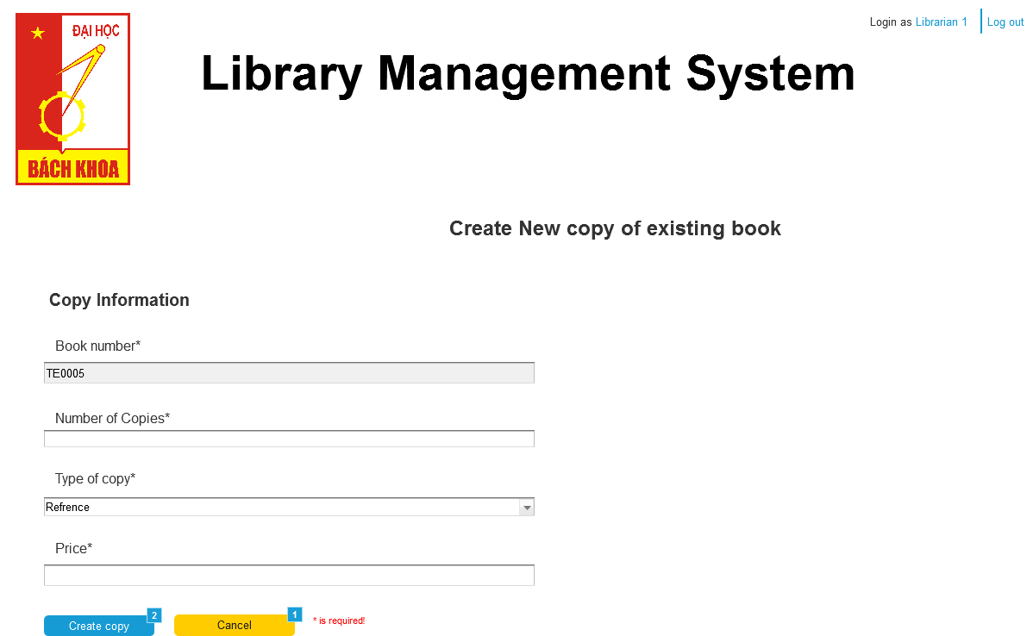

* + 1. Widget Table

|  |  |  |
| --- | --- | --- |
| **Footnote** | **Name** | **Interactions** |
| 1 |  | OnClick:  Case 1:  Open Book detail in Current Window |
| 2 |  | OnClick:  Case 1:  Open Add copy success in Current Window |

* 1. Book catalog
     1. User Interface

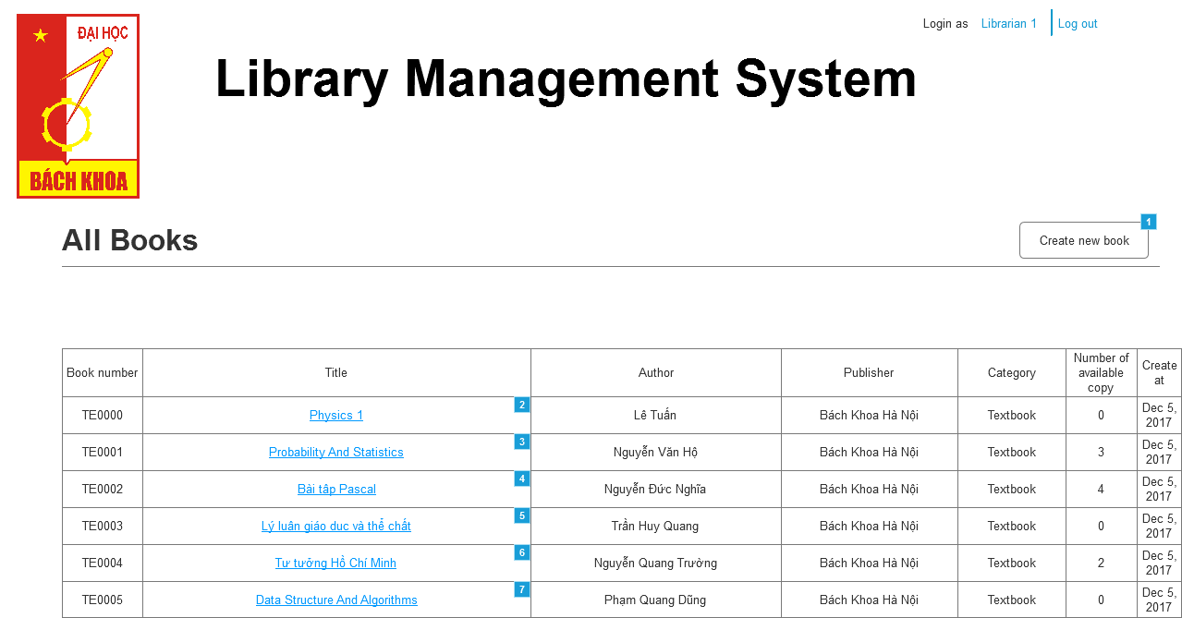

* + 1. Widget Table

|  |  |
| --- | --- |
| **Footnote** | **Interactions** |
| 1 | OnClick:  Case 1:  Open Add New Book in Current Window |
| 2 | OnClick:  Case 1:  Open Book detail in Current Window |
| 3 | OnClick:  Case 1:  Open Book detail in Current Window |
| 4 | OnClick:  Case 1:  Open Book detail in Current Window |
| 5 | OnClick:  Case 1:  Open Book detail in Current Window |
| 6 | OnClick:  Case 1:  Open Book detail in Current Window |
| 7 | OnClick:  Case 1:  Open Book detail in Current Window |

* 1. Add book success
     1. User Interface

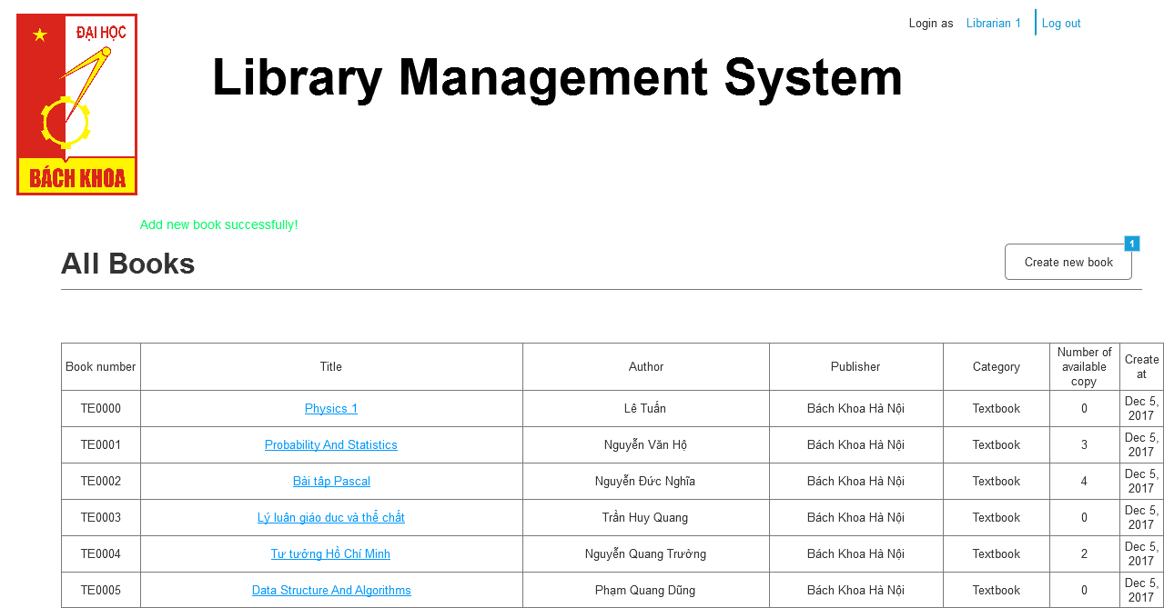

* + 1. Widget Table

|  |  |
| --- | --- |
| **Footnote** | **Interactions** |
| 1 | OnClick:  Case 1:  Open Add New Book in Current Window |

* 1. Book detail
     1. User Interface

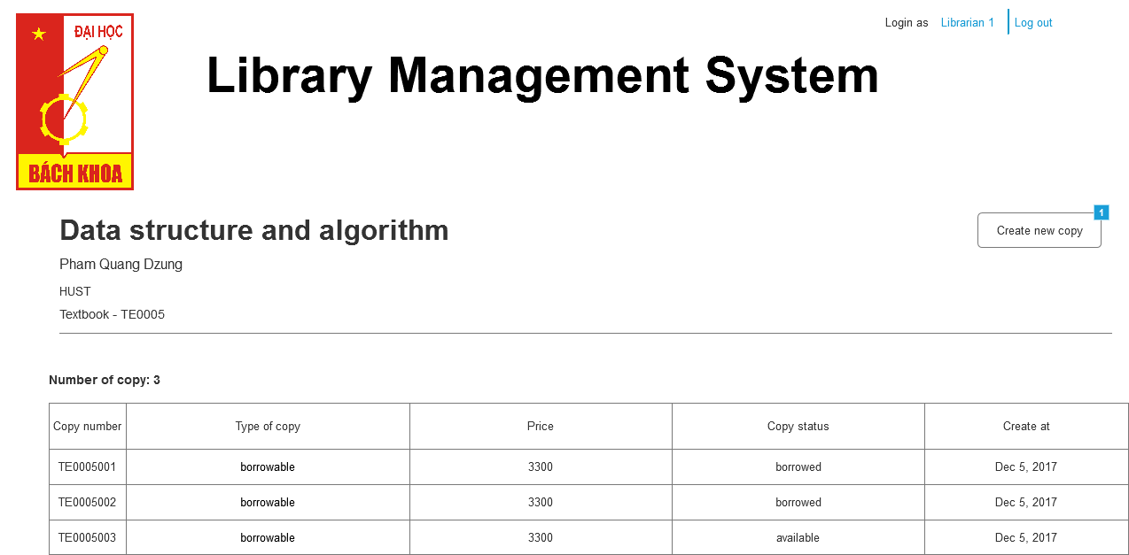

* + 1. Widget Table

|  |  |
| --- | --- |
| **Footnote** | **Interactions** |
| 1 | OnClick:  Case 1:  Open Add Copy of Book in Current Window |

* 1. Add copy success
     1. User Interface

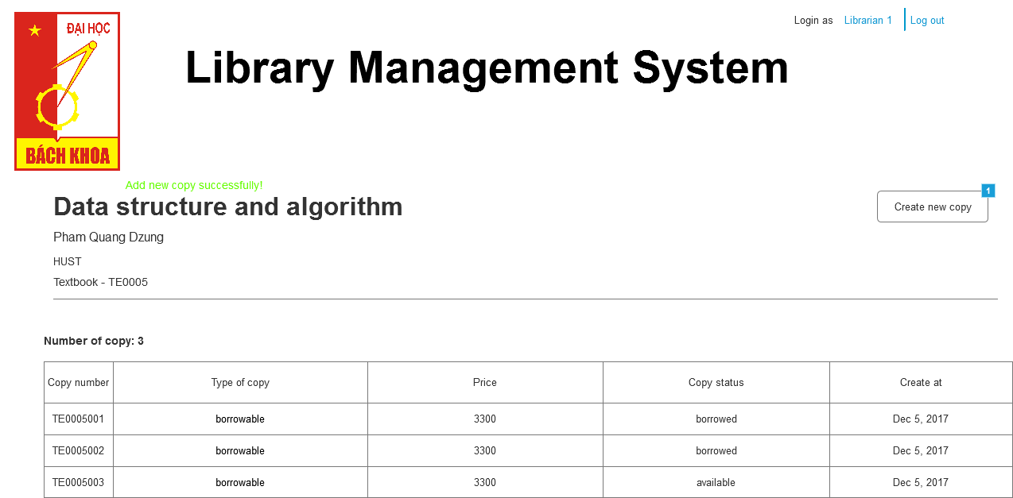

* + 1. Widget Table

|  |  |
| --- | --- |
| **Footnote** | **Interactions** |
| 1 | OnClick:  Case 1:  Open Add New Book in Current Window |