|  |
| --- |
|  |
| Screen Specification |
| Use case Lent book |
|  |
| **Ta Thanh Luong** |
|  |

[Type the abstract of the document here. The abstract is typically a short summary of the contents of the document. Type the abstract of the document here. The abstract is typically a short summary of the contents of the document.]

Table of Contents

[To update the table of contents, right click the message below and select Update Field (F9 on PC, ⌥⌘U on Mac).]

1.Pages 3

1.1.Page Tree 3

1.2.Homepage after login 4

1.2.1.User Interface 4

1.2.2.Widget Table 4

1.3.Lent book 5

1.3.1.User Interface 5

1.3.2.Widget Table 5

1. Pages
   1. Page Tree

Usecase Lent book  
 Homepage after login  
 Lent book

* 1. Homepage after login
     1. User Interface

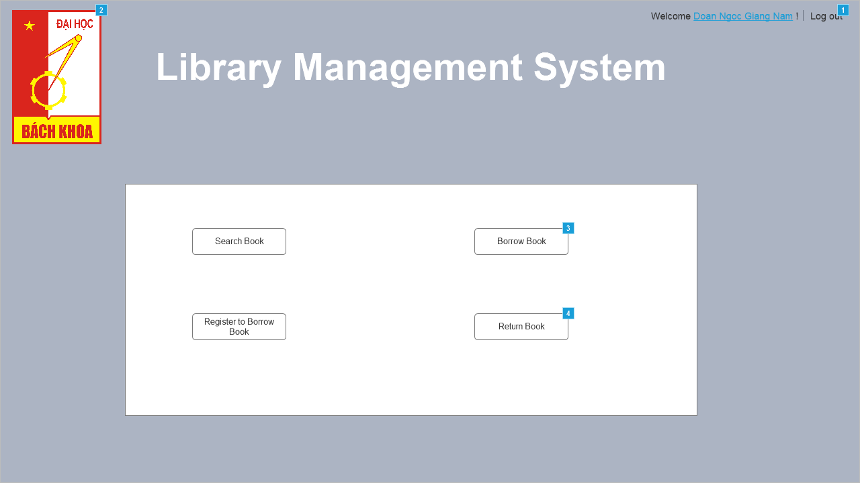

* + 1. Widget Table

|  |  |
| --- | --- |
| **Footnote** | **Interactions** |
| 1 | OnClick:  Case 1:  Open Link in Current Window |
| 2 | OnClick:  Case 1:  Open Link in Current Window |
| 3 | OnClick:  Case 1:  Open Borrow book in Current Window |
| 4 | OnClick:  Case 1:  Open Link in Current Window |

* 1. Lent book
     1. User Interface

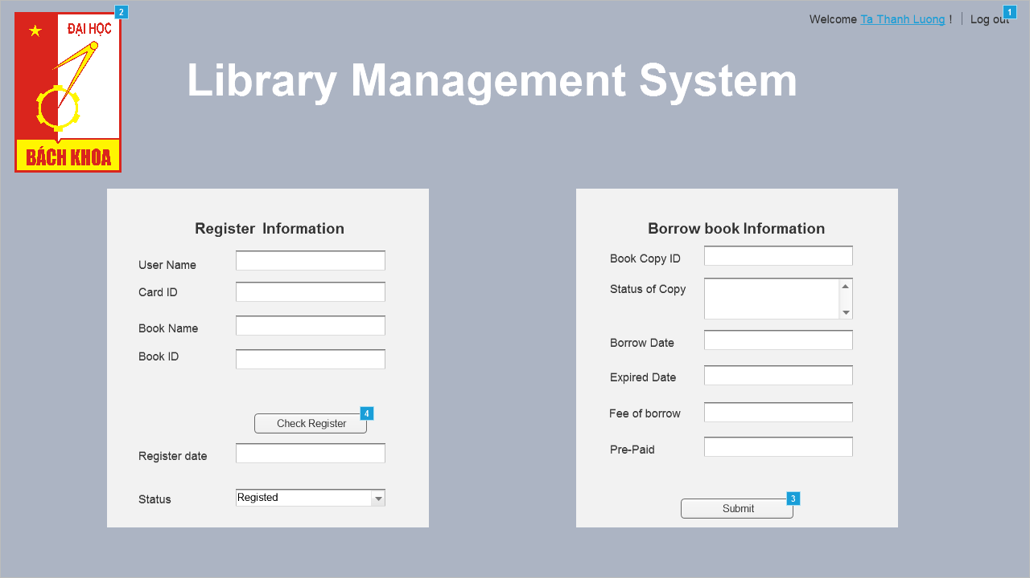

* + 1. Widget Table

|  |  |  |
| --- | --- | --- |
| **Footnote** | **Name** | **Interactions** |
| 1 |  | OnClick:  Case 1:  Open Link in Current Window |
| 2 |  | OnClick:  Case 1:  Open Link in Current Window |
| 3 |  | OnClick:  Case 1  (If text on Status of Copy is alpha-numeric and text on Borrow date is alpha-numeric and text on Expired date is alpha-numeric and text on Fee of borrow is alpha-numeric and text on Pre-paid is alpha-numeric ):  Open Homepage after login in Current Window  Hide Borrow error  Case 2  (Else If True):  Show Borrow error |
| 4 |  | OnClick:  Case 1  (If text on User name is alpha-numeric and text on Card ID is alpha-numeric and text on Book name is alpha-numeric and text on Book ID is alpha-numeric ):  Set text on Register date equal to "10/10/2017"  Hide Register error  Case 2  (Else If True):  Show Register error |