|  |
| --- |
|  |
| Screen Specification |
| For use case Register to borrow books |
|  |
| **Doan Ngoc Giang Nam** |
| **10/10/2017** |

Brieft specification of use case register to borrow books interface designs

Table of Contents

[To update the table of contents, right click the message below and select Update Field (F9 on PC, ⌥⌘U on Mac).]

1.Pages 3

1.1.Page Tree 3

1.2.Book catalog 4

1.2.1.User Interface 4

1.2.2.Widget Table 4

1.3.Invalidate borrow card 5

1.3.1.User Interface 5

1.3.2.Widget Table 5

1.4.Card expires 6

1.4.1.User Interface 6

1.4.2.Widget Table 6

1.5.Success 7

1.5.1.User Interface 7

1.5.2.Widget Table 7

1.6.Register to borrow books 8

1.6.1.User Interface 8

1.6.2.Widget Table 8

2. Defining the field attribute………………………………………………………………………………………………………10

1. Pages
   1. Page Tree

Use case register to borrow books  
 Book catalog  
 Invalidate borrow card  
 Card expires  
 Success  
 Register to borrow books

* 1. Book catalog
     1. User Interface

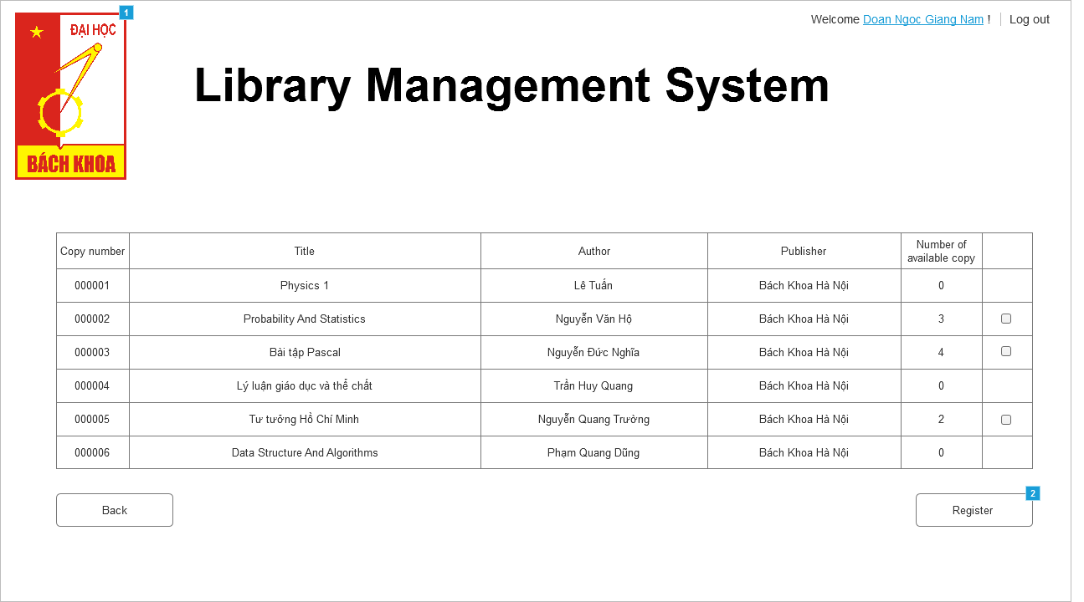

* + 1. Widget Table

|  |  |
| --- | --- |
| **Footnote** | **Interactions** |
| 1 | OnClick:  Case 1:  Open Link in Current Window |
| 2 | OnClick:  Case 1:  Open Register to borrow books in Current Window |

* 1. Invalidate borrow card
     1. User Interface

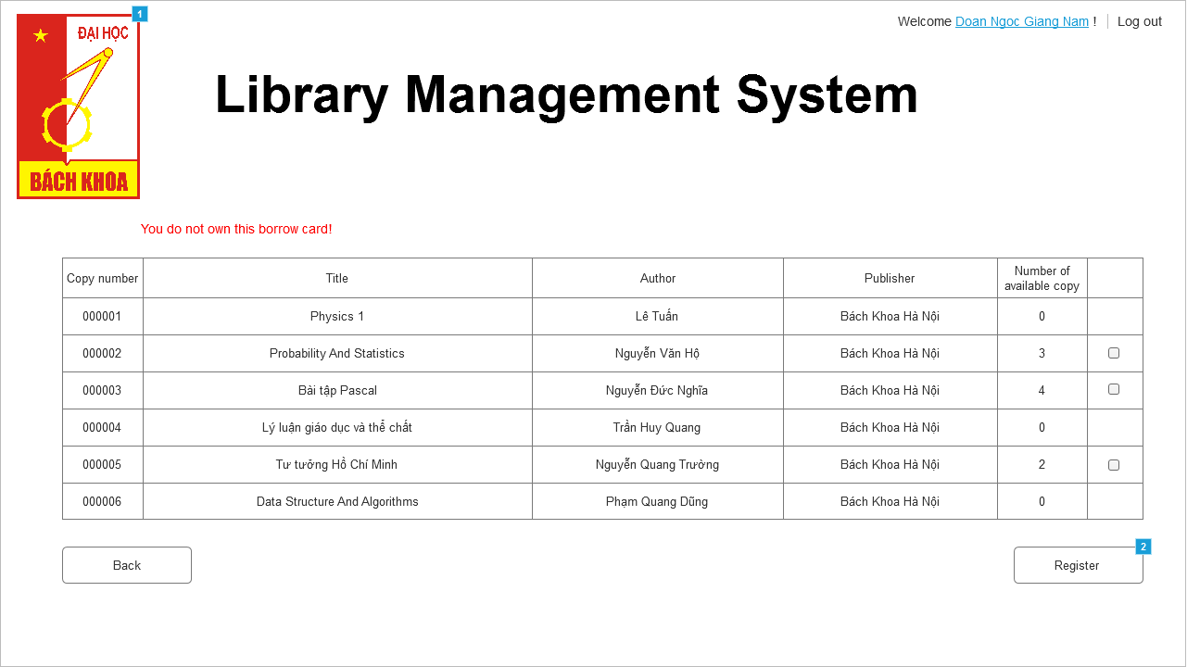

* + 1. Widget Table

|  |  |
| --- | --- |
| **Footnote** | **Interactions** |
| 1 | OnClick:  Case 1:  Open Link in Current Window |
| 2 | OnClick:  Case 1:  Open Register to borrow books in Current Window |

* 1. Card expires
     1. User Interface

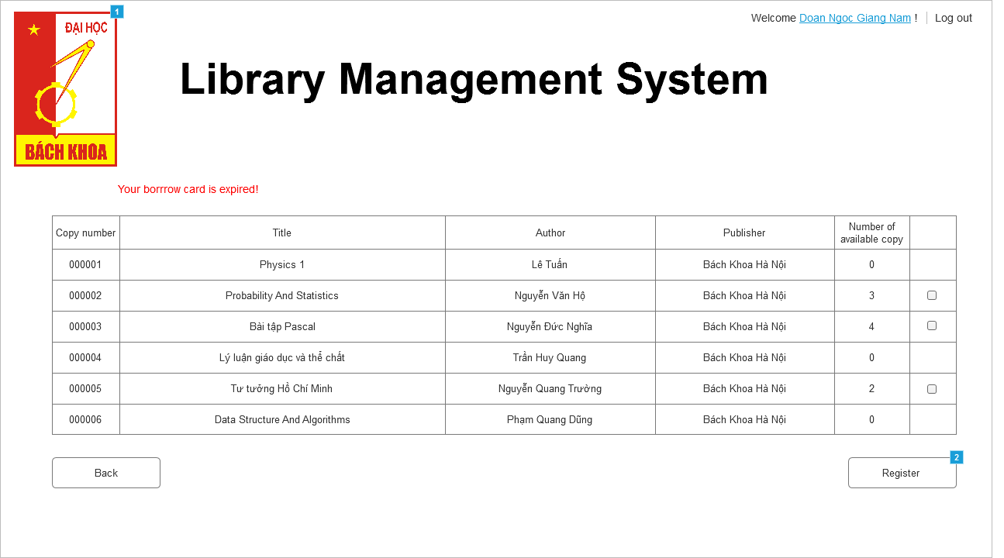

* + 1. Widget Table

|  |  |
| --- | --- |
| **Footnote** | **Interactions** |
| 1 | OnClick:  Case 1:  Open Link in Current Window |
| 2 | OnClick:  Case 1:  Open Register to borrow books in Current Window |

* 1. Success
     1. User Interface

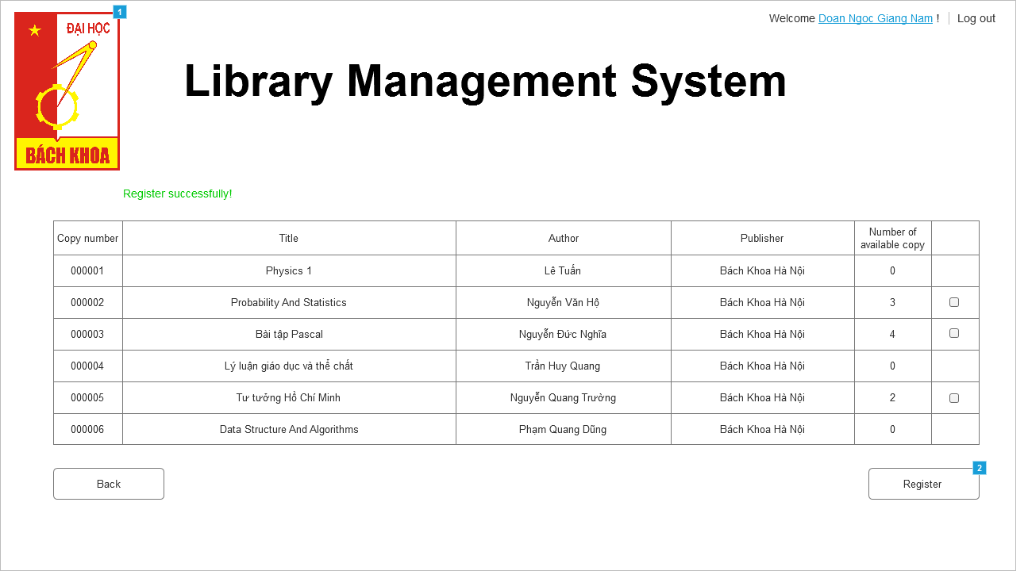

* + 1. Widget Table

|  |  |
| --- | --- |
| **Footnote** | **Interactions** |
| 1 | OnClick:  Case 1:  Open Link in Current Window |
| 2 | OnClick:  Case 1:  Open Register to borrow books in Current Window |

* 1. Register to borrow books
     1. User Interface

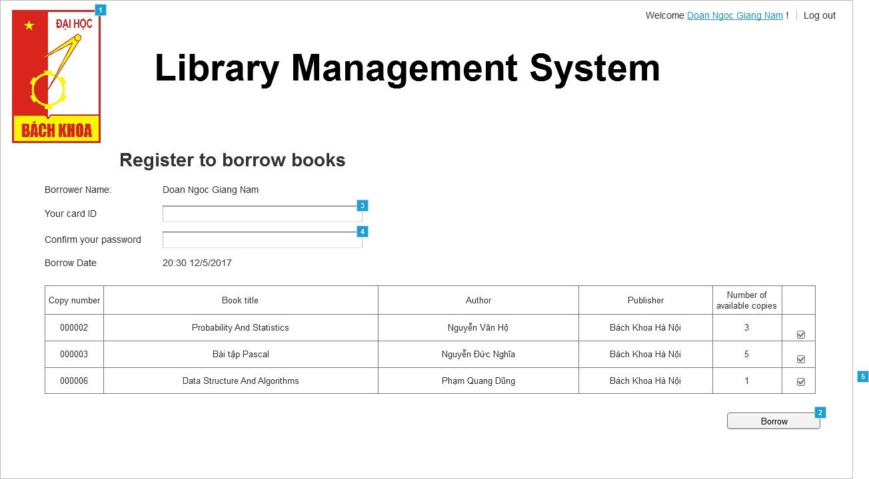

* + 1. Widget Table

|  |  |  |  |
| --- | --- | --- | --- |
| **Footnote** | **Name** | **Interactions** | **Note** |
| 1 |  | OnClick:  Case 1:  Open Book catalog in Current Window | click on this image will navigate to borrower homepage (in this case it is a book catalog) |
| 2 |  | OnClick:  Case 1  (If text on Password equals "" and text on Card ID equals ""):  Show (Rectangle), (Rectangle)  Case 2  (Else If text on Card ID equals "" and text on Password does not equal ""):  Show (Rectangle)  Case 3  (Else If text on Password equals "" and text on Card ID does not equal ""):  Show (Rectangle)  Case 4  (Else If text on Password does not equal "" and text on Card ID does not equal ""):  Open Success in Current Window | If one of the text fields (or both) is empty, click on this will display the warning message. Otherwise, it will navigate to borrow registration result screen |
| 3 | Card ID |  | text field to type in borrower card ID |
| 4 | Password |  | text field to type in password of borrower account to re-confirm that he/she want to borrow those books |
| 5 |  |  | A borrowing status. Uncheck the checkbox if the borrower does not want to borrow that book anymore |

**2. Defining the field attribute (for 1.3 register to borrow book screen)**

|  |  |  |  |  |
| --- | --- | --- | --- | --- |
| Item name | Number of digits(bytes) | Type | Field attribute | Remarks |
| Card ID | 10 | Character | White(red error message) | Display red error message when submitting empty field |
| Password | Greater than 5 | Password format (array of *) | White(red error message) | Display red error message when submitting empty field |