|  |
| --- |
|  |
| Screen Specification |
| Use case Return book |
|  |
| **Ta Thanh Luong** |
|  |

[Type the abstract of the document here. The abstract is typically a short summary of the contents of the document. Type the abstract of the document here. The abstract is typically a short summary of the contents of the document.]

Table of Contents

[To update the table of contents, right click the message below and select Update Field (F9 on PC, ⌥⌘U on Mac).]

**No table of contents entries found.**

1. Pages
   1. Page Tree

Usecase Return book  
 Homepage after login  
 Return book

* 1. Homepage after login
     1. User Interface

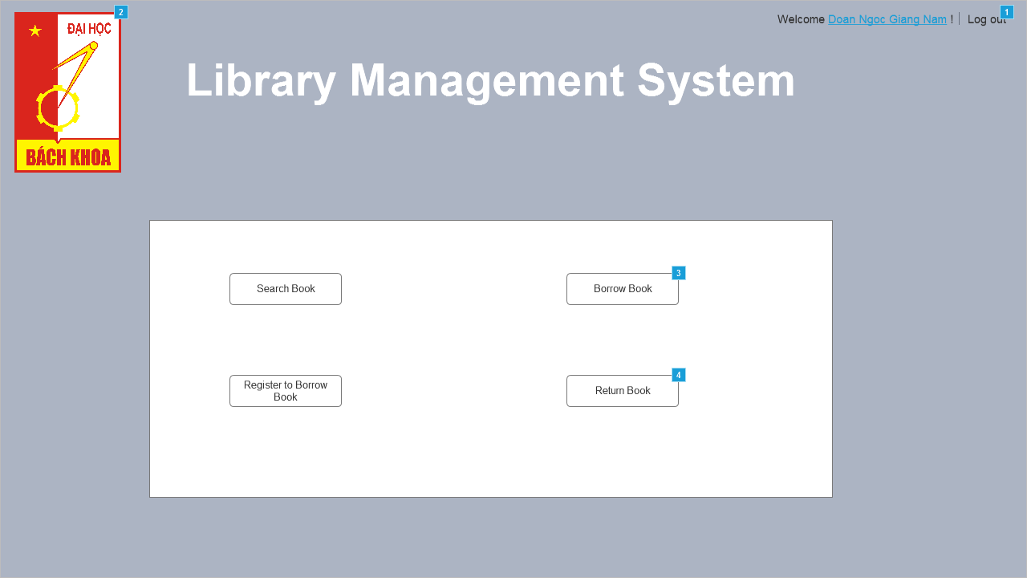

* + 1. Widget Table

|  |  |
| --- | --- |
| Footnote | Interactions |
| 1 | OnClick:  Case 1:  Open Link in Current Window |
| 2 | OnClick:  Case 1:  Open Link in Current Window |
| 3 | OnClick:  Case 1:  Open Link in Current Window |
| 4 | OnClick:  Case 1:  Open Return book in Current Window |

* 1. Return book
     1. User Interface

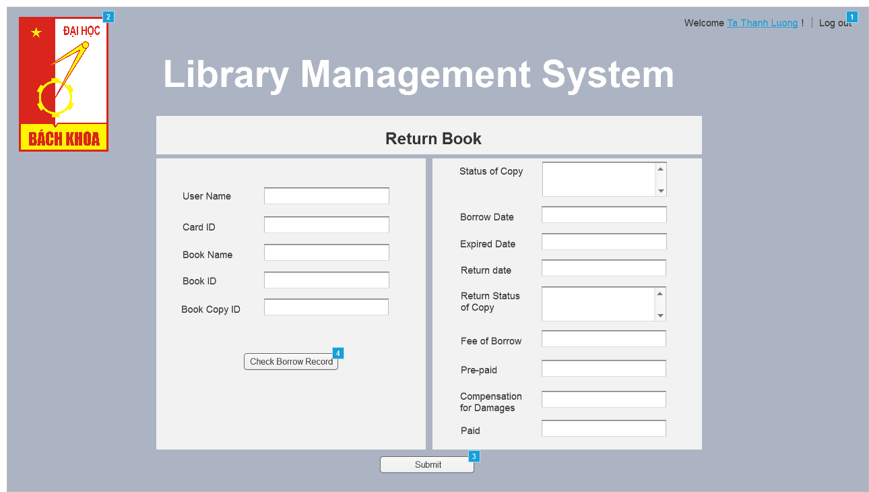

* + 1. Widget Table

|  |  |  |
| --- | --- | --- |
| Footnote | Name | Interactions |
| 1 |  | OnClick:  Case 1:  Open Link in Current Window |
| 2 |  | OnClick:  Case 1:  Open Link in Current Window |
| 3 |  | OnClick:  Case 1:  Open Homepage after login in Current Window |
| 4 |  | OnClick:  Case 1  (If text on User name is alpha-numeric and text on Card ID is alpha-numeric and text on Book name is alpha-numeric and text on Book ID is alpha-numeric and text on Book copy ID is alpha-numeric ):  Set text on Fee of Borrow equal to "10/10/2017"  Set text on Prepaid equal to "10/11/2017"  Set text on Prepaid equal to "$1.00"  Set text on Fee of Borrow equal to "$2.00"  Set text on Return date equal to "10/11/2017"  Hide Check record error  Case 2  (Else If True):  Show Check record error |