Ukrainian Translation

Only once (initially):

Scan me to connect to the WLAN

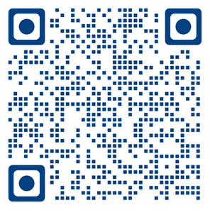

or connect manually to the WLAN **translation**

password **translation**

Every Sunday:

Connect to the Ukrainian Translation System

Scan ME to connect to Jitsi

# 

# Preferred option 1 (Launch in Browser). You do not need to install anything

|  |  |
| --- | --- |
|  | * Allow the Microphone * Mute yourself, if not already muted |

## Option 2 - With the Jitsi App

1. Click on OK:
2. 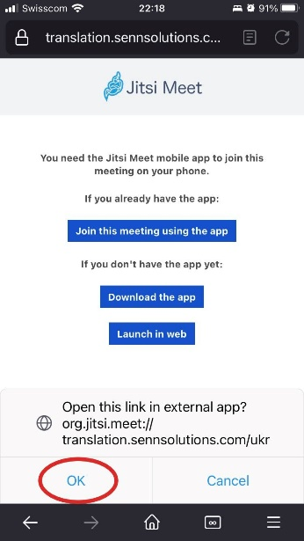

|  |  |
| --- | --- |
| 1. (1) Switch off the Microphone → 2. (2) Switch off the Camera → 3. (3) Join the meeting → |  |

# Option 3 - Manually from the Jitsi App

|  |  |
| --- | --- |
| Open the **Jitsi App**.  (In the Jitsi App go to **Settings** and configure the options below - only once): | Write the Room Name "ukr" and press the button JOIN |
|  |  |

Trouble shooting, see next page

## Trouble Shooting

## Disable Private DNS on Android’s phones

If you cannot connect to Jitsi try disabling the private DNS options:

|  |  |
| --- | --- |
| Go to options – how? |  |