# Instructions for the Translator

1. Connect the network cable from the R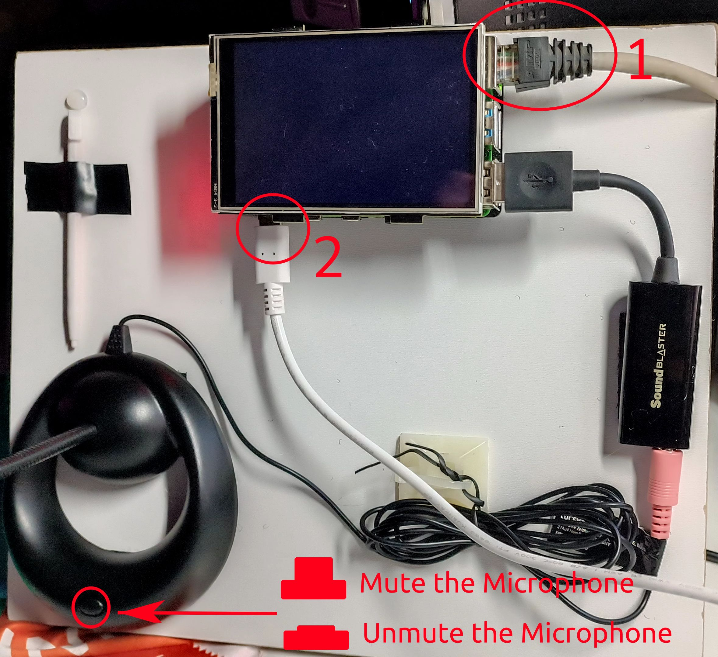outer to the Raspberry-PI (1)

2. Attach the power. (White cable) (2)

3. Wait that you will see on the display the right screen. At this point the system is ready.

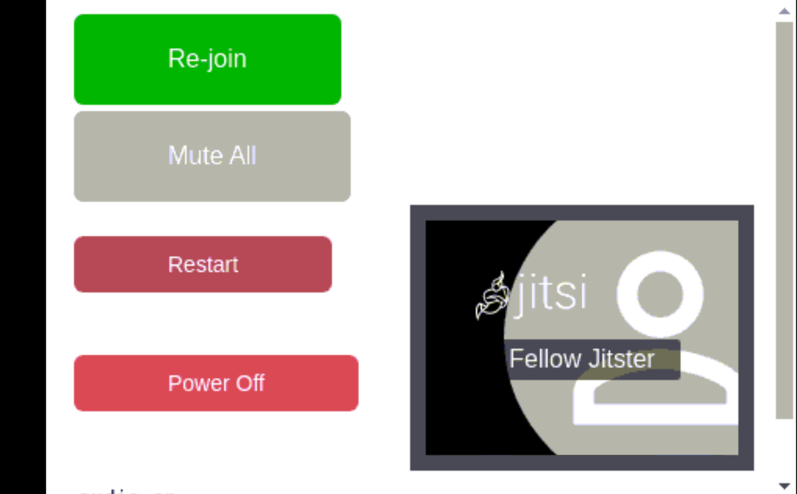

After everybody joined the call be sure to press

the button to mute all the participants and avoid

external noise.

Press the button to rejoin the conference.

You shouldn’t need it.

Press the Button

if something is not working properly.

The system will take few minutes and restart



At the end of the service press the button

and the detach the power cable (white) and the network cable.

**If the screen goes black, just touch it with the plastic pen.**