Scan me to connect to the WLAN

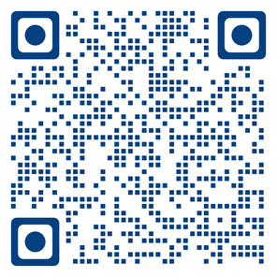

or connect manually to the

WLAN **translation**

password **translation**

How to connect to the Ukrainian Translation System

# Scan ME to connect to Jitsi

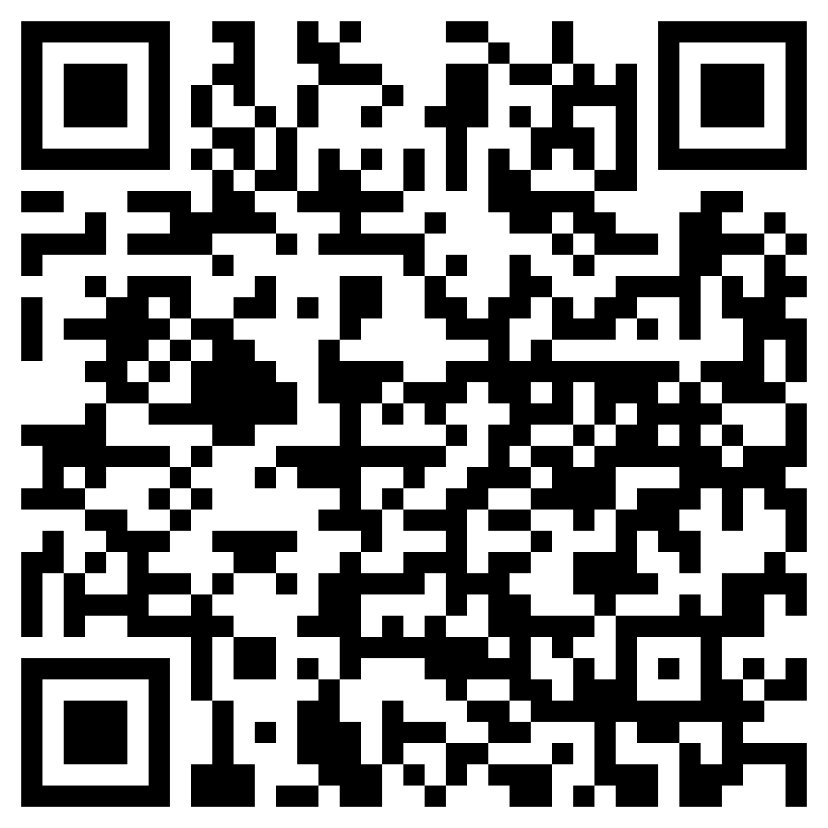

# **Preferred option 1 (Launch in Web).** **You do not need to install anything**

# 

1. ← Allow the Microphone
2. Mute yourself, if not already muted→

## Option 2 - Via QRCODE with the Jitsi App

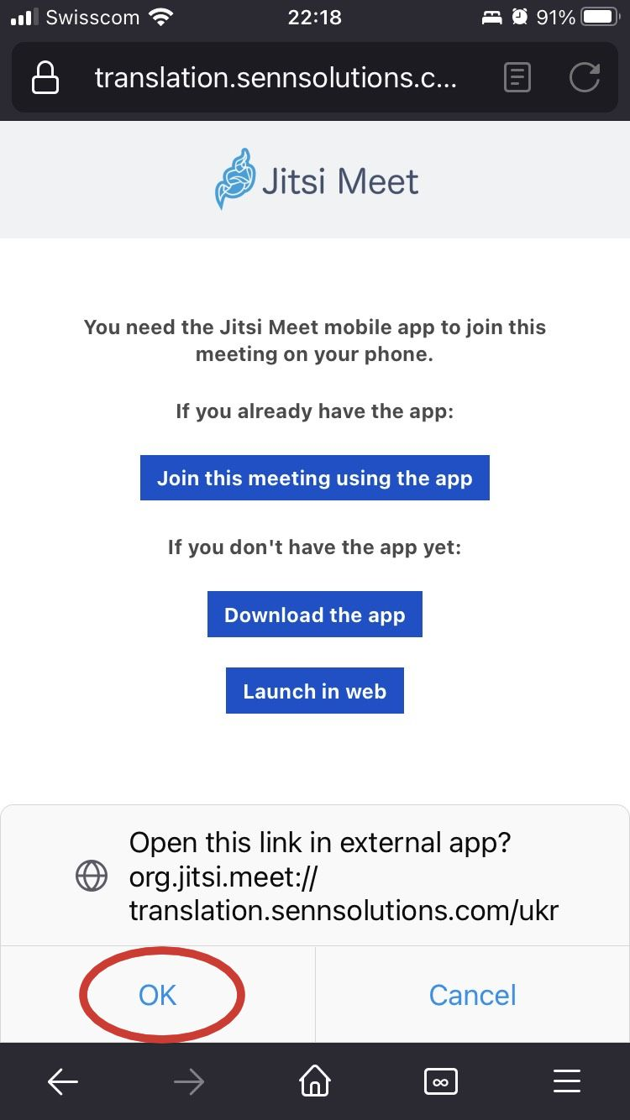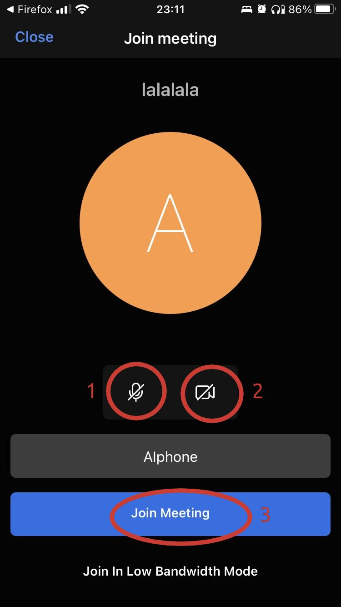

(1) Click on the Microphone →

(2) Click on the Camera →

(3) Join the meeting →

← Click on OK

# Option 3 - Manually from the Jitsi App

|  |  |  |
| --- | --- | --- |
| In the Jitsi App go to settings and configure the options below |  | Write the Room Name ukr and press the button **JOIN** |

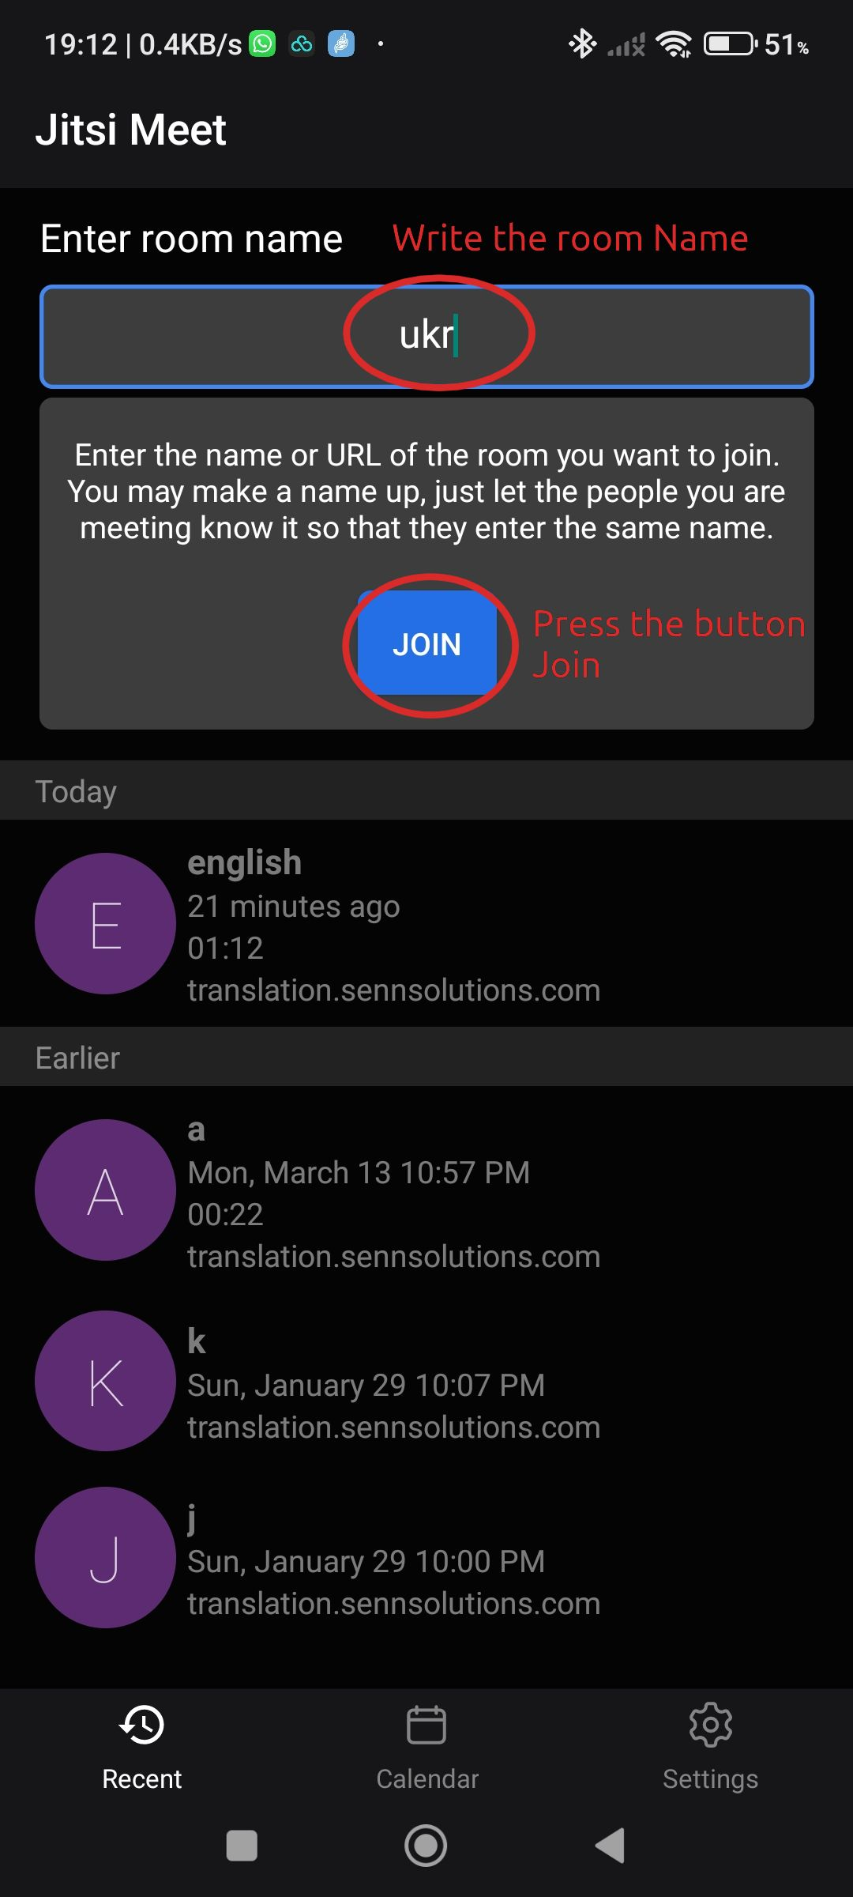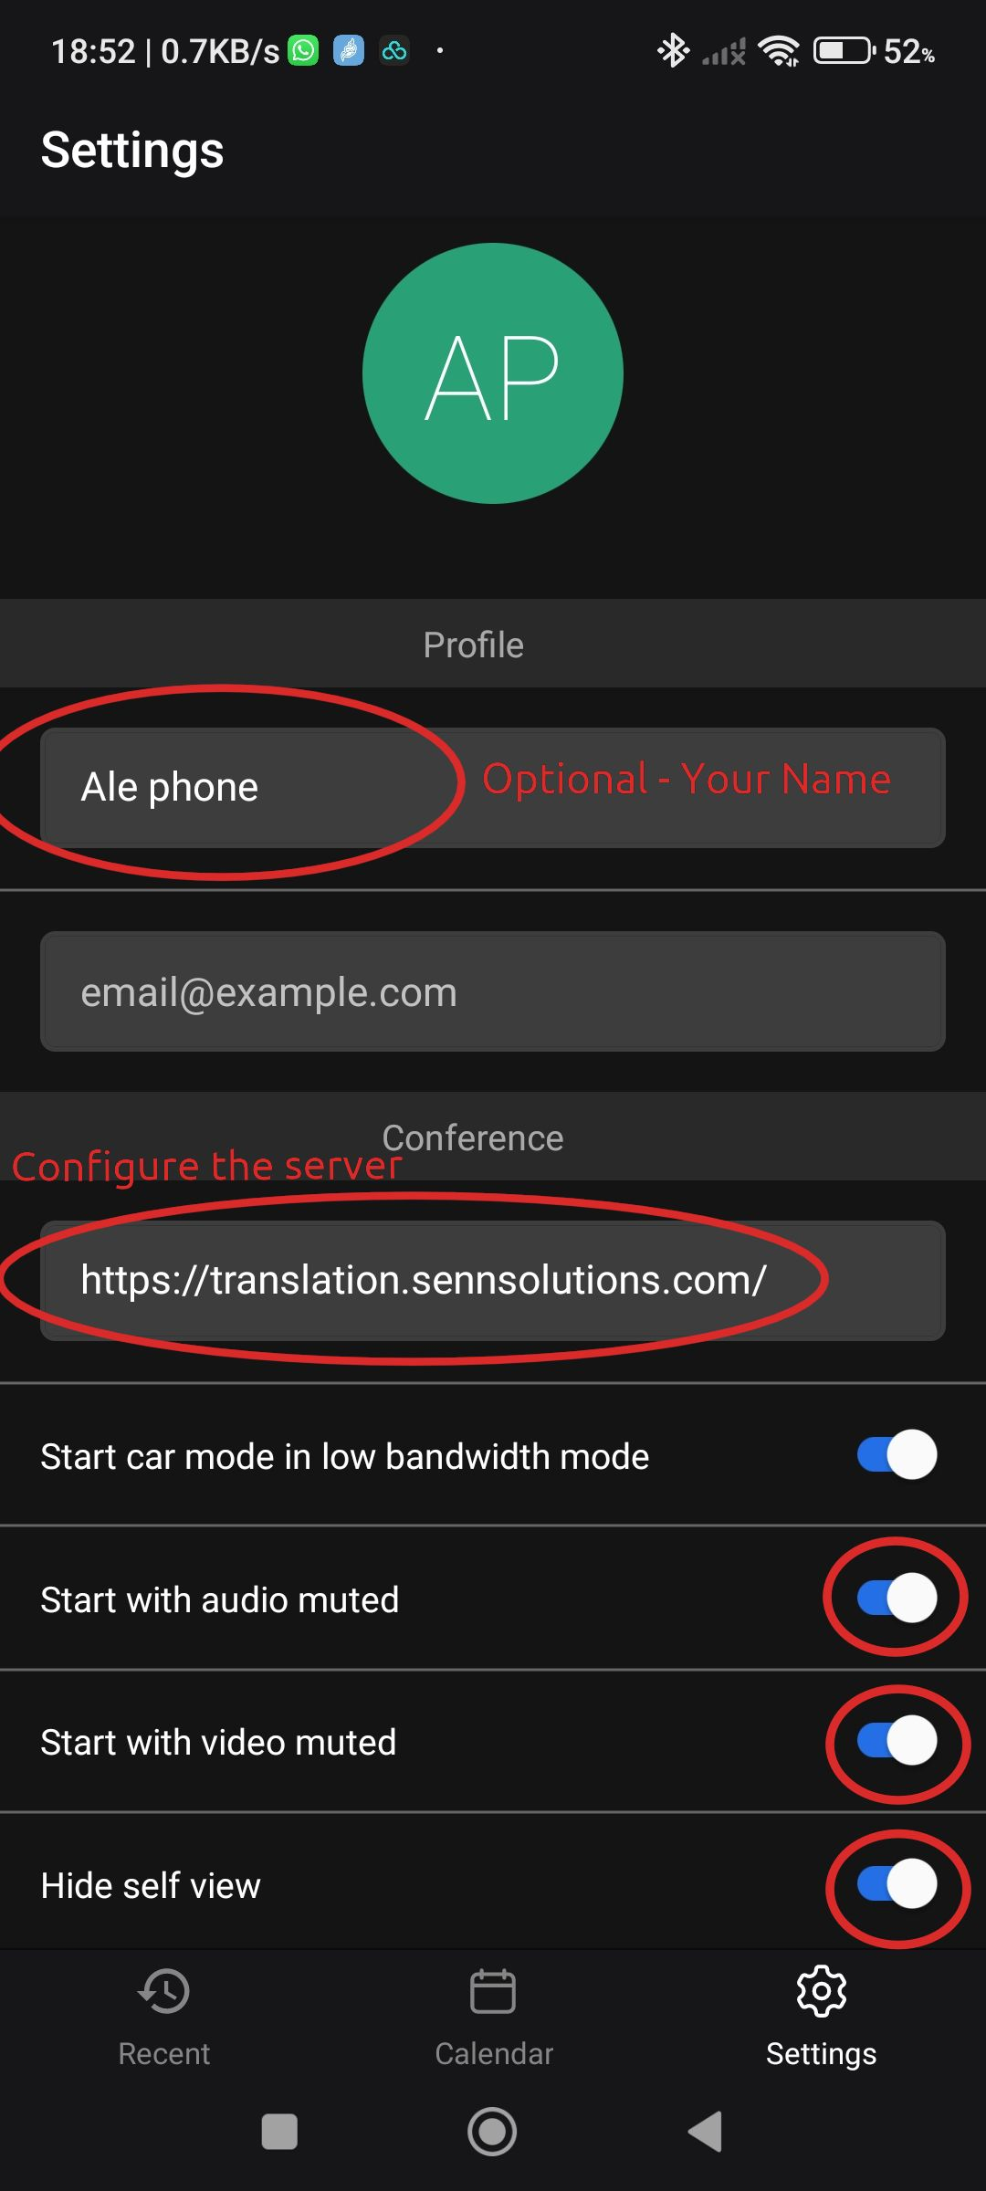

## Disable Private DNS on Android’s phones

If you cannot connect to Jitsi try disabling the private DNS options

