Scan me to connect to the WLAN

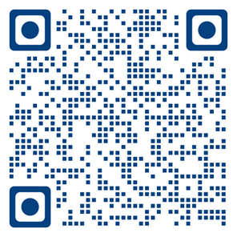

or connect manually to the
WLAN translation
password translation

How to connect to the Ukrainian Translation System

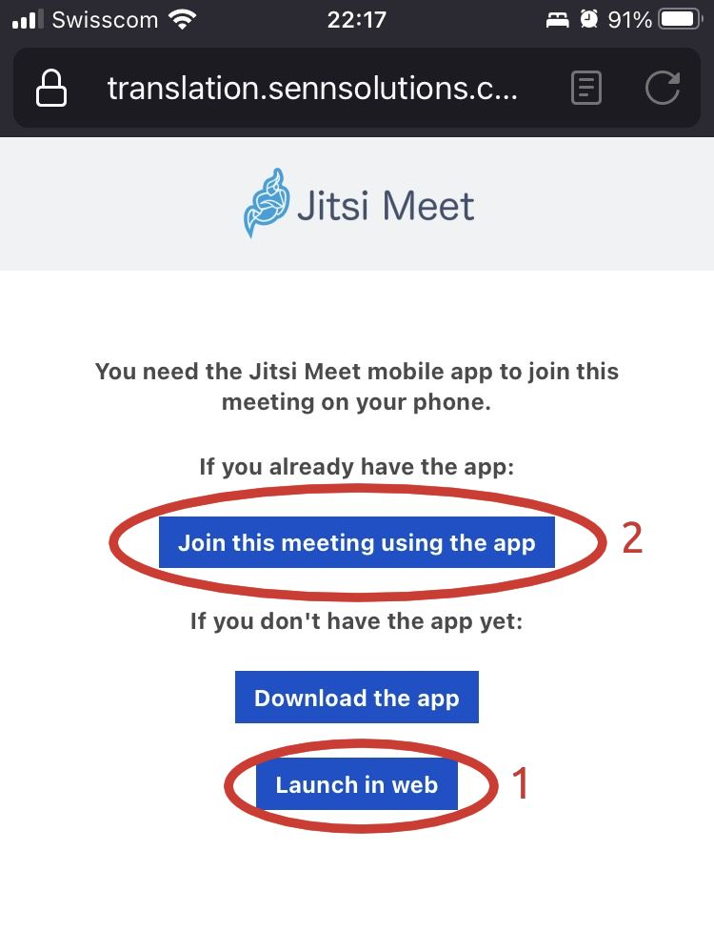
Scan ME to connect to Jitsi
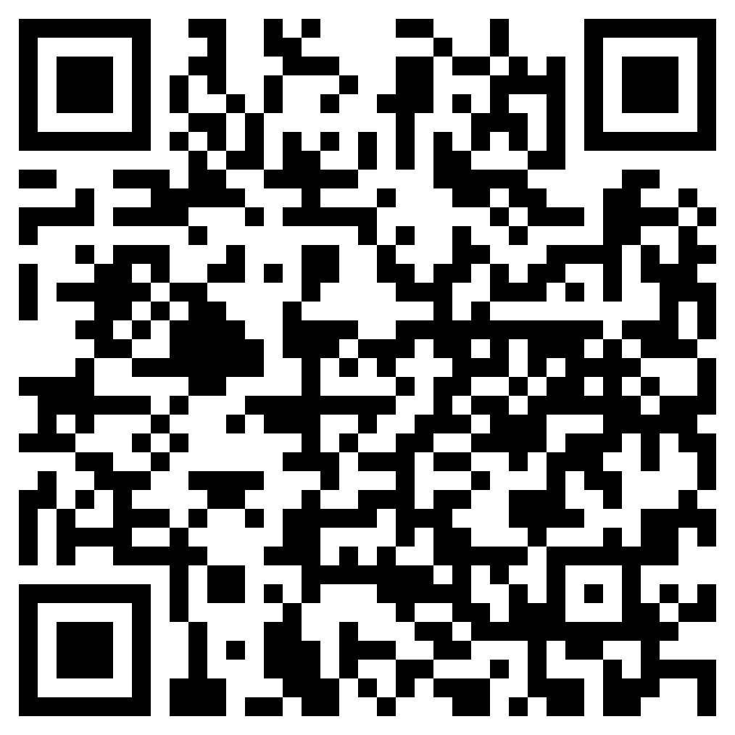

Preferred option 1 (Launch in Web). You do not need to install anything
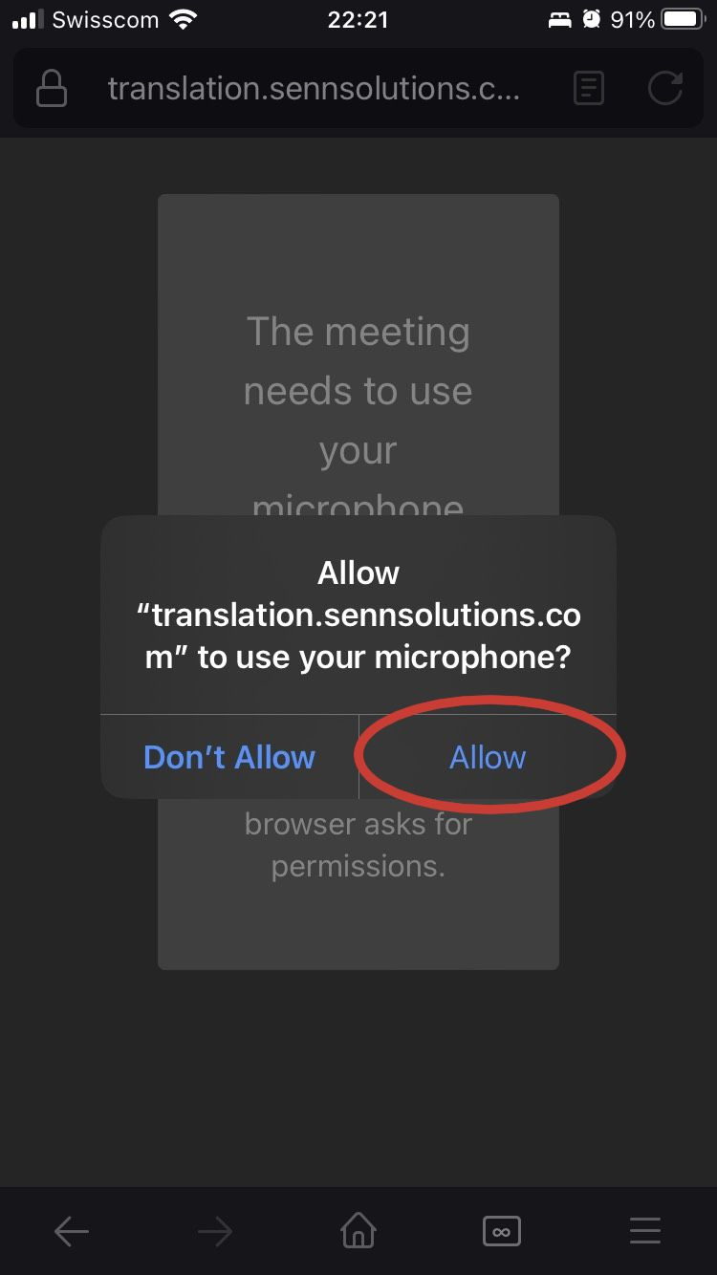
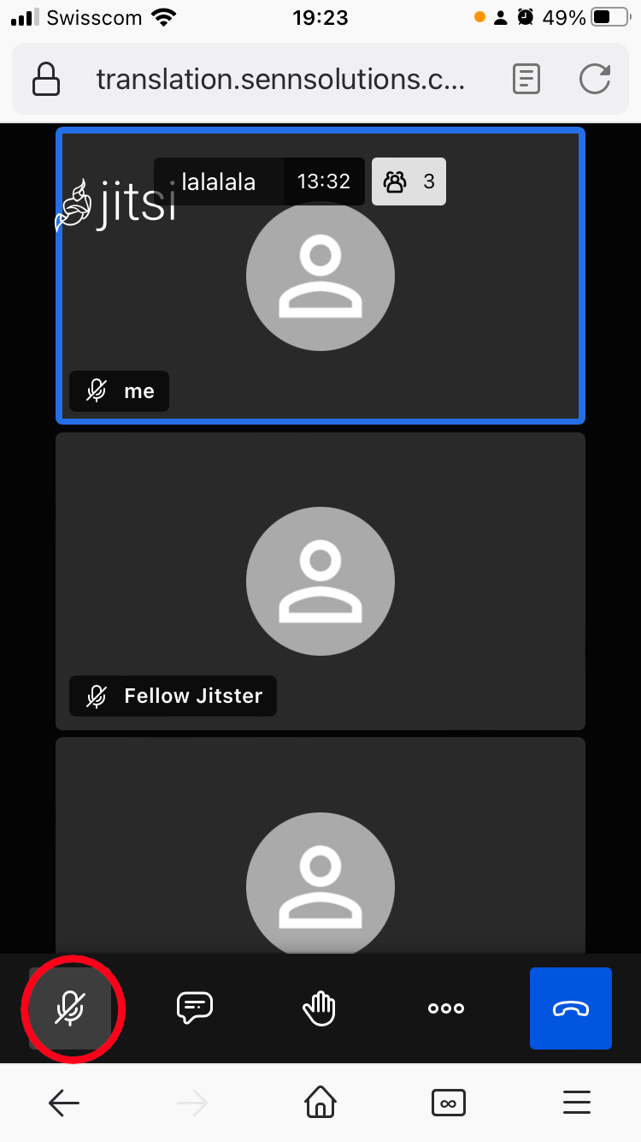

← Allow the Microphone

Mute yourself, if not already muted→

Option 2 - Via QRCODE with the Jitsi App
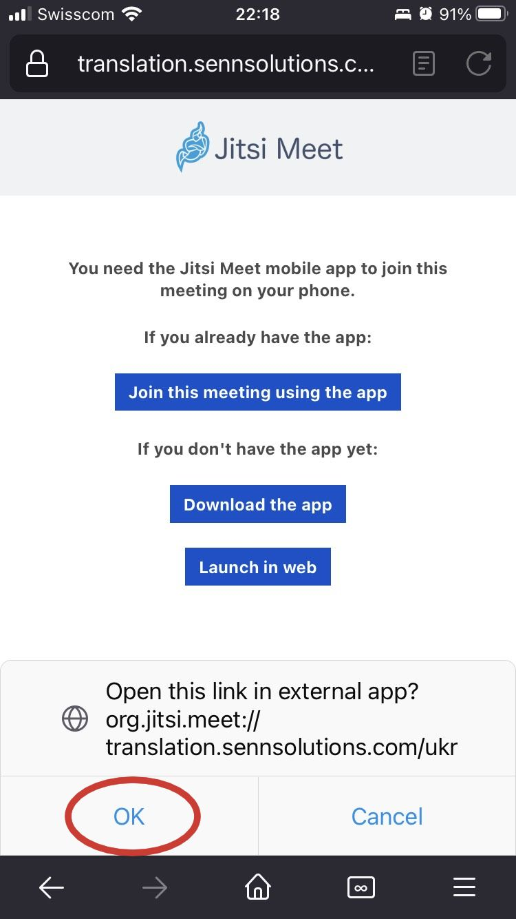
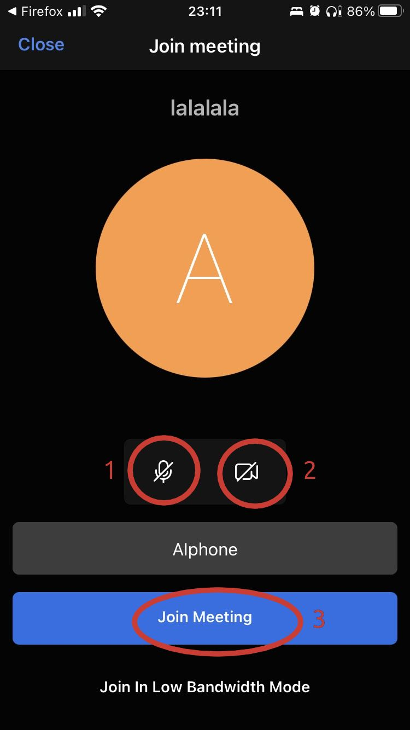

(1) Click on the Microphone →
(2) Click on the Camera →

(3) Join the meeting →
← Click on OK

Option 3 - Manually from the Jitsi App

In the Jitsi App go to settings and configure the options below |  | Write the Room Name ukr and press the button JOIN

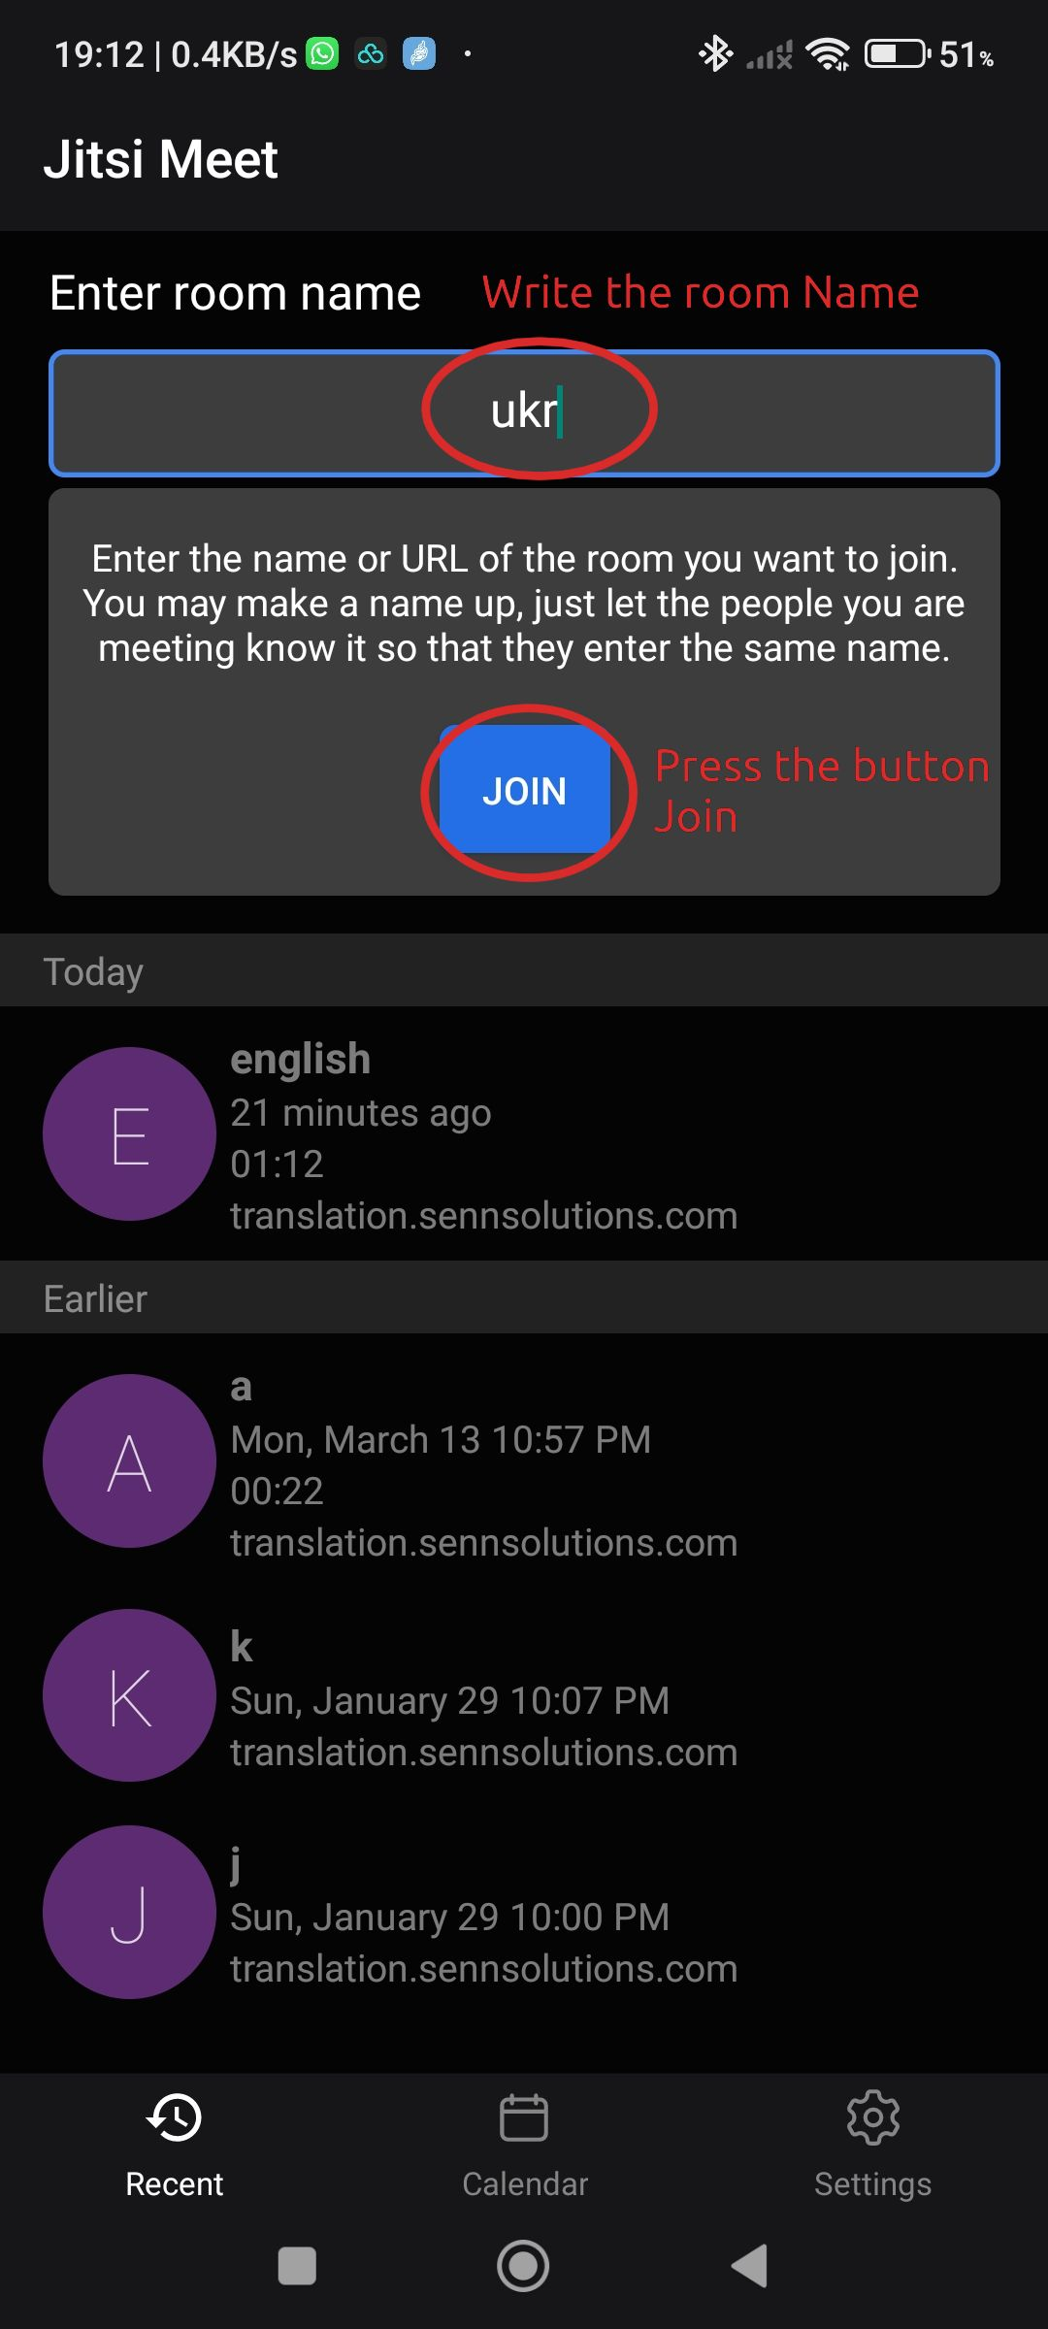
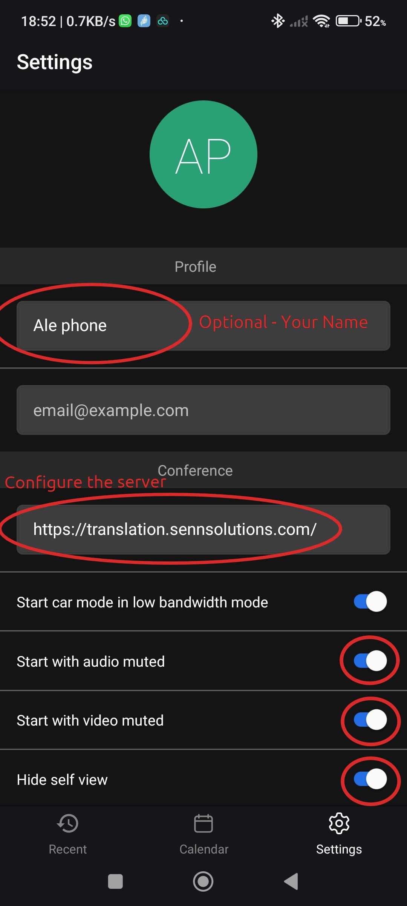

Disable Private DNS on Android’s phones
If you cannot connect to Jitsi try disabling the private DNS options
