
Do you want to listen the English translation with your smartphone?

Follow the follow steps to have it:
- Download VLC player from your phone market / this step is not needed if you have Chrome Browser already installed. YOU NEED AN INTERNET CONNECTION HERE
- Connect to the internal WIFI. The WIFI’s name is either Translation or Translation_5G . The password is EnglishService
- If you are using VLC, configure it to open the stream http://translation:80/en or http://192.168.1.2:80/en / if you are using Chrome open the same address in it.
Enjoy the service.

Scope
The purpose of this document is to guide you to configure your mobile phone to receive the real time translation.

Install the app you need
In your apps market ( play for Android and Apple store for Iphone) install VLC player.

Android | Iphone
https://play.google.com/store/apps/details?id=org.videolan.vlc&hl=en  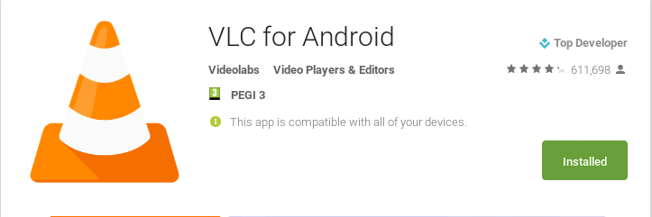 | 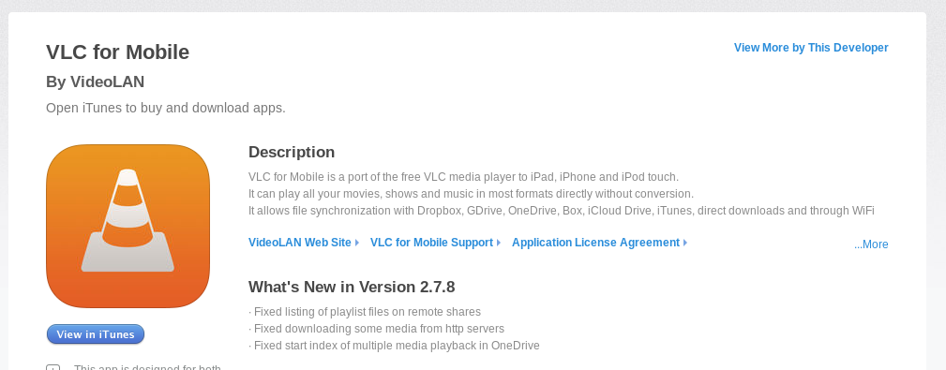  https://itunes.apple.com/us/app/vlc-for-mobile/id650377962?mt=8

Connect to the internal WIFI
The internal wifi SID is called translation ( old phone ).Search and Connect to it with the password: YOUR_WIFI_PASSWORD_HERE
Or use the SID translation_5G ( new phone ). password : YOUR_WIFI_PASSWORD_HERE

Once connected to this wifi you will not have anymore the normal internet connection. Therefore no online bible...no online dictionary ...no online messaging! Download VLC with your data plan before connecting to the internal WIFI.

Configuration
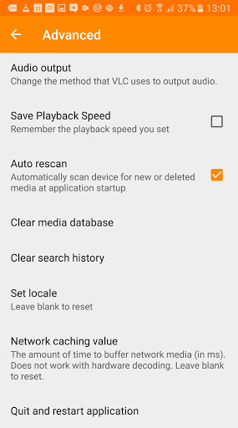
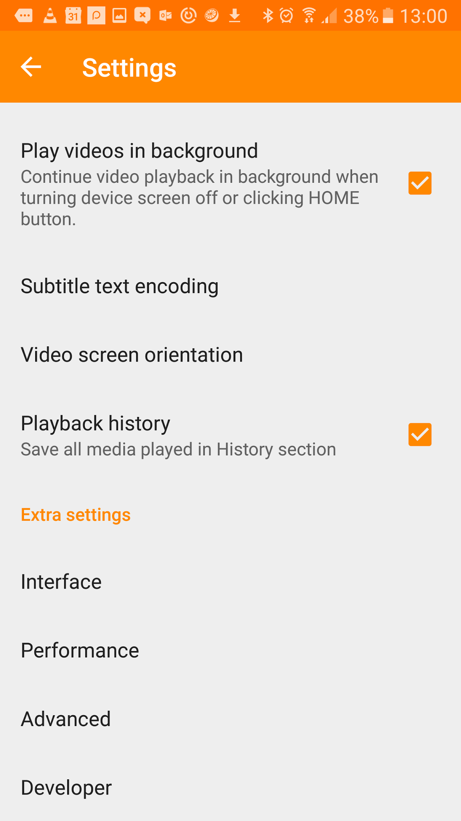
Go in settings → Advanced → Network caching value → specify 0

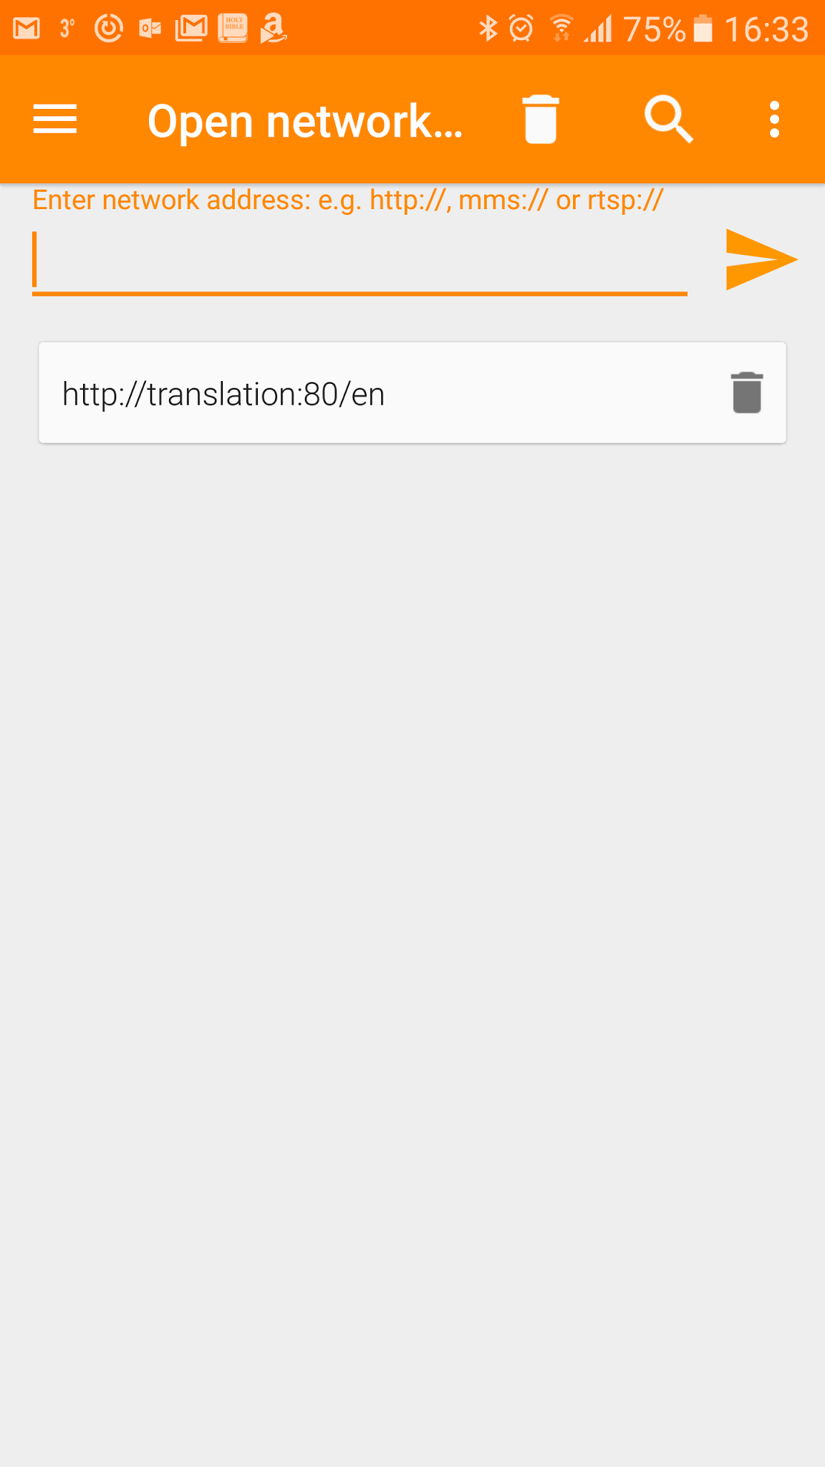
Listen the translation

In the main menu ( upper - left ) select stream.
Specify the url:
http://translation:80/en
Press the left right arrow to start listen.

In case of problem contact THE SUPPORT CONTACTS and / or the Audio guys.

