Instructions for the Translator
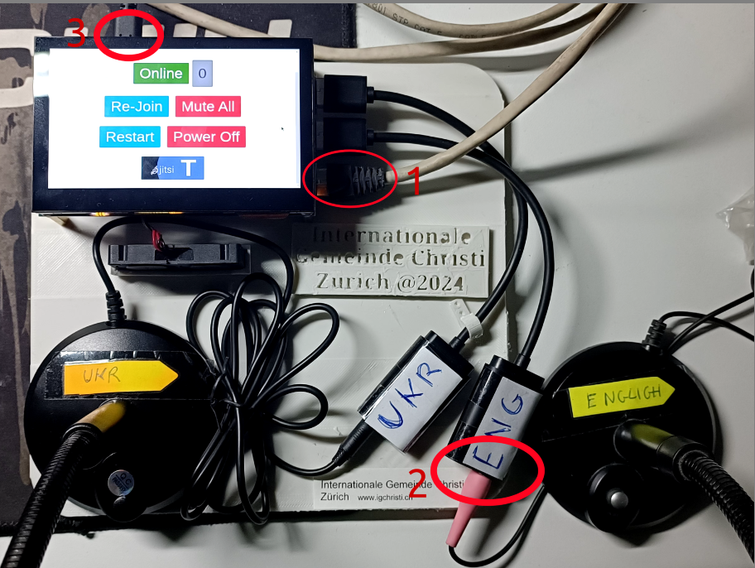
1. Connect the network cable from the Router to the Raspberry-PI (1)
2. Attache the ENGlish microphone to the pink connector (2)
2. Attach the power. (Black cable) (3)
MUTED

UN-MUTED

3. Wait till you will see on the display the follow window. At this point the system is ready.
Here is shown your status (Online/Muted)
and the number of listeners
Every new users will be automatically muted. How can be useful to mute all the participants if any listeners hear noise.
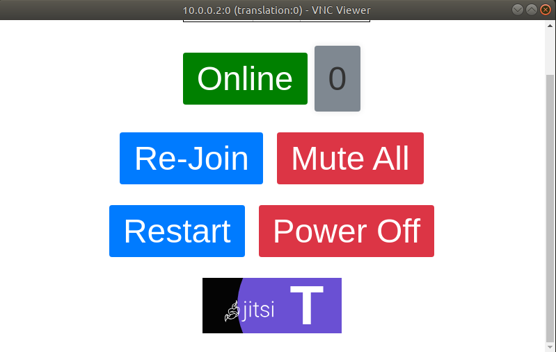
Press the button to rejoin the conference.
You shouldn’t need it.

At the end of the service press the button
and the detach the power cable (black), the network cable and the English microphone.
Press the Restart Button
if something is not working properly.
The system will take few minutes and restart

