Using ANSIBLE set OSPF and ACL on GNS3 environment

# Objectives

Part1:LaunchtheDEVASCVM

Part2:Configure Ansible to Connect on GNS3

Part3:Use Ansible to Configure OSPF

Part4:Use Ansible to Configure ACL

# Background/Scenario

In this lab,you will explore the fundamentals of how to use Ansible to automate some basic device management task. First, you will configure Ansible in your DEVASC VM. Next, you will use Ansible to connect to the GNS3 and configure OSPF and ACL on IOS Router.

# RequiredResources

* 1PC with operating system of your choice
* VirtualBoxorVMWare
* DEVASCVirtualMachine
* GNS3

# Instructions

## Launch the DEVASCVM and GNS3

If you have not already completed the **Lab - Install the Virtual Machine Lab Environment**, do so now. If you have already completed that lab, launch the DEVASC VM now.

If you have not already completed the **Lab-Install the DEVASCLAB and GNS3**,do so now. If you have already completed that lab, launch the GNS3 now.

## Configure Ansible and Connect with GNS3

In this part, you will configure Ansible to connect with GNS3

First set ansible.cfg file with such things

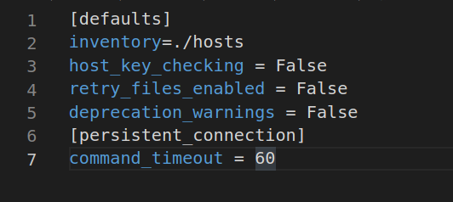

Second change the IP address of hosts

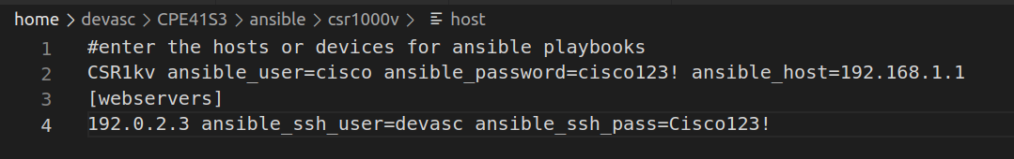

In this part GNS3 Router have set 192.168.1.1 address so input on ansible_host

Third Add setting on Router1 at GNS3

* Input username R1 password Cisco123!
* Input line con 0 login local
* Input line vty 0 15 login local transport input ssh
* Input line vty 5 15 login local transport input ssh
* Input Crypto key gen for SSH connection (ANSIBLE need at least 2.0 ver of SSH) so put 512 bit on module then you can get 1.99 version of ssh so after that declare ip ssh version 2 for fix to version 2

So basic setting of GNS 3 is done

Fourth go back to DEVASCVM check connection with GNS 3 using SSH command



After that Input Cisco123! For password so now You can access GNS3 R1 Router

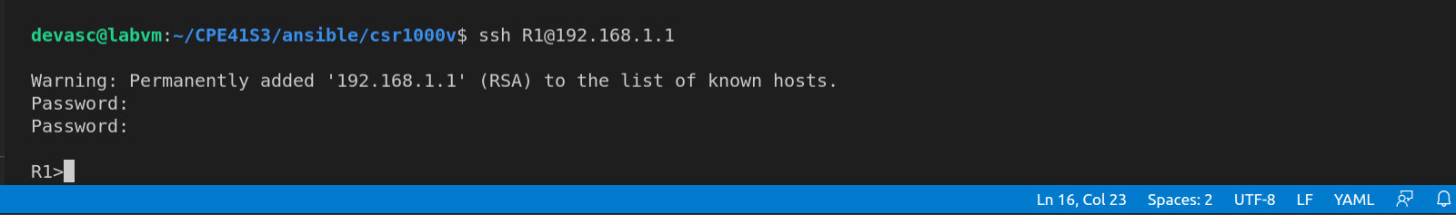

## Use Ansible to Configure OSPF

We have done with connection between GNS3 and Ansible on VM so In this part We are going to Code how to input OSPF on GNS3 through Ansible

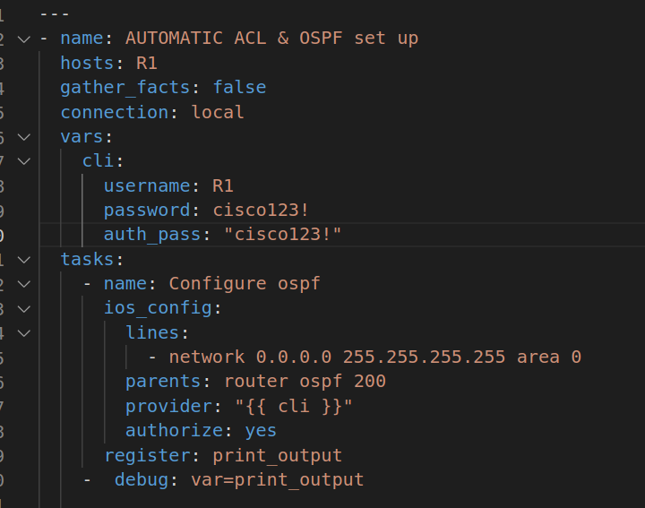

Here is The code for OSPF. In vars: we have to declare such cli for privilege increase for setting OSPF on R1

so input username and password, auth_pass

after that , in task put name of process. Declare line and parents for OSPF then we have to put provider for privilege. and “{{ cli }}” will be input values for login into R1 also have to declare authorize: yes because It make ansible to use “en” option on R1

then finally declare register: print_output for loging on DEVASC VM with “ – debug: var= “

## Use Ansible to Configure ACL

We have done with connection between GNS3 and Ansible on VM so In this part We are going to Code how to input ACL on GNS3 through Ansible

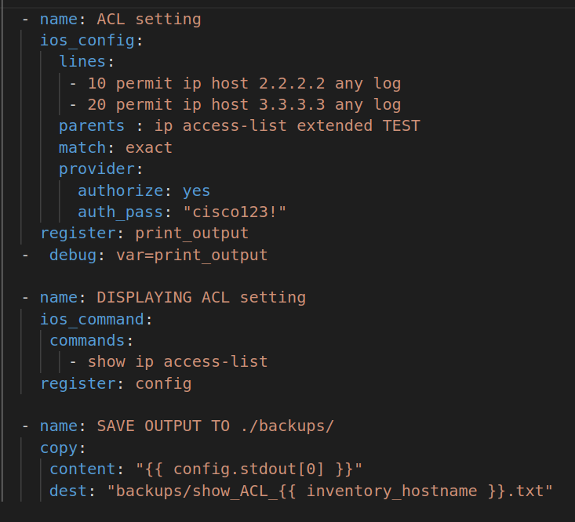

Here is The code for ACL.

It is almost same with OSPF but It would not use variable for privilege increase just declare authorize: yes and auth_pass on provider

then finally declare register: print_output for loging on DEVASC VM with “ – debug: var= “ and backup

Here is the last Demonstration

