Todo Management API
DSS2 Project Report

1. Project Overview
This project is a RESTful Todo Management API built with ASP.NET Core (.NET 10). It provides a backend for managing personal todo items with full CRUD operations, JWT authentication, pagination, filtering, sorting, and search. A React frontend is included for visual interaction.
The backend runs on port 3087 and is fully containerized using Docker.

2. How to Run Locally

2.1 Prerequisites
- Visual Studio 2022 or later
- .NET 10 SDK
- SQL Server LocalDB (included with Visual Studio)

2.2 Steps
- Open Todo.Api.sln in Visual Studio
- Set the startup profile to 'http' in the dropdown next to the Run button
- Press F5 or click Run
- The API starts at http://localhost:3087
- Open Swagger at http://localhost:3087/swagger/index.html

2.3 Database Setup
Migrations are applied automatically on startup. On first run, the application will:
- Create the TodoDb database
- Create the Users and TodoItems tables
- Apply all pending migrations

3. How to Run with Docker

3.1 Prerequisites
- Docker Desktop installed and running

3.2 Steps
Navigate to the project folder and run:
docker-compose up --build
This starts two containers:
- db — SQL Server 2022 on port 1433
- api — Todo API on port 3087

To stop the containers:
docker-compose down

To restart without rebuilding (after first build):
docker-compose up

3.3 Environment Variables (docker-compose.yml)
Variable | Value
ASPNETCORE_URLS | http://+:3087
ConnectionStrings__DefaultConnection | Server=db;Database=TodoDb;User=sa;...
Jwt__Key | super-secret-key-minimum-32-characters-long!
Jwt__Issuer | Todo.Api
Jwt__Audience | Todo.Api

4. API Endpoints
Method | Path | Auth | Description
POST | /api/auth/register | No | Register a new user
POST | /api/auth/login | No | Login and get JWT token
GET | /api/todos/public | No | List public todos
GET | /api/todos | Yes | List user's todos (paged)
POST | /api/todos | Yes | Create a todo
GET | /api/todos/{id} | Yes | Get todo by ID
PUT | /api/todos/{id} | Yes | Update a todo
PATCH | /api/todos/{id}/completion | Yes | Toggle completion
DELETE | /api/todos/{id} | Yes | Delete a todo

5. Swagger Documentation

5.1 API Overview
Swagger UI is available at http://localhost:3087/swagger/index.html
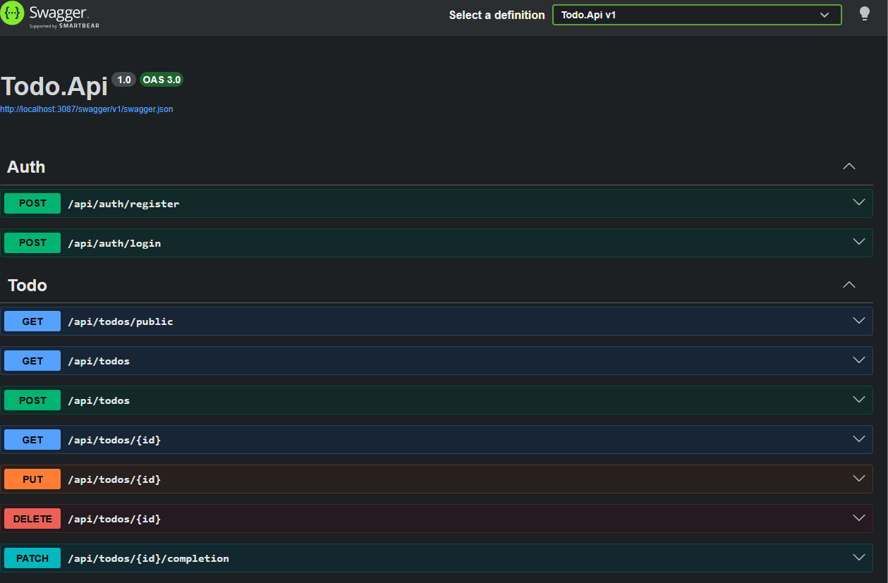

5.2 User Registration (POST /api/auth/register)
Request body contains email, password, and optional displayName. Returns 201 with user data.
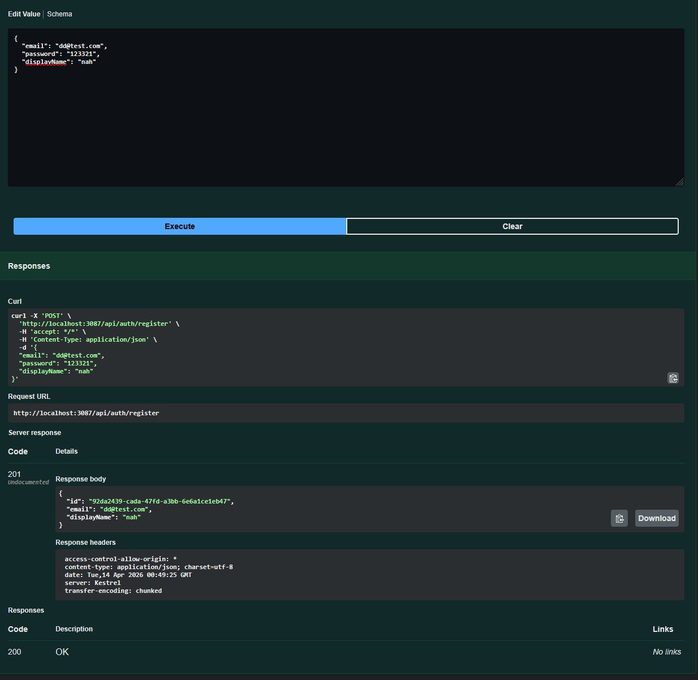

5.3 User Login (POST /api/auth/login)
Returns a JWT access token used for authenticated requests. Token expires in 3600 seconds (1 hour).
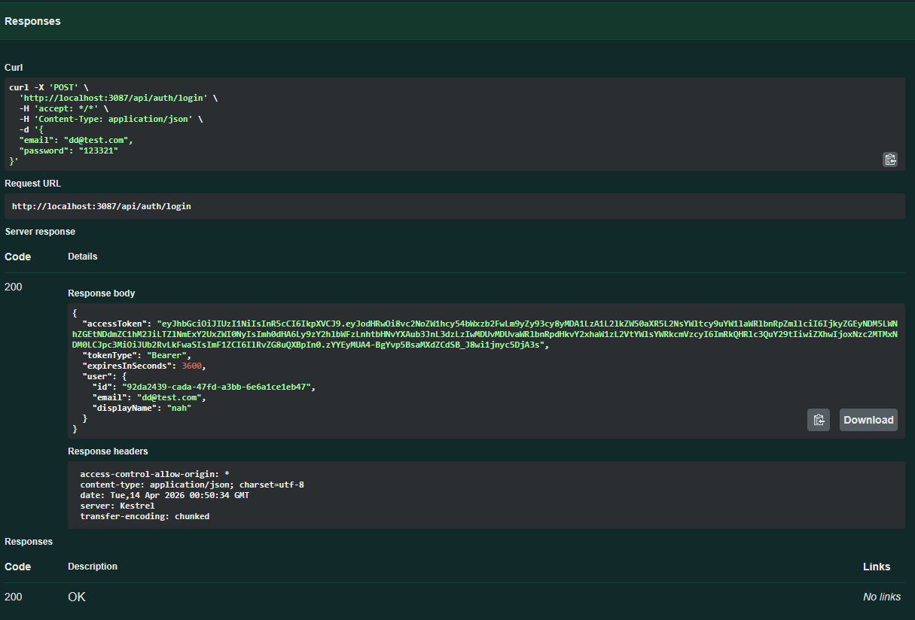

5.4 Create Todo (POST /api/todos) — 401 Without Token
When no JWT token is provided, the endpoint returns 401 Unauthorized. This demonstrates that authentication is correctly enforced.
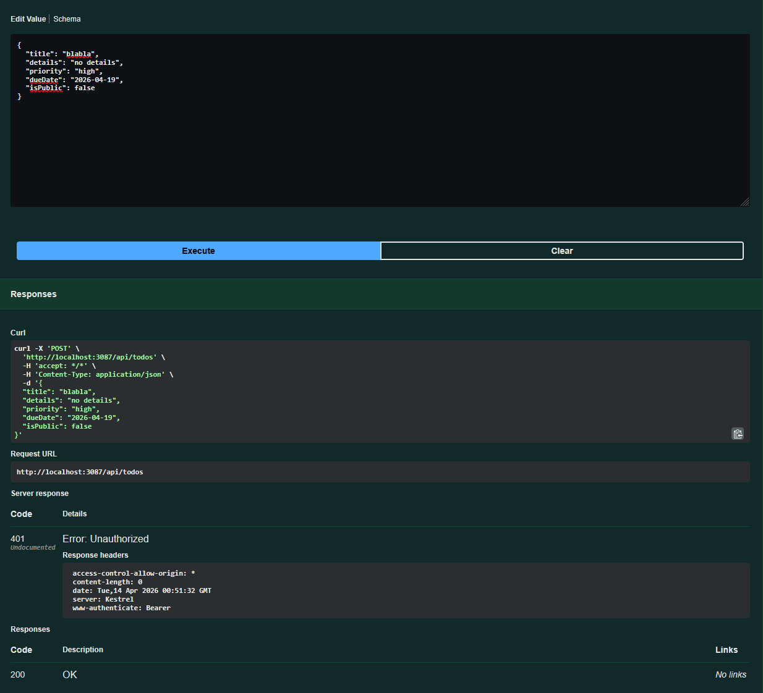

6. Database Tables

6.1 SQL Server Object Explorer
The TodoDb database contains two tables: dbo.Users and dbo.TodoItems. The __EFMigrationsHistory table tracks applied migrations.
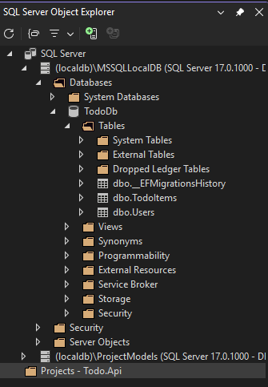

6.2 Table Structure
Users table:
Column | Type | Description
Id | uniqueidentifier | Primary key (UUID)
Email | nvarchar(max) | Unique email address
PasswordHash | nvarchar(max) | BCrypt hashed password
DisplayName | nvarchar(max) | Optional display name
CreatedAt | datetime2 | Registration timestamp

TodoItems table:
Column | Type | Description
Id | uniqueidentifier | Primary key (UUID)
UserId | uniqueidentifier | Foreign key to Users
Title | nvarchar(max) | Todo title (required)
Details | nvarchar(max) | Optional description
Priority | nvarchar(max) | low / medium / high
DueDate | date | Optional due date
IsCompleted | bit | Completion status
IsPublic | bit | Public visibility
CreatedAt | datetime2 | Creation timestamp
UpdatedAt | datetime2 | Last update timestamp

7. Frontend
The React frontend runs on http://localhost:5173 and communicates with the API on port 3087.
Features:
- Register and login
- View, create, edit, delete todos
- Filter by status and priority
- Search by keyword
- Sort by created date, title, priority, due date
- Browse public todos without login

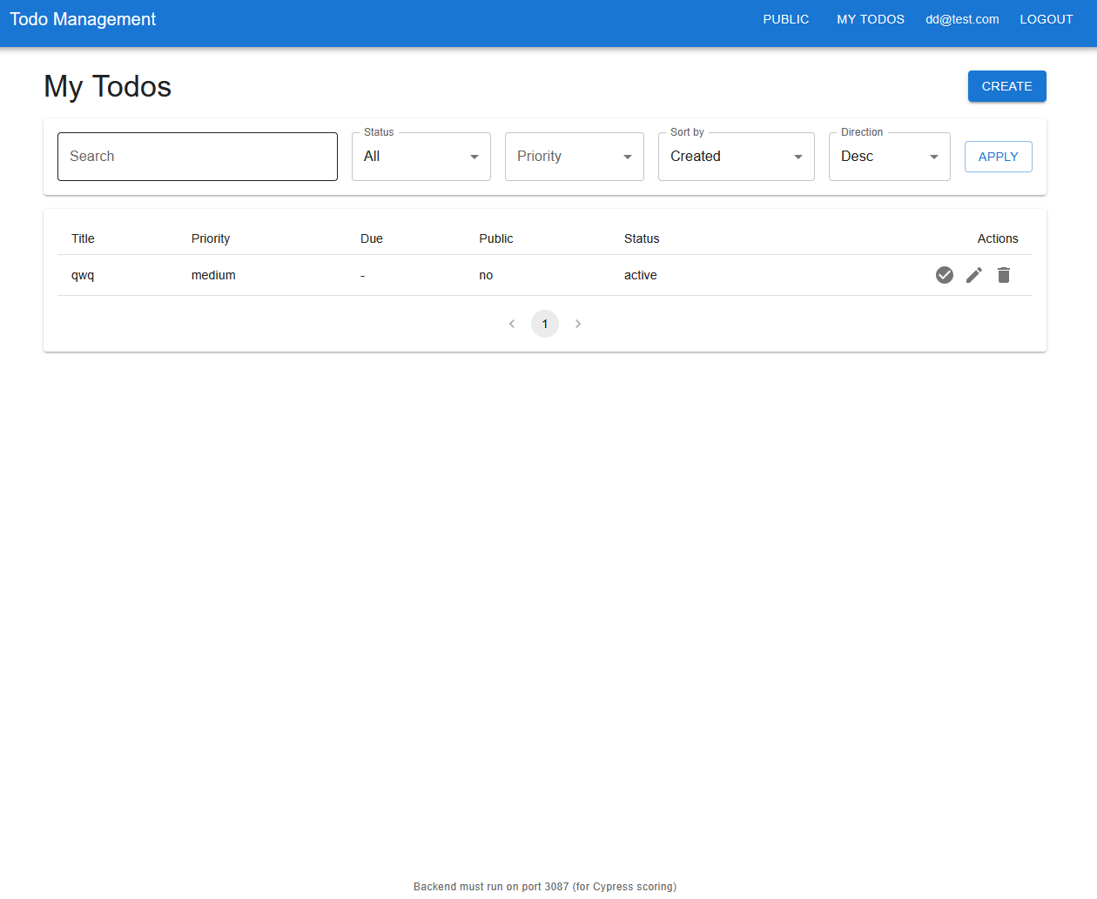

8. Project Structure
Folder/File | Description
Controllers/ | HTTP endpoint handlers (AuthController, TodoController)
Services/ | Business logic (AuthService, TodoService)
Models/ | Entity Framework models (User, TodoItem)
DTOs/ | Request/Response data transfer objects
Data/ | AppDbContext — database connection
Migrations/ | EF Core database migrations
Program.cs | Application entry point and configuration
Dockerfile | Docker image build instructions
docker-compose.yml | Multi-container setup (API + SQL Server)

9. Technologies Used
Technology | Purpose
ASP.NET Core 10 | Web API framework
Entity Framework Core 10 | ORM for database access
SQL Server 2022 | Relational database
JWT Bearer | Authentication tokens
BCrypt.Net | Password hashing
Swashbuckle/Swagger | API documentation
Docker + Docker Compose | Containerization
React + MUI | Frontend UI

