Arctic Foxes
By Isadora White

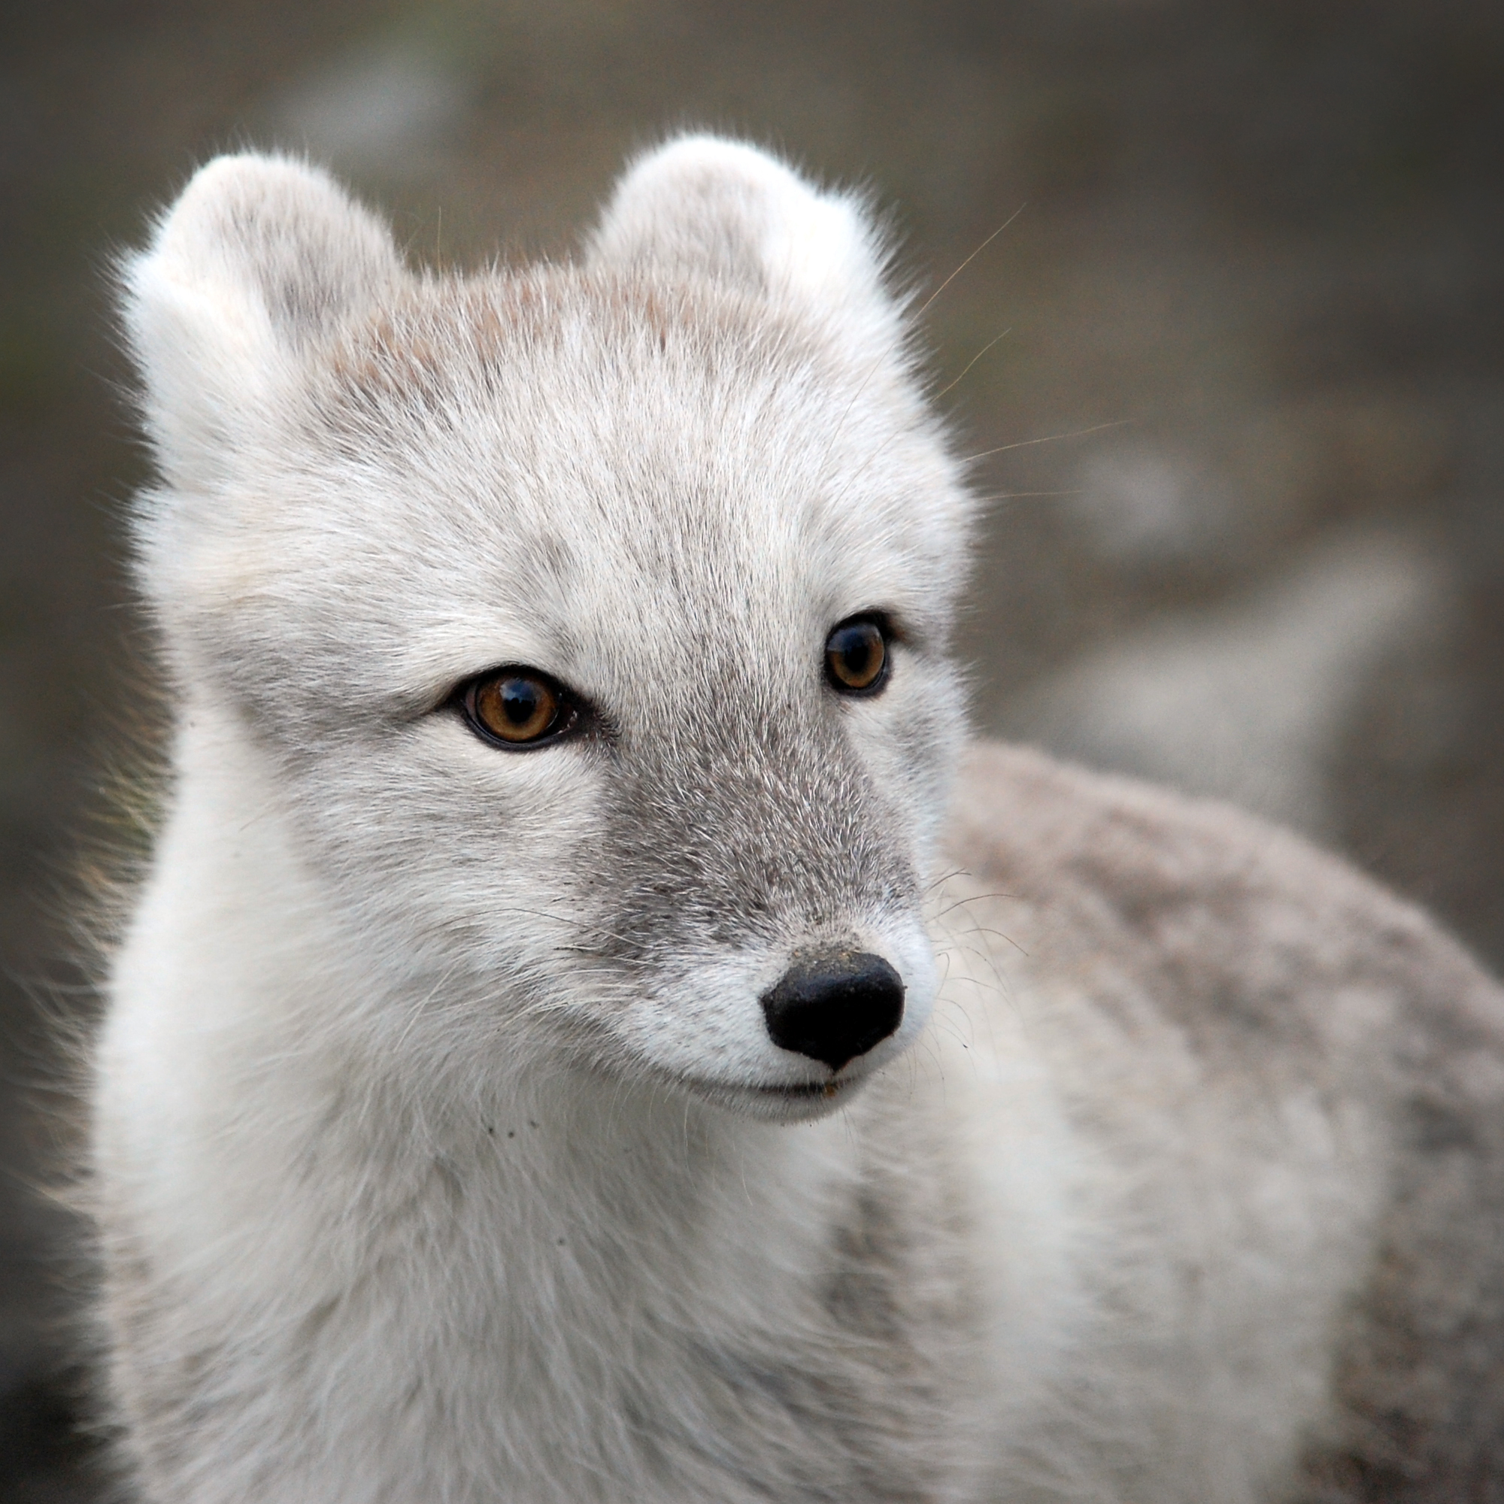

Table of Contents

Description and Adaptations.................................page 1
Lifestyle..................................................................page 2
Communication, Enemies and Dangers..................page 3
Food........................................................................page 4
Habitat.....................................................................page 6
Map..........................................................................page 7
Trivia.........................................................................page 8
Sources.....................................................................page 9

Description and Adaptations
The arctic fox is about the size of a large cat or a small pet dog. It is smaller than it looks, because it has long, fluffy fur that keeps it warm. The arctic fox weighs 2.5 kg to 9 kg and are 28 cm to 32 cm tall. Its body length is 50 cm to 70 cm, but most of it is tail because 28 cm - 40 cm is tail.
Arctic foxes have beautiful snow white coats and sometimes they are pale bluish-grey. Arctic foxes are bluish when they are close to the coast, but not always. They turn brown or a darker bluishgrey in the summer so they can blend in a bit better.
Arctic foxes have lots of fur on their paws to stop them from slipping on ice and so they can stay on top of the snow. They also have a bushier tail for warmth, which they warp around themselves. This is why their tail is so long.
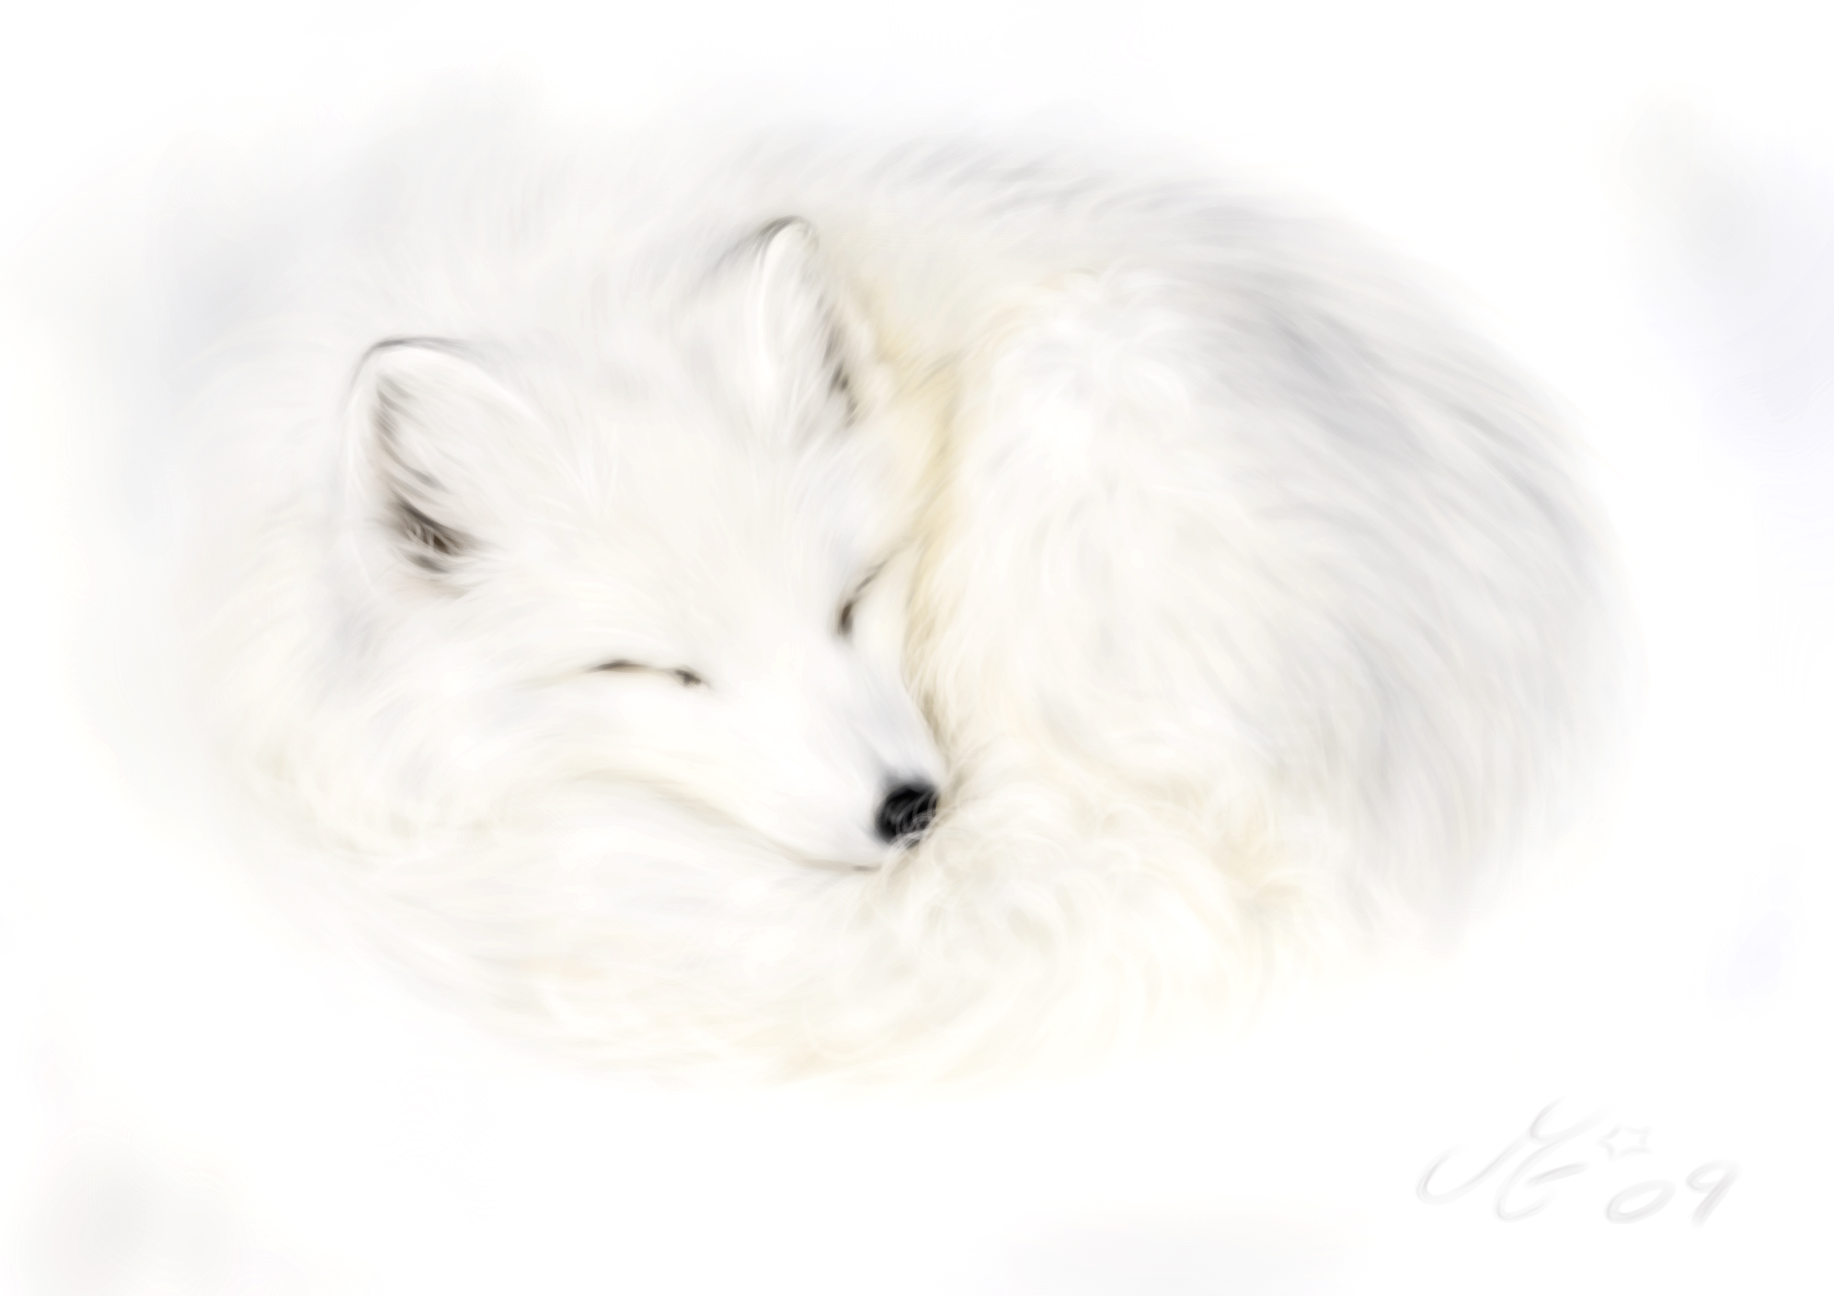

Lifestyle

Arctic fox kits are raised by their mother and father in a den. Sometimes the previous litter will stay to help their mother and father raise new young. There can be 5 to 8 kits in a litter, but most of the time there are 10 or 11. Sometimes there can be up to 25 kits in one litter even though the gestation period is only 51-57 days!!!

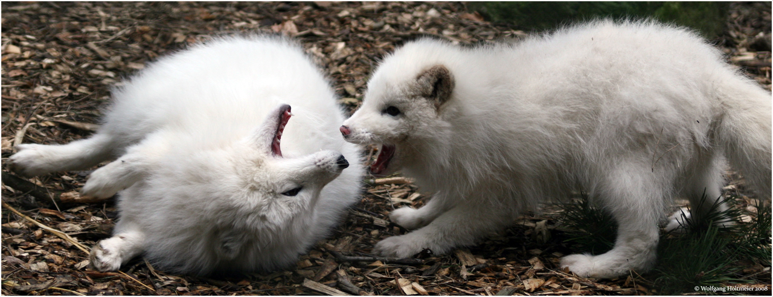

Communication, Enemies and Dangers

The arctic fox is seldom heard. It will bark to warn off intruders and to alert other foxes of danger. You will also hear them during mating season.
Arctic foxes have many predators and dangers. The arctic fox is hunted by golden eagles, polar bears, wolverines, snowy owls, and wolves. They are also hunted by humans, because their coat is so beautiful and warm. Global warming is causing the red fox to move into arctic fox dens and eat all their prey.

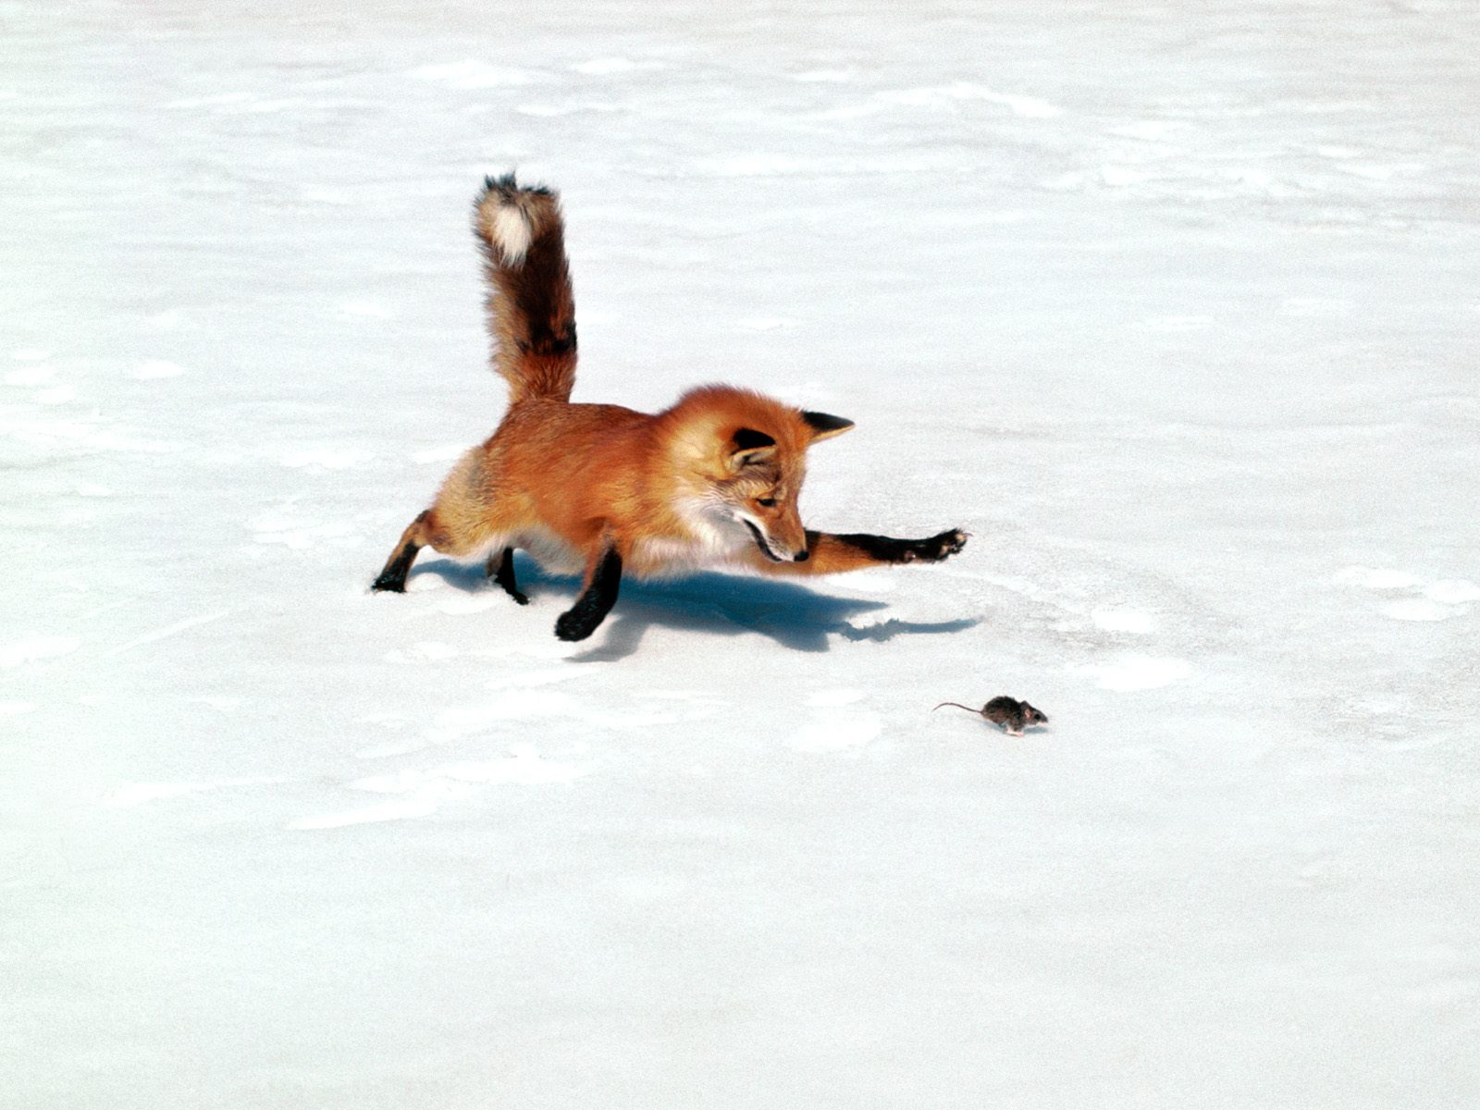

Food

Arctic foxes eat lemmings, arctic hares, and ringed seal, which makes them carnivores. Lemmings are arctic foxes favorite food and they eat a lot of them. Sometimes they will eat dozens a day to feed their family. However, they will eat most anything including fruit, berries and eggs even though they are carnivores.
Arctic foxes follow polar bears and eat their leftovers. They also follow bird researchers around, because they see food and they follow food even if it is with weird two-legged creatures (humans). They also follow bird researches to hopefully catch some birds and steal their eggs.
Arctic foxes get their food by walking quietly on the snow listening for lemmings or arctic hares scampering under the snow. Then, the arctic fox hears a lemming scampering under the snow not far away. The arctic fox stalks the lemming, pounces, and punches the snow, and grabs the lemming.
The arctic fox may eat a lot of lemmings, but they aren't a reliable food source, because they follow a boom bust-cycle. The boom-bust cycle goes like this. First, the population slowly goes up. Then, it reaches a high peak. Finally, the cycle comes to an end by all the lemmings (or most) surprisingly vanish. All of this happens in the span of four years.

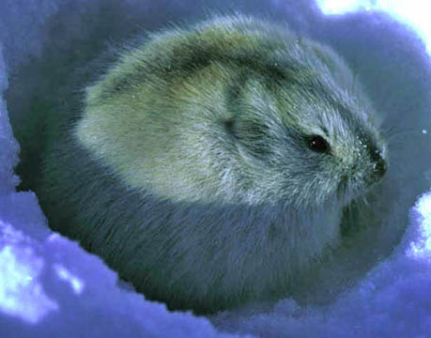Lemming

Habitat

The arctic fox lives in tundras in the Arctic Circle. This includes Greenland, Iceland, North America, Russia and Scandinavia and it does very well in these place and that is why they are not endangered. They are adaptable, because they can eat a lot of different foods, which includes sea birds, geese, and their eggs.
The arctic fox's den is dug into the side of high ledges, hills and cliffs. These dens have more than one entrance and can be complex underground places that are home to many foxes. Sometimes they are simply dug into a snowbank.

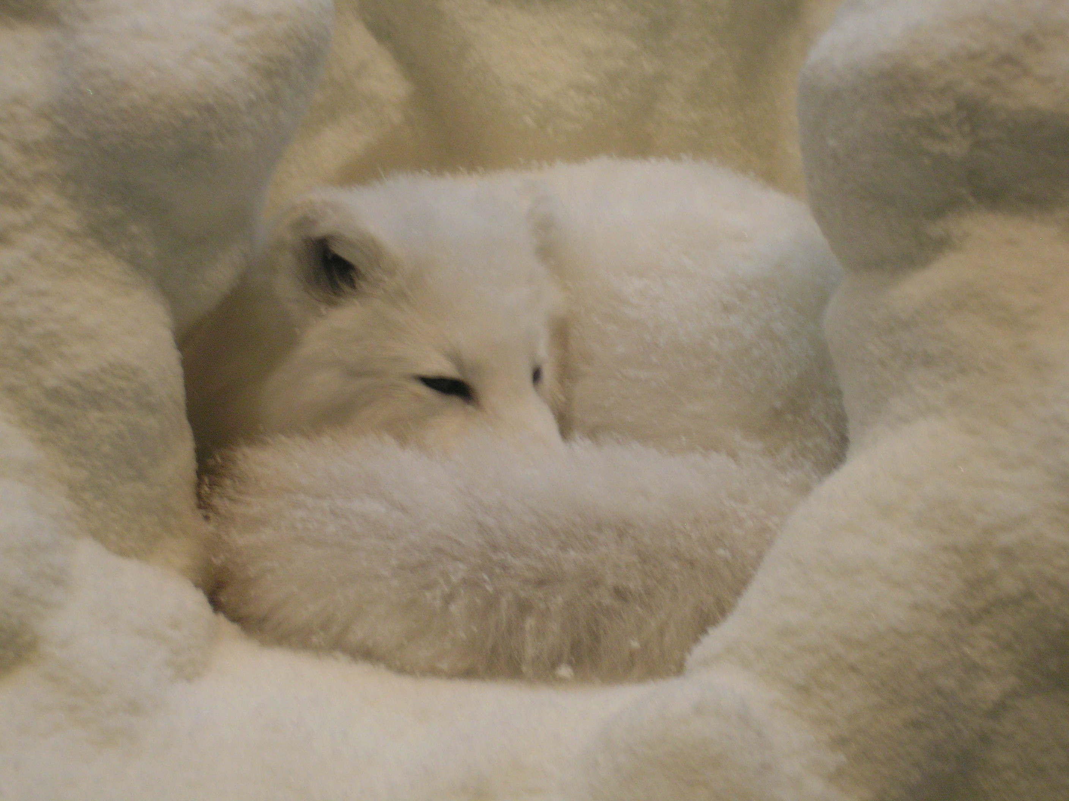

Map
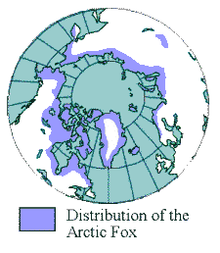

Trivia

- Arctic foxes have the largest litter of all mammals.
- Arctic foxes have the warmest coat.
- Arctic foxes can hear their prey under the snow.
- Arctic foxes don't hibernate.
- Arctic foxes mate for life.
- Arctic foxes have really bushy tails they use for warmth.
- Arctic foxes have claws.
- Arctic foxes and many other species are related (very distantly) to miacis, which are cat-dog creatures.

Sources

- Snow fox – National Geographic Magazine
- www.wikipedia.com/arctic_fox
- www.alexandgregory.com/arcticfox.html
- Arctic Fox information – adaptaions for living in the Arctic year ... www.saskschools.ca/arctic/afox.html
- Hinterland Who's Who – Arctic Fox

