The Lake Harriet Band-Shell
Introduction
Even as early as 1880, newspaper editorials have campaigned for a park that would provide a place for the city band to perform. There were five attempts including our current Band-Shell to create a park like this. The first pavilion was built in 1888, “The Grand Pavilion.” But sadly this pavilion was destroyed by fire, 4 years into its career. Next, in 1891 the Pagoda Pavilion was built – just in time for the next season for the band. This band shell was destroyed in 1903 quickly ending its fame.
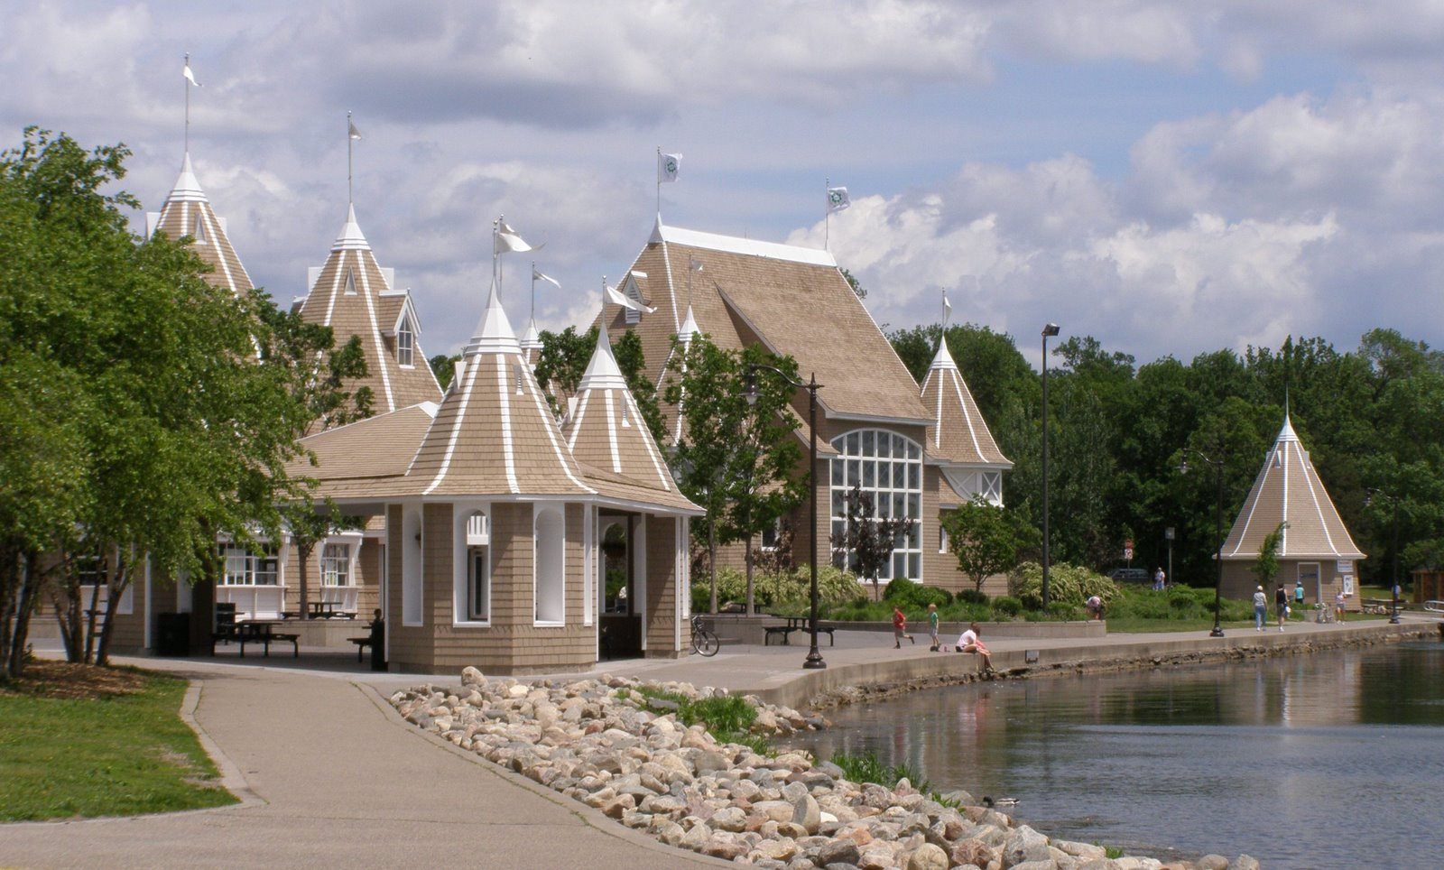

The people were not disheartened by the destruction of the previous two pavilions so they created the People's Pavilion in 1904. The People's Pavilion to the gratitude of the architects was not destroyed until it collapsed in 1925. The People's Pavilion had lasted the longest of all the Band shell's so far. At this point the Park Board did not have enough time or money to bother with another band shell, which was unfortunate for the people desperately wanted one. Grudgingly the Park Board came up with a “Temporary” Solution. This “Temporary” solution was not at all temporary and lasted until 1985 when it was torn down to make room for the current band shell. Hopefully, this one will not be destroyed soon.

Exterior
Today's band shell is a large open-air building. There is a boat house and a restaurant called Bread + Pickle, where you can get refreshments. The original band shell in 1888 was quite different and similar to our band shell today. “The Grand Pavilion” was founded by Thomas Lowry on private property. Thomas Lowry's car industry was booming and Thomas Lowry spent his money on a private band shell for his company. This band shell had an area on the roof , where the new city band could perform. People could pay to sit on the roof and listen to music. The roof only seated 50 people – not nearly as much as our current band shell.
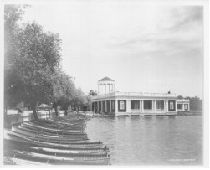

The Pagoda Pavilion in 1892 was designed like a Chinese Lumber Pagoda. It had a floating band shell on water. It was a majestic building until the band shell was blown out to the middle of the lake destroying it. Only 4 musicians made it back alive. The People's Pavilion also known as the Classic Revival Pavilion in 1904 was a huge building on land with a stadium that could hold up to 500 people. The Classic Revival Union is shown in the post card above. This was shown to VIPs who came to the Lake Harriet region.

Interior
Inside the Lake Harriet Band Shell, today, marriage ceremonies are occasionally held. Band concerts are held inside the band shell during the summer. The Grand Pavilion's interior was mainly used for parties and celebrations for Thomas Lowry's company and his personal relaxation. The Grand Pavilion also hosted Operas every Sunday but a minister objected to the fact that the Operas were on Sunday and eventually the Minister won out and they had to stop the Operas.

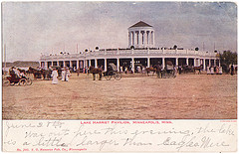

Residents
In 1885, Colonel William S. King lived in the Twin Cities and owned a great big territory where Lake Harriet is today. Then, one day he sold his land to the Park Board to do what they wished with it. The Park Board named the lake, Lake Harriet for Harriet Lovejoy – Colonel William S. King's wife. The Park Board eagerly used the land to build the Grand Pavilion. But, as time went by and the pavilions got more popular, the crowds and the ruckus got more and more. The nearby residents did not like this for it often disturbed their peace and quiet. They started protests to try to make the Pavilion quieter but to no avail.

Activities
Much like the current Lake Harriet Band shell the People's Pavilion and the Pagoda Pavilion hosted entertainment and dancing. People could hold marriage ceremonies there and choose what color flowers they wanted, whether they wanted it to be public of private and who to invite. As depicted in a picture of the Classic Revival pavilion (People's pavilion) many people enjoyed canoeing, swimming and sailing on the lake.

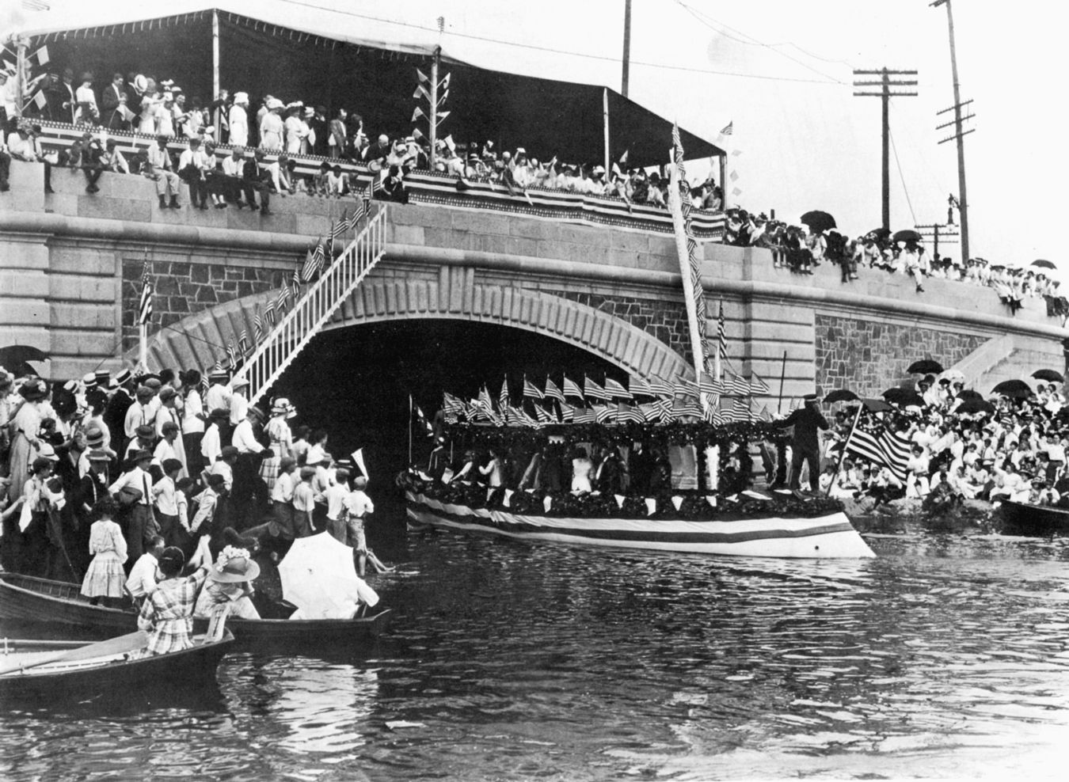

Extra Credit

The Pagoda Pavilion was one of the most popular band shells. It had a floating band shell. The band shell was tied to the Pagoda Pavilion by strings and cords. Then one day in 1903 towards the end of its last summer, a breeze started to pick up. The cords tying the band shell to the Pavilion snapped and the band shell with the entire band members aboard, floated out into the middle of the lake. The musicians played music calling for help. Three musicians were rescued by boat and another floated back to shore clinging to the remains of the band shell.

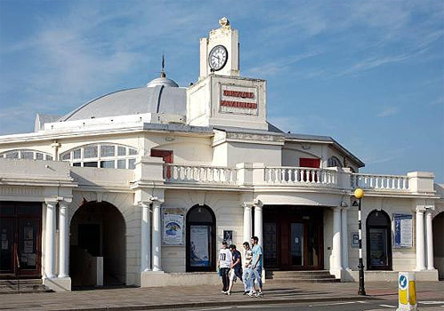

Conclusion

The Lake Harriet Band Shell has come along way since its beginnings in 1888. From the Grand Pavilion to the Pagoda Pavilion to the Classic Revival Pavilion (People's Pavilion) to the “Temporary” solution to now. People to this day visit the Lake Harriet Band shell to listen to concerts and enjoy refreshments. Hopefully this last one will out last all the previous.

Bibliography

Books
Smith, David C. City of Parks: The Story of Minneapolis Parks. Minneapolis, MN: Foundation for Minneapolis Parks, 2008. Print.
This book had a valuable chapter on the Lake Harriet Band shell. It helped me guide my research

Haugo, JoEllen. "Chapter 5." Down at the Lake: A Historical Portrait of Linden Hills and the Lake Harriet District. Minneapolis, MN: Linden Hills History Study Group, 2001. N. pag. Print.
This chapter of this book was a very valuable resource to me. It helped me find information on Lake Harriet.

Lanegran, David A., and Ernest Robert Sandeen. The Lake District of Minneapolis: A History of the Calhoun-Isles Community. St. Paul: Living Historical Museum, 1979. Print.
This book was a very useful source. It gave me good information and photos.

Websites

Nowak, Alison. "The Up and Down History of the Lake Harriet Pavilions - Southwest Minneapolis, MN Patch." Southwest Minneapolis Patch. Alison Nowak, Mar.-Apr. 2011. Web. 19 May 2013.
This website had good info on the Lake Harriet Band shell. It helped me set the foundation for my research.

"Minneapolis Parks and Lakes." Minneapolis Park & Recreation Board. N.p., n.d. Web. 19 May 2013.
This was a good resource. It helped me gain understanding for my research.

Photos

www.robandbee.com/lake-harriet-band-shell-refectory.jpg
This Photo was a Primary source. It helped me gain understanding for my research.

http://25.media.tumblr.com/tumblr_lj8sms9kVk1qgdi7so1_1280.jpg
This Photo was also a primary source. It helped me guide my research.

http://minneapolisparkhistory.files.wordpress.com/2010/09/mpls-parks-fig-15-03.jpg
This Photo is a picture of boats on Lake Harriet. Boating was very popular on Lake Harriet.

8084829404_e93da06_m.jpg
This is a Photo of the Classic Revival Pavilion. It helped me gain understanding

Photo taken by Isadora White 2013 May 14th

The Lake Harriet
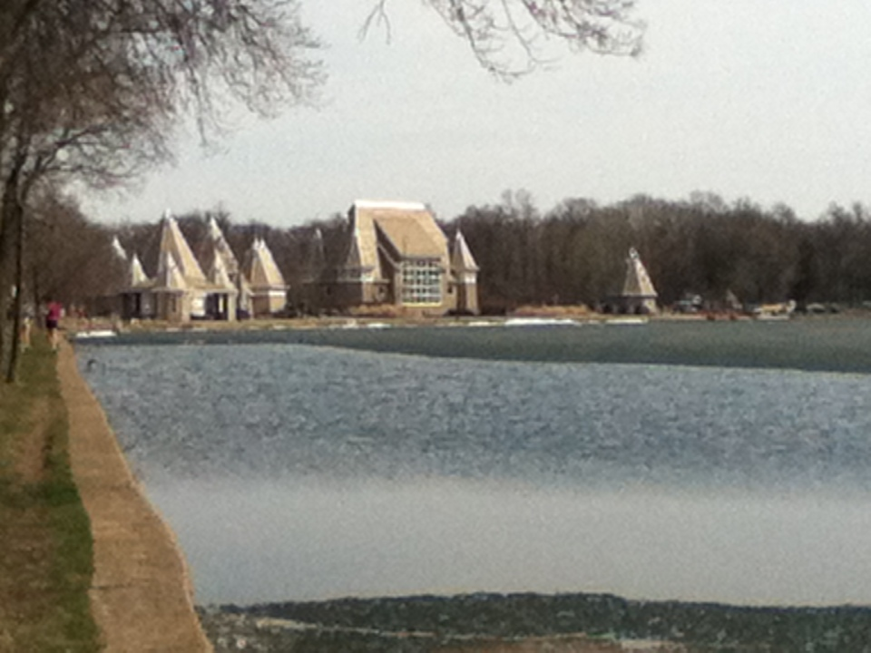
Band Shell
By Isadora White
May 22nd, 2013

