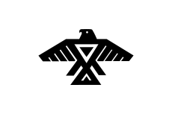
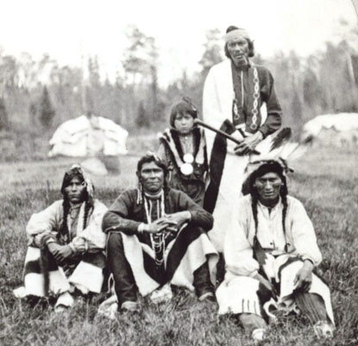
The Life

I woke up that morning at sunrise. My mother was calling me down by the Chi-si-bi ( the great river ). We were to go fishing down by the the Chi-si-bi. It is a year round activity in our tribe. We would hang heavy nets down into the river at nightfall and bring them back up at sunrise. We would then prepare the fish to be eaten by our tribe. The fish were always so delicious, my stomach growled already.
In the summer, the women of our tribe would gather wild foods from the great forest, which gave us life. The forest protected us and gave us food. The trees whispered, si-si-gwa-d ( the sounds the trees make). I never thought I would hear it for myself. My grandmother had told me of the trees and how they whispered to us. The trees looked down on the Ojibwe and smiled for the Ojibwe were the people of the forest. The trees swayed to convey warmth in its presence. They watched over us like the Gitchi Manito (great spirit).
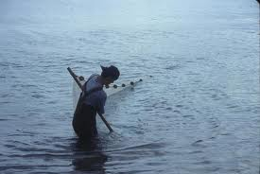

“Come quickly!” demanded my mother, snapping me out of my trance. I sprinted toward the river where my mother was waiting for me.
“There you are my son,” exclaimed my mother. “I need your help.”
As we worked to pull up the nets my mother whispered to me.
“My son,” she whispered, “there will be a time when your skills are needed. Change will come. Mi-gi-zi (eagle) has dreamed it.”
We finished pulling up the nets and I headed back to the camp. I passed by my aunt who was working on a small garden and went to my own little wigwam. I lay there bored thinking what I should do. It was the evening and I would have to lower the nets soon. I longed to go see the storyteller Mi-gi-zi (eagle). That is where I was headed.

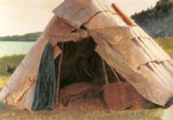

I rose from the bottom of the wigwam and pushed aside the birch bark mat that lay on top of our wigwam. I wandered through the Ojibwe tribe which I called home. I came to the wigwam closest to the middle. The elder tent where all the leaders and elders meet and discuss what they shall do next. Mi-gi-zi was kneeling on the ground praying to the Gitchi Manito. The Ojibwe religion was a world filled with spirits. The spirits were found in birds, animals, rocks, the sun, the moon, and even the four winds, lightning, thunder and thunder birds.
Each person was given a spirit at birth by a namer which found the spirit and song of the person. Often the spirit had to do with their name and they assigned a spirit which was often similar to one of the animal brothers (animals). My spirit was that of a wolf as my name, Ma-iing-an (wolf) implies. Mi-gi-zi had given me my name and I was proud of it.
Mi-gi-zi was smoking Ka-nik-a-nik (tobacco) to honor the Gitchi Manito. Mi-gi-zi turned around and looked at me. His face was grave and I could tell that whatever he was going to tell me was either vague or not good news.
“I have no tales today, Ma-iing-an, I am dreaming and I am afraid we may have to leave soon to find a better place. Strangers are coming” said Mi-gi-zi.
“Thank you for the news Mi-gi-zi”, I said “I shall leave now.”
I went to my wigwam and fell asleep.
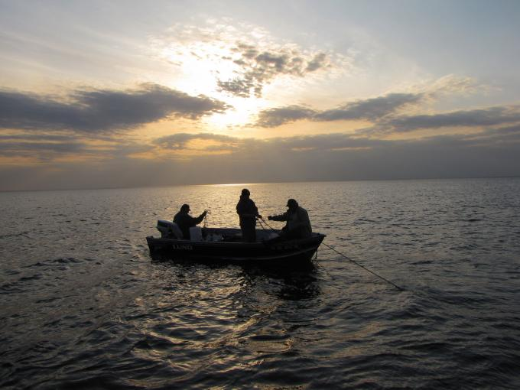
“Wake up! Wake up!” whispered my mother “Mi-gi-zi has dreamed that the strangers are near! Come quick!”
We all crammed into eight canoes and headed down the river to our next camp. I asked my mother why we were leaving and all she ever replied was “the strangers are coming!”
I joined some of the other boys in paddling the canoes. My father, Nii-gaa-nii (he leads) congratulated me on my hard work. I felt proud.

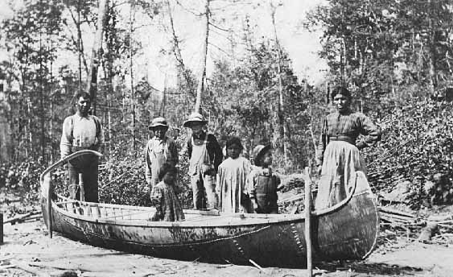
After the first day of our journey we landed on the shore of a lake. All the trees were cut down and almost none were left. The Chi-si-bi flowed beside us as usual but it was larger and more impressive. We looked ahead of us and saw no sign of a better place so we took camp there.
A few weeks passed and we traveled through the “dead lands” as Mi-gi-zi called it. He had promised that there would be a refuge for us at the end of the journey. He was right in a way none of us would imagine, but that was before we met the white men.
One morning a strange white man or was it a spirit was looking at us from a far. He made a motion as if for us to come closer. The elders discussed who they should send and it was decided they would send my father because he was the leader.
My father went over there and the strange white men and him began to talk. They had interpreter I saw. It was an Ojibwe but he was dressed in the manner of a white man. I was confused. My father came back from the debate, a grave look on his face.
“They have offered us a spot in the forest where we can stay, if we send our children to a big village where they will be educated in the ways of the white men.
There was a long council meeting on this topic and it was decided that the children would be sent to the school. I wanted to stay here but pouting would not be permitted in such grave times.
The next day my father dropped me off at the school. Many kids like myself ran to greet me. They spoke my language or some dialect of it and we instantly made friends. At the school they called me Sam Wolf and my teachers spoke in English. They taught me to write in this new foreign language and here I am writing you this story …
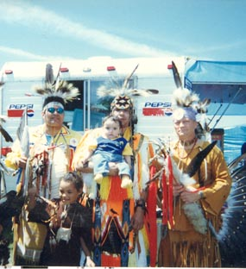

Bibliography

Sources
Broker, Ignatia, and Steven Premo. Night Flying Woman: An Ojibway Narrative. St. Paul: Minnesota Historical Society, 1983. Print.
This book helped me in my project because it gave me an insight on the way of the Ojibwe. It explained their culture and their language. I could not have done this project had we not read this in class.
Stan, Susan, and Luciano Lazzarino. The Ojibwe. Vero Beach, FL: Rourke Publications, 1989. Print.
I used this source because it examined the history, culture and present of the Ojibwe. I found this book in the library.
"Ojibwe Culture." Mpm.edu. Milwaukee Museum, n.d. Web. 18 Nov. 2012. <http://www.mpm.edu/wirp/icw-51.html>.
This website helped me understand in deeper depth about the Ojibwe. It explains all their beliefs and cultures. It also told me of what happened to the Ojibwe when the white settlers came.

Pictures and Sources
"Ojibwe People." Wikipedia. Wikimedia Foundation, n.d. Web. 18 Nov. 2012. <http://en.wikipedia.org/wiki/File:Anishinabe.svg>.
I collected both pictures and information from this site. I used it for the picture on the cover. I also used it to help me understand the Ojibwe's language and how they spoke it.
Pictures
"Apostle Islands." Nps.gov. National Park Service, n.d. Web. 02 Nov. 2012.
This picture is found on the title page.
"Mississippi Name Origin." Mississippi Name Origin. N.p., n.d. Web. 23 Nov. 2012. <http://www.statesymbolsusa.org/Mississippi/MissNameOrigin.html>.
Picture of the wigwam on page two.
"Paul Buffalo Biography -- Tim Roufs -- University of Minnesota Duluth." Paul Buffalo Biography -- Tim Roufs -- University of Minnesota Duluth. N.p., n.d. Web. 23 Nov. 2012. <http://www.d.umn.edu/cla/faculty/troufs/Buffalo/PB42.html>.
I got all the other pictures from this site. Not including the comic.

