The Suntribune
Attack of the cute
by Isadora White
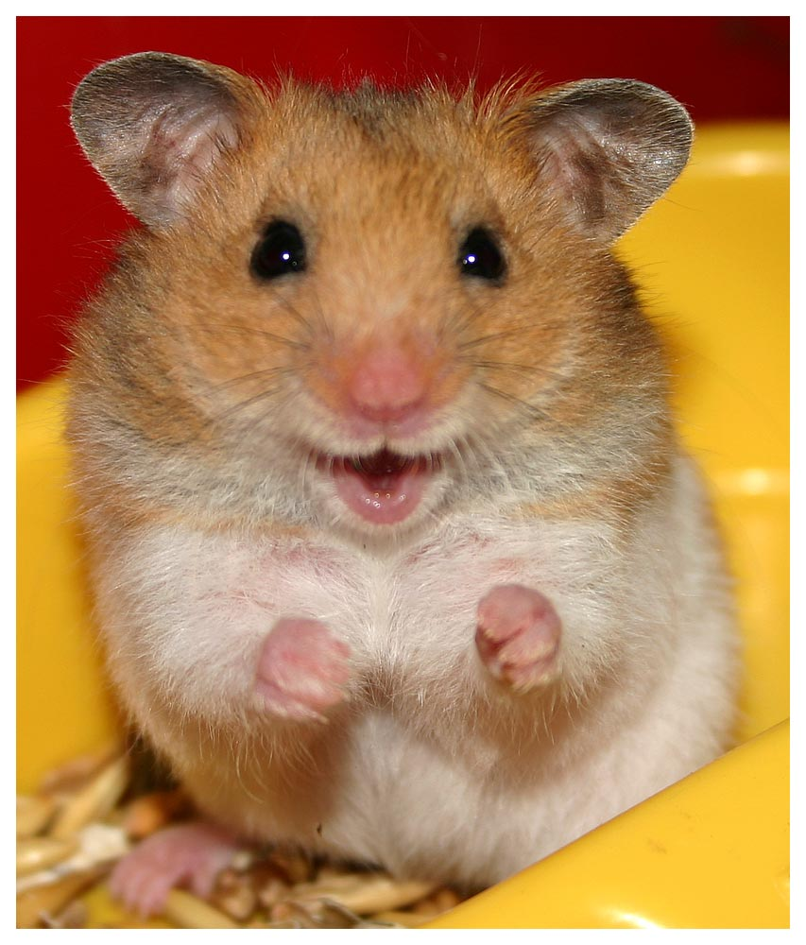

The Attack of the Cute!!

Hamsters have been hiding behind pictures for as long as can be remembered.
They have sought out the cutest of their kind and displayed them google and other
social media. The hamsters are extremely cute and it is hard not to resist their cuteness.

But, BEWARE!! Hamsters can easily mind control us to do things we might not want. Ex: Make them supreme rulers of the School and let them eat candy bars.

Hamsters are one of the most beloved or at least one of the cutest pets in the world. They come in various sizes including the Robodorfhamster which was reported to be the size of a gerbils head. These extremly cute creatures however may pose a threat to the school as we know it. Hamsters doing suspicious things is depicted on the right column.

In the top picture it is obviously depicting a Hamster brainwashing some innocent human (or just simply posing for picture). The hamster looks innocently up at the human obviously meaning Die Human (or the hamster simply wishes to be fed). In the second picture there is a hamster gorging on a tomatoe stolen from a human plate. This is hamster is a runaway.
(Hamsters continued on Page 4)

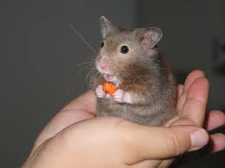

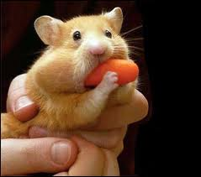

Beginning of the Quarter!!

This is the Beginning of another Quarter at Lake Harriet Community School. People have finally gotten the long awaited Spring Break and everyone is ready to begin another Quarter. The last week of Quarter #3 was a mad rush for grades and test scores. Teachers have been handing out homework left and right and most people are relieved that Spring Break had finally come.

Over Spring Break many people went on vacation. Some went to Florida and some went somewhere entirely different. Others went to the east coast and some people went to the west coast. Most people were visiting relatives or touring.

