Isadora White
3/21/16
Jessica Williams
Class 9

Professional Problem 6.2

Using methods from sections 6.2 and 6.3, set up an integral for the volume of this torus with radii r and R where Then find the volume of this torus in terms of r and R.
One method to approach this problem is through the washer method. When using the washer method, our first step is to find our inner and outer radii. We can do this by taking a horizontal cross-section of the torus, assuming the z-axis is the center of rotation.
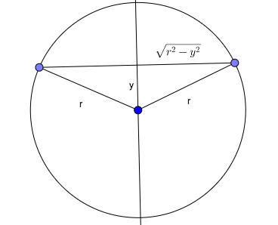
We can see from the above picture that the outer radius of the washer is and the inner radius is We can then set up the following integral,

Note: This is multiplied by 2 because we can take cross sections going both up and down.
We can simplify this to get

Let Then substituting in we get

Using the double angle rule for cosign we have

Therefore, the volume of the torus is

