Isadora White
2/18/2016
Jessica Williams
Class 6
Professional Problem 5.6

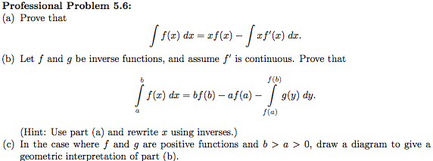
a) Prove that

Let,
then
and
then

Then, Integrating by Parts,

b) Let f and g be inverse functions, and assume f' is continuous. Prove that,

We know from part (a) that,

By the properties of Inverses we know that,

Then, substituting into the second part of the equation above, we get,

Let,

then

Then, using the fact that f' is continuous and substituting in we get,

Finally evaluating the first part of our equation and putting it all together, we get,

