Isadora White
1/28/16
Jessica Williams
Class 4

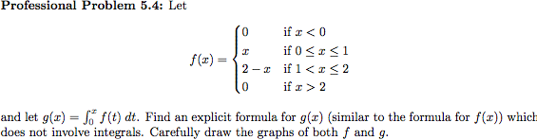

We know

Therefore, when x is less than zero,

so

However, if then

By the Fundamental Theorem of Calculus,

The third case of this problem requires some thought because even though on the interval [1,2], we are still integrating from 0 to x. Therefore,

When we evaluate the first integral we get

To express the second integral without using an integral symbol, we can use the second part of the Fundamental Theorem of Calculus. So we then get

where G(x) is the antiderivative of f(x). Therefore,

Using this fact, you can find g(x) to be

Finally, we consider the case where . Like the previous case we must consider the fact that we are a taking an integral from 0 to x not from 2 to x. Therefore, we can write

Or

We know,

and

Therefore, when substituting in we get

when
In conclusion,

