Isadora White
4/7/16
Jessica Williams
Class 10
Section 11.1: Problem 62

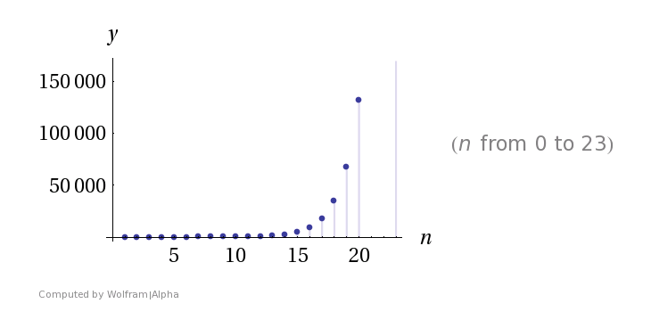
You can see from this graph, that this sequence diverges.

