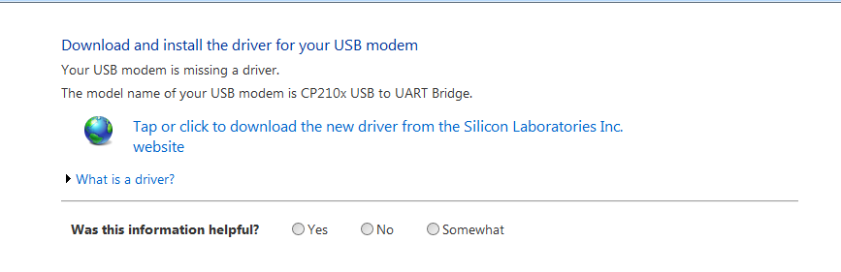

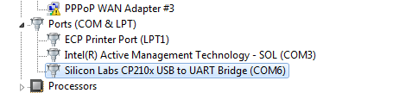

in code set mac and ip address:
byte mac[] = {
0x90, 0xA2, 0xDA, 0x0D, 0x74, 0x84 }; //this comes from the arduino ethernet board
IPAddress ip(192,168,1,176); //176 can be any free number in the subnet

then in browser http://192.168.1.176

