this sketch use arduino ethernet board:





in code set mac and ip address:
byte mac[] = {
0x90, 0xA2, 0xDA, 0x0D, 0x74, 0x84 }; //this comes from the arduino ethernet board
IPAddress ip(192,168,1,176); //176 can be any free number in the subnet

install telnet client in pc
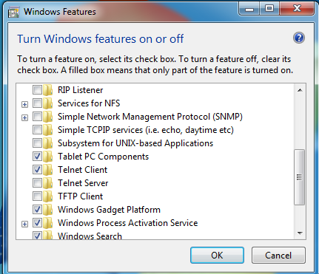

cmd->telnet->open 192.168.1.177

in this sketch the server doesn't differentiate clients . if more than one telnet client connected to server. all client receive same response from the server.

