This document will provide a set of non-automatable tests that should be run before release. The first section includes platform independent tests that should be run on all platforms. The later sections include platform dependent tests.

- Platform independent

  - drawmap

    - run:

[mono] drawmap.exe -o=out.png ../../../Cumberland.Tests/maps/mexico.xml

    - verify image created looks correct:

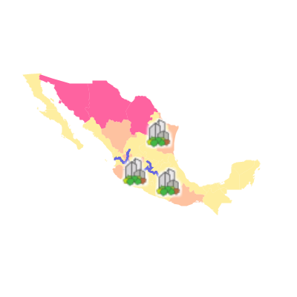

Note: mono output may have an outline on polygons because of a bug:

https://bugzilla.novell.com/show_bug.cgi?id=457426

  - tilepyramider

    - google maps

      - run:

[mono ] tilepyramider.exe -x=5 ../../../Cumberland.Tests/maps/mexico.xml

      - the tiles should shouid notify as rendered in the console:

24 of 24 Finished!

      - verify that 6 directories were created ('0' – '5') corresponding to the zoom level. Below this should be directories for the x value. Check inside these to make sure data is rendered.

    - TMS

      - run:

[mono ] tilepyramider.exe -x=5 -c=tms ../../../Cumberland.Tests/maps/mexico.xml

      - verify that directories were created same as (i)

      - verify that a tilemapresource.xml file was created with the following contents:

<?xml version="1.0" encoding="utf-8"?>
<TileMap version="1.0.0" tilemapservice="http://tms.osgeo.org/1.0.0">
<Title />
<Abstract />
<SRS>EPSG:4326</SRS>
<BoundingBox minx="-120" miny="12" maxx="-82" maxy="34" />
<Origin x="-101" y="23" />
<TileFormat width="256" height="256" mime-type="image/png" extension="png" />
<TileSets profile="local">
<TileSet href=".\0" units-per-pixel="1.40625" order="0" />
<TileSet href=".\1" units-per-pixel="0.703125" order="1" />
<TileSet href=".\2" units-per-pixel="0.3515625" order="2" />
<TileSet href=".\3" units-per-pixel="0.17578125" order="3" />
<TileSet href=".\4" units-per-pixel="0.087890625" order="4" />
<TileSet href=".\5" units-per-pixel="0.0439453125" order="5" />
</TileSets>
</TileMap>l

    - VirtualEarth

      - run:

[mono ] tilepyramider.exe -x=5 -c=ve -o=ve ../../../Cumberland.Tests/maps/mexico.xml

      - Verify that only 23 images were created
      - Verify that a 've' directory was created and that all images are in this single directory.

  - Map2kml

    - run:

[mono] map2kml.exe ..\..\..\Cumb
erland.Tests\maps\mexico.xml map.kml

    - Verify that a map.kml was created
    - Open this in Google Earth to make sure it is valid

- Test PostGIS:

drawmap – run test 1.(a) for '../../../Cumberlands.Tests/postgis.map'

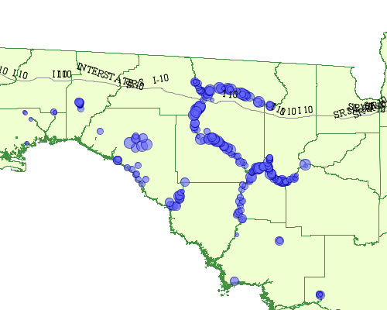

Note: this requires data from http://www.fgdl.org/

- Test Labelling and inline features:

drawmap – run test 1.(a) for '../../../Cumberland.Tests/simplefeatures.xml'.

Make sure labels appear as so:

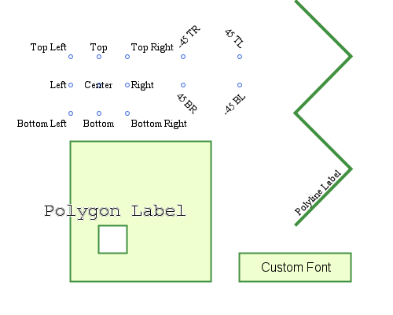

- Windows Platform Only

test SQL Server

  - drawmap – run test 1.(a) for '../../../Cumberland.Tests/sqlserver.map'.

  - shp2sqlserver

    - do the following tests for the following shapefiles: states.shp, roads.shp, cities.shp:

      - run:

shp2sqlserver.exe -s 4326 "Data Source=.\SQLExpress08;Initial Catalog=spatial;Integrated Security=true" <shapefile>

      - verify table exists in SQL management studio

      - run the following SQL (strip '.shp'):

select * from <shapefile>;

      - examine results and spatial results via Management Studio

    - repeat (j) with -a flag. Run "select count(*) from <table>" for each. Should be double.
    - Delete objects created in (i)
    - repeat (i) with -l flag

