This document will provide a set of non-automatable tests that should be run before release. The first section includes platform independent tests that should be run on all platforms. The later sections include platform dependent tests.

- Platform independent

  - drawmap

    - run:

[mono] drawmap.exe -o=out.png ../../../Cumberland.Tests/maps/mexico.xml

    - verify image created looks correct:

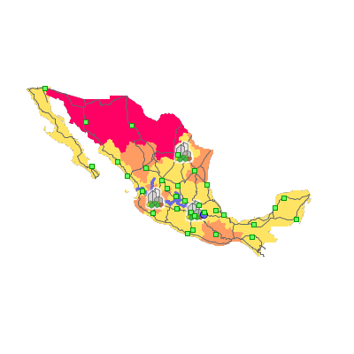

  - tilepyramider

    - run:

[mono ] tilepyramider.exe -x=5 ../../../Cumberland.Tests/maps/mexico.xml

    - the tiles should shouid notify as rendered in the console:

24 of 24 Finished!

    - verify that 5 directories were created ('0' – '5'). Check inside to make sure data is rendered.

    - TODO: test deployment?

- Mono Platform

test PostGIS

  - drawmap – run test 1.(a) for '../../../Cumberlands.Tests/postgis.map'

- Windows Platform

test SQL Server

  - shp2sqlserver

    - do the following tests for the following shapefiles: states.shp, roads.shp, cities.shp:

      - run:

shp2sqlserver.exe "Data Source=.\SQLExpress2008;Initial Catalog=spatialtest;Integrated Security=true" <shapefile>

      - verify table exists in SQL management studio

      - run the following SQL (strip '.shp'):

select * from <shapefile>;

      - examine results and spatial results

  - drawmap – run test 1.(a) for '../../../Cumberland.Tests/sqlserver.map'

