Write HTML and JavaScript that behaves in the following way.

# Do not use jQuery for this section:

Start with an empty document. When the body is doubleclicked, use JavaScript to create five images inside a div (a-e), one button (f) <input type=’button’> after the div, and two images (g, h) below the button.

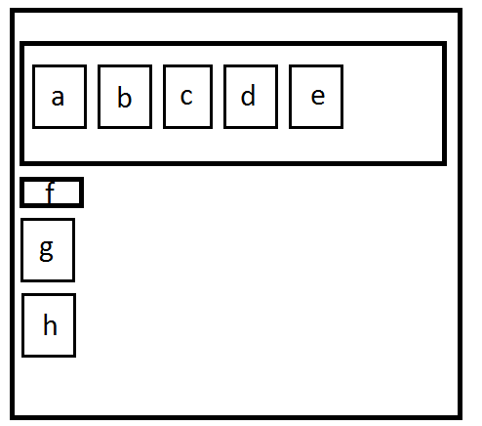

Use JavaScript to attach the following behaviors to each and every image in the div (a-e):

When an image inside the div (a-e) is clicked once, it moves to become the very first image in the div. However, if it is clicked again later, nothing happens. In other words, each of these images only reacts to one click.

When either of the bottom images (g or h) is double clicked, that image begins moving across the screen until it is clicked again, at which time it stops moving. Each time it is clicked, it toggles moving (if it is moving and it is clicked, it stops; if it is stopped and it is clicked, it moves). The very bottom image (h) moves twice as fast as the one above it (g). Use two different timers; one for image g and one for image h.

# Use jQuery for this section:

When the button (f) is clicked, use jQuery to change every image’s (a, b, c, d, e, g, h) css properties so that each one gets a 1px red solid border around it.