Singapore Institute of Technology
Information and Communications Technology Cluster
AAI4001 Capstone Project

Capstone Project Details (Form B)

General Capstone Project Information

Project Information:

(Project Title): AI Security for Critical Infrastructure: A Guardrail Evaluation Test Bench and the Beacon AI-Security Briefing Service

(Organization): Land Transport Authority (LTA)

(Initiation):

☒ Project initiated by industry
☐ Project initiated by student

(Multi-disciplinary):

☐ Project is multi-disciplinary (e.g. ICT and ENG)
☒ Project is single-disciplinary (e.g. ICT only)

Candidate Particulars:

(Name of Candidate): Guo Zi Qiang Robin

(Matriculation Number): 2400989

(Programme):

Applied Artificial Intelligence

(Project Period): 8/10/2026 to 31/3/2027

Main Academic Supervisor Details:

(Name): Professor Upadhyaya, Pulakesh

(Email Address): pulakesh.upadhyaya@singaporetech.edu.sg

(Contact Number): The academic supervisor’s contact number

(Designation): Assistant Professor AI & Data Science (Infocomm Technology)

Industry Supervisor Details:

(Name): Tan Zi Qi

(Email Address): tan_zi_qi@lta.gov.sg

(Contact Number): +65 9823 2058

(Designation): The industry supervisor’s designation

(Department / Division): IT, CYBERSECURITY & DIGITAL SERVICES/Cyber Architecture & Development

Capstone Project Details

Project Overview:
(Please use a separate sheet if necessary)

Two workstreams strengthen how the Cyber Architecture & Development (CYAD) division of the Land Transport Authority (LTA) adopts artificial intelligence (AI) safely and monitors AI-related threats.
Workstream 1: Guardrail Evaluation Test Bench
Guardrails are safety checks around an AI chatbot that allow, block or flag each message (see Annex B, Figure 1), catching harmful requests or jailbreaks (attempts to trick the chatbot into ignoring its rules). Products such as NVIDIA’s NeMo Guardrails (Rebedea et al., 2023), Meta’s Llama Guard (Inan et al., 2023) and the Government Technology Agency (GovTech) Sentinel service (Government Technology Agency, n.d.-b), which serves the LionGuard 2 harmful-content classifier (Tan et al., 2025), differ in what they check and report, making fair comparison hard. The test bench will score each guardrail on the same labelled inputs. It supports ablation: changing one guardrail or setting at a time while holding everything else fixed, to measure its individual effect.
Workstream 2: Beacon
Beacon will be a daily service that turns high-volume AI-security news into an evidence-backed Briefing: a ranked digest of the day’s most significant events, each stating what happened and why it matters (see Annex B, Figure 2). Each event is initially mapped to the Singapore Government’s System Security Plan (SSP) control catalogue, published by GovTech (Government Technology Agency, 2025), and to attacker techniques in MITRE ATT&CK (Adversarial Tactics, Techniques, and Common Knowledge) and MITRE ATLAS (Adversarial Threat Landscape for Artificial-Intelligence Systems) (The MITRE Corporation, n.d.-a, n.d.-b), with every judgement traceable to its evidence.

Project Objectives:
(Please use a separate sheet if necessary)

Across both workstreams, the candidate is expected to:
Workstream 1: Guardrail Evaluation Test Bench
1. Complete the existing comparative research on guardrail products, adding Meta’s Purple Llama safety tools (Meta AI, 2023) and GovTech’s Litmus testing platform (Government Technology Agency, n.d.-a).
2. Build a minimal, reusable evaluation harness: a test program that loads labelled inputs, calls each guardrail and records its verdicts in one common format.
3. Evaluate Tier 1, the first proposed comparison: harmful-content classification of user prompts, and jailbreak / prompt-attack detection.
4. Report, with evidence, which guardrails suit which function, with results by 1 December 2026.
Workstream 2: Beacon
5. Build a daily pipeline that collects items from a fixed list of English-language public sources, filters them for relevance, merges duplicate reports of the same event and rates each event’s significance.
6. Publish a web Briefing and send a condensed daily digest to subscribers through a messaging channel (Telegram bot, subject to LTA policy).
7. Provide an initial mapping of each event to SSP controls and ATT&CK and ATLAS techniques, with every judgement traceable to its evidence.
8. Deploy Beacon by 1 February 2027, with continuous integration and continuous deployment (CI/CD) and monitoring in place throughout February.
Stretch goal: detection of trends across recent events, once the earlier stages are stable.

Industry Relevancy:
(Please use a separate sheet if necessary)

LTA operates critical infrastructure, so both the AI it adopts and the AI-related threats it faces have consequences beyond the organisation.
Workstream 1: Guardrail Evaluation Test Bench
The bench gives CYAD an evidence-based way to choose guardrails before any generative AI system is deployed, instead of relying on vendor claims. This is timely because the SSP defines a dedicated Generative AI system type with its own controls. A parallel LTA AI red-teaming capstone project is building a tool that simulates attacks on AI applications; the bench complements it on the defensive side, with no committed integration.
Workstream 2: Beacon
CYAD needs timely, defensible awareness of AI threats, expressed in recognised security-control and attacker-technique terms. By linking each news event to SSP controls and ATT&CK and ATLAS techniques, Beacon aims to shorten the step from reading a report to knowing which controls it affects.

Project Scope:
(Please use a separate sheet if necessary)

Both workstreams use only open-source, free, free-trial or free-credit technology, developed on a single provided development laptop with an 8 GB graphics processing unit (GPU).
Workstream 1: Guardrail Evaluation Test Bench
Tier 1 is in scope: harmful-content classification of user prompts (NeMo Guardrails, Llama Guard 3/4 and Sentinel’s LionGuard 2), and jailbreak / prompt-attack detection (NeMo Guardrails and Sentinel, with Meta’s Prompt Guard 2 as a planned third comparator). All other guardrail functions form Tier 2, under investigation, each for a stated reason: too few comparable products; products share the same underlying service; it needs a response-generating, document-retrieval or tool-using agent set-up; or it needs more computing power. Checking chatbot responses is the natural next step. Limitations: larger guardrail models run on the laptop in 4-bit quantised (compressed) form where possible, or on free-tier cloud GPU credits; Llama Guard 4 results are subject to model access (Meta, 2025), with Llama Guard 3 as the committed baseline; only public or synthetic test prompts are sent to hosted services.
Workstream 2: Beacon
Beacon covers the outcomes in objectives 5 to 8, using English-language public sources only. It is an awareness service, not a compliance tool. It will be deployed on free-tier or free-credit cloud infrastructure in the Singapore region. Telegram delivery is subject to LTA policy; trend detection is a stretch goal.

Project Outputs and Deliverables
(Please use a separate sheet if necessary)

Each workstream produces working software and evidence, followed by the shared academic submissions.
Workstream 1: Guardrail Evaluation Test Bench
1. Evaluation harness (source code)
2. Tier 1 results dataset
3. Test bench evaluation report (first week of December 2026)
Workstream 2: Beacon
4. Deployed Beacon service with CI/CD and monitoring (by 1 February 2027)
5. Beacon source code and documentation
Academic submissions
6. Interim Report (Form E1)
7. Interim Presentation
8. Final Report (Form E2)
9. Final Presentation
10. Detailed Gantt chart (Gantt_Guo_Zi_Qiang_Robin.xlsx)

Knowledge and Training Requirements

Applicable Knowledge from the Degree Programme
(Please use a separate sheet if necessary)

The project draws on five modules:
AAI3008 Large Language Models: running, prompting and evaluating language models and guardrails.
INF2006 Cloud Computing and Big Data: cloud deployment, scheduled pipelines and cloud GPU use.
INF2005 Cyber Security Fundamentals: threat frameworks, security controls and attacks on AI.
INF2003 Database Systems: stored records, audit trails and results data.
INF2001 Introduction to Software Engineering: requirements, testing, version control and CI/CD.

Additional Knowledge, Skillsets, or Certifications Required
(Please use a separate sheet if necessary)

Practical knowledge of guardrail frameworks (NeMo Guardrails, Llama Guard, and LionGuard 2 through Sentinel); evaluation methods for safety classifiers (labelled test sets, including harmless prompts that resemble harmful ones, precision, recall and false-positive rates); running openly released models in compressed form within limited GPU memory; web collection and text extraction; the Structured Threat Information Expression (STIX) 2.1 and Open Security Controls Assessment Language (OSCAL) data formats; MITRE ATT&CK, MITRE ATLAS and the SSP; CI/CD and service monitoring; React for the web interface; and the Telegram bot application programming interface (API).
No formal certification is a prerequisite.

Training Required and Provided
(Please use a separate sheet if necessary)

An initial orientation to LTA’s AI and information-security policies will be required, including the approval needed before using any external service (for example, hosted guardrail services, cloud hosting and the Telegram channel). LTA provides the development laptop, and Sentinel access is already in place. All other learning is self-directed, through open documentation, published papers and free-tier cloud credits; no further organisation-provided tooling or computing resources are assumed.

Project Timeline
(Please use a separate sheet if necessary; Gantt chart should be included in the annex)

The project runs from 8 October 2026 to 31 March 2027 with the two workstreams in parallel: the test bench is the main focus until early December while Beacon’s design continues, and Beacon is built in December and January.
Workstream 1: Guardrail Evaluation Test Bench
October 2026: complete the comparative research (adding Purple Llama and Litmus), build the evaluation harness and request Llama Guard 4 access.
November 2026: run the Tier 1 evaluations on the laptop and on free cloud GPU credits.
1 December 2026: evaluation results complete.
1–6 December 2026: test bench evaluation report, which also feeds the Interim Report (Form E1).
Workstream 2: Beacon
October – November 2026: design of the analysis stages after collection continues at low intensity.
December 2026 – January 2027: build the pipeline in order: collection, filtering, merging, significance rating, the Briefing and Telegram digest, then initial mapping.
1 February 2027: Beacon deployed.
February 2027: CI/CD, monitoring and fixes from live running.
March 2027: buffer and iteration; trend detection as a stretch goal.
Academic milestones
8–11 October 2026: Form B, due 11 October.
6 December 2026: Interim Report (Form E1).
31 January 2027: Interim Presentation.
21 March 2027: Final Report (Form E2).
31 March 2027: end of the project period.
11 April 2027: Final Presentation (after the project period).
A summary Gantt chart is in Annex A; the detailed chart is provided in Gantt_Guo_Zi_Qiang_Robin.xlsx.

Supervisor Remarks
(Additional details relevant to the project; please use a separate sheet if necessary)

Industry Supervisor Remarks

Please provide any other details that are relevant to the project, e.g., references or research papers, description on the complexity of the project, expected learning opportunities, etc.

Academic Supervisor Remarks

Please provide any other details that are relevant to the project, e.g., references or research papers, description on the complexity of the project, expected learning opportunities, etc.

- Declaration of Conformity

Declaration by Industry Supervisor

I hereby acknowledge that I have engaged and discussed with the Candidate on the Capstone Project details above, and we are in agreement on the contents provided in the sections above.

Signature 
Name of Industry Supervisor: The industry supervisor’s name
Designation: The industry supervisor’s designation
Department: The industry supervisor’s department / division
Contact No: The industry supervisor’s contact number
Email: The industry supervisor’s email address
Date: Click or tap to enter a date

Declaration by Candidate

I hereby acknowledge that I have engaged and discussed with my Industry Supervisor on the Capstone Project details above, and we are in agreement on the contents provided in the sections above.

Signature
Name of Candidate: The candidate’s full name
Contact No: The candidate’s contact number
Email: The candidate’s email address
Date: Click or tap to enter a date

Declaration by Academic Supervisor

I hereby acknowledge that I have read and understood the Capstone Project details above. I believe that the proposed project is appropriate to fulfil the requirements for the AAI4001 Capstone Project module.

Signature
Name of Academic Supervisor: The academic supervisor’s name
Contact No: The academic supervisor’s contact number
Email: The academic supervisor’s email address
Date: Click or tap to enter a date

END OF FORM B

Annex A: Summary Gantt Chart

Month-level summary of the project plan. X = active in that month; M = milestone in that month. The project period is 8 October 2026 to 31 March 2027; the Final Presentation (11 April 2027) falls after it. The detailed weekly chart is provided in Gantt_Guo_Zi_Qiang_Robin.xlsx.

Activity | Oct 2026 | Nov | Dec | Jan 2027 | Feb | Mar | Apr
Academic milestones
Form B (11 Oct) | M
Interim Report (Form E1) (6 Dec) |  | X | M
Interim Presentation (by 31 Jan) |  |  |  | M
Final Report (Form E2) (21 Mar) |  |  |  |  |  | M
Capstone period ends (31 Mar) |  |  |  |  |  | M
Final Presentation (11 Apr) |  |  |  |  |  |  | M
Workstream 1: Guardrail Evaluation Test Bench
Complete research; build evaluation harness | X | X
Run Tier 1 evaluation (results 1 Dec) |  | X | M
Test bench evaluation report; tidy code and dataset |  |  | X
Workstream 2: Beacon
Design (low intensity) | X | X
Build: collect, filter, merge, rate, publish, map |  |  | X | X
Deploy (1 Feb) |  |  |  |  | M
CI/CD, monitoring and fixes |  |  |  |  | X
Buffer and iteration (trend detection is a stretch goal) |  |  |  |  |  | X

Annex B: Figures

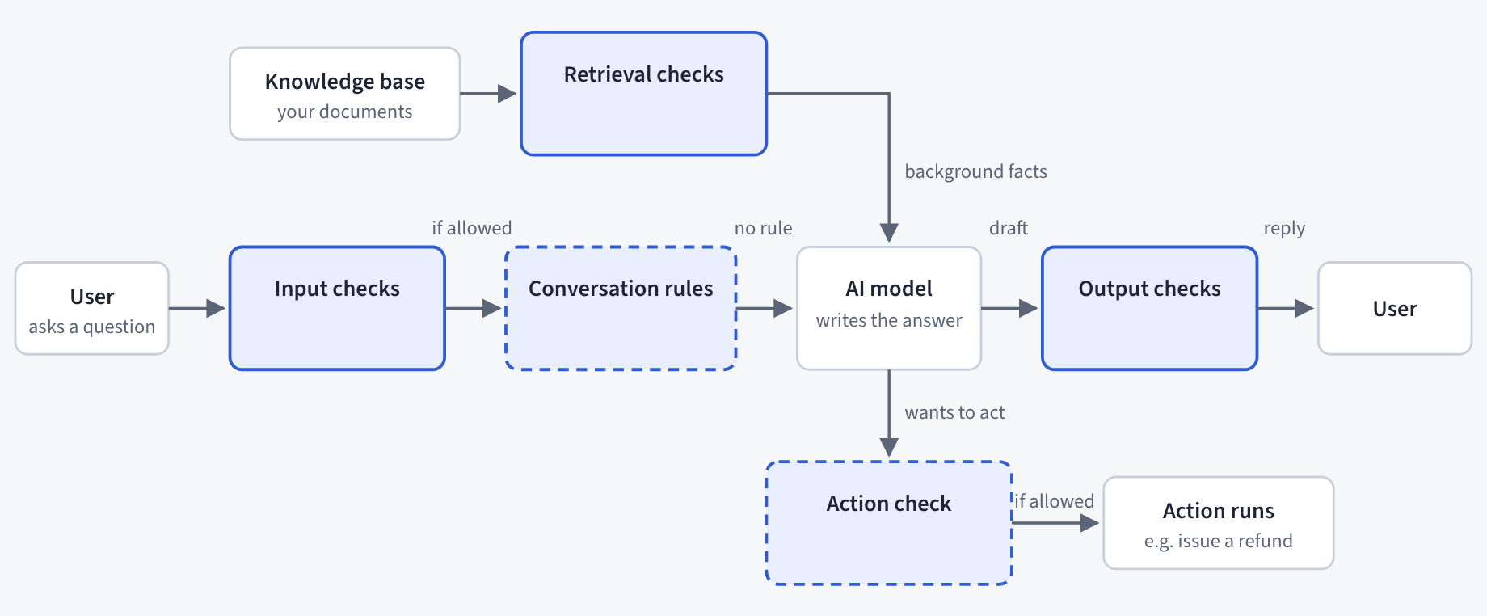
Figure 1. Where a guardrail can sit around an AI chatbot. Input checks inspect what the user types; conversation rules and action checks (dashed boxes) are written by the developer; retrieval checks clean passages from the organisation’s documents; output checks inspect the answer before the user sees it. Tier 1 evaluates the input checks. Adapted from the project’s NeMo Guardrails explainer.

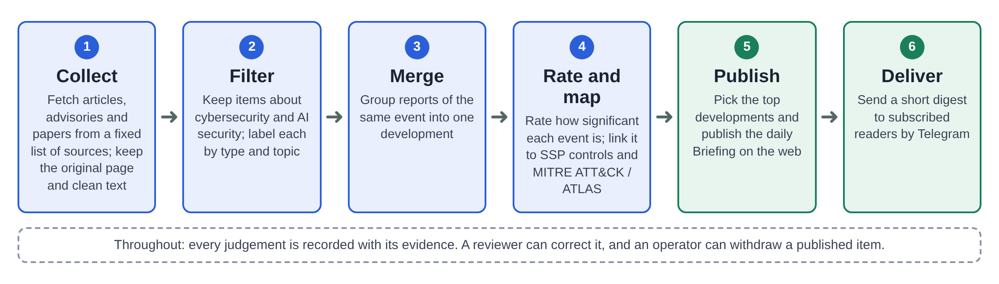
Figure 2. The Beacon daily pipeline in six steps: collect, filter, merge, rate and map, publish, deliver. Every judgement is recorded with its evidence.

Annex C: Glossary

Acronyms and terms used in this form, in alphabetical order.

Term | Plain definition
Ablation | Changing one guardrail or setting at a time while holding everything else fixed, to measure its individual effect.
AI | Artificial intelligence.
API | Application programming interface.
ATLAS | MITRE Adversarial Threat Landscape for Artificial-Intelligence Systems: a public knowledge base of attacker tactics and techniques against AI systems.
ATT&CK | MITRE Adversarial Tactics, Techniques, and Common Knowledge: a public knowledge base of real-world attacker tactics and techniques.
Briefing | Beacon’s evidence-backed daily digest: a ranked list of the day’s most significant AI-security events, each stating what happened and why it matters.
CI/CD | Continuous integration and continuous deployment: automated testing and release of software changes.
CYAD | Cyber Architecture & Development division, Land Transport Authority.
Evaluation harness | The test program that loads labelled inputs, calls each guardrail and records its verdicts in one common format.
GovTech | Government Technology Agency (Singapore).
GPU | Graphics processing unit.
Guardrail | A safety check around an AI chatbot that allows, blocks or flags each message.
LionGuard 2 | GovTech’s Singapore-tuned harmful-content classifier, served through Sentinel.
Litmus | GovTech’s pre-deployment testing platform for generative AI applications.
Llama Guard | Meta’s openly released safety classifier for chatbot inputs and outputs.
LTA | Land Transport Authority.
NeMo Guardrails | NVIDIA’s open-source toolkit for adding guardrails to chatbot applications.
OSCAL | Open Security Controls Assessment Language: a machine-readable format for security controls.
Prompt Guard 2 | Meta’s small classifier for jailbreak and prompt-attack detection (part of Purple Llama).
Purple Llama | Meta’s umbrella project of open safety tools and evaluations.
Sentinel | GovTech’s hosted guardrail service.
SSP | The Singapore Government’s System Security Plan control catalogue, published by GovTech.
STIX | Structured Threat Information Expression: a standard data format for threat knowledge.
Test bench (Guardrail Evaluation Test Bench) | The set-up that scores each guardrail in the comparison on the same labelled inputs.
Tier 1 / Tier 2 | Tier 1: the first proposed comparison (harmful-content classification of user prompts; jailbreak / prompt-attack detection). Tier 2: all other guardrail functions, under investigation, each for a stated reason.

Annex D: References

Government Technology Agency. (n.d.-a). Litmus. Retrieved October 8, 2026, from https://www.developer.tech.gov.sg/products/categories/cybersecurity/litmus
Government Technology Agency. (n.d.-b). Sentinel. Retrieved October 8, 2026, from https://www.developer.tech.gov.sg/products/categories/cybersecurity/sentinel
Government Technology Agency. (2025). System Security Plan (SSP). https://info.standards.tech.gov.sg/ssp/
Inan, H., Upasani, K., Chi, J., Rungta, R., Iyer, K., Mao, Y., Tontchev, M., Hu, Q., Fuller, B., Testuggine, D., & Khabsa, M. (2023). Llama Guard: LLM-based input-output safeguard for human-AI conversations (arXiv:2312.06674). arXiv. https://doi.org/10.48550/arXiv.2312.06674
Meta. (2025). Llama Guard 4 [Model card and prompt format]. Retrieved October 8, 2026, from https://developer.meta.com/ai/docs/model-cards-and-prompt-formats/llama-guard-4/
Meta AI. (2023, December 7). Announcing Purple Llama: Towards open trust and safety in the new world of generative AI. https://ai.meta.com/blog/purple-llama-open-trust-safety-generative-ai/
The MITRE Corporation. (n.d.-a). MITRE ATLAS: Adversarial Threat Landscape for Artificial-Intelligence Systems. Retrieved October 8, 2026, from https://atlas.mitre.org/
The MITRE Corporation. (n.d.-b). MITRE ATT&CK. Retrieved October 8, 2026, from https://attack.mitre.org/
Rebedea, T., Dinu, R., Sreedhar, M., Parisien, C., & Cohen, J. (2023). NeMo Guardrails: A toolkit for controllable and safe LLM applications with programmable rails. In Proceedings of the 2023 Conference on Empirical Methods in Natural Language Processing: System Demonstrations (pp. 431–445). Association for Computational Linguistics. https://doi.org/10.18653/v1/2023.emnlp-demo.40
Tan, L., Chua, G., Ge, Z., & Lee, R. K.-W. (2025). LionGuard 2: Building lightweight, data-efficient and localised multilingual content moderators. In Proceedings of the 2025 Conference on Empirical Methods in Natural Language Processing: System Demonstrations (pp. 264–285). Association for Computational Linguistics. https://aclanthology.org/2025.emnlp-demos.20/

