Singapore Institute of Technology
Information and Communications Technology Cluster
AAI4001 Capstone Project

Capstone Project Details (Form B)

General Capstone Project Information

Project Information:

(Project Title): Beacon

(Organization): Land Transport Authority (LTA)

(Initiation):

☒ Project initiated by industry
☐ Project initiated by student

(Multi-disciplinary):

☐ Project is multi-disciplinary (e.g. ICT and ENG)
☒ Project is single-disciplinary (e.g. ICT only)

Candidate Particulars:

(Name of Candidate): Guo Zi Qiang Robin

(Matriculation Number): 2400989

(Programme):

Applied Artificial Intelligence

(Project Period): 8/10/2026 to 31/3/2027

Main Academic Supervisor Details:

(Name): Professor Upadhyaya, Pulakesh

(Email Address): pulakesh.upadhyaya@singaporetech.edu.sg

(Contact Number): The academic supervisor’s contact number

(Designation): Assistant Professor AI & Data Science (Infocomm Technology)

Industry Supervisor Details:

(Name): Tan Zi Qi

(Email Address): tan_zi_qi@lta.gov.sg

(Contact Number): +65 9823 2058

(Designation): The industry supervisor’s designation

(Department / Division): IT, CYBERSECURITY & DIGITAL SERVICES/Cyber Architecture & Development

Capstone Project Details

Project Overview:

Please provide a description of the candidate’s capstone project, including its purpose, etc.

Project Objectives:

Please provide a detailed description of the project objectives, i.e., what is the candidate expected to accomplish

Industry Relevancy:

Please provide information regarding the relevance of the project to the hosting organization, and / or to the industry at large

Project Scope:

Please provide a detailed description of the project scope, including any limitations of the project

Project Outputs and Deliverables

Please provide a detailed description of the expected outputs and deliverables by the candidate

Knowledge and Training Requirements

Applicable Knowledge from the Degree Programme

Please provide details of any pre-requisite knowledge and / or skillsets from the degree programme that is required by the candidate for the project

Additional Knowledge, Skillsets, or Certifications Required

Please provide details of any other required knowledge, skillsets, or certifications beyond the degree programme that the candidate will require to complete the project

Training Required and Provided

Please provide details of any additional relevant training that is required by, and that will be provided to the candidate for the purpose of the project

Project Timeline
(Please use a separate sheet if necessary; Gantt chart should be included in the annex)

Please provide a detailed timeline of the project, including expected output and deliverables

Supervisor Remarks
(Additional details relevant to the project; please use a separate sheet if necessary)

Industry Supervisor Remarks

Please provide any other details that are relevant to the project, e.g., references or research papers, description on the complexity of the project, expected learning opportunities, etc.

Academic Supervisor Remarks

Please provide any other details that are relevant to the project, e.g., references or research papers, description on the complexity of the project, expected learning opportunities, etc.

- Declaration of Conformity

Declaration by Industry Supervisor

I hereby acknowledge that I have engaged and discussed with the Candidate on the Capstone Project details above, and we are in agreement on the contents provided in the sections above.

Signature 
Name of Industry Supervisor: The industry supervisor’s name
Designation: The industry supervisor’s designation
Department: The industry supervisor’s department / division
Contact No: The industry supervisor’s contact number
Email: The industry supervisor’s email address
Date: Click or tap to enter a date

Declaration by Candidate

I hereby acknowledge that I have engaged and discussed with my Industry Supervisor on the Capstone Project details above, and we are in agreement on the contents provided in the sections above.

Signature 
Name of Candidate: The candidate’s full name
Contact No: The candidate’s contact number
Email: 2400989@sit.singaporetech.edu.sg
Date: 9/10/2026

Declaration by Academic Supervisor

I hereby acknowledge that I have read and understood the Capstone Project details above. I believe that the proposed project is appropriate to fulfil the requirements for the AAI4001 Capstone Project module.

Signature
Name of Academic Supervisor: The academic supervisor’s name
Contact No: The academic supervisor’s contact number
Email: The academic supervisor’s email address
Date: Click or tap to enter a date

END OF FORM B

Annex A: Summary Gantt Chart

Month-level summary of the project plan. X = active in that month; M = milestone in that month. The project period is 8 October 2026 to 31 March 2027; the Final Presentation (11 April 2027) falls after it. The detailed weekly chart is provided in Gantt_Guo_Zi_Qiang_Robin.xlsx.

Activity | Oct 2026 | Nov | Dec | Jan 2027 | Feb | Mar | Apr
Academic milestones
Form B (11 Oct) | M
Interim Report (Form E1) (6 Dec) |  | X | M
Interim Presentation (by 31 Jan) |  |  |  | M
Final Report (Form E2) (21 Mar) |  |  |  |  |  | M
Capstone period ends (31 Mar) |  |  |  |  |  | M
Final Presentation (11 Apr) |  |  |  |  |  |  | M
Workstream 1: Guardrail Evaluation Test Bench
Complete research; build evaluation harness | X | X
Run Tier 1 evaluation (results 1 Dec) |  | X | M
Test bench evaluation report; tidy code and dataset |  |  | X
Workstream 2: Beacon
Design (low intensity) | X | X
Build: collect, filter, merge, rate, publish, map |  |  | X | X
Deploy (1 Feb) |  |  |  |  | M
CI/CD, monitoring and fixes |  |  |  |  | X
Buffer and iteration (trend detection is a stretch goal) |  |  |  |  |  | X

Annex B: Figures
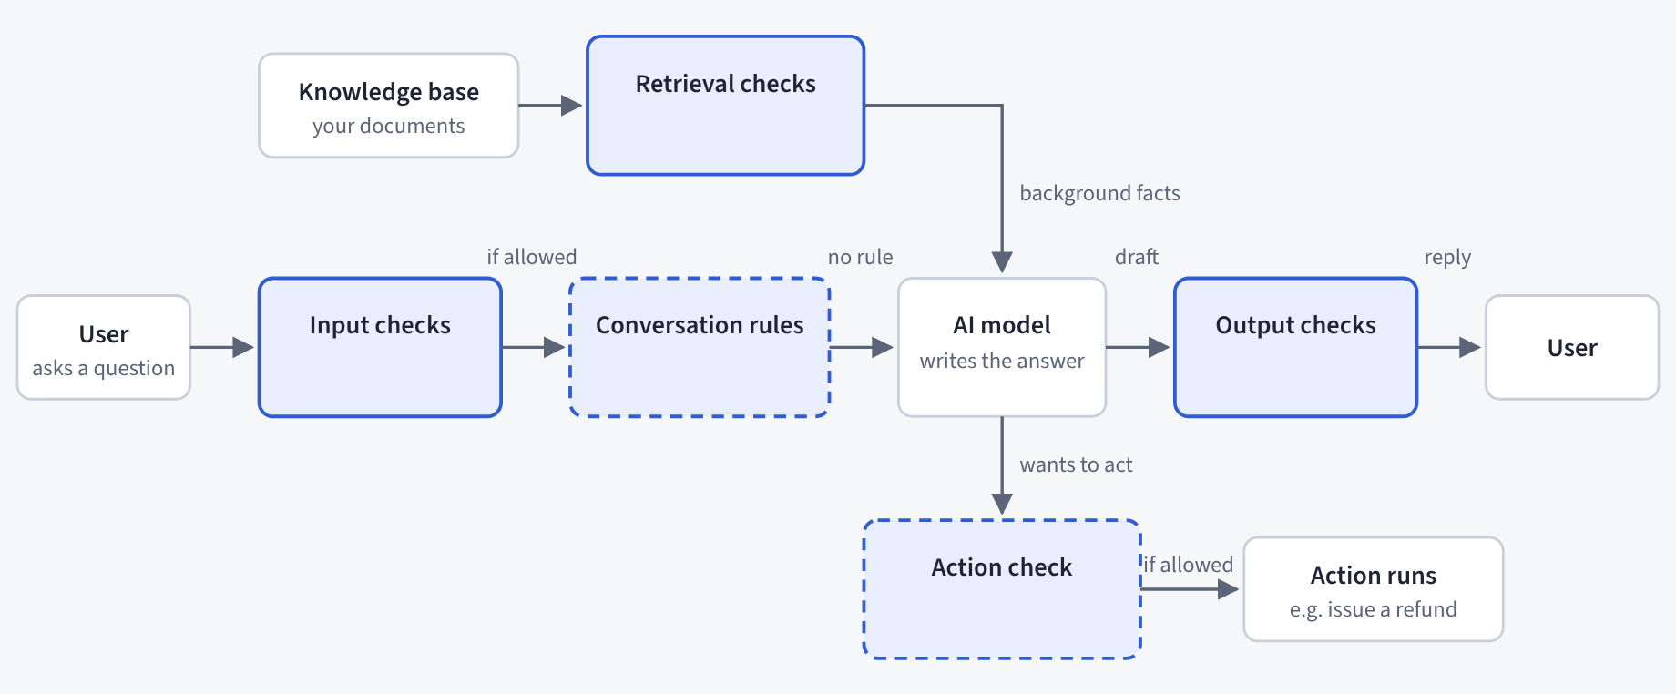
Figure 1. Where a guardrail can sit around an AI chatbot. Input checks inspect what the user types; conversation rules and action checks (dashed boxes) are written by the developer; retrieval checks clean passages from the organisation’s documents; output checks inspect the answer before the user sees it. Tier 1 evaluates the input checks. Adapted from the project’s NeMo Guardrails explainer

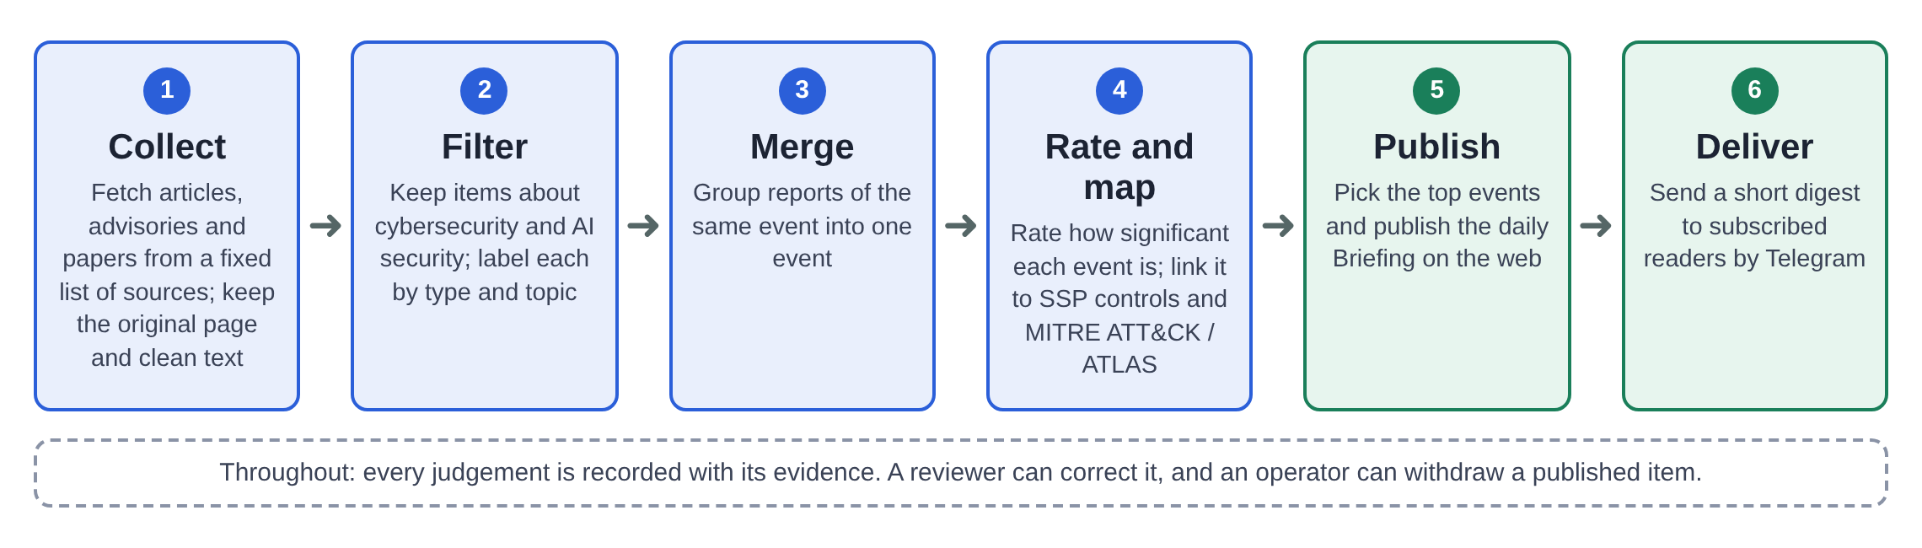
Figure 2. The Beacon daily pipeline in six steps: collect, filter, merge, rate and map, publish, deliver. Every judgement is recorded with its evidence

Annex C: Glossary

Acronyms and terms used in this form, in alphabetical order.

Term | Plain definition
Ablation | Changing one guardrail or setting at a time while holding everything else fixed, to measure its individual effect.
AI | Artificial intelligence.
API | Application programming interface.
ATLAS | MITRE Adversarial Threat Landscape for Artificial-Intelligence Systems: a public knowledge base of attacker tactics and techniques against AI systems.
ATT&CK | MITRE Adversarial Tactics, Techniques, and Common Knowledge: a public knowledge base of real-world attacker tactics and techniques.
Briefing | Beacon’s evidence-backed daily digest: a ranked list of the day’s most significant AI-security events, each stating what happened and why it matters.
CI/CD | Continuous integration and continuous deployment: automated testing and release of software changes.
CYAD | Cyber Architecture & Development division, Land Transport Authority.
Evaluation harness | The test program that loads labelled inputs, calls each guardrail and records its verdicts in one common format.
GovTech | Government Technology Agency (Singapore).
GPU | Graphics processing unit.
Guardrail | A safety check around an AI chatbot that allows, blocks or flags each message.
LionGuard 2 | GovTech’s Singapore-tuned harmful-content classifier, served through Sentinel.
Litmus | GovTech’s pre-deployment testing platform for generative AI applications.
Llama Guard | Meta’s openly released safety classifier for chatbot inputs and outputs.
LTA | Land Transport Authority.
NeMo Guardrails | NVIDIA’s open-source toolkit for adding guardrails to chatbot applications.
OSCAL | Open Security Controls Assessment Language: a machine-readable format for security controls.
Prompt Guard 2 | Meta’s small classifier for jailbreak and prompt-attack detection (part of Purple Llama).
Purple Llama | Meta’s umbrella project of open safety tools and evaluations.
Sentinel | GovTech’s hosted guardrail service.
SSP | The Singapore Government’s System Security Plan control catalogue, published by GovTech.
STIX | Structured Threat Information Expression: a standard data format for threat knowledge.
Test bench (Guardrail Evaluation Test Bench) | The set-up that scores each guardrail in the comparison on the same labelled inputs.
Tier 1 / Tier 2 | Tier 1: the first proposed comparison (harmful-content classification of user prompts; jailbreak / prompt-attack detection). Tier 2: all other guardrail functions, under investigation, each for a stated reason.

Annex D: References
s
Government Technology Agency. (n.d.-a). Litmus. Retrieved October 8, 2026, from https://www.developer.tech.gov.sg/products/categories/cybersecurity/litmus
Government Technology Agency. (n.d.-b). Sentinel. Retrieved October 8, 2026, from https://www.developer.tech.gov.sg/products/categories/cybersecurity/sentinel
Government Technology Agency. (2025). System Security Plan (SSP). https://info.standards.tech.gov.sg/ssp/
Inan, H., Upasani, K., Chi, J., Rungta, R., Iyer, K., Mao, Y., Tontchev, M., Hu, Q., Fuller, B., Testuggine, D., & Khabsa, M. (2023). Llama Guard: LLM-based input-output safeguard for human-AI conversations (arXiv:2312.06674). arXiv. https://doi.org/10.48550/arXiv.2312.06674
Meta. (2025). Llama Guard 4 [Model card and prompt format]. Retrieved October 8, 2026, from https://developer.meta.com/ai/docs/model-cards-and-prompt-formats/llama-guard-4/
Meta AI. (2023, December 7). Announcing Purple Llama: Towards open trust and safety in the new world of generative AI. https://ai.meta.com/blog/purple-llama-open-trust-safety-generative-ai/
The MITRE Corporation. (n.d.-a). MITRE ATLAS: Adversarial Threat Landscape for Artificial-Intelligence Systems. Retrieved October 8, 2026, from https://atlas.mitre.org/
The MITRE Corporation. (n.d.-b). MITRE ATT&CK. Retrieved October 8, 2026, from https://attack.mitre.org/
Rebedea, T., Dinu, R., Sreedhar, M., Parisien, C., & Cohen, J. (2023). NeMo Guardrails: A toolkit for controllable and safe LLM applications with programmable rails. In Proceedings of the 2023 Conference on Empirical Methods in Natural Language Processing: System Demonstrations (pp. 431–445). Association for Computational Linguistics. https://doi.org/10.18653/v1/2023.emnlp-demo.40
Tan, L., Chua, G., Ge, Z., & Lee, R. K.-W. (2025). LionGuard 2: Building lightweight, data-efficient and localised multilingual content moderators. In Proceedings of the 2025 Conference on Empirical Methods in Natural Language Processing: System Demonstrations (pp. 264–285). Association for Computational Linguistics. https://aclanthology.org/2025.emnlp-demos.20/

